Abstract

Introduction

Methods

Data
Data on juvenile Coho salmon densities (#/km) and habitat characteristics were collected from 24 Oregon coastal watersheds from 1998 to 2019 (Figure Map). The habitat data for each stream segment included: stream slope, maximum gradient, stream width, distance to the ocean, spring precipitation, MWMT_index, and W3Dppt. Because the scale of the watershed and the annual effort varied between years, the annual total number of observations within a watershed range between 0 and 37 (Table 1).
We developed a suite of estimation models (e.g., frequentist, Bayesian, random forest, gam) and model structures (e.g., habitat only, temporal, spatial, and spatiotemporal autocorrelation) to predict the density of juvenile Coho salmon which Oregon ESU. For each model, we included all the habitat covariates because the maximum absolute correlation between habitat covariates was 0.51, suggesting little evidence for confounding between covariates (Figure 1; (Hosmer Jr et al., 2013)).

Parameteric models
The frequentist and Bayesian models used a similar structure to account for the fixed and random effects. We assume that log of the predicted density of juvenile Coho ($η$; number/km of stream surveyed) for population i, for location s, during year t, is a linear combination of fixed and random effects,
$$η_{s,t}=X_{s,t}b+\sum_{j}{h_{j(s)}}+v_{s}+w_{t}+ε_{st}$$
Where, $X_{s,t}$ is vector of covariates, b is vector of parameters describing the marginal effect of the covariates, $h_{j(s)}$ are non-spatial or non-temporal random effects for location s (e.g., watershed, stream reach, etc.), $v_{s}$ is the spatial deviate for location s, $w_{t}$ is the temporal deviate for year t, and $ε_{st}$ is the deviate for the interaction between location s during year t.
We assume that the observations of juvenile Coho salmon density ($y_{s,t})$follow a Tweedie distribution
$$y_{s,t}\sim Tweedie\left(\exp\left(η_{s,t}\right),p,ϕ\right), 1<p<2$$
where, $\exp\left(η_{s,t}\right)$ is the expected density, $p$ is a power parameter, and $ϕ$ is an over-dispersion parameter. For the temporal, spatial and spatiotemporal random effects of the model we assume a multivariate normal distribution,
$$v∼MVN(0,Σ_{v})$$
$$w∼MVN(0,Σ_{w})$$
$$ε∼MVN(0,Σ_{ε})$$
Elements of the spatial covariance are described by the distance between locations, a decay parameter $λ$, and a variance parameter $σ_{v}^{2}$,
$$Σ_{v}(s_{i},s_{j})=σ_{v}^{2}\exp\left(-\frac{\left|s_{i}-s_{j}\right|}{{2λ}^{2}}\right)$$
While, the elements of the temporal covariance are the time between years, a correlation parameter $ϕ$, and a variance parameter $σ_{w}^{2}$,
$$Σ_{w}\left(t_{i}, t_{j}\right)=σ_{w}^{2}ϕ^{\left|t_{i}-t_{j}\right|}{ }$$
Mapping spatial observations to a spatial grid
For our analysis we use Euclidean distances to estimate the spatial covariance. Other authors have shown that stream distances can provide less biased estimates of the spatial processes in stream networks (Hocking et al. 2018, VerHoof or Petersen articles), and have provided efficient procedures for estimating the fixed and random effects in mixed-effects spatiotemporal models; however, creating the stream distances from GIS shapefiles of stream networks remains a considerable hurdle for the available R packages (e.g., VAST or SSN). For our analysis, we used the glmmTMB (Brooks et al., 2017) and sdmTMB (Anderson et al., 2022; Barnett et al., 2021) packages in R to estimate the fixed effects and random effects of the spatiotemporal mixed-effects models.
For our analysis, there are over 1,400 unique spatial locations and estimating the covariance matrix of that size failed to converge. The method for reducing the size of the spatial covariance differs between the two packages. The sdmTMB package uses the INLA package to create a “mesh” over the spatial domain and then assign spatial observations to cells within the mesh. The package glmmTMB

Parametric estimation
We used a generalized likelihood to describe

Non-parameteric models

Non-parameteric estimation
In addition

Results
Exploratory models
Through exploration of multiple modeling structures for the entire data set, we found that models for juvenile and adult densities with spatiotemporal processes provided the lowest root mean-square-error for the random forest (RMSE_{adult} =, RMSE_{juvenile} = ), GAM (RMSE_{adult} =, RMSE_{juvenile} = ), and GLMM (RMSE_{adult} =, RMSE_{juvenile} = ) estimation routines (Fig. x; Table S 1, Table S 2, Table S 3). Visually examining just the 1998 and 2019, each of the models
Comparing predictive ability of the models for zero, one and two years into the future, based on the RMSE for 2015 to 2019, the random forest model, again, provided the highest predictive ability for zero years into the future; however, the predictive ability of the random forest model was much smaller for one and two years into the future relative to the GAM and GLMM models (Fig. x).
, the random forest model provide the lowest RMSE for the entire data, as For each the three estimations types, we found that models with the lowest RSME included a spatiotemporal process to describe deviations in the juvenile and adult salmon densities (Table 1). We assessing the predictive ability of the best fit models for each of the three estimation types, we found that the random forest provided the lowest RMSE (i.e., highest predictive ability) for zero, one, and two years into the future (Fig. xx)

model random forest model to have the lowest RMSE for the

Figure 1. Map of the watersheds and observations.

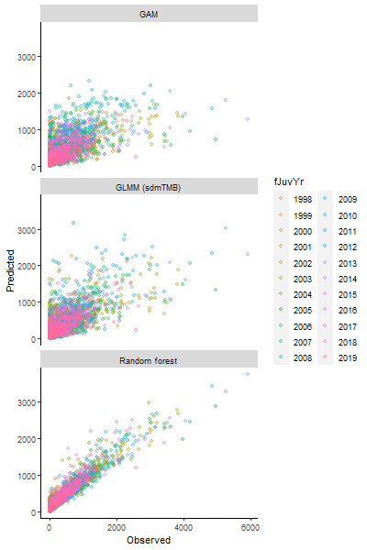
Figure 2. Correlation between observed and predicted juvenile densities between 1998 and 2019 for the GAM, GLMM and random forest models. R packages are parenthetically references in the margins.
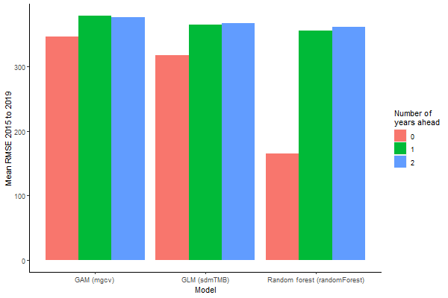
Figure 3. Predictive ability of GAM, GLMM, and random forest models for juvenile Coho salmon densities in the Coastal Oregon evolutionary significant unit (ESU) for zero, one, and two years into the future using rot mean-square-error average for years 2015 to 2019.

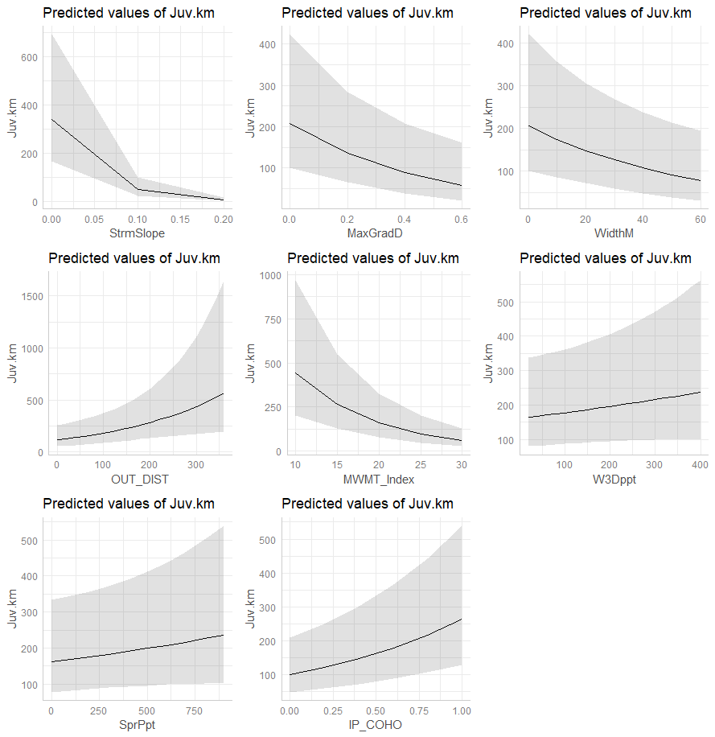
Figure 4. Marginal effects of the covariates.

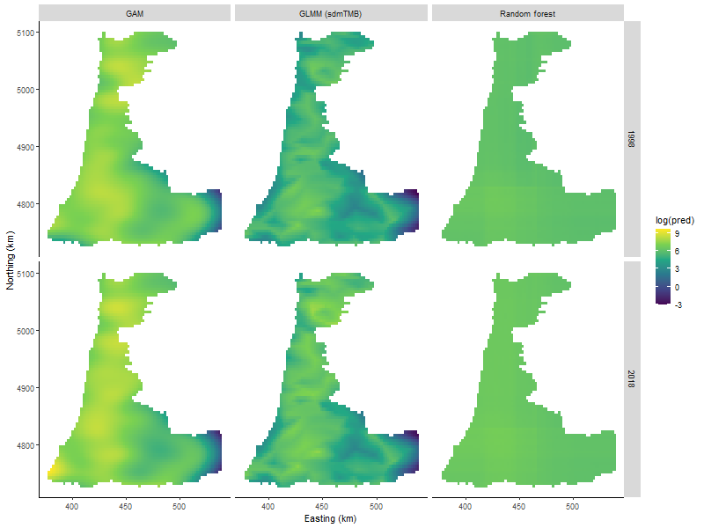
Figure 5. Spatiotemporal predictions (model 5) of juvenile Coho densities across the domain for the Oregon coastal ESU from 1998 to 2019. Dots represent the log observed positive juvenile densities superimposed on the predicted juvenile density (raster image).

Table 1. Annual number of observation of juvenile Coho salmon densities for each watershed population group in the coastal Oregon ESU.
Population Group | 1998 | 1999 | 2000 | 2001 | 2002 | 2003 | 2004 | 2005 | 2006 | 2007 | 2008
Alsea | 7 | 6 | 6 | 10 | 8 | 1 | 6 | 11 | 7 | 12 | 10
Beaver | 0 | 1 | 0 | 0 | 1 | 1 | 0 | 1 | 0 | 2 | 3
Coos | 13 | 10 | 8 | 9 | 11 | 10 | 10 | 9 | 8 | 12 | 18
Coquille | 14 | 12 | 8 | 9 | 8 | 12 | 13 | 12 | 12 | 17 | 13
Floras | 3 | 1 | 2 | 1 | 1 | 0 | 2 | 2 | 1 | 3 | 2
Lower Umpqua | 0 | 4 | 11 | 6 | 5 | 6 | 8 | 16 | 9 | 10 | 18
MCDependent | 4 | 3 | 4 | 4 | 5 | 6 | 3 | 4 | 5 | 5 | 5
Middle Umpqua | 0 | 7 | 3 | 3 | 6 | 3 | 7 | 4 | 7 | 7 | 7
MSDependent | 1 | 1 | 0 | 0 | 0 | 0 | 0 | 0 | 0 | 0 | 0
NCDependent | 1 | 1 | 1 | 2 | 2 | 1 | 1 | 1 | 2 | 1 | 1
Necanicum | 0 | 1 | 4 | 6 | 1 | 3 | 5 | 2 | 3 | 4 | 1
Nehalem | 9 | 12 | 14 | 11 | 17 | 12 | 10 | 16 | 13 | 12 | 15
Nestucca | 4 | 5 | 4 | 37 | 23 | 18 | 18 | 17 | 23 | 11 | 6
North Umpqua | 0 | 2 | 3 | 2 | 0 | 9 | 0 | 0 | 3 | 10 | 7
Salmon | 0 | 1 | 2 | 0 | 0 | 2 | 0 | 0 | 2 | 2 | 1
Siletz | 4 | 6 | 5 | 2 | 3 | 3 | 2 | 7 | 5 | 9 | 8
Siltcoos | 0 | 0 | 2 | 1 | 0 | 1 | 0 | 0 | 1 | 0 | 2
Siuslaw | 16 | 10 | 15 | 20 | 15 | 17 | 19 | 15 | 15 | 20 | 19
Sixes | 2 | 2 | 2 | 3 | 3 | 3 | 3 | 3 | 4 | 4 | 2
South Umpqua | 0 | 15 | 13 | 11 | 13 | 16 | 10 | 12 | 11 | 16 | 18
Tahkenitch | 0 | 0 | 1 | 0 | 0 | 0 | 0 | 1 | 1 | 2 | 2
Tenmile | 0 | 0 | 2 | 0 | 1 | 0 | 1 | 0 | 0 | 3 | 0
Tillamook Bay | 11 | 13 | 12 | 7 | 7 | 10 | 11 | 9 | 11 | 19 | 16
Yaquina | 3 | 3 | 6 | 3 | 7 | 5 | 6 | 4 | 4 | 6 | 5

Table 1 – continued
Population Group | 2009 | 2010 | 2011 | 2012 | 2013 | 2014 | 2015 | 2016 | 2017 | 2018 | 2019
Alsea | 10 | 7 | 6 | 7 | 8 | 4 | 5 | 6 | 5 | 6 | 4
Beaver | 2 | 1 | 3 | 2 | 1 | 2 | 2 | 1 | 2 | 2 | 1
Coos | 15 | 17 | 12 | 14 | 16 | 11 | 8 | 12 | 14 | 14 | 16
Coquille | 15 | 13 | 16 | 17 | 14 | 8 | 15 | 9 | 12 | 13 | 17
Floras | 1 | 3 | 3 | 2 | 3 | 4 | 2 | 3 | 2 | 2 | 3
Lower Umpqua | 12 | 8 | 12 | 14 | 12 | 9 | 10 | 8 | 10 | 11 | 10
MCDependent | 4 | 3 | 4 | 4 | 3 | 4 | 4 | 3 | 3 | 4 | 4
Middle Umpqua | 6 | 7 | 7 | 6 | 7 | 8 | 7 | 7 | 9 | 7 | 9
MSDependent | 0 | 0 | 0 | 0 | 0 | 0 | 0 | 0 | 0 | 0 | 0
NCDependent | 2 | 1 | 0 | 1 | 3 | 1 | 1 | 2 | 1 | 2 | 1
Necanicum | 3 | 4 | 2 | 2 | 4 | 1 | 2 | 2 | 2 | 4 | 4
Nehalem | 12 | 14 | 13 | 20 | 12 | 10 | 5 | 14 | 13 | 12 | 15
Nestucca | 4 | 7 | 8 | 3 | 6 | 4 | 5 | 5 | 6 | 2 | 7
North Umpqua | 4 | 3 | 2 | 5 | 1 | 1 | 1 | 1 | 1 | 3 | 1
Salmon | 1 | 0 | 0 | 2 | 1 | 0 | 1 | 0 | 1 | 1 | 1
Siletz | 4 | 5 | 6 | 2 | 5 | 4 | 2 | 3 | 3 | 2 | 5
Siltcoos | 0 | 0 | 0 | 1 | 0 | 0 | 1 | 0 | 0 | 1 | 0
Siuslaw | 18 | 17 | 21 | 20 | 21 | 13 | 13 | 14 | 20 | 14 | 16
Sixes | 2 | 5 | 3 | 3 | 2 | 2 | 2 | 2 | 2 | 0 | 0
South Umpqua | 13 | 15 | 16 | 16 | 17 | 13 | 13 | 13 | 13 | 13 | 14
Tahkenitch | 2 | 1 | 2 | 2 | 1 | 2 | 2 | 2 | 2 | 1 | 0
Tenmile | 0 | 1 | 0 | 0 | 1 | 0 | 0 | 1 | 0 | 0 | 0
Tillamook Bay | 10 | 9 | 11 | 16 | 8 | 6 | 12 | 7 | 10 | 11 | 7
Yaquina | 4 | 3 | 4 | 6 | 5 | 3 | 4 | 5 | 4 | 6 | 6

Table 2. AIC values for the parameteric models.

Supplemental
Supplemental Table S 1. Grid search for GLMM model (found in output$exploratory$sdm$grid_search).
Model ID | Temporal | Spatial | Spatiotemporal | RMSE
1 | FALSE | FALSE | AR1 | 415.4570
2 | i.i.d. | FALSE | AR1 | 415.4571
3 | FALSE | TRUE | i.i.d. | 416.4262
4 | i.i.d. | TRUE | i.i.d. | 416.4363
5 | FALSE | TRUE | AR1 | 417.9972
6 | i.i.d. | TRUE | AR1 | 418.0085
7 | i.i.d. | FALSE | i.i.d. | 418.6337
8 | FALSE | FALSE | i.i.d. | 423.5655
9 | i.i.d. | TRUE | FALSE | 458.9284
10 | FALSE | TRUE | FALSE | 460.0261
11 | FALSE | FALSE | FALSE | 563.9657
12 | i.i.d. | FALSE | FALSE | 567.0365

Supplemental Table S 2. Grid search for GAM models (output$exploratory$gam$grid_search).
Model ID | Covariates | Temporal | spatial | spatiotemporal | RMSE
1 | Included | Not included | NA | Spline | 448.5172
2 | Not included | Not included | NA | Spline | 497.7657
3 | Included | Spline | NA | NA | 500.3849
4 | Included | Not included | NA | NA | 510.8561
5 | Not included | Not included | Spline | N.I. | 526.1989
6 | Included | Factor | Spline | Implicit | D.N.C.

Supplemental Table S 3. Grid search for random forest model. (output$exploratory$rf$grid_search[order(output$exploratory$rf$grid_search$rmse),][1:10,])
Model ID | Covariates | Temporal | Spatial | Spatiotemporal | Try |  | Tree | R.M.S.E.
1 | Included | Not included | NA | Spline | 3 | 600 |  | 416.4299
2 | Included | Not included | NA | Spline | 3 | 1000 |  | 416.7446
3 | Included | Not included | NA | Spline | 3 | 700 |  | 416.7945
4 | Included | Not included | NA | Spline | 3 | 500 |  | 417.0357
5 | Included | Not included | NA | Spline | 5 | 500 |  | 417.3331
6 | Included | Not included | NA | Spline | 3 | 800 |  | 417.6237
7 | Included | Not included | NA | Spline | 3 | 400 |  | 417.8634
8 | Included | Not included | NA | Spline | 5 | 1000 |  | 418.3400
9 | Included | Not included | NA | Spline | 3 | 300 |  | 418.4207
10 | Included | Not included | NA | Spline | 3 | 900 |  | 418.5007

