Results
Exploratory models
Through exploration of multiple modeling structures for the entire data set, we found that models for juvenile and adult densities with spatiotemporal processes provided the lowest root mean-square-error for the random forest (RMSE_{adult} =, RMSE_{juvenile} = ), GAM (RMSE_{adult} =, RMSE_{juvenile} = ), and GLMM (RMSE_{adult} =, RMSE_{juvenile} = ) estimation routines (Fig. x; Table S 1, Table S 2, Table S 3). Visually examining just the 1998 and 2019, each of the models
Comparing predictive ability of the models for zero, one and two years into the future, based on the RMSE for 2015 to 2019, the random forest model, again, provided the highest predictive ability for zero years into the future; however, the predictive ability of the random forest model was much smaller for one and two years into the future relative to the GAM and GLMM models (Fig. x).
, the random forest model provide the lowest RMSE for the entire data, as For each the three estimations types, we found that models with the lowest RSME included a spatiotemporal process to describe deviations in the juvenile and adult salmon densities (Table 1). We assessing the predictive ability of the best fit models for each of the three estimation types, we found that the random forest provided the lowest RMSE (i.e., highest predictive ability) for zero, one, and two years into the future (Fig. xx)

model random forest model to have the lowest RMSE for the
Discussion
Random forest model are not good at generalizing to completely new data.

Figure 1. Map of the watersheds and observations.

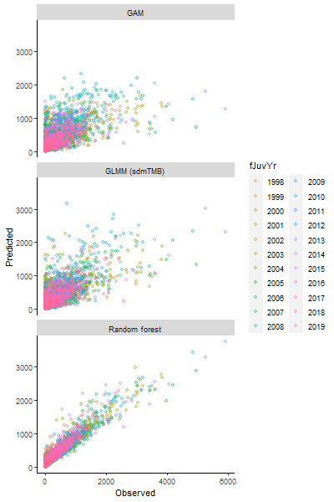
Figure 2. Correlation between observed and predicted juvenile densities between 1998 and 2019 for the GAM, GLMM and random forest models. R packages are parenthetically references in the margins.
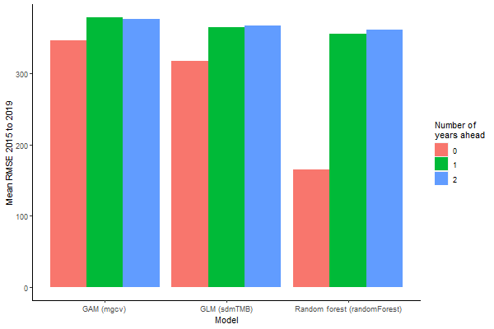
Figure 3. Predictive ability of GAMM, GLMM, and RF models for juvenile Coho salmon densities in the Coastal Oregon evolutionary significant unit (ESU) for zero, one, and two years into the future using rot mean-square-error average for years 2015 to 2019.

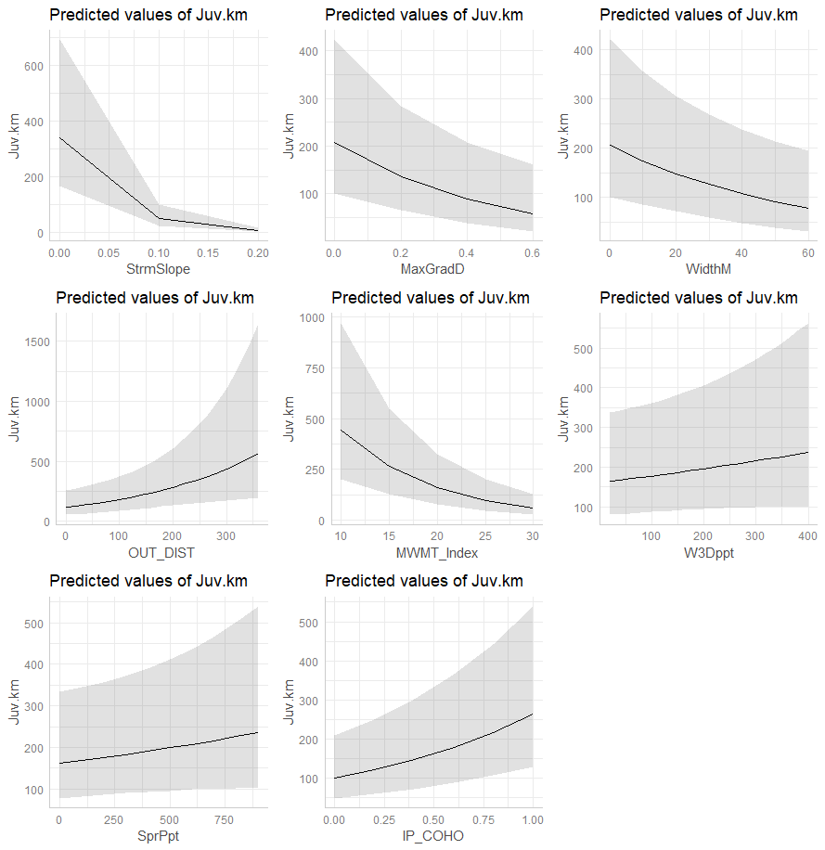
Figure 4. Marginal effects of the covariates.

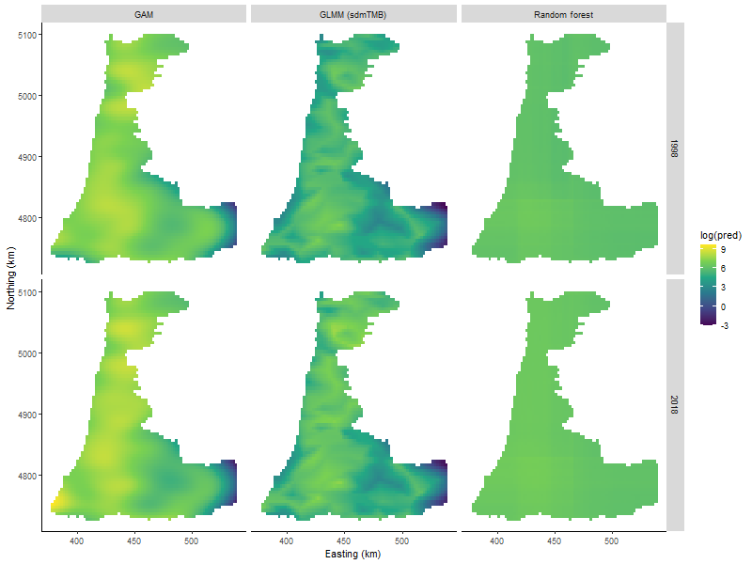
Figure 5. Spatiotemporal predictions (model 5) of juvenile Coho densities across the domain for the Oregon coastal ESU from 1998 to 2019. Dots represent the log observed positive juvenile densities superimposed on the predicted juvenile density (raster image).

Table 1. Annual number of observation of juvenile Coho salmon densities for each watershed population group in the coastal Oregon ESU.
Population Group | 1998 | 1999 | 2000 | 2001 | 2002 | 2003 | 2004 | 2005 | 2006 | 2007 | 2008
Alsea | 7 | 6 | 6 | 10 | 8 | 1 | 6 | 11 | 7 | 12 | 10
Beaver | 0 | 1 | 0 | 0 | 1 | 1 | 0 | 1 | 0 | 2 | 3
Coos | 13 | 10 | 8 | 9 | 11 | 10 | 10 | 9 | 8 | 12 | 18
Coquille | 14 | 12 | 8 | 9 | 8 | 12 | 13 | 12 | 12 | 17 | 13
Floras | 3 | 1 | 2 | 1 | 1 | 0 | 2 | 2 | 1 | 3 | 2
Lower Umpqua | 0 | 4 | 11 | 6 | 5 | 6 | 8 | 16 | 9 | 10 | 18
MCDependent | 4 | 3 | 4 | 4 | 5 | 6 | 3 | 4 | 5 | 5 | 5
Middle Umpqua | 0 | 7 | 3 | 3 | 6 | 3 | 7 | 4 | 7 | 7 | 7
MSDependent | 1 | 1 | 0 | 0 | 0 | 0 | 0 | 0 | 0 | 0 | 0
NCDependent | 1 | 1 | 1 | 2 | 2 | 1 | 1 | 1 | 2 | 1 | 1
Necanicum | 0 | 1 | 4 | 6 | 1 | 3 | 5 | 2 | 3 | 4 | 1
Nehalem | 9 | 12 | 14 | 11 | 17 | 12 | 10 | 16 | 13 | 12 | 15
Nestucca | 4 | 5 | 4 | 37 | 23 | 18 | 18 | 17 | 23 | 11 | 6
North Umpqua | 0 | 2 | 3 | 2 | 0 | 9 | 0 | 0 | 3 | 10 | 7
Salmon | 0 | 1 | 2 | 0 | 0 | 2 | 0 | 0 | 2 | 2 | 1
Siletz | 4 | 6 | 5 | 2 | 3 | 3 | 2 | 7 | 5 | 9 | 8
Siltcoos | 0 | 0 | 2 | 1 | 0 | 1 | 0 | 0 | 1 | 0 | 2
Siuslaw | 16 | 10 | 15 | 20 | 15 | 17 | 19 | 15 | 15 | 20 | 19
Sixes | 2 | 2 | 2 | 3 | 3 | 3 | 3 | 3 | 4 | 4 | 2
South Umpqua | 0 | 15 | 13 | 11 | 13 | 16 | 10 | 12 | 11 | 16 | 18
Tahkenitch | 0 | 0 | 1 | 0 | 0 | 0 | 0 | 1 | 1 | 2 | 2
Tenmile | 0 | 0 | 2 | 0 | 1 | 0 | 1 | 0 | 0 | 3 | 0
Tillamook Bay | 11 | 13 | 12 | 7 | 7 | 10 | 11 | 9 | 11 | 19 | 16
Yaquina | 3 | 3 | 6 | 3 | 7 | 5 | 6 | 4 | 4 | 6 | 5

Table 1 – continued
Population Group | 2009 | 2010 | 2011 | 2012 | 2013 | 2014 | 2015 | 2016 | 2017 | 2018 | 2019
Alsea | 10 | 7 | 6 | 7 | 8 | 4 | 5 | 6 | 5 | 6 | 4
Beaver | 2 | 1 | 3 | 2 | 1 | 2 | 2 | 1 | 2 | 2 | 1
Coos | 15 | 17 | 12 | 14 | 16 | 11 | 8 | 12 | 14 | 14 | 16
Coquille | 15 | 13 | 16 | 17 | 14 | 8 | 15 | 9 | 12 | 13 | 17
Floras | 1 | 3 | 3 | 2 | 3 | 4 | 2 | 3 | 2 | 2 | 3
Lower Umpqua | 12 | 8 | 12 | 14 | 12 | 9 | 10 | 8 | 10 | 11 | 10
MCDependent | 4 | 3 | 4 | 4 | 3 | 4 | 4 | 3 | 3 | 4 | 4
Middle Umpqua | 6 | 7 | 7 | 6 | 7 | 8 | 7 | 7 | 9 | 7 | 9
MSDependent | 0 | 0 | 0 | 0 | 0 | 0 | 0 | 0 | 0 | 0 | 0
NCDependent | 2 | 1 | 0 | 1 | 3 | 1 | 1 | 2 | 1 | 2 | 1
Necanicum | 3 | 4 | 2 | 2 | 4 | 1 | 2 | 2 | 2 | 4 | 4
Nehalem | 12 | 14 | 13 | 20 | 12 | 10 | 5 | 14 | 13 | 12 | 15
Nestucca | 4 | 7 | 8 | 3 | 6 | 4 | 5 | 5 | 6 | 2 | 7
North Umpqua | 4 | 3 | 2 | 5 | 1 | 1 | 1 | 1 | 1 | 3 | 1
Salmon | 1 | 0 | 0 | 2 | 1 | 0 | 1 | 0 | 1 | 1 | 1
Siletz | 4 | 5 | 6 | 2 | 5 | 4 | 2 | 3 | 3 | 2 | 5
Siltcoos | 0 | 0 | 0 | 1 | 0 | 0 | 1 | 0 | 0 | 1 | 0
Siuslaw | 18 | 17 | 21 | 20 | 21 | 13 | 13 | 14 | 20 | 14 | 16
Sixes | 2 | 5 | 3 | 3 | 2 | 2 | 2 | 2 | 2 | 0 | 0
South Umpqua | 13 | 15 | 16 | 16 | 17 | 13 | 13 | 13 | 13 | 13 | 14
Tahkenitch | 2 | 1 | 2 | 2 | 1 | 2 | 2 | 2 | 2 | 1 | 0
Tenmile | 0 | 1 | 0 | 0 | 1 | 0 | 0 | 1 | 0 | 0 | 0
Tillamook Bay | 10 | 9 | 11 | 16 | 8 | 6 | 12 | 7 | 10 | 11 | 7
Yaquina | 4 | 3 | 4 | 6 | 5 | 3 | 4 | 5 | 4 | 6 | 6

Table 2. AIC values for the parameteric models.

Supplemental
Supplemental Table S 1. Grid search for GLMM model (found in output$exploratory$sdm$grid_search).
Model ID | Temporal | Spatial | Spatiotemporal | RMSE
1 | FALSE | FALSE | AR1 | 415.4570
2 | i.i.d. | FALSE | AR1 | 415.4571
3 | FALSE | TRUE | i.i.d. | 416.4262
4 | i.i.d. | TRUE | i.i.d. | 416.4363
5 | FALSE | TRUE | AR1 | 417.9972
6 | i.i.d. | TRUE | AR1 | 418.0085
7 | i.i.d. | FALSE | i.i.d. | 418.6337
8 | FALSE | FALSE | i.i.d. | 423.5655
9 | i.i.d. | TRUE | FALSE | 458.9284
10 | FALSE | TRUE | FALSE | 460.0261
11 | FALSE | FALSE | FALSE | 563.9657
12 | i.i.d. | FALSE | FALSE | 567.0365

Supplemental Table S 2. Grid search for GAM models (output$exploratory$gam$grid_search).
Model ID | Covariates | Temporal | spatial | spatiotemporal | RMSE
1 | Included | Not included | NA | Spline | 448.5172
2 | Not included | Not included | NA | Spline | 497.7657
3 | Included | Spline | NA | NA | 500.3849
4 | Included | Not included | NA | NA | 510.8561
5 | Not included | Not included | Spline | N.I. | 526.1989
6 | Included | Factor | Spline | Implicit | D.N.C.

Supplemental Table S 3. Grid search for random forest model. (output$exploratory$rf$grid_search[order(output$exploratory$rf$grid_search$rmse),][1:10,])
Model ID | Covariates | Temporal | Spatial | Spatiotemporal | Try |  | Tree | R.M.S.E.
1 | Included | Not included | NA | Spline | 3 | 600 |  | 416.4299
2 | Included | Not included | NA | Spline | 3 | 1000 |  | 416.7446
3 | Included | Not included | NA | Spline | 3 | 700 |  | 416.7945
4 | Included | Not included | NA | Spline | 3 | 500 |  | 417.0357
5 | Included | Not included | NA | Spline | 5 | 500 |  | 417.3331
6 | Included | Not included | NA | Spline | 3 | 800 |  | 417.6237
7 | Included | Not included | NA | Spline | 3 | 400 |  | 417.8634
8 | Included | Not included | NA | Spline | 5 | 1000 |  | 418.3400
9 | Included | Not included | NA | Spline | 3 | 300 |  | 418.4207
10 | Included | Not included | NA | Spline | 3 | 900 |  | 418.5007

