Documentation

1. Background
   1. This project to create a datamart whose data comes from <https://www.kaggle.com/datasets/datascientist97/e-commerece-sales-data-2024>.
   2. ETL process using python script and sqlite as data storage for datamart.
   3. Automate jobs using task scheduler in windows system by running batch file that calls python script or put the python/bat script in apache airflow
   4. Datamart results in sqlite databases are used to build dashboards with Power BI
2. ETL Process
   1. Data collecting from E-commerce Sales Data 2024 dataset on Kaggle. consist of customer_details.csv,E-commerece sales data 2024.csv, product_details.csv
   2. Data extraction using python script. This stage is a process
      1. Checking data
      2. Cleaning data
      3. Remove duplicate
      4. Remove unused column
      5. Transform data
   3. Load data into sqlite databases from pandas dataframes, the steps are
      1. Create table for datamart purpose (staging,dimension and fact table).
      2. Insert into table staging for temporary data
      3. Load data from table staging to datamart (dimension and fact table).
3. Datawarehouse Architecture

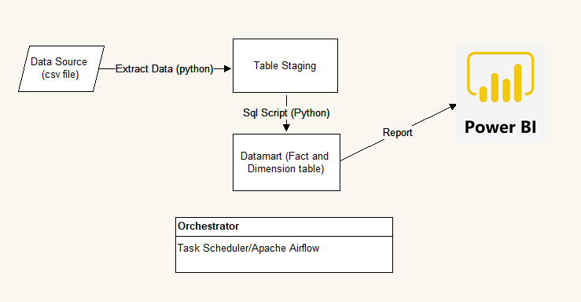

1. Databases Structure
   1. Customer_Staging

CREATE TABLE "customer_staging" (

"Customer ID" INTEGER,

"Age" INTEGER,

"Gender" TEXT,

"Item Purchased" TEXT,

"Category" TEXT,

"Purchase Amount (USD)" INTEGER,

"Location" TEXT,

"Size" TEXT,

"Color" TEXT,

"Season" TEXT,

"Review Rating" REAL,

"Subscription Status" TEXT,

"Shipping Type" TEXT,

"Discount Applied" TEXT,

"Promo Code Used" TEXT,

"Previous Purchases" INTEGER,

"Payment Method" TEXT,

"Frequency of Purchases" TEXT

)

* 1. Sales Staging

CREATE TABLE "sales_staging" (

"user id" REAL,

"product id" TEXT,

"Interaction type" TEXT,

"Time stamp" TEXT

)

* 1. Product_Staging

CREATE TABLE "product_staging" (

"Uniqe Id" TEXT,

"Product Name" TEXT,

"Brand Name" REAL,

"Asin" REAL,

"Category" TEXT,

"Upc Ean Code" TEXT,

"List Price" REAL,

"Selling Price" TEXT,

"Quantity" REAL,

"Model Number" TEXT,

"About Product" TEXT,

"Product Specification" TEXT,

"Technical Details" TEXT,

"Shipping Weight" TEXT,

"Product Dimensions" TEXT,

"Image" TEXT,

"Variants" TEXT,

"Sku" REAL,

"Product Url" TEXT,

"Stock" REAL,

"Product Details" REAL,

"Dimensions" REAL,

"Color" REAL,

"Ingredients" REAL,

"Direction To Use" REAL,

"Is Amazon Seller" TEXT,

"Size Quantity Variant" REAL,

"Product Description" REAL

)

* 1. Customer_dim

CREATE TABLE customer_dim (

customer_id INTEGER PRIMARY KEY UNIQUE,

Age INTEGER,

Gender TEXT,

Item_Purchased TEXT,

Category TEXT,

Purchase_Amount_USD INTEGER,

Location TEXT,

Size TEXT,

Color TEXT,

season TEXT,

Review_Rating INTEGER,

Subscription_Status TEXT,

Shipping_Type TEXT,

Discount_Applied TEXT,

Promo_Code_Used TEXT,

Previous_Purchases INTEGER,

Payment_Method TEXT,

Frequency_of_Purchases TEXT)

* 1. Product_dim

CREATE TABLE product_dim

(Uniqe_Id TEXT PRIMARY KEY UNIQUE,

Product_Name TEXT,

Category TEXT,

Upc_Ean_Code TEXT,

Selling_Price NUMERIC,

Model_Number TEXT,

About_Product TEXT,

Product_Specification TEXT,

Technical_Details TEXT,

Shipping_Weight TEXT,

Product_Dimensions TEXT,

Image TEXT,

Variants TEXT,

Product_Url TEZT,

Is_Amazon_Seller TEXT)

* 1. Sales_fact

CREATE TABLE sales_fact (

user_id INTEGER PRIMARY KEY UNIQUE,

product_id TEXT,

Interaction_type TEXT,

Time_stamp TEXT,

datekey TEXT UNIQUE)

* 1. Date_dim

CREATE TABLE date_dim (

Datekey TEXT PRIMARY KEY,

Date TEXT,

Year INTEGER,

MonthNumber INTEGER,

Month TEXT,

Days_In_Month INTEGER,

Quarter_Number INTEGER,

Quarter TEXT,

Week_of_Year TEXT,

MonthYearKey INTEGER,

WeekNumber INTEGER,

QuarterYear INTEGER,

WeekYearKey INTEGER)

1. Datawarehouse Design using star schema model, check picture below

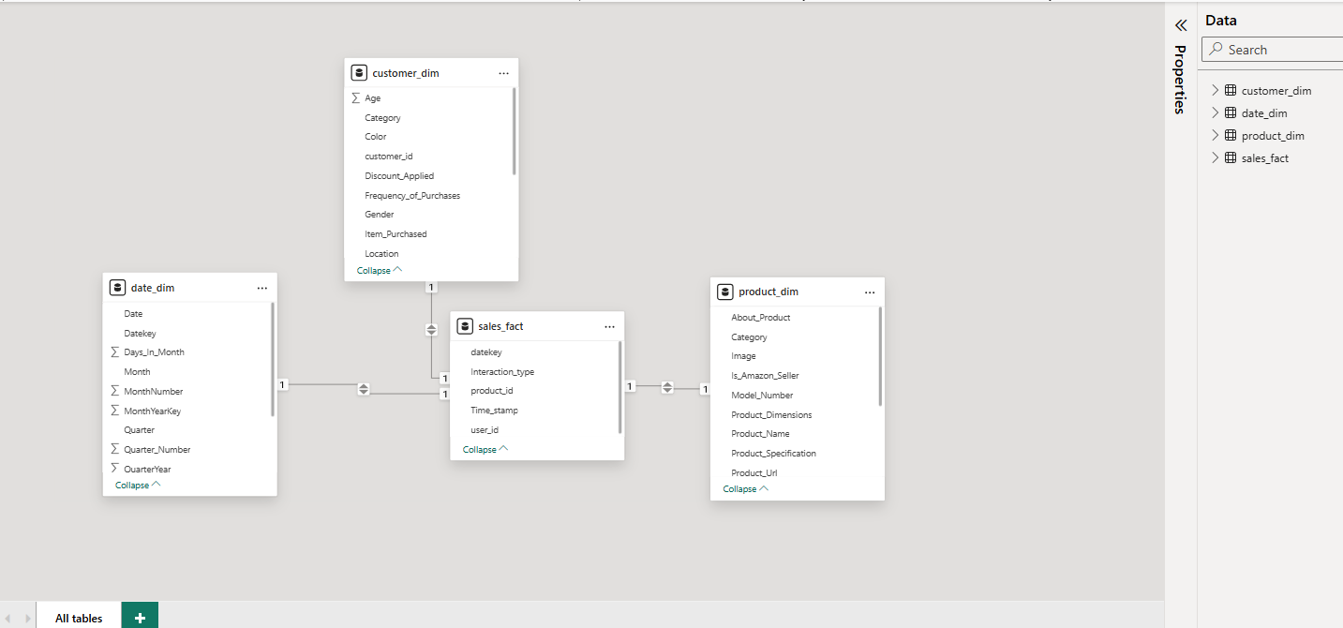

1. Visualization and sample report (Power BI)

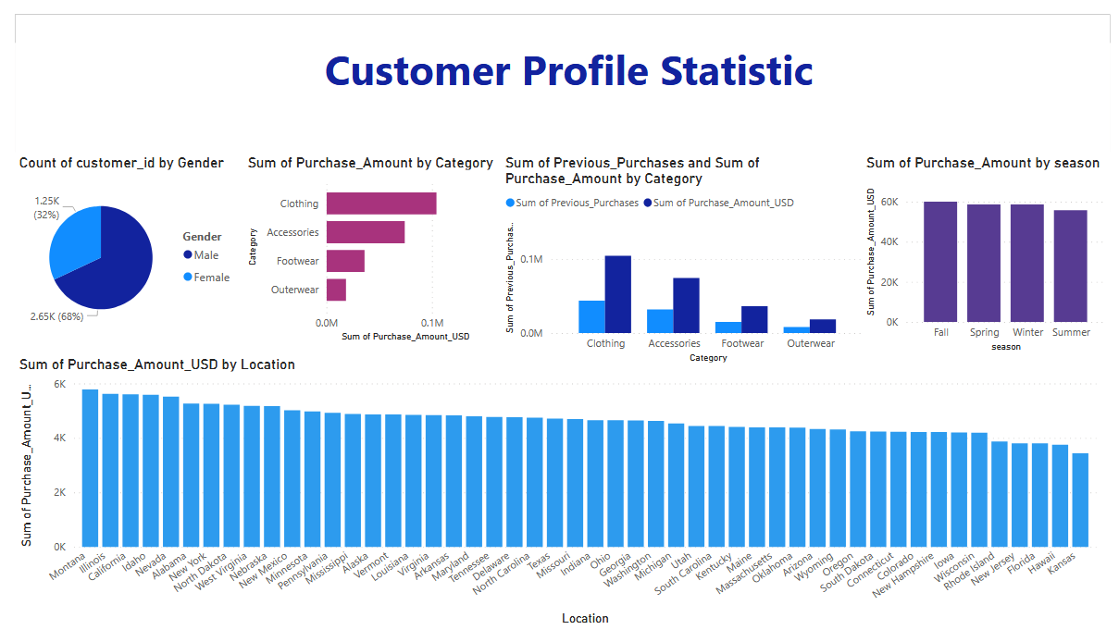

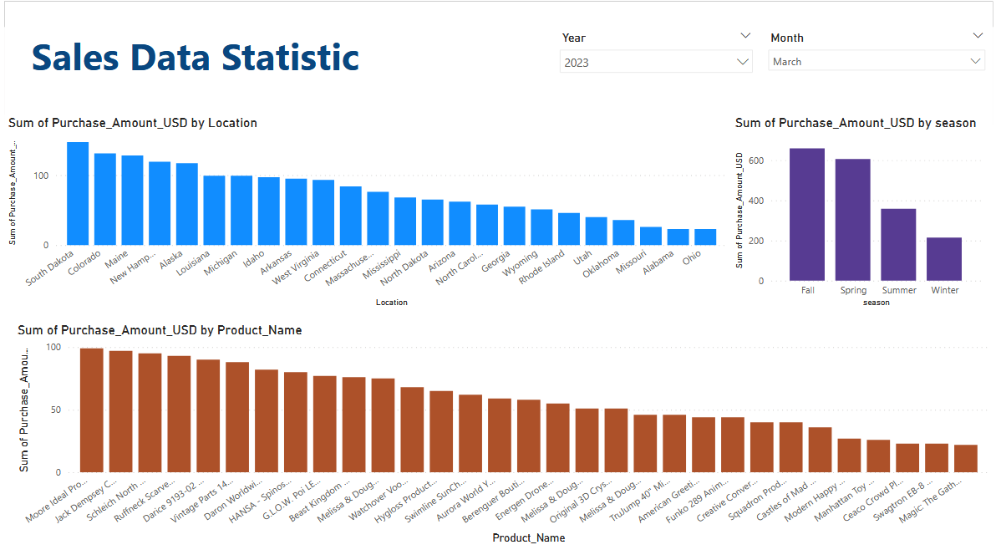

1. Job Scheduled. Using task schedule in windows system to run program autamatically (call batch file) or put the python/bat script in apache airflow.

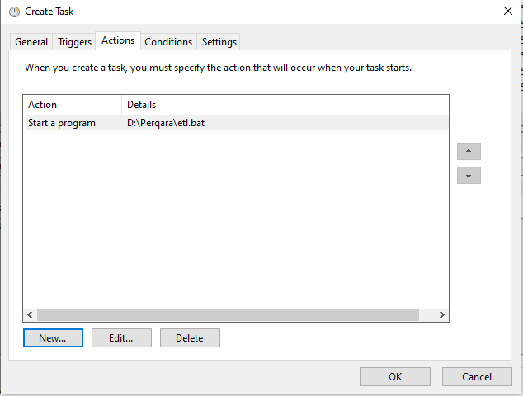

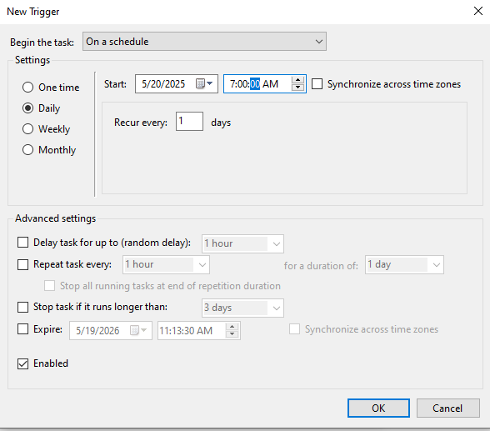

1. Attachment file, find in github repository (https://github.com/firmanrachman/datawarehouse)
   1. data.zip (source data)
   2. script_databases_sqlite.zip (sql file script)
   3. exctract_data.zip (python and batch file script)
   4. sales_data_perqara_report.zip (Power BI report)
   5. Documentation Project (docx file)
   6. sales_data.zip (ready-made sqlite database)
2. Installation instruction
   1. Extract source data (data.zip)
   2. Create sqlite database with the name sales_data.db and then execute sql file to generate table (script_databases_sqlite.zip) or use a ready-made sqlite database (sales_data.zip).
   3. Extract python and batch file script then modified code for adjust data source location and sqlite databases (exctract_data.zip)
   4. Modified connection in power BI report to access your datamart and install odbc diver for sqlite if needed (sales_data_perqara_report.zip).
   5. Modified batch file to adjus script python location
   6. Testing batch file to run program
   7. Create task schedule in windows system to run program autamatically (call batch file) or put the python/bat script in apache airflow.