FRM-RND-17 — Research Findings Report
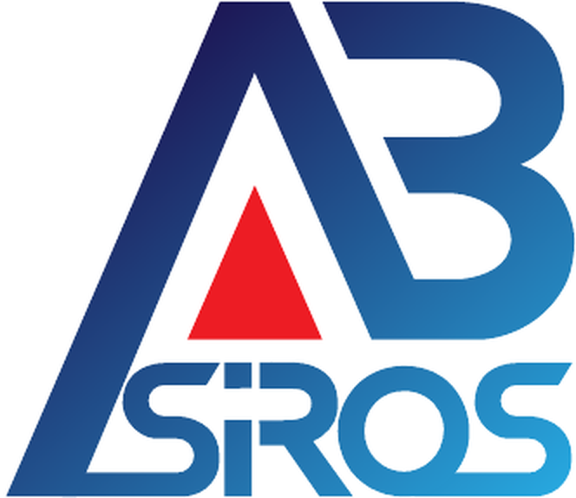 | PT AGATHOERGEO BRAKAH SIROS  Research & Development

RESEARCH FINDINGS REPORT
Form FRM-RND-17 · SOP Reference: ABS-RND-SOP-016
Report the findings, analysis, implications and options from an exploratory research activity. Unlike the Validation Report (FRM-RND-05), it does not issue a proven / not-proven verdict.
FORM IDENTIFICATION
Form ID | FRM-RND-17 | Version | 1.0
SOP Reference | ABS-RND-SOP-016 | Date Issued | [ YYYY-MM-DD ]
Entity | [ ABS / APW / BSN / WAC / Cross-sector / Undetermined ] | Unit | Research & Development
Prepared by (PIC) | [ Name / Position ] | Reference No. | [ RSCH-YYYY-NNN — same as FRM-RND-16 ]
Status | ACTIVE (IN FORCE) | Effective Date | 2026-07-23
EXECUTIVE SUMMARY (3–5 sentences)
Summary * | [ .............................................................................................. ]
FINDINGS (one row per key question from FRM-RND-16)
Key question (from FRM-RND-16) | Finding | Supporting source
ANALYSIS
Interpretation * | [ .............................................................................................. ]
Opportunities | [ .............................................................................................. ]
Obstacles | [ .............................................................................................. ]
Remaining uncertainties | [ .............................................................................................. ]
IMPLICATIONS BY DIMENSION (per FRM-RND-16 scope)
Regulatory | [ ]
Market | [ ]
Technical | [ ]
Financial | [ ]
Risk | [ ]
RECOMMENDATIONS (OPTIONS — NOT A VERDICT)
Option A | [ .............................................................................................. ]
Option B | [ .............................................................................................. ]
Option C | [ .............................................................................................. ]
State follow-up OPTIONS with rationale (e.g. proceed to feasibility study / form a unit / postpone / stop). This report does not issue a proven / not-proven verdict; the decision remains with the Board (Direksi).
LIMITS & VERIFICATION
Unanswered items | [ .............................................................................................. ]
High-risk items needing expert verification | [ Legal / licensing / regulatory matters requiring human expert confirmation before any decision. ]
FOLLOW-UP
Forwarded to | [ ]
Subsequent form (if any) | [ ]
APPROVAL — HUMAN GATE
Prepared by (R&D) | [ Name / Signature / Date ]
Reviewed by | [ Name / Signature / Date ]
Recommendations are options only. The final decision remains with the Board (Direksi).

