**UI Automation**

**Approach** -

1. I have chosen BDD approach using cucumber as a framework.

Benefits of this is it is very easy to read Scenario flow and easy to maintain.

2. Using cucumber we can write scenarios in plain english language and map that with step definitions.

**Library used to automate Front End** -

1. I have chosen Selenium as a Java based library to automate UI actions.

2. Selenium is open source library to automate user actions.

3. Selenium is compatible with lot of different tools ex – Junit/TestNG etc.

4. Selenium uses JSON Wire protocol for communication purpose.

**Programming language** -

1. I have chosen JAVA as a programming language.

2. Java is most widely used programming language and lot of libraries available to read/write json , excel etc.

3. We can use same programming language for UI as well as API Automation.

**Unit testing framework** -

1. I have chosen JUnit as a unit testing framework because it is most compatible with cucumber.

**Build tool** -

1. I have chosen Maven as a build management tool and using this i can manage all dependencies required to run the project.

**How to run** -

1. Clone entire project on local machine from Github.

2. Execute maven command from command-line as per below screen-shot.

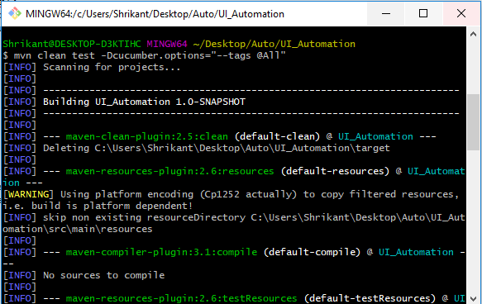

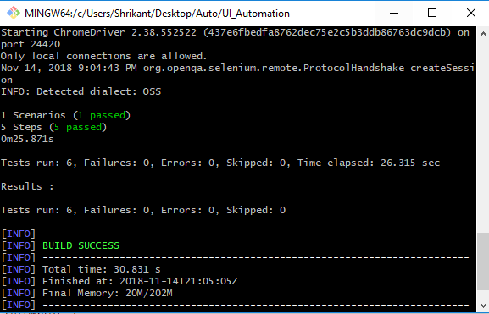

**What feature I can add to framework** -

1. Execute Automation scripts on remote machine using selenium grid.

2. Execute Automation scripts in headless mode for faster execution.

3. Implement parallel execution using cucumber library or using selenium Grid.

4. Integrate Automation with Jenkins for continuous integration.

5. Pull code at runtime from Github by jenkins and execute and send emailable report to relevant audience.

6. Create Automation dashboard to monitor 24*7 jenkins jobs status.

7. Store automation reports on cloud ex – S3 bucket in AWS.

8. Manage most of Automation configuration as a command-line arguments.

9. Seperate Object Repository/Test Data on Cloud or any other Third Party tool for less maintenance.

10. Add Browser Compatibility feature to execute scripts on different browsers/OS etc.

11. Execute same scripts on different environments ex – Integration/Staging/Preview/Production etc.

12. Integrate Automation with different Third party tools ex – Slack for notification purpose / Integrate with JIRA to update automation result.