**Below are the steps to run the ‘TestFlowDriveApp’ project.**

**Step1: Install Appium v1.7.2 server**

**Step2: Launch Eclipse .(I have used Mars.2 for executing the tests)**

**Step3:Import the ‘TestFlowDriveApp’ project**

**Step4:Configure Eclipse with Selenium WebDriver Jars(selenium-java-3.8.1) .Import the below jar files by clicking on Add External JARs.**

client-combined-3.8.1.jar

client-combined-3.8.1-sources.jar

byte-buddy-1.7.5.jar

commons-codec-1.10.jar

commons-exec-1.3.jar

commons-logging-1.2.jar

gson-2.8.2.jar

guava-23.0.jar

httpclient-4.5.3.jar

httpcore-4.4.6.jar

**Step5: Configure Eclipse with Selenium Android Driver Jar.**

Selenium-android-driver.jar

## Step6: Configure Eclipse with Appium Java Client Jar

java-client-6.0.0-BETA2.jar

**Step7:Configure Eclipse with JUnit Jar**

junit-4.12.jar

**Step8:List of other JAR files** **hamcrest-core, commons-lang and JXL**

hamcrest-core-1.3.jar

commons-lang3-3.7.jar

jxl-2.6.12

**Step9: Configure Eclipse with TestNG Plugin.**

**Step10: Ensure that the Flow Drive app is available on the mobile device.**

**Step11: Connect your mobile device to your computer using USB cable.**

**Step12: Get the Device Name, Platform Name and Platform Version of the connected device.**

**Step13: Now open command prompt and run this command: adb devices. This will give the information about the device id.**

**Step14: Open the test.FlowLoginWithPageFactory.java file under TestFlowDriveApp Project in Eclipse.**

**Step15: Replace the deviceName(in line number 66),device id (in line number 67), platform Name(in line number 68), platform version (in line number 69) given in the code with the connected device information.**

**Step16: Start the appium server on Host 0.0.0.0 and port 4723.**

**Step17: From Eclipse, select the testsuite testflowdriveapp.xml and click on Run As TestNG Suite.**

Below is a Snaphot of the Tests executed on TestNG build.

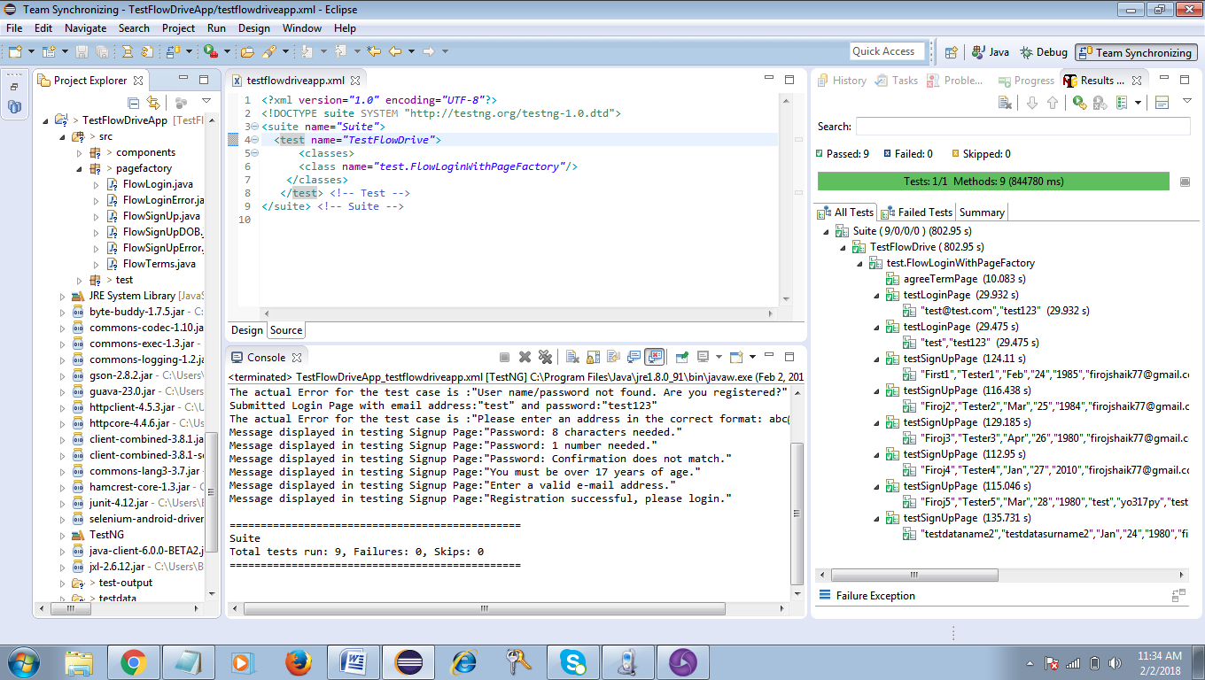

Below are the snapshots taken on the connected mobile device during execution.