Firoz Mahmud  Address: Banaful  Noyab Mia Road  North-East Race-course, Comilla  Mobile : 01982-988766  E-Mail : fmahmud99@gmail.com | 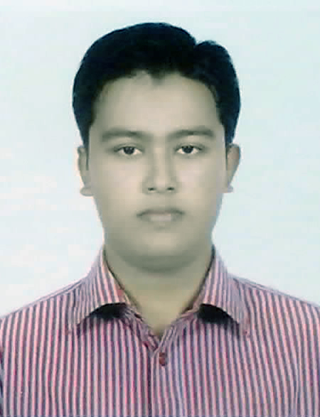

Career objective:

Self-motivated and hardworking, seeking for an opportunity to work in a challenging environment in the field of Computer Science and Engineering to prove my technical skills and utilize my knowledge and intelligence in the growth of the organization. I want to build up my career in software engineering profession. Given my academic qualification I hope I have all the potentials to cope with other candidates.

What makes me different?

I am self-motivated, able to adapt any organizational environment, diligent and ready to give my best effort to achieve the targets. I am a natural team player and I can lead and be led, as the situation requires, I am an optimist by nature and sensible to my concern.

Scholastic Status:

Exam Title | Concentration | Institute | Result | Passing Year | Duration
BSc | CSE | Comilla University | CGPA 3.25 out of 4 | 2015 | 4
HSC | Science | Comilla Govt. College | CGPA: 4.20  out of 5 | 2010 | 2
SSC | Science | Police Line High School, Comilla | CGPA: 5.00  out of 5 | 2008 | 10

Key Strengths:

- Good analytical and problem solving ability.
- Excellent knowledge of core subjects.
- Quick learner and ability to work under pressure.
- Ability to work in a team.
- Can easily adapt with the underlying environment.
- Excellent speaking and coordinating ability.

Technical Skill:

- Python
- Django framework
- MVT/MVC framework
- MySQL, SQLite
- Java
- C
- C++
- HTML, CSS, Javascript, Ajax
- JQuery
- PHP
- Laravel framework
- Wordpress CMS

Project work during academic period:

- Criminal record management using Python, Django, SQLite.
- Web crawler using Python.
- Result processing system using PHP, MySQL, HTML, CSS, JQuery.
- eCommerce(POS system) with Wordpress
- Department automation system using Java swing, MySQL.
- Puzzle game using Java.

Computer Skills:

Operating System: Linux, Windows, Mac.
Office Application: MS Word, MS Excel, MS Power Point.

Working Software:

- SQL Server 2005, 2008, 2012 and MySQL Server, DB browser for SQLite, MS Access.
- Xampp, Wampp, Netbeans, Eclipse, Pycharm, CodeBlocks, Borland C, Turbo C, Turbo C++, Cisco Packet Tracer, Matlab etc.

Job interest:

- IT –Software(Python, PHP)
- Software Development and Web Development
- Application Programming
- Backend Database and Backend Process

Research interest:

- Pattern recognition & image processing.
- Data mining.

Language Proficiency:

Languages | Speaking | Listening | Reading | Writing
English | High | High | High | High
Bangla | High | High | High | High

Interests and Hobbies:

- Programming contest, Learning new programming language, Traveling, Reading and introducing new persons, History Analysis, Playing Cricket, Gossiping.
- Computer & Technology, Web crawling, Researching.

Extra-Curricular Activities:

- Member Secretary, Comilla Student Forum, Comilla University.
- Executive Member, CSE Society, Dept. of CSE, Comilla University.
- Member of Bangladesh Computer Society.

Self-Commitment:

- Hopeful, Co-operative, Innovative & Hardworking
- Ability to cope up with different situation.
- Very good temperament and enjoy challenges.

Personal Information:

- Name : Firoz Mahmud
- Father’s Name : Abdul Hoque
- Mother’s name : Shamsun Nahar
- Date of Birth : 1 March 1993
- Religion : Islam
- Nationality : Bangladeshi (by Birth)
- Marital Status : Single
- Blood Group : O+
- Present Address : Banaful, Noyab Mia Road
North-East Race-course, Comilla
- Permanent Address : Banaful, Noyab Mia Road
North-East Race-course, Comilla

References:

Md. Mahfuzur Rahman  Assistant Professor  Department of Computer Science & Engineering  Comilla University  Mobile: 01914-378566  Email : mahfuzcseiu01@yahoo.com | Mahmudul Hasan  Assistant Professor  Department of Computer Science & Engineering  Comilla University  Mobile : 01712-948098  Email: mhasanraju@gmail.com

I certify that all information stated in this curriculum vita is true & complete to the best of my knowledge.

Yours Sincerely,
Firoz Mahmud

Date: 23.02.2017

