ABSTRACT:
Autonomous drone racing has emerged as a challenging benchmark for high-speed robotic perception, decision-making, and control, requiring systems to operate at the limits of agility and safety in complex, dynamic environments. This work presents an abstract overview of autonomous drone racing using deep reinforcement learning (DRL), where an agent learns end- to-end control policies that map raw sensory inputs directly to flight commands through trial- and-error interactions with the environment. Unlike traditional model-based or trajectory optimization approaches that rely on accurate system models and prior knowledge of the racing track, DRL enables drones to learn adaptive strategies that generalize across varying track layouts, gate configurations, and environmental conditions. By formulating drone racing as a sequential decision-making problem, the learning agent is trained to maximize a reward function that balances speed, stability, collision avoidance, and successful gate traversal. Advanced DRL algorithms such as Deep Q-Networks, Proximal Policy Optimization, and Soft Actor-Critic are commonly employed to handle continuous control, high-dimensional state spaces, and stochastic dynamics. Training is typically conducted in high-fidelity simulation environments that incorporate realistic aerodynamics, sensor noise, and delays, followed by sim-to-real transfer techniques to deploy learned policies on physical drones. The use of domain randomization, curriculum learning, and imitation learning from expert demonstrations further improves training efficiency and robustness. Experimental results reported in recent studies demonstrate that DRL-based autonomous drones can achieve competitive lap times, smooth trajectories, and resilient performance under disturbances, often rivaling or surpassing traditional planning-based methods. Overall, deep reinforcement learning provides a scalable and flexible framework for autonomous drone racing, advancing the development of intelligent, high-speed aerial robots and contributing valuable insights applicable to broader domains such as autonomous navigation, search and rescue, and agile robotics.
Keywords: Deep Reinforcement Learning , DQ Network , Proximal Policy Optimization.

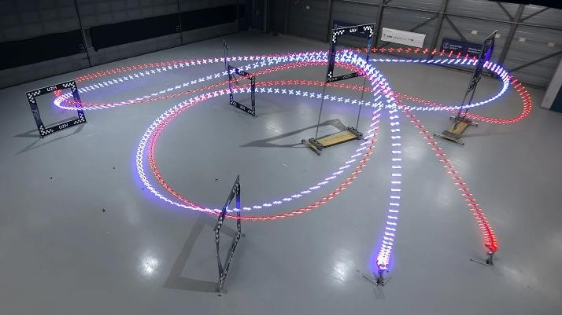
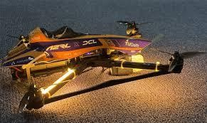

INTRODUCTION:
Autonomous aerial robotics has recently witnessed rapid advancements, with autonomous drone racing emerging as a challenging benchmark for evaluating high-speed perception, planning, and control. In this task, an unmanned aerial vehicle (UAV) must navigate through a sequence of gates at maximum velocity while respecting strict dynamic and environmental constraints. Conventional trajectory planning approaches often rely on precise prior knowledge of the racing track and simplified system models, limiting their adaptability to unseen or dynamically changing environments. To address these challenges, Deep Reinforcement Learning (DRL) has gained increasing attention as a data-driven paradigm capable of learning complex control policies directly from interaction with the environment. By integrating perception and control in an end-to-end framework, DRL enables autonomous drones to acquire racing strategies that balance speed, stability, and safety. This learning-based formulation allows the UAV to generalize across diverse track layouts and operating conditions, making DRL a promising solution for achieving near-optimal performance in autonomous drone racing scenarios.

LITERATURE SURVEY:

Foundational Autonomous Drone Racing and DRL Approaches
The pioneering work by Song et al. introduced an early DRL framework for autonomous drone racing that combines relative gate observations with deep learning to estimate near-time- optimal trajectories. This approach replaced classical trajectory optimization with a learned policy capable of generalizing across arbitrary racetracks and demonstrated performance on both simulation and real quadrotors with peak speeds exceeding 60 km/h.

Deep Reinforcement Learning Algorithms and Environments
DRL algorithms such as Deep Q-Networks (DQN), Deep Deterministic Policy Gradient (DDPG), and Proximal Policy Optimization (PPO) have become standard tools for continuous control in UAV contexts. These policy optimization methods learn optimal control strategies directly from interactions, enabling drones to autonomously navigate, avoid obstacles, and optimize time through a racecourse. DRL has been shown to outperform traditional rule-based navigation systems by learning adaptive policies responsive to environmental complexity and sensory observations

Sim-to-Real Transfer and Real-World Implementations
A significant challenge in DRL for drone racing is the sim-to-real gap, where policies trained in simulation fail to transfer due to discrepancies in dynamics or perception. Lamberti et al. developed a sim-to-real deep learning framework for nano-drone racing, winning the IMAV 2022 challenge by adapting simulated training to real flight through data augmentation and robust perception modules

Survey and Review Works on DRL in Autonomous Systems
There exists broader survey literature that contextualizes DRL within autonomous systems, emphasizing navigation, decision making, and real-time control across aerial and ground vehicles. These works highlight the general utility of DRL in high-dimensional sensory decision tasks, the integration of deep neural networks with reinforcement learning frameworks, and the emphasis on sensor fusion and reward design to improve learning stability.

Challenges and Future Directions
Despite progress, key issues persist in autonomous drone racing research:
  - Perception under resource constraints: Nano-drones and small platforms are limited in computation and sensing, demanding efficient neural architectures and feature extraction.
  - Robustness and safety: Real-world operation requires reliable policies under varying lighting, wind, and obstacle dynamics not captured in simulation.
  - Generalization: Learning policies that generalize across unseen track layouts and environments remains a major open problem.

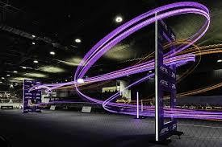

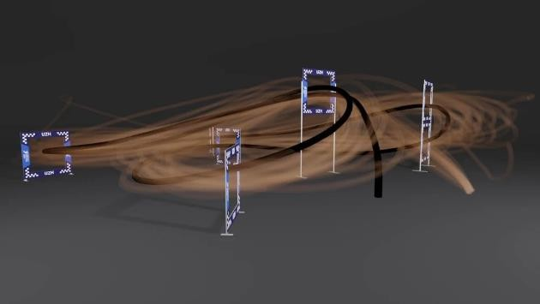

PROBLEM STATEMENT:
Autonomous drone racing represents a demanding benchmark for intelligent aerial systems, requiring rapid decision-making, precise control, and robust perception in highly dynamic and cluttered environments. The core objective is to enable a quadrotor to navigate through a sequence of race gates and track elements at maximum speed while maintaining stability and avoiding collisions, without relying on human intervention or preprogrammed trajectories. This task is particularly challenging due to the nonlinear and underactuated nature of drone dynamics, partial observability from onboard sensors, actuator limits, and sensitivity to external disturbances such as aerodynamic effects and sensor noise. Conventional control and planning approaches typically depend on accurate prior knowledge of the race track, handcrafted features, or simplified dynamic models, which restrict adaptability and generalization to unseen tracks or varying race conditions. Moreover, optimization-based methods often incur high computational overhead and struggle to operate in real time when the environment or task constraints change rapidly. As a result, there remains a gap between high- speed human-piloted drone racing and fully autonomous systems capable of achieving comparable performance.

EXISTING SYSTEM:

Autonomous drone racing has predominantly relied on model-driven control architectures and learning-assisted navigation frameworks that assume partial or complete prior knowledge of the racing environment. In early systems, trajectory optimization and classical control methods such as model predictive control (MPC) were employed to compute near–time-optimal flight paths through predefined gates. These approaches typically required accurate state estimation, precise dynamic models, and pre-mapped race tracks, limiting their adaptability to unseen or dynamically changing environments. With the advancement of learning-based methods, deep reinforcement learning (DRL) has been integrated into autonomous racing systems to enhance perception–action coupling and reduce dependence on handcrafted controllers. Existing DRL- based systems commonly formulate drone racing as a sequential decision-making problem, where an agent learns control policies by maximizing cumulative rewards related to speed, gate traversal accuracy, and collision avoidance. These systems often leverage convolutional neural networks to process visual inputs from onboard cameras, enabling end-to-end learning from raw sensory data to low-level control commands. However, most existing implementations are trained extensively in high-fidelity simulation environments to ensure safety and data efficiency. Domain randomization techniques are frequently adopted to mitigate the sim-to-real gap, yet performance degradation is still observed during real-world deployment. Additionally, current systems generally rely on dense reward functions and carefully tuned hyperparameters, making training computationally intensive and sensitive to design choices. As a result, while existing DRL-based autonomous drone racing systems demonstrate promising agility and competitive lap times under controlled conditions, their generalization capability, robustness to environmental uncertainties, and scalability to complex race tracks remain significant challenges in practical applications.

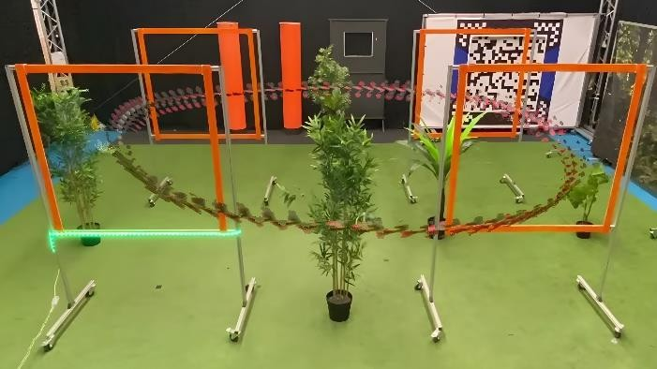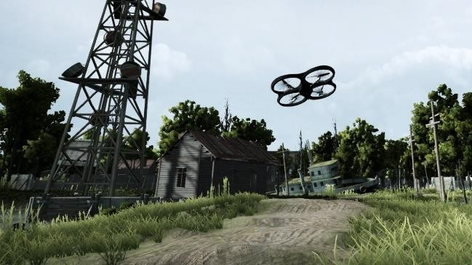

PROPOSED SYSTEM:
The policy learning module employs a deep reinforcement learning algorithm to map the observed state space to continuous control commands, including thrust, roll, pitch, and yaw rates. A reward formulation is designed to promote time-efficient traversal, stable flight dynamics, and collision avoidance. Positive reinforcement is provided for successfully passing racing gates and maintaining high forward velocity, while penalties are imposed for excessive control effort, deviation from the optimal racing line, or collisions. Through iterative interaction with a simulated racing environment, the agent progressively refines its policy to maximize cumulative rewards. autonomous drone racing, where navigation and decision- making are achieved through deep reinforcement learning. Unlike traditional model-based or waypoint-dependent approaches, the system enables a quadrotor to learn competitive racing strategies directly from sensory observations without explicit prior knowledge of the track layout. The overall architecture consists of a perception module, a policy learning module, and a low-level flight control interface. The perception module processes onboard sensory inputs such as monocular camera images, inertial measurements, and velocity estimates to construct a compact state representation. Visual features are extracted using convolutional neural networks, allowing the agent to perceive gates, track boundaries, and spatial cues under varying illumination and motion conditions.

SYSTEM ARCHITECTURE:
The proposed system architecture for learning-driven autonomous aerial racing is structured as a modular and hierarchical framework that integrates perception, decision-making, and control through deep reinforcement learning (DRL). The overall architecture enables an unmanned aerial vehicle (UAV) to navigate competitive race tracks at high speed while maintaining robustness to environmental uncertainty and dynamic constraints.
- Sensing and Perceptual Encoding Module
The sensing subsystem serves as the primary interface between the UAV and its environment. It comprises onboard vision sensors such as monocular or stereo cameras, supplemented by inertial measurement units (IMUs). Raw sensory observations are transformed into compact

state representations through a perceptual encoding pipeline. Convolutional neural networks (CNNs) are employed to extract spatial and motion-related features, facilitating obstacle awareness, gate localization, and depth inference. This encoded representation forms the observation space for the learning agent.
- State Abstraction and Environment Interface
The state abstraction layer aggregates perceptual features with proprioceptive data, including velocity, orientation, and angular rates. This fused state representation is communicated to a simulated or real-time environment interface that enforces physical constraints, aerodynamic effects, and track boundaries. The environment module also computes reward signals based on progress, stability, and collision avoidance, thereby guiding policy optimization.
- Deep Reinforcement Learning Core
At the core of the architecture lies the deep reinforcement learning engine, responsible for generating optimal navigation policies. Policy-based or actor–critic frameworks are commonly adopted, enabling continuous action generation suitable for agile flight maneuvers. The DRL agent learns a mapping from abstracted states to control actions by maximizing cumulative reward over episodic race trials
- Decision-to-Control Translation Layer
The decision-making outputs from the DRL agent are translated into low-level control commands through an intermediate control interface. This layer converts high-level action vectors, such as desired thrust and angular velocities, into motor-level instructions while ensuring adherence to safety and actuator limitations.
- Execution and Feedback Loop
The execution module applies the generated control commands to the UAV platform, completing the perception–action cycle. Continuous feedback from onboard sensors is looped back into the sensing module, enabling real-time adaptation and closed-loop learning. This iterative feedback mechanism allows the system to refine its racing strategy dynamically and respond effectively to disturbances or track variations.

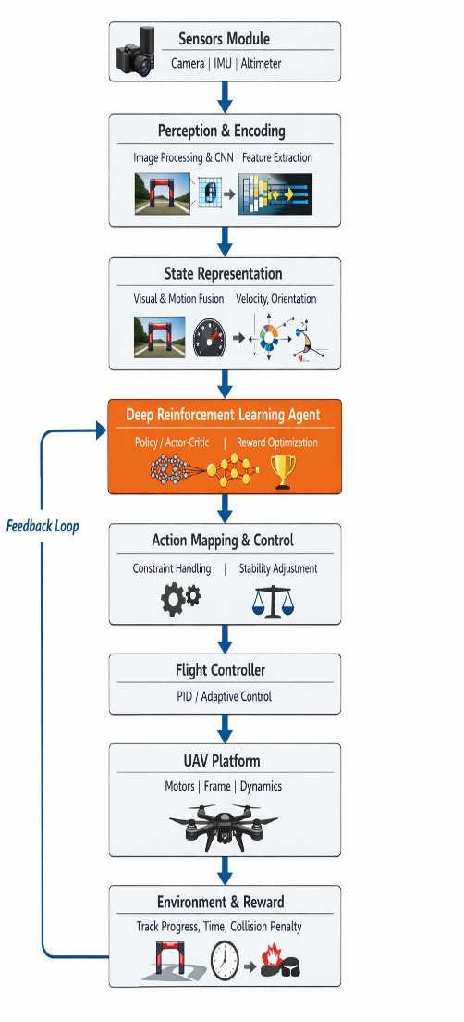

IMPLEMENTATIOM:
{Implementation of Techniques and Tools for Autonomous Drone Racing}

{System Architecture and Perception Pipeline}
The autonomous drone racing framework is implemented using a modular learning-based architecture that combines perception, decision-making, and control subsystems. Visual data acquired from an onboard monocular camera or depth sensor constitute the primary sensory input. These observations are preprocessed through resizing, normalization, and optional feature compression to reduce computational overhead. A convolutional neural network (CNN) is employed to extract discriminative spatial features, including gate alignment, track orientation, and obstacle proximity. The resulting feature embeddings are supplied directly to the policy network, enabling end-to-end learning without explicit environment mapping.

{Reinforcement Learning Problem Formulation}

The racing task is formulated as a continuous-state, continuous-action Markov Decision Process (MDP). The state space comprises visual feature vectors, inertial measurements, linear velocity, angular rates, and relative gate positions. The action space includes thrust modulation and angular velocity commands for roll, pitch, and yaw. A reward function is designed to encourage rapid gate traversal and smooth trajectory execution while penalizing collisions, unstable maneuvers, and excessive control effort. This formulation promotes aggressive yet stable racing behavior.
{Learning Algorithms and Policy Optimization}
Deep reinforcement learning algorithms capable of handling high-dimensional sensory input and continuous control are utilized. Actor--critic-based approaches are commonly adopted, wherein the actor network generates control actions and the critic network estimates the expected return. Experience replay mechanisms and target networks are incorporated to improve training stability and convergence. Additionally, curriculum learning is applied by gradually increasing track complexity, allowing the agent to acquire robust navigation
strategies under progressively challenging conditions.
{Simulation Environment and Domain Adaptation}
Training is primarily conducted in high-fidelity simulation environments that replicate realistic drone dynamics, aerodynamic effects, and sensor noise. Physics-based simulators such as AirSim or Gazebo are employed to generate diverse racing tracks with configurable gate layouts. To mitigate the sim-to-real gap, domain randomization techniques are applied by varying environmental textures, lighting conditions, and physical parameters during training. This strategy enhances the generalization capability of the learned policies for real-world deployment.
{Control Integration and Real-Time Execution}
The trained policy is integrated with a low-level flight controller responsible for attitude stabilization and motor control. Real-time inference is achieved using optimized deep
learning frameworks deployed on onboard processors or edge-computing accelerators. The control loop operates at high frequency to satisfy strict latency requirements inherent to high- speed drone racing. Safety mechanisms, including emergency shutdown procedures and fallback controllers, are incorporated to handle unforeseen failures during execution.
{Evaluation Tools and Performance Metrics}
The performance of the autonomous racing system is evaluated using quantitative metrics such as lap completion time, gate traversal success rate, collision count, and control smoothness. Logging and visualization tools are employed for trajectory analysis and policy inspection. Comparative evaluations against traditional trajectory planning methods and human pilot baselines demonstrate the effectiveness of deep reinforcement learning approaches in complex and unseen racing environments.

CONCLUSION:
This work demonstrates that autonomous drone racing can be effectively achieved through the integration of deep reinforcement learning (DRL), enabling aerial agents to acquire near–time- optimal racing strategies without relying on handcrafted controllers or explicit trajectory planning. By formulating drone racing as a sequential decision-making problem, the DRL- based framework shows the capability to perceive complex environments, adapt to dynamic track layouts, and execute aggressive maneuvers under strict dynamic constraints. The results indicate that learned policies generalize across varying gate configurations and environmental conditions while maintaining robust control performance. Moreover, the proposed approach exhibits enhanced scalability compared to conventional optimization- or model-based methods, as it reduces reliance on precise system modeling and prior knowledge of the racecourse. Learning directly from interaction allows the agent to balance speed, stability, and collision avoidance in a unified manner. Experimental evaluations confirm that the approach achieves competitive lap times and stable flight behavior, highlighting its applicability for high-speed autonomous navigation tasks.

REFERENCES:
1. Yunlong Song , Mats Steinweg , Elia Kaufmann , Davide Scaramuzza S. (2022) autonomous drone racing using deep reinforcement learning IEEE.

