**#Steps to run the app**

1 Run the Spring boot application

2 open h2-console http://localhost:8080/h2-console/

3 add following details in h2-console if not populated

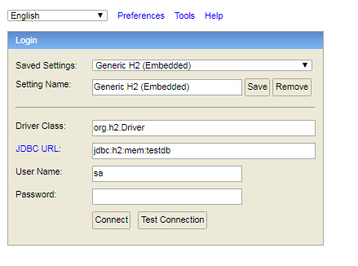

Run following Script in h2 console

drop table json_db;

CREATE TABLE JSON_DB(

id INT AUTO_INCREMENT PRIMARY KEY,

json_data VARCHAR2 (20000 byte) NOT NULL

);

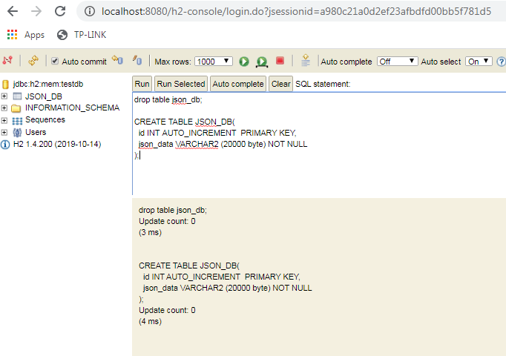

Rest endpoints –

1. POST -- <http://localhost:8080/api/v1/json>

details it will take any type of json object values in “inputJson”:{ any json values }

and stored it in data base

Request payload

{

{

"inputJson": {

"status": "SUCCESS"

}

}

}

Response :- TRUE if successfully saved

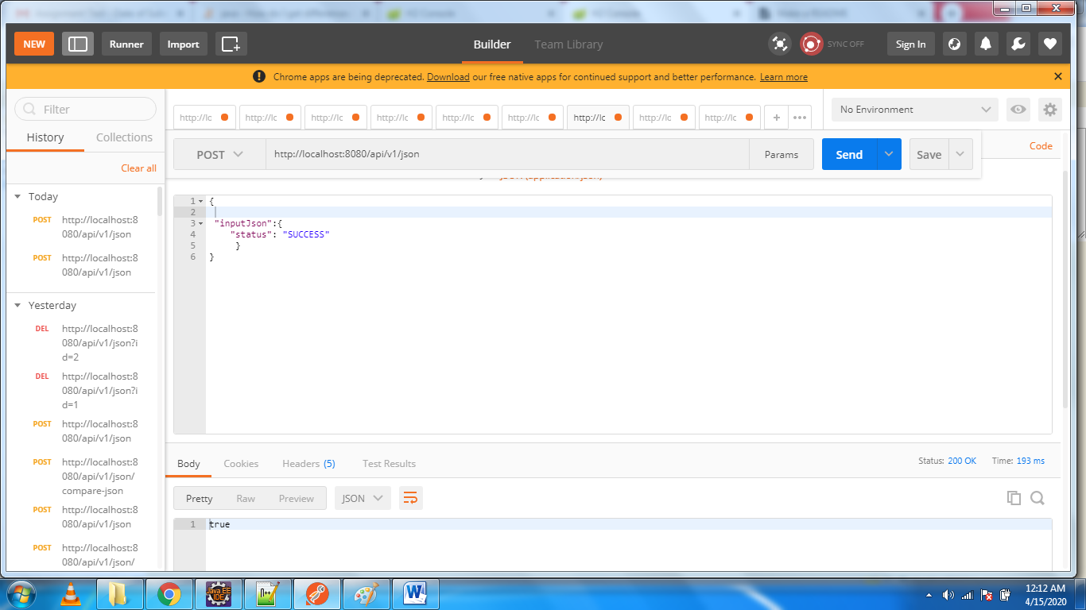

2 - <http://localhost:8080/api/v1/json/compare-json> METHOD - POST

Details it will take the second json to in input along with the id which is available to compare in database

Payload

{

"baseJsonID": 1,

"inputJson":{

"status": "fail",

"val":"test"

}

}

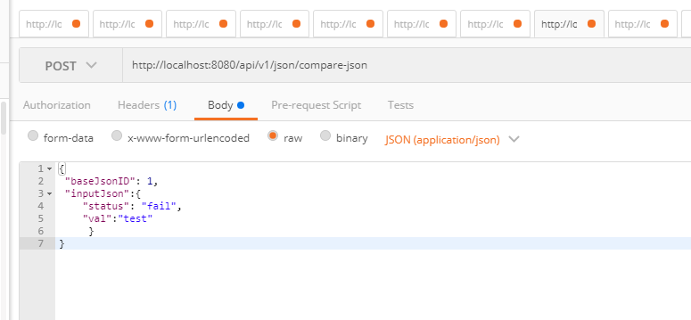

Response _

IT will compare the JSON from database and which we sent and return the

1 Left side json’s entries which is different from right side

2 Right side json’s entries which different from left side

3 Common entries which have updated values

{

"Right Side different entries ": "{/val=test}",

"Left Side different entries ": "{}",

"Both Side different value ": "{/status=(SUCCESS, fail)}"

}

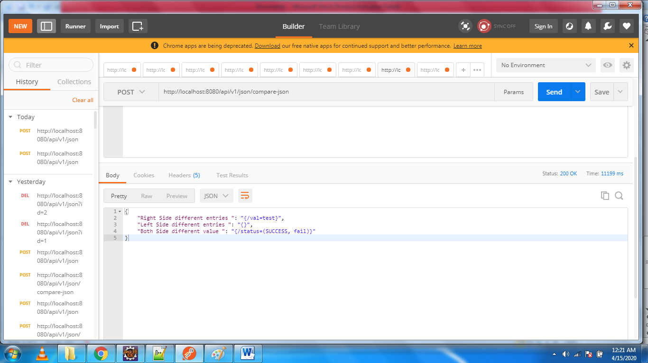

3 delete

<http://localhost:8080/api/v1/json?id=2> method :- delete

will delete entries from data base