MEDIA RELEASE

Monash students turn their first $1 container refund into a story
“First Return, First 10¢” invites students to make their first CDS Vic return and leave their mark on the First $1 Wall
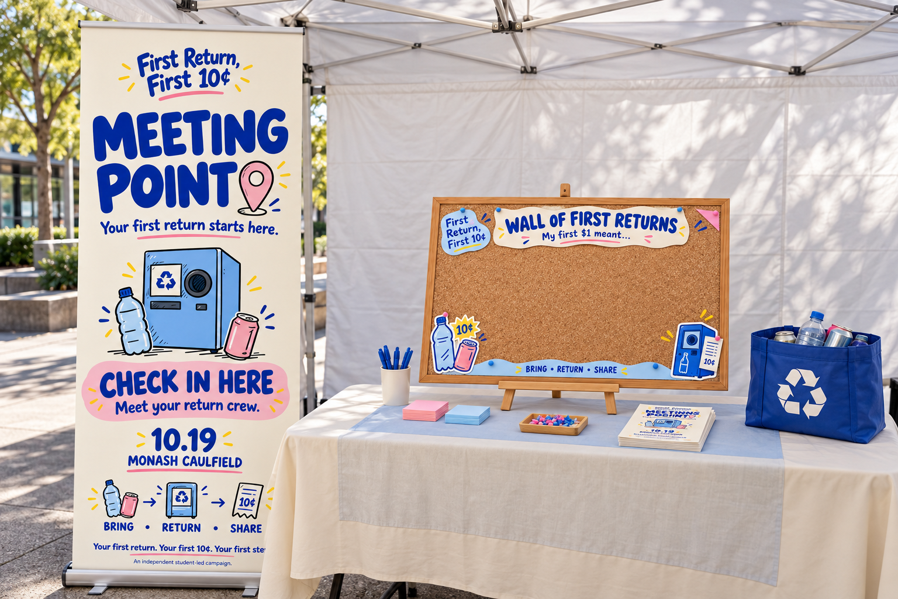
Melbourne, Victoria — 24 October 2026 — What does your first $1 from recycling mean to you?
A new student-led campaign, First Return, First 10¢, is inviting Monash students who have never used Victoria’s Container Deposit Scheme before to collect 10 eligible containers, make their first return, and share their experience on the campaign’s First $1 Wall.
After completing their return, students can finish one simple sentence:
“My first $1 meant…”
Their responses then become part of a growing display of first-return stories, turning an everyday recycling action into something visible across campus.
The idea behind the campaign is simple: rather than asking students to immediately become committed recyclers, First Return, First 10¢ focuses on helping them take the first step.
Campaign research involving 48 students found a clear awareness and knowledge gap. 56.3% had never heard of Victoria’s Container Deposit Scheme (CDS Vic), while 16.7% had heard of the scheme but did not know how it worked. 41.7% were also unaware of the CDS Vic East app’s container-eligibility feature.
For the campaign team, these findings pointed to a different kind of barrier.
Students were not necessarily rejecting recycling. For many, the process simply felt unfamiliar — from knowing which containers could be returned to understanding where to take them.
For the campaign team, the biggest challenge was clear: helping students feel confident enough to try the scheme for the first time.
“Instead of telling students to recycle more, we wanted to make that first return feel easy, social and worth trying. Once someone has done it once, the whole process feels much more familiar.”
The First $1 Wall sits at the centre of the campaign, supported by short-form social media videos that show students how to identify eligible containers, use the CDS Vic barcode scanner and complete a return.
The campaign website also brings these resources together and helps students follow a simple participation journey:
Check. Collect. Return. Share.
Students are encouraged to start with just 10 eligible containers — enough to make their first $1.
The campaign’s message is:
Collect ten. Return once. Start a habit.
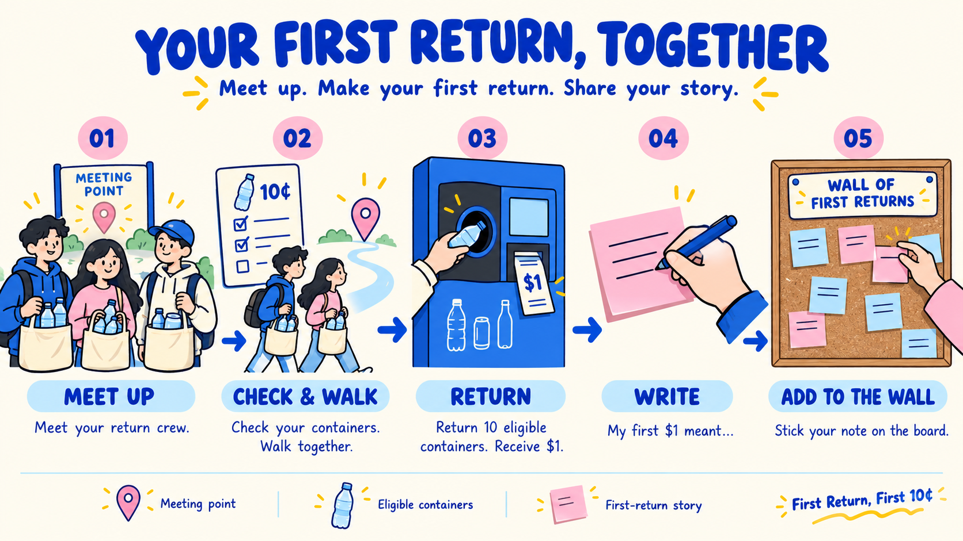
How to take part
Students can:
- Check whether their bottles and cans are eligible through Victoria’s Container Deposit Scheme.
- Collect 10 eligible containers.
- Complete their first return.
- Add their response to the First $1 Wall by finishing the sentence: “My first $1 meant…”
More information and campaign resources are available at:
First Return, First 10¢
Website: https://lww9057-prog.github.io/first10c.github.io-/First-Return-Website/

Media contact
Xin Lin — xlin0068@student.monash.edu
Leyi Chen — lche0276@student.monash.edu
Liwen Qiu — lqiu0010@student.monash.edu
About First Return, First 10¢
First Return, First 10¢ is an independent student-led campaign designed to encourage first-time participation in Victoria’s Container Deposit Scheme among Monash University students.
The campaign focuses on making the first return easier to understand, easier to try and more visible through peer participation, short-form social content and the interactive First $1 Wall.
ENDS

