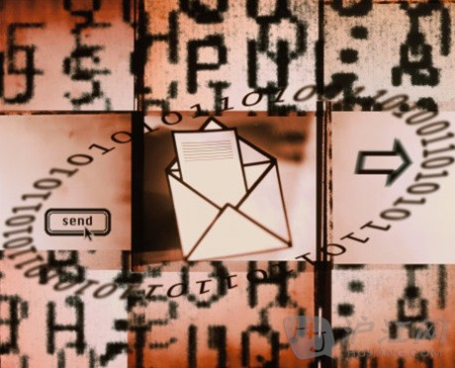
A recent post on the DailyMuse outlined the most common business writing mistakes you don’t even know you are making. Before you draft your next email, consider the following examples of bad habits to avoid:
最近职业女性社区DailyMuse在线版上刊登了一篇报道，指出了商务写作中最常见的错误，有些错误甚至你都不知道自己正在犯。在你下次起草一封电邮之前，看一看以下列举的这些发邮件时的易错处，尽量避免这些坏习惯吧：
1. “btw, need u 2 sign tom. thx.”
“顺便说一下，谢谢把这份邮件转发给Tom”
Being too casual in an email may lead the receiver to think (A) you are unprofessional and not taking the conversation seriously, (B) too busy to address their needs, or (C) they may have no idea what the heck you are talking about in the first place. Business should always be handled with care and this can by done so by taking the time to properly communication regardless of how laid-back the environment is.
在写邮件时用词太随意可能会让收件人产生以下想法：（1）发件人不够专业或者没有认真对待此次谈话；（2）发件人太忙了，都没有时间来说清楚自己的要求；（3）不知道发件人到底想要干什么。所有商业活动都需要认真对待，不管身处什么样的环境，都要花时间来进行恰当的交流。
2. “It was a pleasure meeting you yesterday!! Looking forward to our nextencounter! Take care!”
“昨天见到你很高兴！！期待下次再见！保重！”
Exclamation points are sometimes 100% necessary in business emails to expressenthusiasm and even good manners, but overusing this punctuation takes on a whole new and unwanted meaning. With one too many exclamation points, your positive attitude turns…. quite weird and unwelcoming.
在商务信函中，有时使用惊叹号是有很必要的，可以表达出热烈的情感和良好的礼仪。不过，过分使用标点符号就会适得其反了。就像上面提到的这句话一样，滥用惊叹号来表达积极情感反而会让人觉得奇怪和不受欢迎。
3. Subject: Meeting
主题：开会
First, imagine how many emails professionals receive a day. Now, imagine how many emails professionals receive a day including the word “meeting.” Subject lines are thefiltering mechanism and the best way to draw help the recipient distinguish the reason behind your email. Don’t be vague in your subject lines. It is your job to summarize the body of your email.
首先，想象一下一个职场人每天要收到多少封电子邮件。现在，再想象一下有多少封邮件中会带有“开会”的关键词。邮件中的主题栏是一种过滤机制，让收件人可以更好地区分出每封邮件主旨内容。千万不要在主题栏中含糊其辞，你有责任把正文内容提纲挈领地展示在邮件主题栏中。

