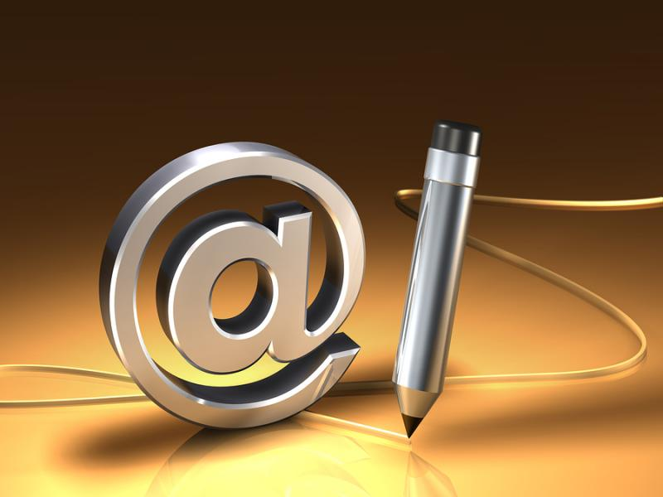
If you’re reading this, there’s a good chance that you have an email account. You may well have several – perhaps separate accounts for professional and personal contacts.
如果你正在阅读这篇文章，你肯定有一个或若干个甚至是不同帐号的私人或办公邮箱。
It’s easy to assume that we know how to use email effectively: it’s been around for long enough. But if you find yourself struggling to communicate effectively by email, these six tips should help:
邮件这样的沟通方式早已经渗入到了我们的生活工作中，因此可以说大多数人都能有效地使用邮件与他人交流。但如果你发现自己还没做得足够有效，我想以下这六点可以帮到你：
1. Start With an Appropriate Salutation
邮件开头称呼要恰当：
Some people jump straight into the text of an email without so much as a “hi”. It’s polite to add a salutation, just as you would with a letter. That might look like:
有些人写邮件不喜欢加称呼，甚至连简单的“你好”都忽略，直接开始正文内容。孰不知就像在传统的信件上一样，写上称呼是一种礼貌的象征。称呼可以这样写：
#Dear Sir/Madam 亲爱的先生/女士
#Dear Mr. Johnson 亲爱的约翰逊先生
#Hi Sue 苏，你好
#Hello Fred 你好，福瑞德
Your salutation needs to be appropriate. If you’re writing to a prospective employer, “Dear Mr. Johnson” is probably the best way to go. “Hi Bob” is going to look unprofessional.
称呼必须恰当。若邮件对象是你未来的上司，“亲爱的约翰先生”这样的称呼应该为最得体的。像“你好，鲍勃”更适用于随意的场合。
But don’t assume that formality is always the right answer. If you’re writing to a friend of a friend, using “Dear” plus their surname is going to seem oddly stilted.
那么，是不是正式的用语就万能呢？绝对不是。若你给你朋友的朋友写邮件，那用“亲爱的+姓”就显得异常别扭。
If in doubt, “Dear [first name]” will usually work just fine.
当你判断不出哪种场合该用什么称呼合适，你可以使用“亲爱的+名”来应付所有情况。
2. Get Straight to the Point
直奔主题
Your correspondent won’t want to wade through paragraphs of waffle – so get straight to the point. If you’re writing to someone out of the blue, don’t give them your life story before you make a request.
相信阅读你邮件的人不会愿意仔细浏览你那空洞无聊的长篇大论，所以你需要直奔主题。如果你想写封邮件安慰某个心灵受伤的朋友，开头先把你的建议亮出来，然后再用你的亲身经历来辅助说明。
Getting straight to the point might mean that the first line of your email (after the salutation) looks something like this:
直奔主题意味着邮件内容的第一行应该是这样：
#I’m working on an article about Acme Widgets for XYZ publication, and wondered if you had a few minutes to answer the following three questions.
我现在正在写一篇要交给某某出版社关于极致控件的文章，不知道您有没有时间回答3个问题呢？
#Could you supply me with a quote for the following project?
可否对下面的设计项目进行引证？
#I’d like to discuss the revisions with you. Would Tuesday at 2pm be a good time?
我想和你谈谈修订的事。这周二下午两点您有空吗？
#I’ve attached the documents you requested at our meeting yesterday.
昨天会议上您要求的文件已附上，请查收。
You may well need to include more details, but if you put the important point up front, your email is more likely to get a timely response. If your question comes too far down, the recipient may not even realise that you need a reply.
当然，你需要再增加更多的细节内容。若将邮件重点放到内容的开头，你将收到更加及时的回复信息。如果你的问题在邮件后头，收信人可能都不会意识到你在等他回复。
3. Keep it Short
内容言简意赅
Try to keep your email as short as possible. Make the paragraphs short, too – long paragraphs can be difficult to read and take in.
尽可能将你的邮件内容写得简单明了。文章太长不易阅读和吸收。
Do make sure you give enough information for your correspondent to be able to make a decision, if that’s required. You might find that it’s best to offer this as an attachment – you’ll have more flexibility over formatting, and your correspondent can print out the attachment easily.
若对方需要通过你的邮件来做决策，那你一定要在邮件中将相关信息写完整。为了能更灵活地排版，你可以把这些信息作成附件形式，以方便对方将其打印出来。
4. Use Numbered Points
将内容编号
If you’ve got several questions or points to make, it’s very helpful to number them. This makes it easy for the other person to respond to each one, especially if some just require a yes/no response or a single word answer. For instance:
对于那些为了咨询或提供各种问题的邮件，最好将问题一点一点的列举出来，以便于他人对每个问题作答，尤其当某些人更倾向于对问题只回答“是”和“否”的时候。例如：
#Could you let me know:
能否告知：
#1. How much it would cost for the website design
1. 网站设计费用
#2. How much for the website design plus a tri-fold brochure
2. 网页设计加一份三页宣传册的费用
#3. Whether you could complete #2 by the end of April
3. 您能否在四月底完成第二点所述工作？
It’s also useful to list your questions or points as bullets in this way; if you write a single paragraph, some of your questions might get missed.
将你的问题或观点用图标的方式罗列出来是很实用的，倘若你用一段话将几个点全部涵盖，那对方有可能会漏看其中的几点。
5. Re-read and Use Spell-Check
重新阅读一遍，校对拼写错误
A typo or spelling mistake can turn one word into an entirely different one. If you’re using email in a professional capacity, that mistake could be embarrassing – or even offensive. It might alter the whole meaning of your email: a missing “not”, for instance, could potentially cause problems.
排版或拼写错误有时能导致对一个单词的误解。尤其当你用邮件来沟通专业性内容时，这样的错误就很尴尬，甚至有些失礼。它可能改变你整个邮件的意思。比如：少写了个“不”，就可能会引起某些问题。
Spell-check should help you avoid any silly mistakes – but use your eyes and brain too. There are plenty of words that spell-check won’t pick up. If you’re emailing from a device with predictive text and an auto-correct feature, make sure you always re-read what you’ve typed.
因此检查拼写将避免你犯这些低级错误，但这里强调——不仅仅用眼睛检查，还得用大脑思考。有些错误不一定能轻易检查出来。如果你的邮件系统有字句联想功能和自动纠错功能，一定要把写出来的内容再通读检查一遍。
6. Make Your Signature Useful
充分利用邮件签名
Do you have an email signature? (That’s the text that appears automatically at the bottom of your email.) Some people don’t use one at all; others have a funny quote or favorite saying.
你设置过邮件签名吗（它将会在你每次邮件内容的下方自动生成）？有些人从来都没有使用过它，但我们也看过一些非常有意思和哲理的签名。
Whether you’re using email for professional or personal reasons, make your signature useful for both you and your recipient. That might mean:
无论你是为了工作还是私人聊天，加注签名对你和邮件接收者都有好处，因为这意味着可以：
Giving the link to your website
加上你的网页链接
Including your work address and/or phone number
写上你的工作地址或电话号码
Adding links to your social media accounts
注上你的社会媒体工具帐号（例如博客，微博，论坛）
Putting in a line to promote your recent book / blog / product
宣传你最新的书籍，博文或产品
If your email provider allows it, you may even want to create several signatures to use for different purposes (e.g. one for emailing friends, one for new business contacts).
有些邮箱甚至还提供用户根据不同目的设计不同签名的服务（比如：一个对朋友使用，一个对新结识的企业伙伴使用）。

