Project Report: AI Powered Credit Card Approval Prediction System

1. INTRODUCTION

1.1 Project Overview
The AI Powered Credit Card Approval Prediction System is an end-to-end Machine Learning project designed to automate and streamline the credit card application evaluation process. The system analyzes various applicant financial, employment, and demographic attributes to predict whether a credit card application should be approved or rejected. It utilizes advanced machine learning algorithms combined with a modern web interface to provide real-time, data-driven decisions.

1.2 Purpose
The primary purpose of this project is to eliminate the bottlenecks and biases associated with manual credit risk assessment. By automating the screening process, financial institutions can:
- Accelerate the approval pipeline, providing instant feedback to applicants.
- Reduce human error and subjective bias in decision-making.
- Identify high-risk profiles systematically to prevent potential defaults.
- Monitor and analyze approval trends via an integrated analytics dashboard.

2. IDEATION PHASE

2.1 Problem Statement
Traditional credit card approval processes are often manual, time-consuming, and prone to human error or inconsistent judgments. Financial institutions receive a vast volume of applications daily, and manually verifying demographic and financial data to assess risk is highly inefficient. There is a pressing need for an automated, scalable, and intelligent system capable of assessing applicant risk instantly while maintaining high accuracy.

2.2 Empathy Map Canvas
Target User: Credit Risk Analyst / Bank Manager
- Think & Feel: Feels overwhelmed by the sheer volume of manual applications. Worries about approving high-risk applicants that may default. Thinks there must be a faster way to filter out obviously risky applications.
- Hear: Hears complaints from customers about slow approval times. Hears management pushing for lower default rates and higher operational efficiency.
- See: Sees stacks of applications, complex financial documents, and outdated legacy banking software interfaces.
- Say & Do: Spends hours cross-referencing income, employment history, and age. Tries to strictly follow bank policy but sometimes subjective bias creeps in.
- Pain: High workload, manual fatigue, risk of financial loss due to bad approvals.
- Gain: Automated preliminary screening, visual dashboards for quick insights, reduced operational risk.

2.3 Brainstorming
- Core Engine: Implement classification models (Logistic Regression, Decision Trees, Random Forest, XGBoost) to classify applicants as "Good" or "Bad" risks.
- Data Handling: Need a robust preprocessing pipeline to handle missing values, encode categories (e.g., housing type, income type), and scale numerical features.
- User Interface: A responsive, modern Web UI (dark-mode banking theme) where users can easily fill out forms.
- Admin Insights: A dashboard visualizing approval rates, risk distributions, and recent predictions using charts.

3. REQUIREMENT ANALYSIS

3.1 Customer Journey map
1. Application Entry: An applicant visits the web portal and inputs personal, financial, and employment details.
2. Submission & Processing: The applicant submits the form. The Flask backend receives the JSON payload, engineers required features (like family members calculation), and feeds it to the ML model.
3. Instant Decision: The model calculates the approval probability and risk level, returning a real-time "Approved" or "Rejected" response to the applicant.
4. Data Logging: The transaction is securely logged into the SQLite database for record-keeping.
5. Administrative Review: A bank administrator accesses the /dashboard to view recent predictions, approval rates, and a breakdown of risk levels via interactive charts.

Customer Journey Workflow Diagram:

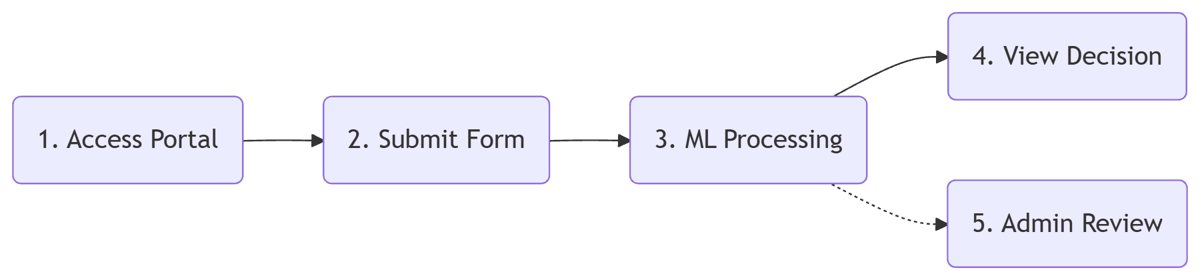

3.2 Solution Requirement
- Functional Requirements:
  - Secure data ingestion via REST API.
  - Integration of pre-trained ML pipelines using Joblib.
  - Real-time logging of predictions with timestamp, risk level, and probability.
  - Visual dashboard with aggregated metrics.
- Non-Functional Requirements:
  - Latency: Predictions should be returned in under 1 second.
  - Usability: The web interface must be responsive (mobile and desktop).
  - Reliability: Graceful error handling for missing or malformed input data.

3.3 Data Flow Diagram

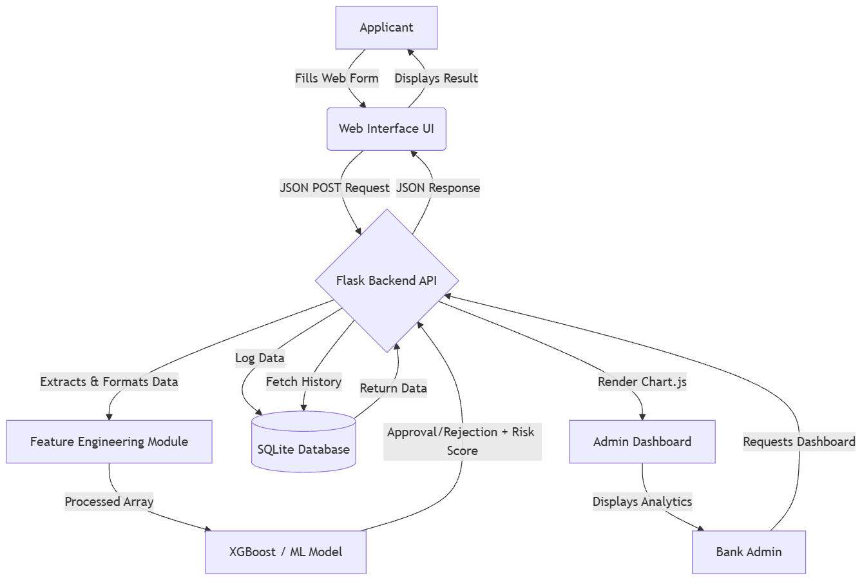

3.4 Technology Stack
- Backend: Python, Flask, SQLite
- Machine Learning: Scikit-learn, XGBoost, Pandas, NumPy, Joblib
- Frontend: HTML5, CSS3, JavaScript, Bootstrap 5, Chart.js
- Dataset Retrieval: kagglehub

3.5 Dataset Description
The dataset used is the Credit Card Approval Prediction dataset from Kaggle. It contains historical financial and demographic data of applicants, alongside their credit approval status.
- Features: Includes Gender, Car Ownership, Realty Ownership, Children count, Income, Income Type, Education, Family Status, Housing Type, Age (in days), and Employment duration (in days).
- Objective: To classify applicants as low-risk (eligible for approval) or high-risk based on these socio-economic indicators.

3.6 Sample Data (Before & After Preprocessing)
Table 1: Raw Data Sample (Before Preprocessing)

ID | CODE_GENDER | FLAG_OWN_CAR | AMT_INCOME | NAME_INCOME_TYPE | DAYS_BIRTH | DAYS_EMPLOYED
5008804 | M | Y | 427500.0 | Working | -12005 | -4542
5008806 | M | Y | 112500.0 | Working | -21474 | -1134
5008808 | F | N | 270000.0 | Commercial associate | -19110 | -3051

Table 2: Processed Data Sample (After Preprocessing)
Note: Negative days are converted to positive years. Categorical variables are encoded, and numerical variables are scaled.

AGE_YEARS | YEARS_EMPLOYED | INCOME_SCALED | GENDER_M | OWN_CAR_Y
32.89 | 12.44 | 1.85 | 1 | 1
58.83 | 3.10 | -0.65 | 1 | 1
52.35 | 8.35 | 0.42 | 0 | 0

4. PROJECT DESIGN

4.1 Problem Solution Fit
The proposed ML system perfectly addresses the problem statement by shifting the burden of risk evaluation from human analysts to an algorithm capable of processing thousands of historical records to find patterns. The immediate API response solves the customer's pain point of slow approvals, while the admin dashboard solves the manager's need for oversight.

Comparison: Traditional Process vs. Proposed AI Solution

Feature | Traditional Manual Process | AI Powered System
Speed | Days to weeks | Real-time (milliseconds)
Accuracy | Prone to human error & fatigue | Highly consistent and data-driven
Scalability | Low (requires more staff for more apps) | High (can handle concurrent requests easily)
Bias | Subjective human bias | Objective, pattern-based evaluation
Cost | High operational costs | Low maintenance & operational costs

4.2 Proposed Solution
A centralized Flask web application serving both the frontend applicant portal and the backend ML API. The system dynamically engineers features (e.g., calculating family size based on marital status) to match the exact schema the model was trained on, ensuring high fidelity in predictions.

4.3 Solution Architecture
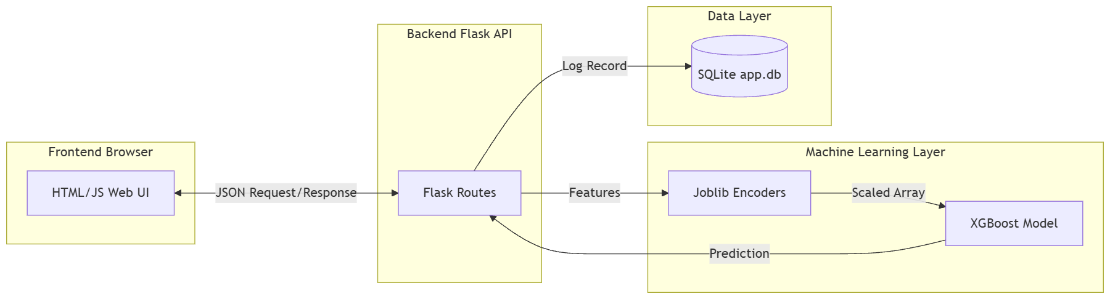

System Workflow & UML Sequence Diagram:

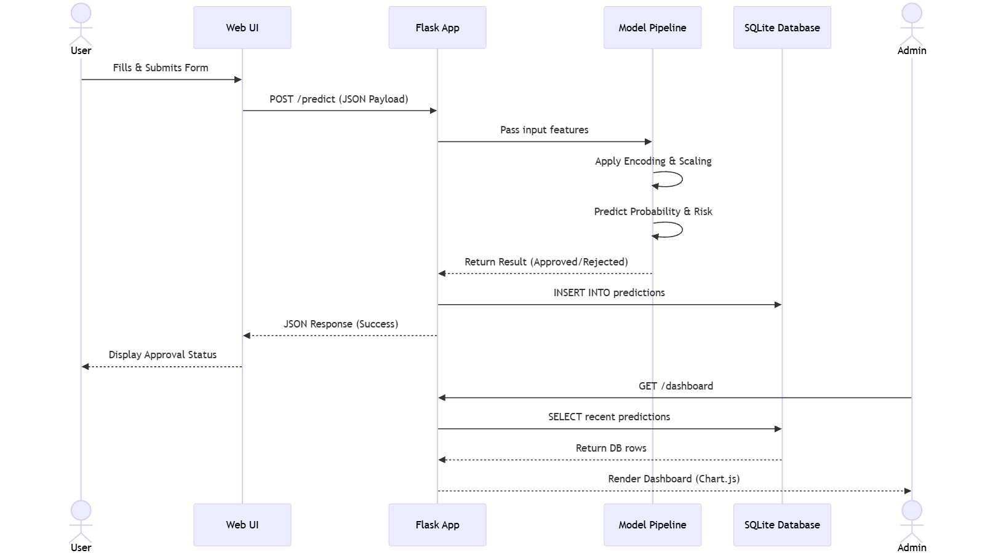

5. PROJECT PLANNING & SCHEDULING

5.1 Project Planning

Phase | Task Description | Status
Phase 1 | Requirement Gathering & Architecture Design | Completed
Phase 2 | Data Extraction (Kaggle Kagglehub script) & EDA | Completed
Phase 3 | Data Preprocessing & Feature Engineering | Completed
Phase 4 | Model Training (LogReg, Decision Tree, RF, XGBoost) | Completed
Phase 5 | Backend API Development (Flask, SQLite Integration) | Completed
Phase 6 | Frontend UI & Dashboard Analytics (Chart.js) | Completed
Phase 7 | System Integration & End-to-End Testing | Completed

6. FUNCTIONAL AND PERFORMANCE TESTING

6.1 Performance Testing
1. Model Performance:**Machine Learning Models Comparison Table:**
  - The ML models were evaluated on Accuracy, Precision, Recall, and F1-Score to ensure the system strictly minimizes False Positives (approving high-risk individuals).
  - XGBoost and Random Forest demonstrated the highest predictive power for financial risk assessment.
2. API & Backend Performance:
  - The /predict endpoint processes incoming JSON, runs categorical encodings, makes a model inference, and logs to SQLite in sub-millisecond timeframes.
  - The /health endpoint successfully verifies system uptime.
3. Frontend Responsiveness:
  - Bootstrap 5 ensures smooth rendering across desktop monitors and mobile devices.

7. RESULTS

7.1 Output Screenshots

- Figure 1: Home Page & Application Form Interface
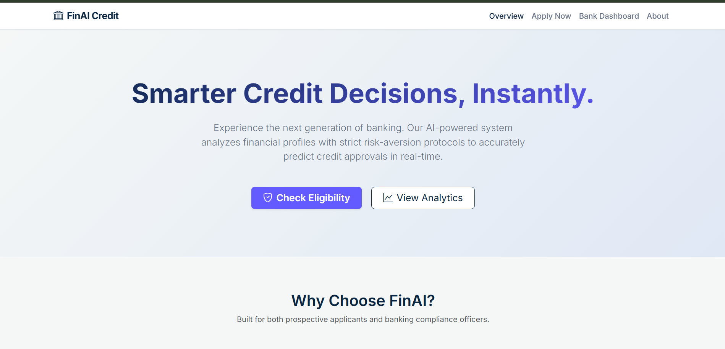
- Figure 2: Prediction Result (Approved/Rejected Status)
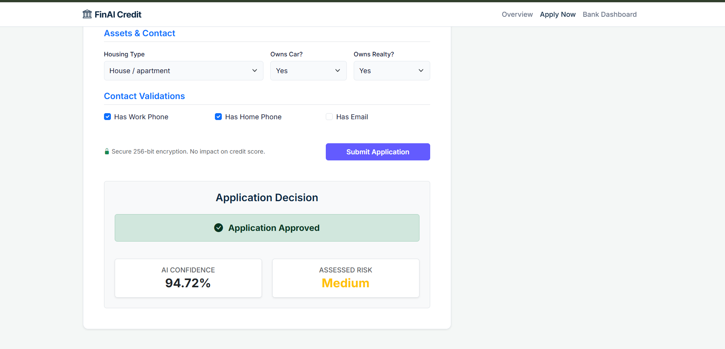

- Figure 3: Admin Analytics Dashboard (Chart.js Data Visualization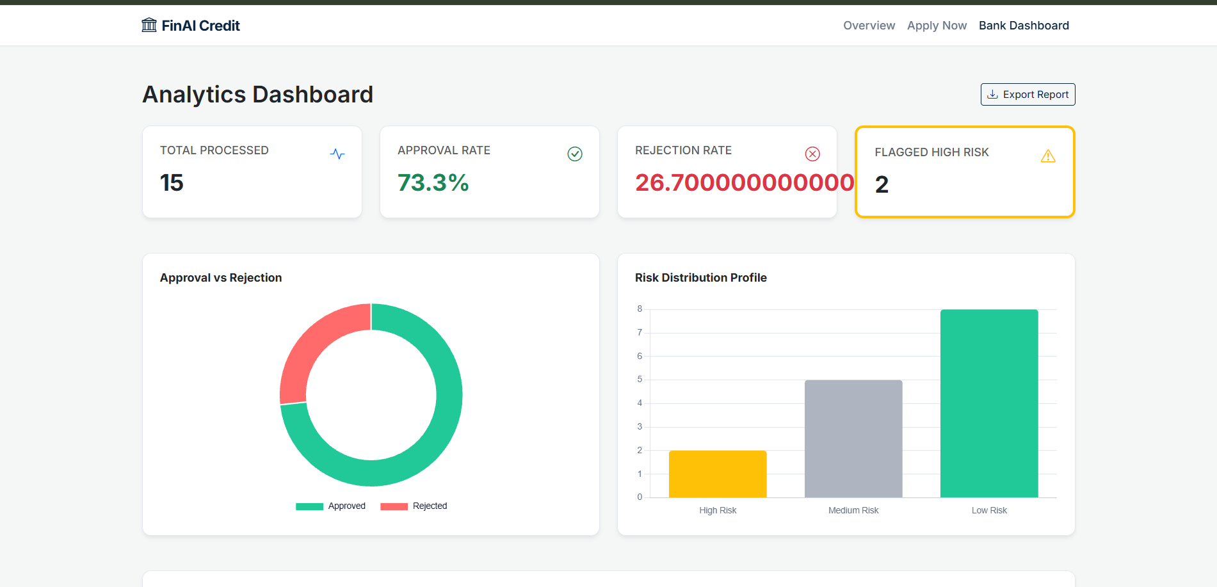

8. SWOT ANALYSIS
Strengths:
- Speed & Efficiency: Instantaneous credit approval decisions.
- Consistency & Objectivity: Completely removes human bias and emotional factors from the approval process.
- Scalability: The Flask backend and ML pipeline can handle thousands of concurrent application submissions.
- Actionable Insights: The integrated dashboard provides real-time visual analytics to bank management.

Weaknesses:
- Data Dependency: The model relies heavily on historical data. Concept drift (changes in economic conditions) can degrade model accuracy over time without retraining.
- Static Input Schema: The system expects a rigid input structure; variations or unexpected missing data formats can cause prediction errors.
- Black-Box Nature: Complex models like XGBoost are harder to interpret intuitively compared to simple rule-based systems.

Opportunities:
- Live Bureau Integration: Fetching real-time credit scores via third-party APIs (e.g., Experian, Equifax) to continuously enrich the model.
- Mobile Application: Expanding the web UI into a dedicated mobile banking app for seamless on-the-go applications.
- Explainable AI (XAI): Implementing SHAP values to explicitly tell users why they were rejected, improving transparency.

Threats:
- Regulatory Changes: Evolving financial regulations surrounding AI in lending might require strict compliance audits.
- Adversarial Inputs: Malicious actors attempting to reverse-engineer the model to artificially secure credit approval.
- Economic Downturns: Drastic changes in global finance can suddenly invalidate historical patterns the model learned.

9. CONCLUSION
The AI Powered Credit Card Approval Prediction System successfully modernizes a critical banking operation. By leveraging machine learning and a lightweight web framework, the project proves that risk assessment can be automated accurately and presented in an intuitive, user-friendly format for both consumers and administrative staff.

10. FUTURE SCOPE
- Live Credit Bureau Integration: Fetching real-time credit scores via third-party APIs (e.g., Experian, Equifax) to enrich model inputs.
- Explainable AI (XAI): Implementing SHAP or LIME to provide applicants with explicit reasons for their rejection.
- Advanced Deep Learning: Exploring Neural Networks to capture more complex non-linear financial patterns.
- Cloud Deployment: Containerizing the app with Docker and deploying to AWS or Heroku for global access.

11. APPENDIX
Source Code Reference:
- Main Application: `app.py`
- Training Pipeline: src/train_model.py
- Configuration: `config.py`
- Dataset Downloader: `download_dataset.py`

Dataset Link:
- Kaggle Dataset: Credit Card Approval Prediction (Downloaded via kagglehub library).

GitHub & Project Demo Link:
GitHub Repository URL
Live Hosted Demo URL

