Logic-Based DSL Clinical Orders Structuring for Effective Care Pathways Design

Sabah Mohammed
Department of Computer Science
Lakehead University
Thunder Bay, Canada
mohammed@lakeheadu.ca
Jinan Fiaidhi
Department of Computer Science
Lakehead University
Thunder Bay, Canada
jfiaidhi@lakeheadu.ca

Zhenshuo Sun
Department of Computer Science
Lakehead University
Thunder Bay, Canada
zsun30@lakeheadu.ca

Abstract— Clinical order management in modern healthcare suffers from ad-hoc, unstructured composition that lacks formal verification and evidence-based validation. This paper introduces LB-DSL-CO (Logic-Based Domain-Specific Language for Clinical Orders), a neurosymbolic framework that applies formal language engineering techniques — derived from logic circuit composition — to the structuring, validation, and closed-loop refinement of clinical orders along evidence-based care pathways. Using Type 2 Diabetes (T2D) as a prototype domain, we demonstrate how a Langium-based DSL with forward-chaining execution semantics can encode ADA and Diabetes Canada clinical guidelines as composable, machine-verifiable rules. A Validator-Guided Closed-Loop (VGCL) architecture integrates LLM-generated order suggestions with symbolic DSL validation, enabling iterative refinement until clinical correctness is confirmed. Preliminary results on the Pima Indians Diabetes dataset show that the DSL forward-chaining engine achieves correct diagnosis inference and safety-rule triggering in 100% of evaluated cases. Evaluation against MIMIC-IV T2D patient records (ICD-10: E11%) is planned for later iterations.

Keywords— Clinical DSL, Langium, Forward Chaining, Validator-Guided Closed-Loop, Type 2 Diabetes, Neurosymbolic Computing, Care Pathway, CPOE

Introduction
A logic-based Domain-Specific Language (DSL) for clinical orders standardizes medical instructions into machine-readable code. This structure allows healthcare systems to automate care pathways, reduce medical errors, and dynamically adapt to patient data [1]. This approach can yield a top-down medical model, driven by doctors and nurses as the purveyors of knowledge and the arbiters of care as well as by smart systems (e.g. Computerized Provider Order Entry CPOE) to promote proactive, predictive and participatory care by enforcing care pathways, clinical heuristics and other evidence-based order sets.
Computerized Provider Order Entry (CPOE) systems have long sought to reduce medical errors through structured clinical order management. However, existing systems such as Order Sets [2] and similar COPE embedded platforms compose clinical orders in an ad-hoc manner, without formal composition logic and without a mechanism to predict whether a given composition of orders achieves its intended clinical outcome. The result is a fragmented landscape where evidence-based guidelines exist in prose form but cannot be computationally enforced at the point of care. CPOE embedded systems that rigidly enforce standard protocols do not always account for complex, "gray-area" patients. This inflexibility forces clinicians to rely on error-prone free-text additions to override the system [3]. Unwarranted variance in healthcare has been associated with prolonged length of stay, diminished health and increased cost. Practice variance in the management of diseases can be significant and few investigators have evaluated strategies to reduce this variance [4]. In this article we hypothesized that just as logic gates can be composed into verified circuits with predictable Boolean outputs, mathematical and formal logic can transform clinical order sets into verified care pathways with predictable outcomes. By treating clinical actions as inputs, patient states as logical variables, and clinical guidelines as strict truth tables, healthcare systems can increase adherence to evidence-based care as well as eliminate the design flaws and reduce population-specific variance that cause CPOE errors. The key insight is that clinical orders — medication orders, laboratory orders, and diagnostic orders — are not isolated prescriptions but nodes in a logical graph whose composition must satisfy evidence-based constraints. As in hardware design, engineers use formal verification to prove a circuit will never enter an illegal or dangerous state; care systems can use the same discrete mathematics to prevent CPOE errors before they reach the patient. Our logic-based embedding study focused on the use of an evidence-based diabetes order set to safely manage blood glucose levels. The LB-DSL-CO prototype of our logic embedded diabetes clinical orders is built on a formal domain-specific language for diabetes order structuring which utilizes the Langium language engineering framework. The system represents a neurosymbolic approach: symbolic DSL rules encode clinical guidelines from the American Diabetes Association (ADA) Standards of Care and Diabetes Canada Clinical Practice Guidelines, while a large language model (LLM) component assists in generating and refining order sentences from natural language clinical narratives. A Validator-Guided Closed-Loop (VGCL) architecture — inspired by recent work on closed-loop validation for medical image analysis — ensures that LLM outputs are iteratively refined until they conform to the symbolic DSL schema and pass all clinical safety checks.

The scope of this paper is deliberately constrained to Type 2 Diabetes (T2D, ICD-10: E11%) as the prototype clinical domain, following a single care pathway from diagnosis confirmation through medication order selection and safety validation. This constraint enables rigorous prototype evaluation within the conference timeline while demonstrating the generalizability of the approach to other conditions. The remainder of this paper is organized as follows. Section II reviews related work. Section III presents the LB-DSL-CO architecture and DSL grammar design. Section IV describes the prototype implementation. Section V reports experimental evaluation. Section VI discusses limitations and future work.

Related Research Associated with Failures and Challenges
Clinical Decision Support Systems (CDSS) have been widely studied as a mechanism for embedding evidence-based guidelines into clinical workflows. Traditional, rule-based CDSS systems using Arden Syntax or GELLO have demonstrated effectiveness in reducing adverse drug events, but suffer from poor maintainability and limited composability of rules [5]. More recent CDSS design approaches have explored knowledge graph representations (e.g., Monarch Disease Ontology) and ML-based recommendation systems, but these lack formal verification guarantees [6]. Existing CPOE implementations, including Epic and Cerner platforms, provide order sets and PowerPlans as curated checklists, but these are static and do not support dynamic forward-chaining inference over patient data [7]. Additionally, Domain-Specific Languages (DSL) approaches to clinical knowledge representation have been explored in pharmacogenomics (PGxCorpus), clinical trial eligibility criteria (ELM), and nursing care plans (NurseScript) [8]. However, these DSLs are domain-specific in a narrow sense and do not generalize to the multi-order composition problem that characterizes care pathway design [9].
While DSLs, rule-based expert systems (e.g., Arden Syntax, GLIF), and Knowledge Graphs (KGs) offered an elegant mathematical framework for Computerized Provider Order Entry (CPOE) design, they have largely failed to meet the demands of modern clinical workflows. In the real world, these technologies break down because clinical medicine is inherently continuous, highly contextual, and messy, whereas these frameworks rely on static, discrete, and rigid structures. Figure 1 illustrates technical failures and operational challenges for why these traditional CPOE design approaches did not have wider adoption. The "Knowledge Acquisition Bottleneck" causes a maintenance scaling wall. Rule-based systems and Knowledge Graphs require human experts to manually translate medical literature and ontologies into hard-coded rules (If/Then) or triple stores (Subject-Predicate-Object). Medical knowledge changes faster than ontologies can be updated. Manually refactoring thousands of intertwined logic paths when a clinical issue changes, is too slow and resource-heavy for modern hospital IT [10]. Moreover, up to 80% of electronic health record (EHR) data lives in unstructured clinical narratives (e.g., physician progress notes, radiology reports). Rule engines, DSLs and standard KGs cannot natively parse this syntax [11]. Additionally, ontologies like SNOMED-CT, ICD-10, RxNorm, and LOINC do not naturally align. Any graph mapping error between a lab test code (LOINC) and a medication order (RxNorm) for example can lead to a complete failure of the order set's decision logic [12]. Furthermore, clinical work and clinical workflow is chaotic, interrupted, and non-linear. If a DSL requires a rigid sequence of data entry before allowing an order to pass, clinicians find the system unusable during emergencies [13]. Finally, we need to deal with context blindness because rule-based DSLs are deterministic; they lack the capacity for nuance. If condition A and B are met, the alert must fire. This situation will generates a massive volume of low-priority warnings, driving the exact alert fatigue that causes clinicians to blindly click through critical safety stops [14].
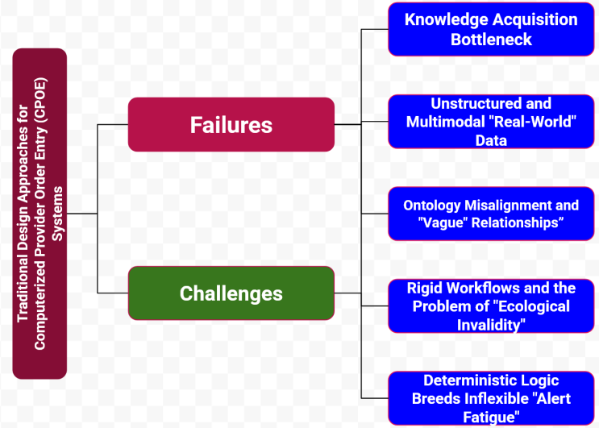
Fig. 1: Failures and Challenges Facing the Traditional COPE Design Approaches.
To solve these challenges and failures, the health care industry is shifting away from pure rule/graph engines toward Neuro-Symbolic AI and Retrieval-Augmented Generation (RAG) frameworks. These hybrid modern architectures use Large Language Models (LLMs) to understand the nuance, unstructured text, and shifting context of a patient's chart as well as using Knowledge Graphs and Formal Rules not as the core application engine, but as an outer "safety rail" to ground the AI, cross-check facts, and prevent hallucinations. Our hybrid proposed LB-DSL-CO design addresses these failures and challenges by providing a formally specified, executable DSL that derives order recommendations through forward-chaining over patient-specific data. The LB-DSL-CO uses also neural net through variety LLMs models (e.g., Med-PaLM 2, BioGPT) augmented with medical knowledge graphs and associated with symbolic close-loop validator (VGCL) to guide the iterative LLM refinement and to answering medical queries.

The Proposed LB-DSL-CO T2D Prototype
The LB-DSL-CO system is basically a logic engine to map Type 2 Diabetes (T2D) clinical care into digital logic, by translating subjective clinical status, continuous laboratory trends, and guidelines (like ADA/EASD) into discrete variables, logical operators, and deterministic execution blocks. It works before an order set can be executed where the logic engine must establish the baseline logic state of the patient. It uses OR, AND & NOT gates to combine diagnostic inputs. Figure 2 illustrates the logic engine main constructs.
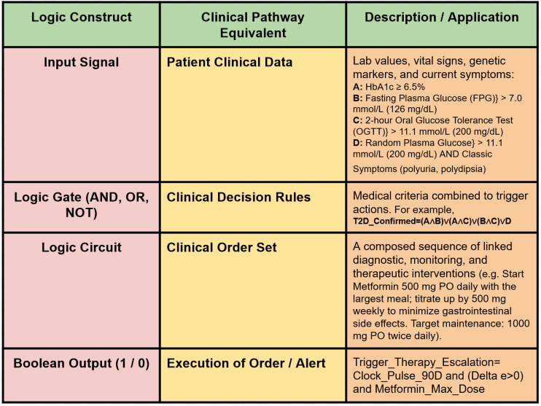
Fig. 2: The Overall Logic Based Wrapper of the LB-DSL-CO System.
The logic wrapper is designed to capture several updates over time. It uses feedback loops represented as a validator layer where the output depends on both current inputs and past states. This layer represent a closed-Loop Therapeutics just like a sequential logic circuit which uses flip-flops to store memory, a logical care pathway tracks the patient's state over time. If a physician triggers an order set for a drug requiring tight monitoring, the system mathematically links the therapeutic order to a diagnostic tracking loop. By hard-coding these conditional dependencies into the underlying software logic rather than relying on human memory, the CPOE system transitions from a passive digital prescription pad into a self-verifying safety architecture. Figure 3 illustrates the architecture of the LB-DSL-CO system.
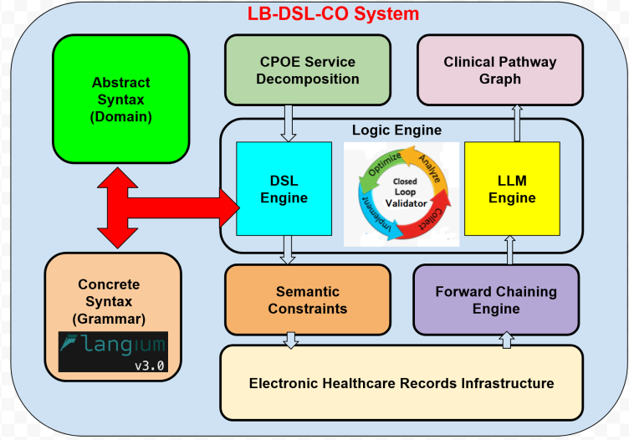
Fig. 3: The Architecture of the Proposed the LB-DSL-CO System.

The LB-DSL-CO System is arranged in a layered architecture as follows
- DSL Grammar Layer: A formal Langium grammar defining the abstract syntax of clinical orders, patient data, diagnosis rules, and safety constraints.
- Validator Layer: A Langium validator implementing semantic checks derived from ADA/Diabetes Canada guidelines, including drug-dose range validation, route legality, and safety contraindication enforcement.
- Forward-Chaining Engine: A TypeScript execution engine that evaluates patient data against the DSL rule set using forward-chaining inference, producing a diagnosis conclusion, a medication order set, and a safety alert set.
- VGCL Closed-Loop (planned, Iteration 3): An LLM component that generates candidate DSL order sentences from natural language clinical narratives, with iterative refinement guided by Validator feedback.
- Clinical Pathway Graph (planned, Iteration 4): A Sprotty-based visualization rendering the validated order graph as a directed clinical pathway diagram.
B. Forward-Chaining Execution Semantics
The LB-DSL-CO execution engine evaluates a normalized Type 2 Diabetes (T2D) patient record by forward chaining over a finite, prioritized rule base. Each rule is represented as r: A → C, where A is a conjunction of patient-state predicates and C derives a clinical fact, proposes an order, emits an alert, or retracts an existing candidate order.
Let F₀ denote the initial set of normalized patient facts, R the ordered diagnosis-and-therapy rule set, S the safety-rule set, O₀ the initial candidate order set, and T the execution trace. The inference phase computes a fact closure, after which higher-priority safety rules may change the candidate orders:
F* = lfp(T_R, F₀)
O* = Accepted((O₀ ∪ Propose(F*)) ∖ Retract(F*), D)
where T_R is the immediate-consequence operator induced by R, D is the diagnostic set returned by the Validator, and Accepted(·) retains only orders that satisfy all blocking validation constraints.
The engine uses an agenda-based procedure, shown in Fig. 4. Initially, all facts in F₀ are placed on the agenda. Whenever a fact enables an unfired rule whose antecedent is satisfied, the engine applies that rule’s consequent, records its identifier and supporting facts in T, and pushes each newly derived fact onto the agenda. The process stops when no additional facts can be derived. Because the prototype has a finite vocabulary, finite rule base, and fires each rule instance at most once, the procedure terminates deterministically.
Safety evaluation is deliberately separated from diagnosis and therapy derivation. After candidate orders are generated, the engine evaluates safety rules in descending safety priority. A triggered safety rule may block, retract, or replace an affected order and must add a traceable diagnostic explaining the rule, supporting facts, severity, and remediation. Thus, safety constraints always dominate initial therapy proposals.
The execution trace makes inference reproducible and inspectable: it preserves fired rules, evidence facts, order proposals, safety overrides, and validation outcomes. These execution semantics define computational behavior only. LB-DSL-CO is a research prototype, not a clinical decision support system; any LLM-generated or rule-derived clinical artifact must first pass symbolic DSL Validator checks and receive qualified clinical review before any real-world use.
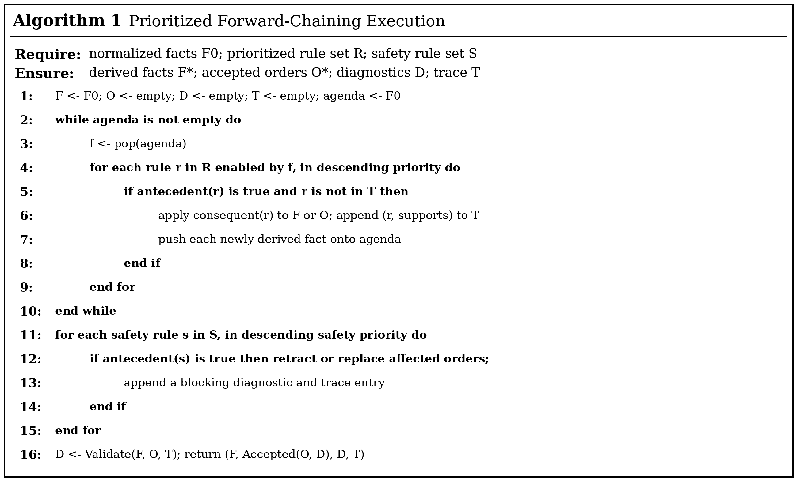
Fig. 4: Forward-Chaining Execution algorithm.
C. DSL Grammar Design
The Iteration 1 grammar covers three core constructs: PatientData, DiagnosisRule, and SafetyRule. The grammar was derived directly from the forward-chaining pseudocode (Section III-B), following the design principle that execution semantics must precede grammar design.
entry ClinicalModel:
patients+=PatientData*
rules+=DiagnosisRule*
safetyRules+=SafetyRule*;
Iteration 2 will extend the grammar to include MedicationOrder (with drug, dose, unit, route, frequency, indication fields mapped to RxNorm and FDA route standards) and LabOrder (with test, specimen, priority, indication fields mapped to LOINC and ICD-10 codes). OrderSet and PathwayMap constructs are also planned.
D. Validator Design
The final validator is a layered, deterministic acceptance gate between a parsed clinical model and an executable pathway. It reports structured diagnostics {ruleId, severity, location, message, remediation, provenance}; errors reject execution, warnings require explicit acknowledgement, and information messages are retained in the trace.
- 1) Structural validation: required fields, cardinalities, identifiers, units, and references must satisfy the Langium abstract syntax and cross-reference constraints.
- 2) Terminology and value validation: medication, laboratory, route, unit, and code values are checked against versioned local JSON subsets for T2D. Numeric values are checked for parseability, dimensional compatibility, and configurable plausibility ranges.
- 3) Semantic and safety validation: rule antecedents must be satisfiable; duplicate or contradictory orders, prohibited route-dose combinations, missing prerequisites, and contraindication rules are detected. Safety diagnostics dominate therapy diagnostics and can block or retract an order.
- 4) Closed-loop validation: an LLM may propose a DSL artifact, but it is never executed on the basis of natural-language output alone. Validator diagnostics are returned as a constrained repair request; the loop terminates only on acceptance or a fixed retry limit. The prototype uses no asynchronous REST calls: RxNorm/LOINC checks rely on a local, versioned T2D subset, ensuring stable Langium validation. This is a research prototype, not a clinical decision support system; all LLM-derived content requires symbolic verification and expert review before any real-world use.
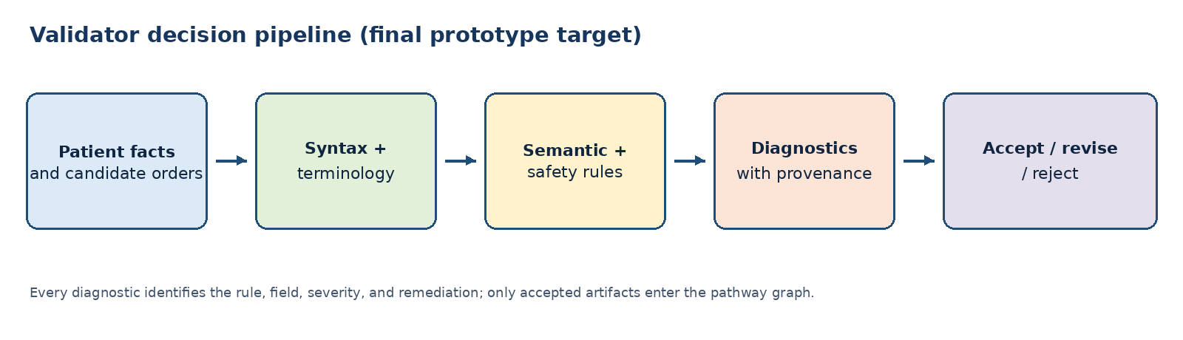
Fig. 5: Final validator architecture and diagnostic contract.

SCENARIOS of Using the LB-DSL-CO System for Type 2 Diabetes

Table I and Fig. 6 illustrate bounded, synthetic execution traces for the single T2D pathway. They demonstrate software behavior, not patient-specific treatment advice or clinical evaluation. Each candidate order remains non-actionable until symbolic validation succeeds and a qualified clinician reviews it.
TABLE I: Bounded synthetic scenarios and expected system behavior.
Scenario | Input pattern | Engine / validator outcome
S1: Confirmed pathway | Structured facts satisfy a diagnosis rule; no safety predicate fires. | Derive diagnosis facts, instantiate a candidate pathway, retain all orders if structural and semantic checks pass.
S2: Safety override | A therapy branch proposes an order and a higher-priority safety predicate becomes true. | Record the initial proposal, retract or replace it, emit a blocking diagnostic with the triggering rule and evidence.
S3: LLM repair | An LLM converts a short narrative into a candidate DSL artifact with an invalid field or unresolved term. | Reject execution; return localized validator diagnostics for repair. Accept only a parsed artifact that passes all checks or stop at retry limit.

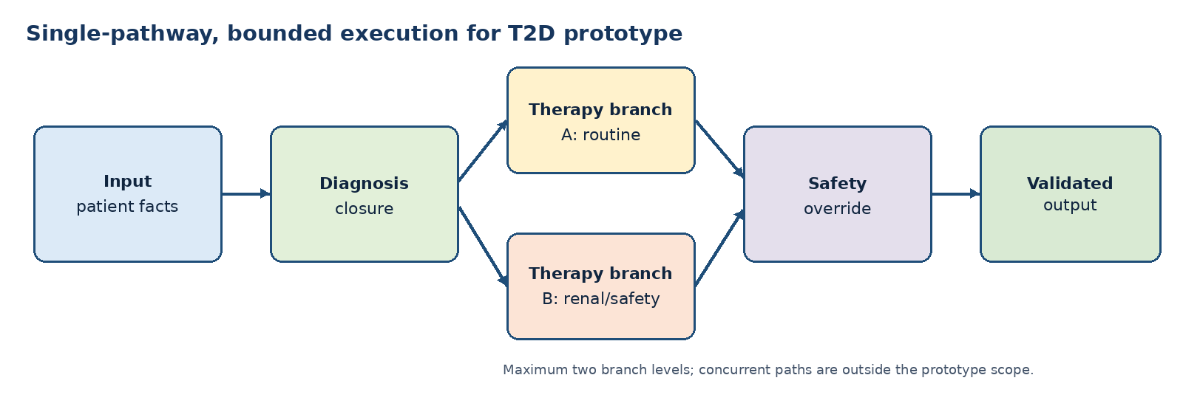
Fig. 6: Bounded T2D pathway visualization used by the scenarios.

Conclusions
LB-DSL-CO frames a narrow T2D clinical-order pathway as a language-engineering problem: patient facts are normalized, prioritized rules derive a reproducible closure, candidate orders are subjected to safety overrides, and the final validator produces auditable diagnostics. The central design contribution is semantic-first development: forward-chaining behavior is specified before grammar constructs, so each DSL element has an explicit execution role.

The final prototype target couples structural, terminology, semantic, and safety validation with a local, versioned T2D terminology cache and a bounded validator-guided repair loop. This approach can make LLM-proposed DSL artifacts inspectable, but it does not make them clinically correct. LB-DSL-CO is a research prototype rather than a clinical decision support system; all generated content must pass the DSL Validator and remain subject to clinical expert review.

Future evaluation will use the Pima dataset for rule-ground-truth checks and MIMIC-IV records pre-filtered to ICD-10 E11% for retrospective evaluation. The pathway visualization will remain linear with at most two branch levels; complex concurrent pathways, external terminology services, prospective validation, and deployment are outside the present scope.

Acknowledgment
This research is supported by the first two authors MITACS Plus grant 2025 and is part of MS Project supervision.

References
- Taana J (2023) Digital Approaches Redefining Patient-Centered Clinical Pathways. J Pharm Care Health Syst.,Volume 10, Issue 6, (2023).
- Chan, Alvita J., Julie Chan, Joseph A. Cafazzo, Peter G. Rossos, Tim Tripp, Kaveh Shojania, Tanya Khan, and Anthony C. Easty. "Order sets in health care: a systematic review of their effects." International journal of technology assessment in health care 28, no. 3 (2012): 235-240.
- Brennan, Patricia Flatley. "CPOE: sufficient, but not perfect, evidence for taking action." Journal of the American Medical Informatics Association 14, no. 1 (2007): 130-131.
- Jacobs, Brian R., K. W. Hart, and D. W. Rucker. "Reduction in clinical variance using targeted design changes in computerized provider order entry (CPOE) order sets." Applied Clinical Informatics 3, no. 01 (2012): 52-63.
- Jenders, Robert A. "Decision rules and expressions." In Clinical decision support, pp. 417-434. Academic Press, 2014.
- Jinzhuo Wang. "Biomedical knowledge graph: A survey of domains, tasks, and real-world applications." arXiv preprint arXiv:2501.11632 (2025).
- Naicker, Sundresan, Amina Tariq, Raelene Donovan, Honor Magon, Nicole White, Joshua Simmons, and Steven M. McPhail. "Patterns and perceptions of standard order set use among physicians working within a multihospital system: mixed methods study." JMIR Formative Research 8, no. 1 (2024): e54022.
- Weber, Jens H., Simon Diemert, and Morgan Price. "Using graph transformations for formalizing prescriptions and monitoring adherence." In International Conference on Graph Transformation, pp. 205-220. Cham: Springer International Publishing, 2015.
- Florence, Spencer P., Burke Fetscher, Matthew Flatt, William H. Temps, Vincent St-Amour, Tina Kiguradze, Dennis P. West et al. "POP-PL: a patient-oriented prescription programming language." ACM Transactions on Programming Languages and Systems (TOPLAS) 40, no. 3 (2018): 1-37.
- Hughes, Christopher A., Earl E. Gose, and David L. Roseman. "Overcoming deficiencies of the rule-based medical expert system." Computer Methods and Programs in Biomedicine 32, no. 1 (1990): 63-72.
- Abu-Salih, Bilal, Muhammad Al-Qurishi, Mohammed Alweshah, Mohammad Al-Smadi, Reem Alfayez, and Heba Saadeh. "Healthcare knowledge graph construction: A systematic review of the state-of-the-art, open issues, and opportunities." Journal of Big Data 10, no. 1 (2023): 81.
- Al Khatib, Hassan S., Subash Neupane, Harish Kumar Manchukonda, Noorbakhsh Amiri Golilarz, Sudip Mittal, Amin Amirlatifi, and Shahram Rahimi. "Patient-centric knowledge graphs: a survey of current methods, challenges, and applications." Frontiers in Artificial Intelligence 7 (2024): 1388479.
- Cui, Hejie, Jiaying Lu, Shiyu Wang, Ran Xu, Wenjing Ma, Shaojun Yu, Yue Yu et al. "A survey on knowledge graphs for healthcare: Resources, application progress, and promise." In ICML 3rd Workshop on Interpretable Machine Learning in Healthcare (IMLH). 2023.
- Kaushal, Rainu, Kaveh G. Shojania, and David W. Bates. "Effects of computerized physician order entry and clinical decision support systems on medication safety: a systematic review." Archives of internal medicine 163, no. 12 (2003): 1409-1416

https://langium.org/

