|  |  |
| --- | --- |
| **[cond_vert_fill_pink](http://wordpress.condatis.org.uk/wp-content/uploads/cond_vert_fill_pink.png)** | **How Condatis Works**  **Information for prospective users** |

**Condatis is a decision support tool to identify the best locations for habitat creation and restoration to enhance existing habitat networks and increase connectivity across landscapes.**

The key functions of Condatis are to:

* Highlight pathways that allow both dispersal and multiplication of species as they cross a landscape
* Pinpoint bottlenecks in the habitat network (where there are restricted opportunities for colonisation)
* Rank the feasible sites for habitat creation and restoration to enhance the existing habitat network efficiently

Condatis models a landscape of habitats as if it were an electrical circuit. A circuit board consists of a number of wires joining up resistors in combinations. When a voltage is applied to the board at one end, the current will pass through the board to the other end but the amount of current passing through each wire will vary according to the resistances it meets through each pathway. Condatis considers a landscape as analogous to a circuit board, with a source population of species being considered the voltage, the links between habitat useable by these species being the resistors, and the flow of species colonising the available habitat across those links being considered the current. A full description of the underlying scientific method  can be found in the following papers [2011](http://dx.doi.org/10.1111/j.1755-263X.2011.00177.x) [2012](http://dx.plos.org/10.1371/journal.pone.0047141)

**Habitat**

A Condatis analysis begins with a raster containing the habitat in the area of interest which is appropriate to the species  under consideration. All habitat is assumed to be useable for colonisation and reproduction, but immigration and emigration rates will be proportional to the habitat area in each raster cell.

Next, source and target locations are specified: the source either representing a nominal population of species or an actual population, the target representing an area for eventual colonisation. The direction of travel is defined by the placement of source and target and will depend on the purpose of study. For instance, if looking at likely species movement due to climate change, a south to north or lowland to upland direction might be required. Condatis looks at how the habitat in between the source and target could contribute to the species progress over multiple generations, so it is not designed to look in detail at individual patch-to-patch movements.

The calculations for flow and colonisation effectively ignore the possibility of patches going extinct once initially colonised, so additional methods should be considered if an evaluation of extinction probability is needed.

**[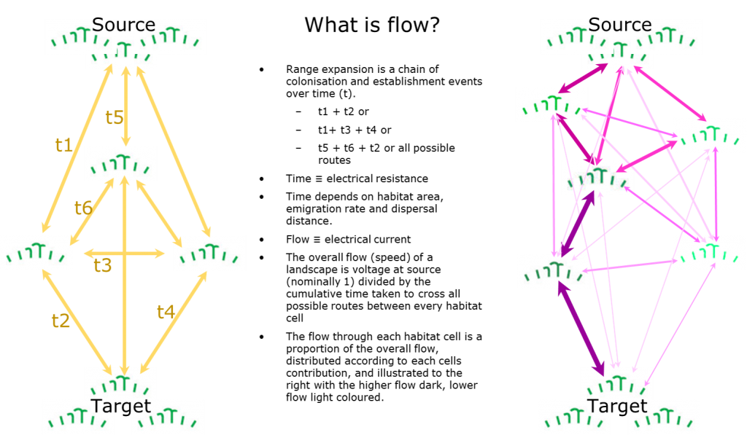](http://wordpress.condatis.org.uk/wp-content/uploads/What-is-flow2-1.png)Flow**

Each habitat cell is assumed to be linked with every other habitat cell; the strength of each of these links is dependent on the time it would take for the population of one cell to send colonists to populate the other cell. The time taken is considered analogous to resistance in the Condatis model. By selecting a dispersal distance (the average dispersal distance per generation) and the reproductive rate of a species (either known or representative), Condatis will calculate the overall flow from source to target and the portion of this flow travelling through each individual habitat cell. This is plotted on a map, colour coded to highlight the areas of most concentrated flow. Condatis also calculates the time it would take for the species to colonise the target (in number of generations) and the overall flow speed which is a measure of the connectivity of the landscape and is directly comparable across different scenarios and habitats.

**Where to create habitat?**

Prioritisation by ‘Dropping’ is a process which allows  a map of proposed restoration sites to be tested in turn and ranked in order of their impact on connectivity. Often a relatively small number of potential restoration sites make a disproportionate contribution to the landscape flow and this allows prioritisation of scarce resources into sites likely to have the greatest impact on connectivity and which are also realistic targets for habitat creation.

**Text by Jenny Hodgson and Mark Nelson, 2017, For more information see www.condatis.org.uk**