Project ข้อที่ 1
กลุ่มที่ 4
1.นางสาว พิมพ์พิมล ราชหิรินทร์ 66172110035-4
2. นาย กีรติ ชื่นจอหอ 66172110370-2
3. นาย จิรวัฒน์ เทียมทะนงค์ 66172110399-8
1. เครื่องควบคุมอุปกรณ์ไฟฟ้าตามอุณหภูมิแบบตั้งเวลามีฟังก์ชันการทำงานแสดงดังตาราง
- สามารถตั้งเวลาเปิดปิดได้อย่างน้อย 2 ช่วงเวลา
- สามารถกำหนดช่วงค่าอุณหภูมิที่ต้องการควบคุมได้
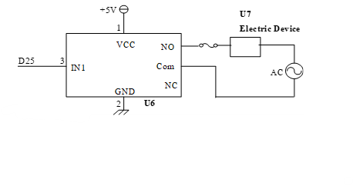
- ข้อมูลที่ใช้ในการควบคุมและสถานะการทำงานของอุปกรณ์จะไม่สูญหาย เมื่อมีการปิด-เปิดหรือรีเซ็ตเครื่อง
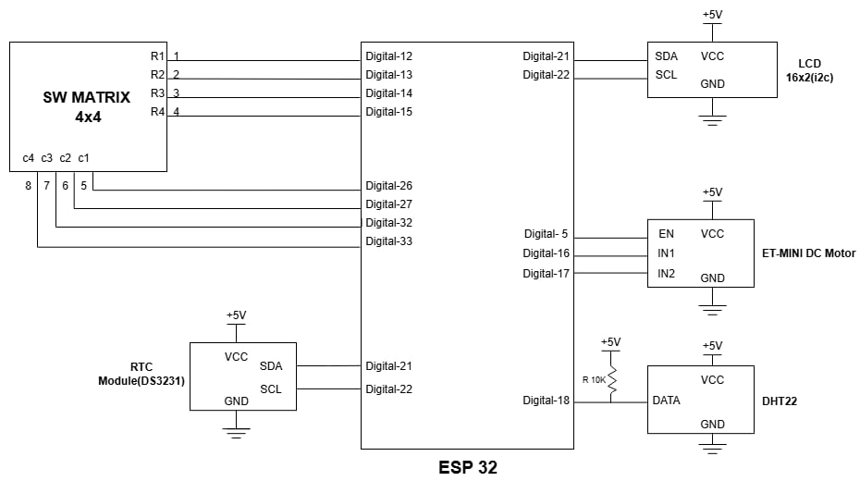
D22
D21
Digital -25
D17
Digital -4
D4
D22
D21
D12
D13
D15
D26
D27
D32
D33
D14
Function | Operation
1 | Set time
2 | DEV OFF
3 | DEV ON
4 | TIMER OFF
5 | TIMER ON
6 | Set the start time 1
7 | Set the stop time 1
8 | Show the start and stop time 1
9 | Set the start time 2
10 | Set the stop time 2
11 | Show the start and stop time 2
12 | Set the start temp
13 | Set the stop temp
14 | Show the start and stop temp

1. การตั้งค่าให้กดปุ่ม ‘*’ ตามด้วยหมายเลขฟังก์ชัน แล้วกดปุ่ม ‘#’ เช่น “*1#” เป็นต้น
2. หน้าจอ LCD จะแสดงเวลา และสถานะอุปกรณ์
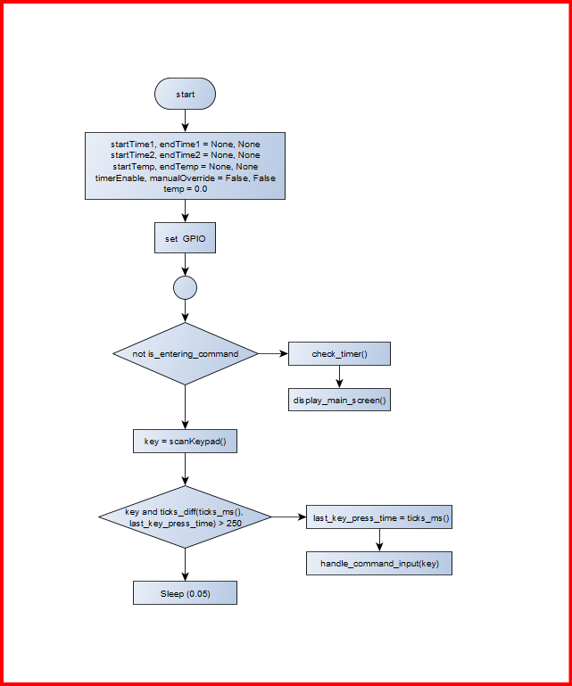
วาดโฟลว์ชาร์ตของโปรแกรม

โฟลว์ชาร์ตโปรแกรมหลัก

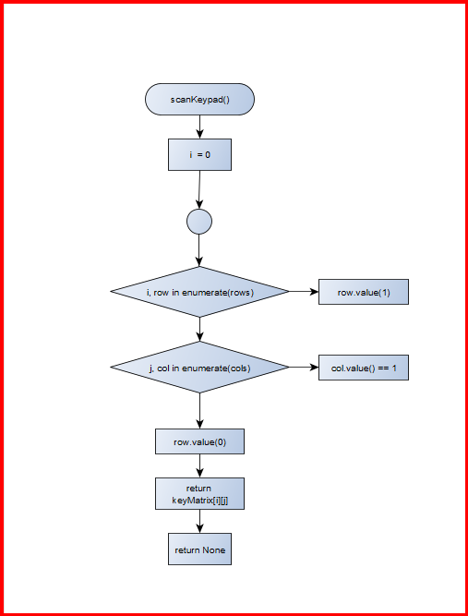
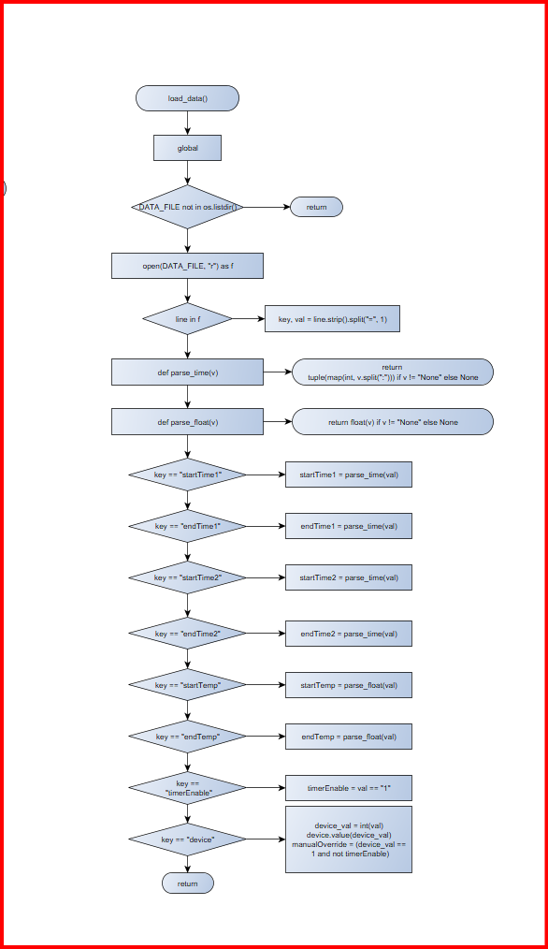
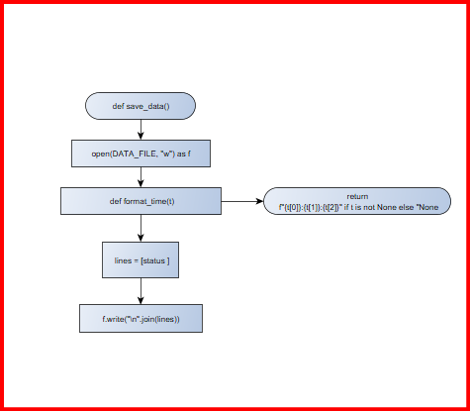

โฟลว์ชาร์ตของฟังก์ชัน
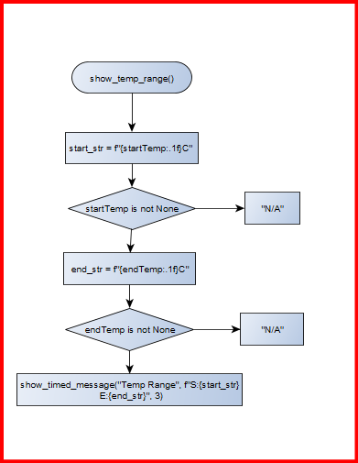
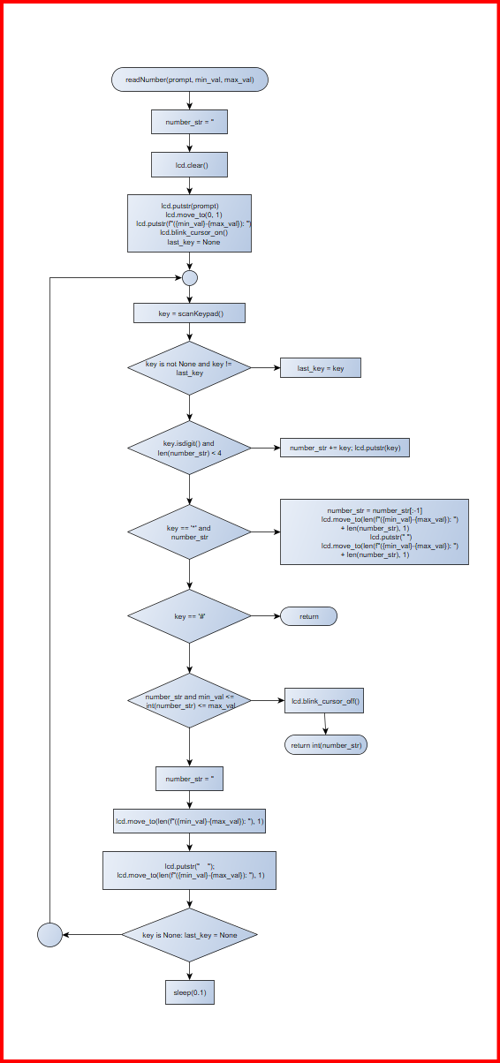

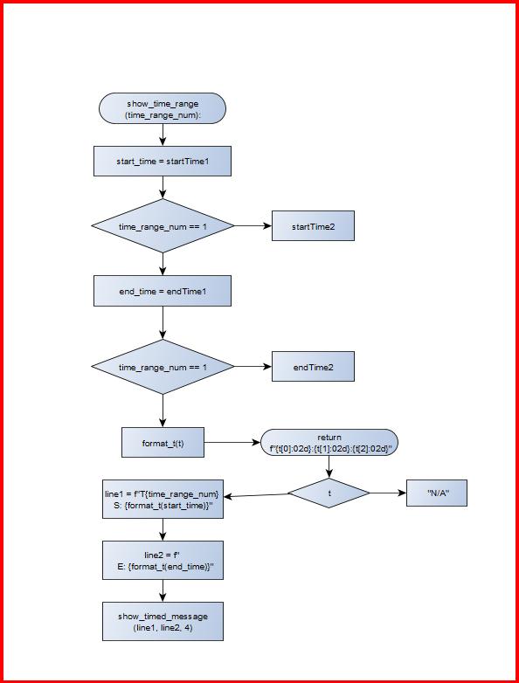

โฟลว์ชาร์ตของฟังก์ชัน
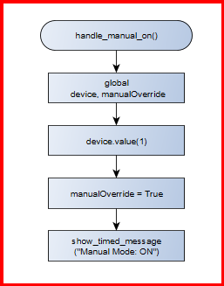
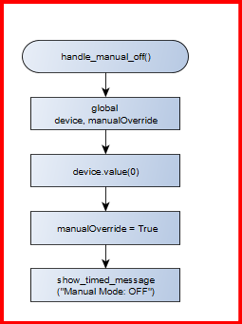
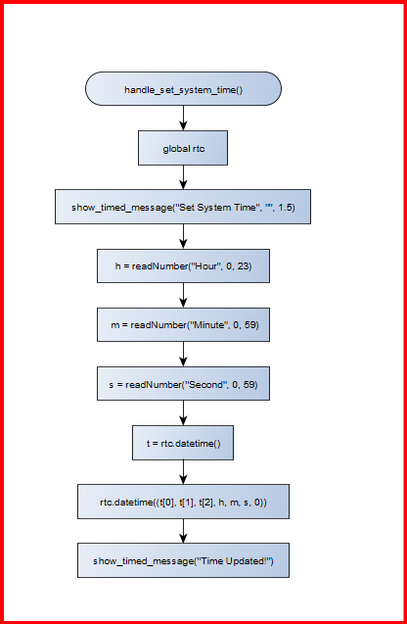

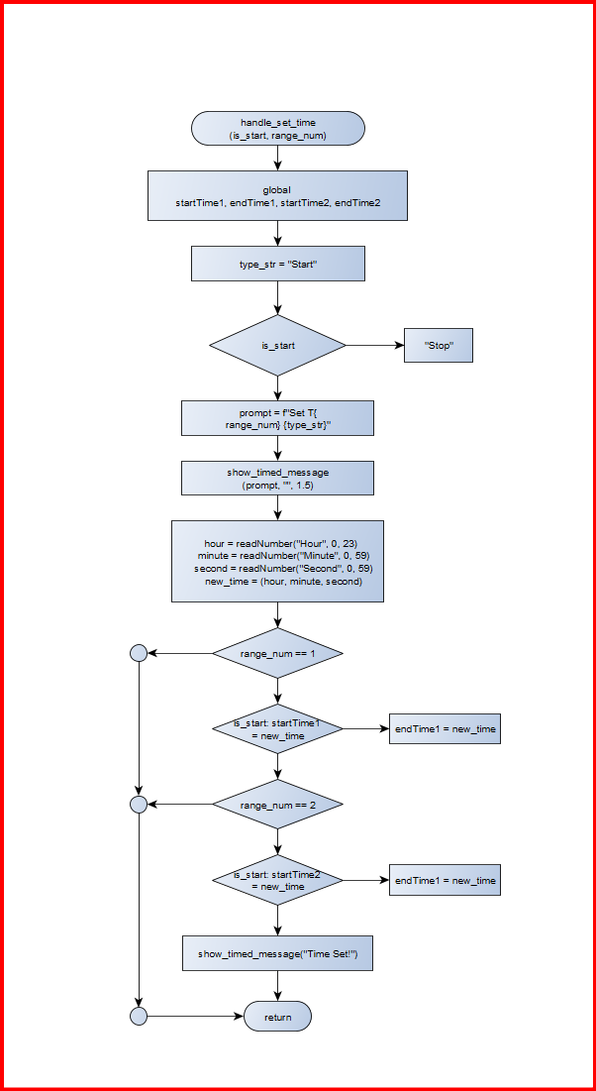

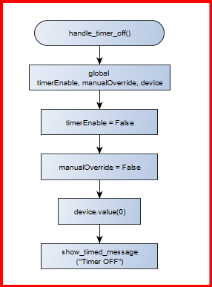
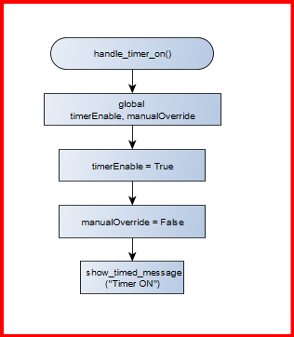

โฟลว์ชาร์ตของฟังก์ชัน

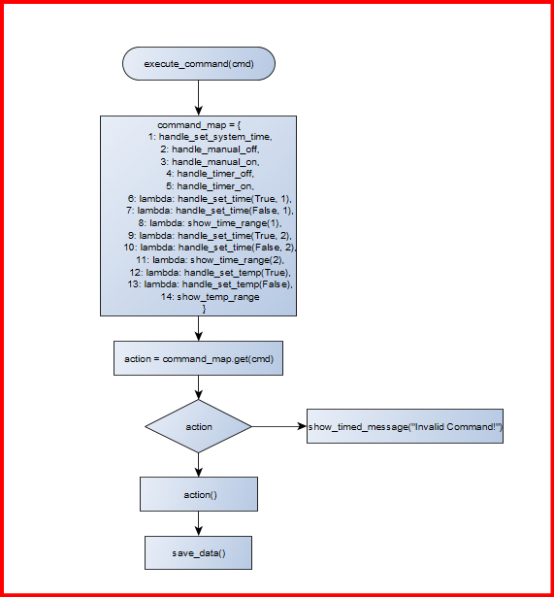
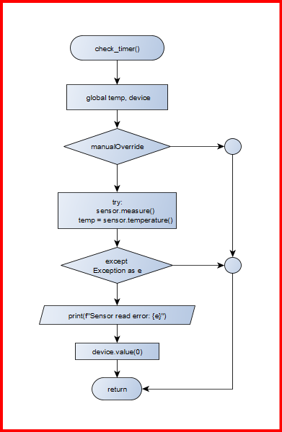

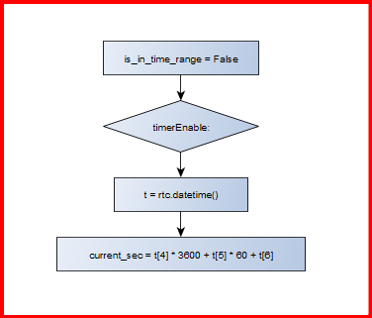

โฟลว์ชาร์ตของฟังก์ชัน

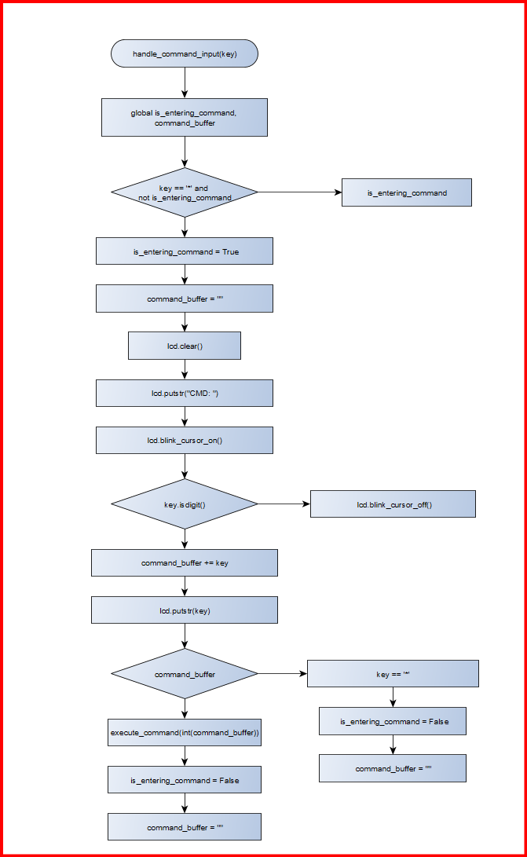
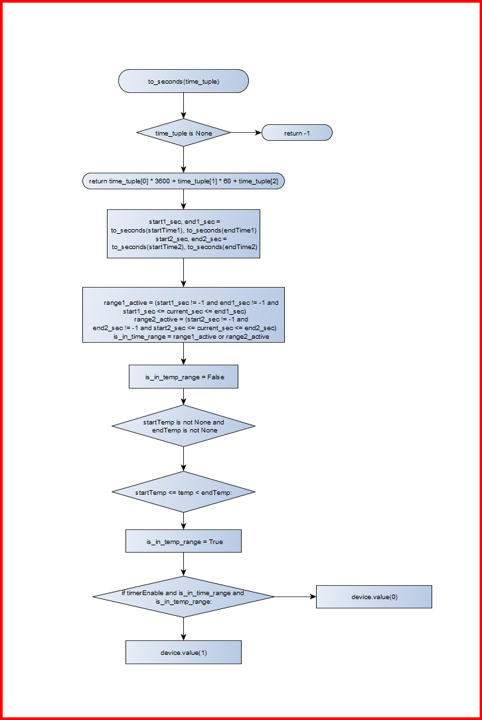

โฟลว์ชาร์ตของฟังก์ชัน

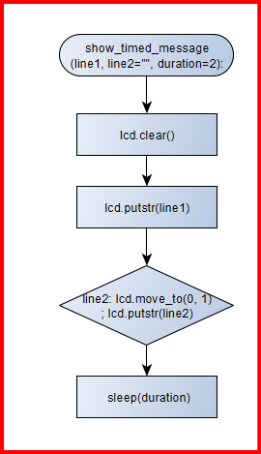
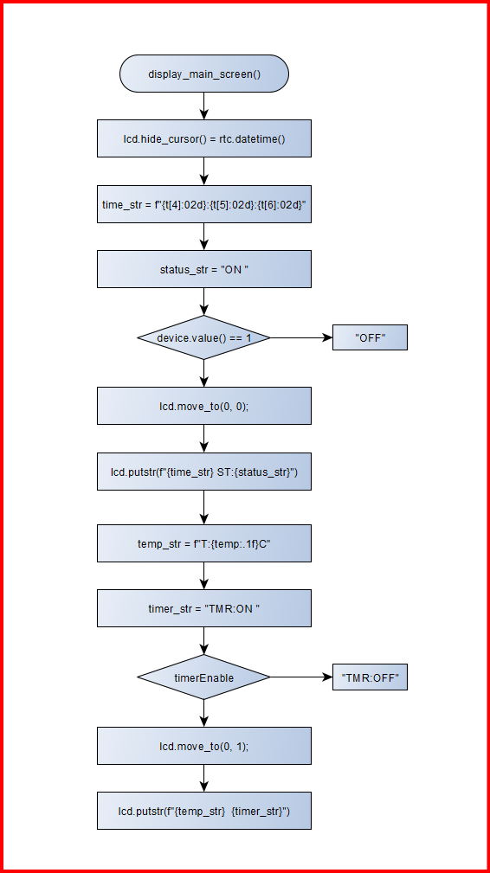

โฟลว์ชาร์ตของฟังก์ชัน

เขียนโปรแกรม
# =================================================================
# DEVICE CONTROLLER - REFACTORED
# =================================================================
# Import libraries
from machine import Pin, SoftI2C
from lcd_api import LcdApi
from lcd_i2c import I2cLcd
from ds3231 import DS3231
from time import sleep, ticks_ms, ticks_diff
import os
import dht

# ================= Hardware Initialization =================
sensor = dht.DHT22(Pin(4))
I2C_ADDR = 0x27
totalRows = 2
totalColumns = 16
i2c = SoftI2C(scl=Pin(22), sda=Pin(21), freq=100000)
lcd = I2cLcd(i2c, I2C_ADDR, totalRows, totalColumns)
rtc = DS3231(i2c)
device = Pin(25, Pin.OUT)
device.value(0)
keyMatrix = [
['1', '2', '3', 'A'], ['4', '5', '6', 'B'],
['7', '8', '9', 'C'], ['*', '0', '#', 'D']
]
rowPins = [12, 13, 14, 15]
colPins = [26, 27, 32, 33]
rows = [Pin(r, Pin.OUT) for r in rowPins]
cols = [Pin(c, Pin.IN, Pin.PULL_DOWN) for c in colPins]

# ================= Global Variables =================
DATA_FILE = "data.txt"
startTime1, endTime1 = None, None
startTime2, endTime2 = None, None
startTemp, endTemp = None, None
timerEnable, manualOverride = False, False
temp = 0.0
command_buffer = ""
is_entering_command = False
last_key_press_time = 0

# ================= Data Persistence Functions =================
def save_data():
with open(DATA_FILE, "w") as f:
def format_time(t): return f"{t[0]}:{t[1]}:{t[2]}" if t is not None else "None"
lines = [
f"startTime1={format_time(startTime1)}", f"endTime1={format_time(endTime1)}",
f"startTime2={format_time(startTime2)}", f"endTime2={format_time(endTime2)}",
f"startTemp={startTemp if startTemp is not None else 'None'}",
f"endTemp={endTemp if endTemp is not None else 'None'}",
f"timerEnable={1 if timerEnable else 0}", f"device={device.value()}"
]
f.write("\n".join(lines))

def load_data():
global startTime1, endTime1, startTime2, endTime2, timerEnable, device, startTemp, endTemp, manualOverride
if DATA_FILE not in os.listdir(): return
with open(DATA_FILE, "r") as f:
for line in f:
key, val = line.strip().split("=", 1)
def parse_time(v): return tuple(map(int, v.split(":"))) if v != "None" else None
def parse_float(v): return float(v) if v != "None" else None
if key == "startTime1": startTime1 = parse_time(val)
elif key == "endTime1": endTime1 = parse_time(val)
elif key == "startTime2": startTime2 = parse_time(val)
elif key == "endTime2": endTime2 = parse_time(val)
elif key == "startTemp": startTemp = parse_float(val)
elif key == "endTemp": endTemp = parse_float(val)
elif key == "timerEnable": timerEnable = val == "1"
elif key == "device":
device_val = int(val)
device.value(device_val)
manualOverride = (device_val == 1 and not timerEnable)

# ================= Keypad and Input Functions =================
def scanKeypad():
for i, row in enumerate(rows):
row.value(1)
for j, col in enumerate(cols):
if col.value() == 1:
row.value(0)
return keyMatrix[i][j]
row.value(0)
return None

def readNumber(prompt, min_val, max_val):
number_str = ''
lcd.clear()
lcd.putstr(prompt)
lcd.move_to(0, 1)
lcd.putstr(f"({min_val}-{max_val}): ")
lcd.blink_cursor_on()
last_key = None
while True:
key = scanKeypad()
if key is not None and key != last_key:
last_key = key
if key.isdigit() and len(number_str) < 4:
number_str += key; lcd.putstr(key)
elif key == '*' and number_str:
number_str = number_str[:-1]
lcd.move_to(len(f"({min_val}-{max_val}): ") + len(number_str), 1)
lcd.putstr(" ")
lcd.move_to(len(f"({min_val}-{max_val}): ") + len(number_str), 1)
elif key == '#':
if number_str and min_val <= int(number_str) <= max_val:
lcd.blink_cursor_off()
return int(number_str)
number_str = ''
lcd.move_to(len(f"({min_val}-{max_val}): "), 1)
lcd.putstr(" "); lcd.move_to(len(f"({min_val}-{max_val}): "), 1)
elif key is None: last_key = None
sleep(0.1)

# ================= Display Functions =================
def display_main_screen():
"""Updates the main LCD screen with current status."""
lcd.hide_cursor()
t = rtc.datetime()
time_str = f"{t[4]:02d}:{t[5]:02d}:{t[6]:02d}"

# แก้ไข Bug การแสดงผล "OFFF" โดยการกำหนดความยาวข้อความให้เท่ากันเสมอ
status_str = "ON" if device.value() == 1 else "OFF"
lcd.move_to(0, 0)
lcd.putstr(f"{time_str} ST:{status_str:<3}")

temp_str = f"T:{temp:.1f}C"
timer_str = "TMR:ON " if timerEnable else "TMR:OFF"
lcd.move_to(0, 1)
lcd.putstr(f"{temp_str} {timer_str}")

def show_timed_message(line1, line2="", duration=2):
lcd.clear()
lcd.putstr(line1)
if line2: lcd.move_to(0, 1); lcd.putstr(line2)
sleep(duration)

def show_time_range(time_range_num):
start_time = startTime1 if time_range_num == 1 else startTime2
end_time = endTime1 if time_range_num == 1 else endTime2
def format_t(t): return f"{t[0]:02d}:{t[1]:02d}:{t[2]:02d}" if t else "N/A"
line1 = f"T{time_range_num} S: {format_t(start_time)}"
line2 = f" E: {format_t(end_time)}"
show_timed_message(line1, line2, 4)

def show_temp_range():
start_str = f"{startTemp:.1f}C" if startTemp is not None else "N/A"
end_str = f"{endTemp:.1f}C" if endTemp is not None else "N/A"
show_timed_message("Temp Range", f"S:{start_str} E:{end_str}", 3)

# ================= Command Handler Functions =================
def handle_set_system_time():
global rtc
show_timed_message("Set System Time", "", 1.5)
h = readNumber("Hour", 0, 23)
m = readNumber("Minute", 0, 59)
s = readNumber("Second", 0, 59)
t = rtc.datetime()
rtc.datetime((t[0], t[1], t[2], h, m, s, 0))
show_timed_message("Time Updated!")

def handle_manual_off():
global device, manualOverride
device.value(0)
manualOverride = True
show_timed_message("Manual Mode: OFF")

def handle_manual_on():
global device, manualOverride
device.value(1)
manualOverride = True
show_timed_message("Manual Mode: ON")

def handle_timer_off():
global timerEnable, manualOverride, device
timerEnable = False
manualOverride = False
device.value(0)
show_timed_message("Timer OFF")

def handle_timer_on():
global timerEnable, manualOverride
timerEnable = True
manualOverride = False
show_timed_message("Timer ON")

def handle_set_time(is_start, range_num):
global startTime1, endTime1, startTime2, endTime2
type_str = "Start" if is_start else "Stop"
prompt = f"Set T{range_num} {type_str}"
show_timed_message(prompt, "", 1.5)

hour = readNumber("Hour", 0, 23)
minute = readNumber("Minute", 0, 59)
second = readNumber("Second", 0, 59)
new_time = (hour, minute, second)

if range_num == 1:
if is_start: startTime1 = new_time
else: endTime1 = new_time
elif range_num == 2:
if is_start: startTime2 = new_time
else: endTime2 = new_time
show_timed_message("Time Set!")

def handle_set_temp(is_start):
global startTemp, endTemp
if is_start:
startTemp = readNumber("Start Temp", 0, 99)
show_timed_message("Start Temp Set!")
else:
endTemp = readNumber("Stop Temp", 0, 99)
show_timed_message("Stop Temp Set!")

# ================= Core Logic & Command Execution =================
def execute_command(cmd):
"""Executes a command by calling its dedicated handler function."""
command_map = {
1: handle_set_system_time,
2: handle_manual_off,
3: handle_manual_on,
4: handle_timer_off,
5: handle_timer_on,
6: lambda: handle_set_time(True, 1),
7: lambda: handle_set_time(False, 1),
8: lambda: show_time_range(1),
9: lambda: handle_set_time(True, 2),
10: lambda: handle_set_time(False, 2),
11: lambda: show_time_range(2),
12: lambda: handle_set_temp(True),
13: lambda: handle_set_temp(False),
14: show_temp_range
}

action = command_map.get(cmd)
if action:
action()
else:
show_timed_message("Invalid Command!")

save_data()

def check_timer():
"""Checks time and temperature to control the device automatically."""
global temp, device
if manualOverride:
return

try:
sensor.measure()
temp = sensor.temperature()
except Exception as e:
print(f"Sensor read error: {e}")
device.value(0)
return

is_in_time_range = False
if timerEnable:
t = rtc.datetime()
current_sec = t[4] * 3600 + t[5] * 60 + t[6]
def to_seconds(time_tuple):
if time_tuple is None: return -1
return time_tuple[0] * 3600 + time_tuple[1] * 60 + time_tuple[2]

start1_sec, end1_sec = to_seconds(startTime1), to_seconds(endTime1)
start2_sec, end2_sec = to_seconds(startTime2), to_seconds(endTime2)

range1_active = (start1_sec != -1 and end1_sec != -1 and start1_sec <= current_sec <= end1_sec)
range2_active = (start2_sec != -1 and end2_sec != -1 and start2_sec <= current_sec <= end2_sec)
is_in_time_range = range1_active or range2_active

is_in_temp_range = False
if startTemp is not None and endTemp is not None:
if startTemp <= temp < endTemp:
is_in_temp_range = True

if timerEnable and is_in_time_range and is_in_temp_range:
device.value(1)
else:
device.value(0)

# ================= Main System Loop =================
def handle_command_input(key):
"""Manages the state of entering a command."""
global is_entering_command, command_buffer

if key == '*' and not is_entering_command:
is_entering_command = True
command_buffer = ""
lcd.clear()
lcd.putstr("CMD: ")
lcd.blink_cursor_on()
elif is_entering_command:
if key.isdigit():
command_buffer += key
lcd.putstr(key)
elif key == '#':
lcd.blink_cursor_off()
if command_buffer:
execute_command(int(command_buffer))
is_entering_command = False
command_buffer = ""
elif key == '*':
is_entering_command = False
command_buffer = ""

# --- Program Start ---
lcd.clear()
lcd.putstr("Device Control")
lcd.move_to(0,1)
lcd.putstr("System Init...")
load_data()
sleep(2)

while True:
if not is_entering_command:
check_timer()
display_main_screen()

key = scanKeypad()

if key and ticks_diff(ticks_ms(), last_key_press_time) > 250:
last_key_press_time = ticks_ms()
handle_command_input(key)

sleep(0.05)

ครั้งที่รันโปรแกรม | ป้อนข้อมูลผ่านคีย์แพ็ด | การแสดงผลของแอลซีดี | การทำงานของอุปกรณ์
1 | *1# Set time | 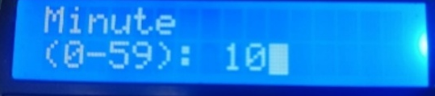 | ตั้งเวลา
2 | *2# DEV OFF | 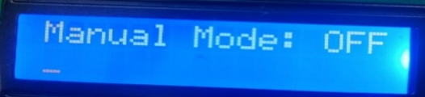 | # DEV OFF
3 | *3# DEV ON | 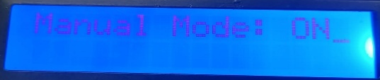 | DEV ON
4 | *4# TIMER OFF | 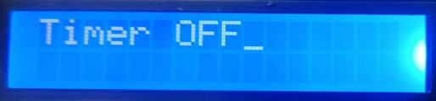 | ขึ้นอยู่กับเงื่อนไข
5 | *5# TIMER ON | 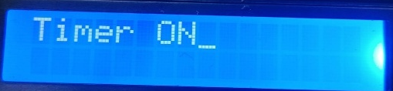 | ขึ้นอยู่กับเงื่อนไข
6 | *6# Set the start time 1 |  | 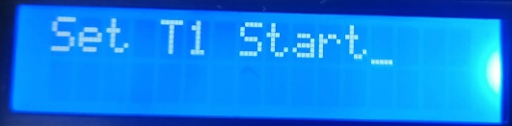  ตั้งเวลาเริ่มT1
7 | *7# Set the stop time 1 | 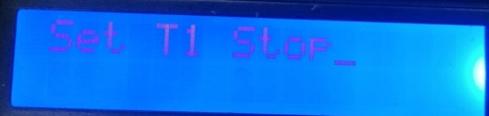 | ตั้งเวลาหยุดT1
8 | *8# Show the start and stop time 1 |  | 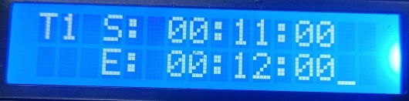  โชว์เวลาที่ตั้งT1
9 | *9# Set the start time 2 | 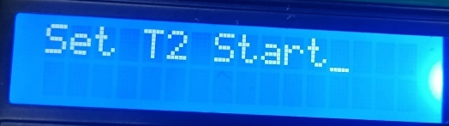 | ตั้งเวลาเริ่มT2
10 | *10# Set the stop time 2 |  | 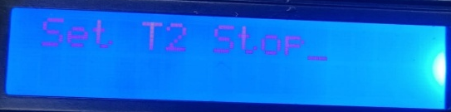  ตั้งเวลาหยุดT2
11 | *11# Show the start and stop time 2 |  | 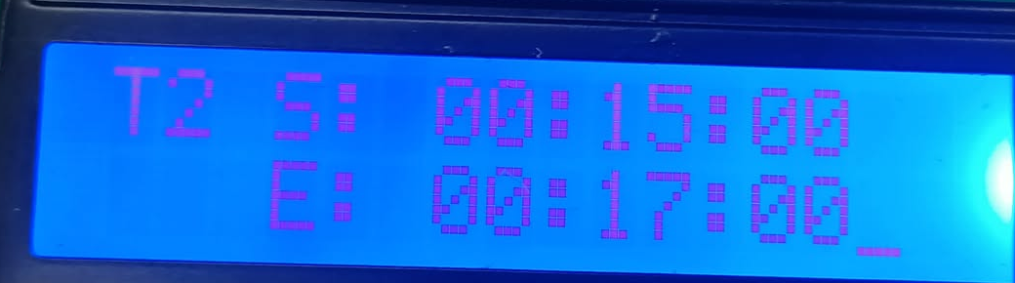  โชว์เวลาที่ตั้งT2
12 | *12# Set the start temp | 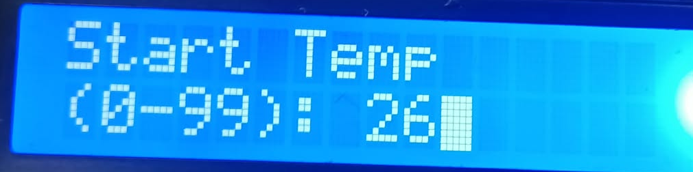 | ตั้งอุณหภูมิเริ่มต้น
13 | *13# Set the stop temp |  | 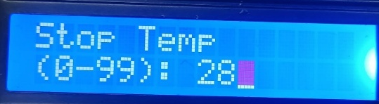  ต้งอุณหภูมิหยุด
14 | *14# Show the start and stop temp | 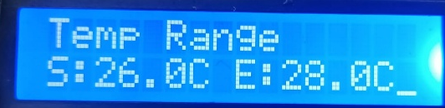 | โชว์อุณหภูมิที่ตั้ง

