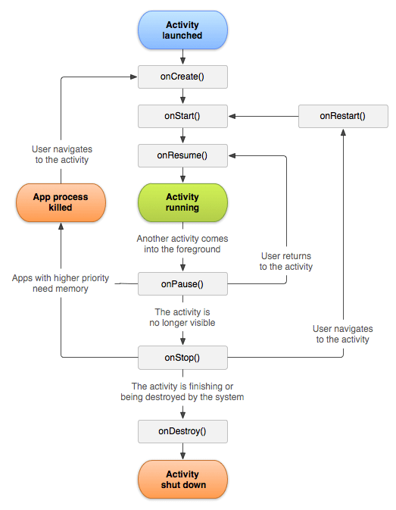

AsyncTask is an abstract Android class which helps the Android applications to handle

the Main UI thread in efficient way. AsyncTask class allows us to perform long lasting

tasks/background operations and show the result on the UI thread without affecting the main thread.

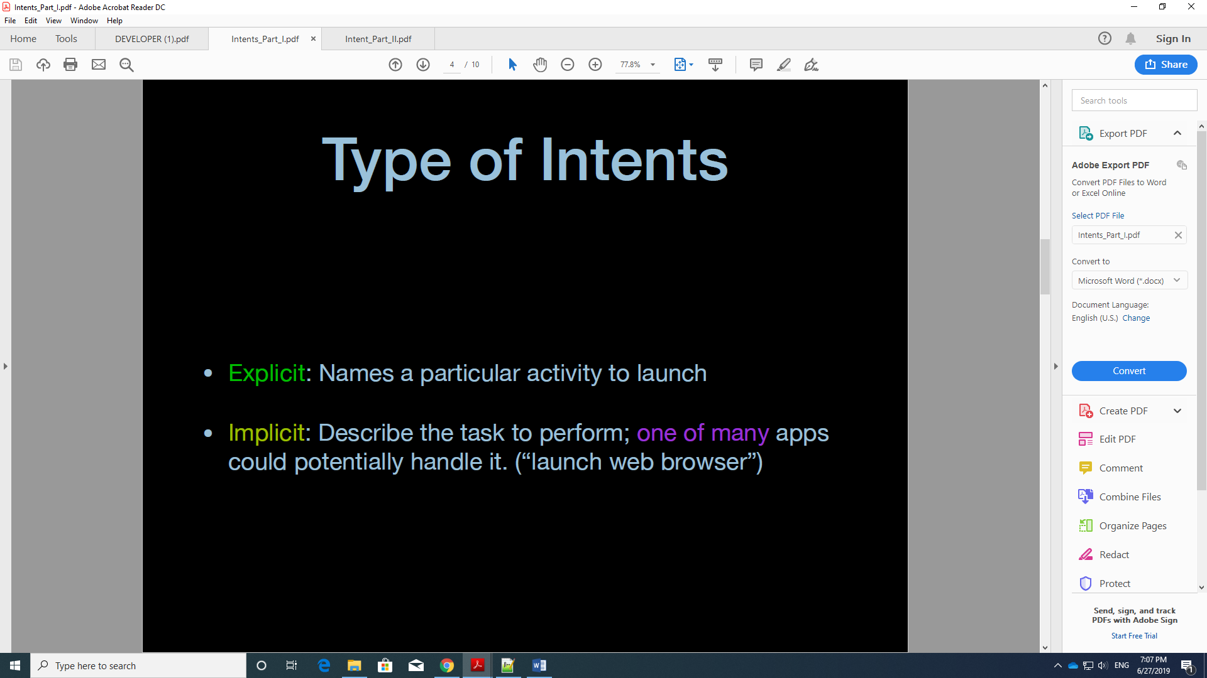

What is SQLiteOpenHelper?

SQLiteDatabase has methods to create, delete, execute SQL commands, and perform other common database management tasks. **SQLiteOpenHelper**. A helper class to manage database creation and version management.

What is getWritableDatabase?

Android SQLite Database Tutorial. ... To work with SQLite in Android, it provides two main classes SQLiteOpenHelper and SQLiteDatabase. SQLiteOpenHelper manages database creation, up gradation and provides the methods like onCreate(), onUpgrade(), **getWritableDatabase**().

What are content values?

**ContentValues** is a name **value** pair, used to insert or update **values** into database tables. ... **Content values** are used to inset record in SQLite database .Cursor is used to get all table **values** with column names and uses to display all records from the table.

What is Android cursor?

**Cursors** are what contain the result set of a query made against a database in**Android**. The **Cursor** class has an API that allows an app to read (in a type-safe manner) the columns that were returned from the query as well as iterate over the rows of the result set.

What is SQLite

SQLite is embedded relational database management system. It is self-contained, serverless, zero configuration and transactional SQL database engine.

SQLite is free to use for any purpose commercial or private. In other words, "SQLite is an open source, zero-configuration, self-contained, stand alone, transaction relational database engine designed to be embedded into an application".

SQLite is different from other SQL databases because unlike most other SQL databases, SQLite does not have a separate server process. It reads and writes directly to ordinary disk files. A complete SQL database with multiple tables, indices, triggers, and views, is contained in a single disk file.

**onProgressUpdate**(Progress… ) is called on the UI thread and is used to display progress to the user while the task is running (e.g. a progress ...

1. [onPostExecute(Result)](https://developer.android.com/reference/android/os/AsyncTask.html#onPostExecute(Result)), invoked on the UI thread after the background computation finishes. The result of the background computation is passed to this step as a parameter.