# International Student Management System – ISMS

1. Background about the case

***Number and percent of international students in Canada, by province/territory (2017)***

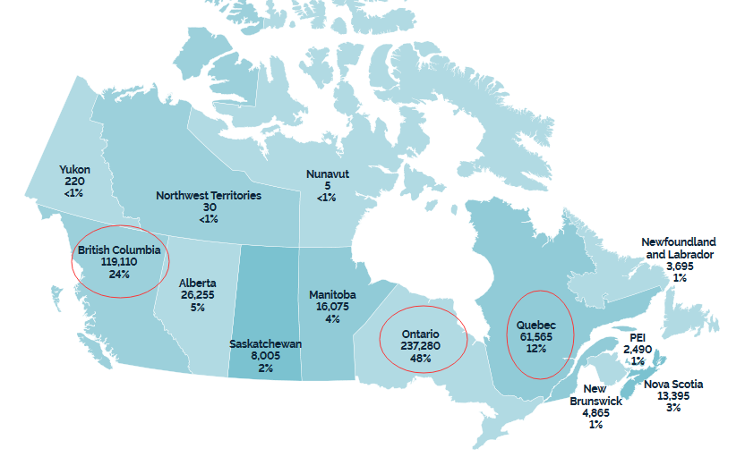

Every year, there are many Chinese students as international student study in Canada. Because their parents can’t accompany with their children Canada for a long lime, So, their parents need to hire the service companies to take care of their children.

Normally, Chinese International Students and the service companies locate in Canada, Student’s parents locate in China or other countries. So, a web-based tools will be act as the bridge to connect students, parents and the service companies.

1. What Information should be stored then handled by ISMS?

* Students

Student basic information

Student visa information

Student activities and status information

* Parents

Parent basic information

Parent Payment Information

Parent comments and visit plan

Parent need to know their children status and school feedback

* Service Companies

service company basic information

service company employees information

service company tasks for signed parents

service company tasks for signed students

1. ISMS Framework
2. 3 modules: mod-students, mod-parents, mod-ServiceCom
3. 3 authentications for 3 type accounts: aut-students, aut-parents, aut-ServiceCom
4. ISMS fold structures

**ISMS**

/index.php *-- main page*

/Docs *-- project documents*

/Upload *-- uploaded files for each companies*

/companyA-ID

/companyB-ID

/companyC-ID

/DB *-- DB files*

/Apps *-- Web site scripts*

/students

/parents

/companies

/includes

1. ISMS Database Tables

Students

Parents

ServiceCompanies