# International Student Management System – ISMS

1. Background about the case

***Number and percent of international students in Canada, by province/territory (2017)***

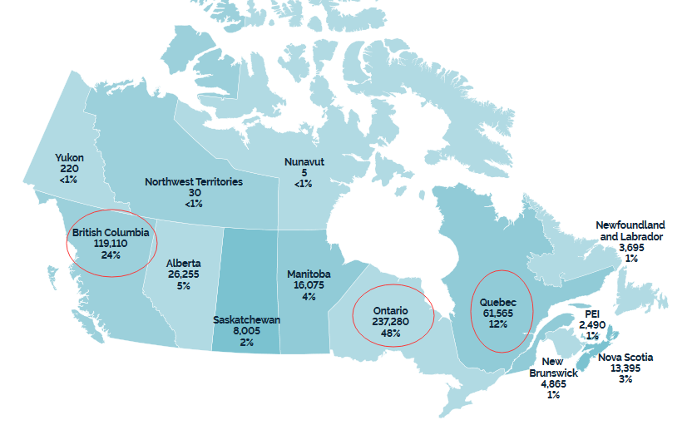

Every year, there are many Chinese students as international students go to Canada to study. Because their parents can’t live in Canada long lime, So, their parents need to hire the service companies to take care of their kids.

Normally, Chinese International Students and the service companies locate in Canada, Student’s parents locate in China or other countries. So, a web-based tools will be act as the bridge to connect students, parents and the service companies.

1. What Information should be stored then handled by ISMS?

* Students

Student basic information

Student visa information

Student activities and status information

* Parents

Parent basic information

Parent Payment Information

Parent comments and visit plan

Parent need to know their children status and school feedback

* Service Companies

service company basic information

service company employees information

service company tasks for signed parents

service company tasks for signed students

1. ISMS Framework
2. 4 modules:

* mod-students
* mod-parents
* mod-ServiceCompany,
* mod-SuperAdmin

1. 4 authentications:

* aut-students
* aut-parents
* aut-ServiceCompany
* aut-SuperAdmin

1. ISMS fold structures

**ISMS**

/index.php *-- Main page for ISMS*

/__superadmin__*.php -- Backend SuperAdmin login page*

/admintools -- ISMS admin tools directory

/CSS -- ISMS CSS

/images -- ISMS images

/DB -- db files for all sites

/site -- site root directory

/CompanyA --siteA

/Apps --siteA applications

/Uploads --siteA uploads

/index.php -- siteA main page

/CompanyB --siteB

/Apps --siteB applications

/Uploads --siteB uploads

/index.php -- siteB main page

/CompanyC --siteC

/Apps --siteC applications

/Uploads --siteC uploads

/index.php -- siteC main page

/site_templete -- Site templete directory

/templeteA

1. Example URLs

* ISMS Main Page URL

<https://www.isms.com>

* ISMS Super Admin URL

<https://www.isms.com/__superadmin__.php>

* SiteA URL (for CompanyA)

<https://www.isms.com/site/companyA>

* SiteB URL (for CompanyB)

<https://www.isms.com/site/companyB>

* SiteC URL (for CompanyC)

<https://www.isms.com/site/companyC>

1. ISMS Database/Scripts Naming Conversion
2. Database Name

db_company_name

Example: db_companyA

1. Database Table Name

tbl_table_name

Example: tbl_students_info

tbl_students_actions

tbl_parents_info

tbl_parents_requests

tbl_companyA_info

tbl_companyA_operation

1. Prefix for table columns
   * “s_xxxxx” -- column’s prefix for student tables

Example: s_id, s_name, s_passport

* + “p_xxxxx” -- column’s prefix for parent tables

Example: p_id, p_name, p_phone

* + “c_xxxxx” -- column’s prefix for company tables

Example: c_id, c_name, c_address

* + “spr_xxxxx” – column’s prefix for ISMS Super Admin tables

Example: spr_id, spr_password

1. ISMS Database Tables

* ISMS Super Admins

tbl_superadmin (

spr_id,

spr_password,

spr_last_login

)