# Enemy & Collectables

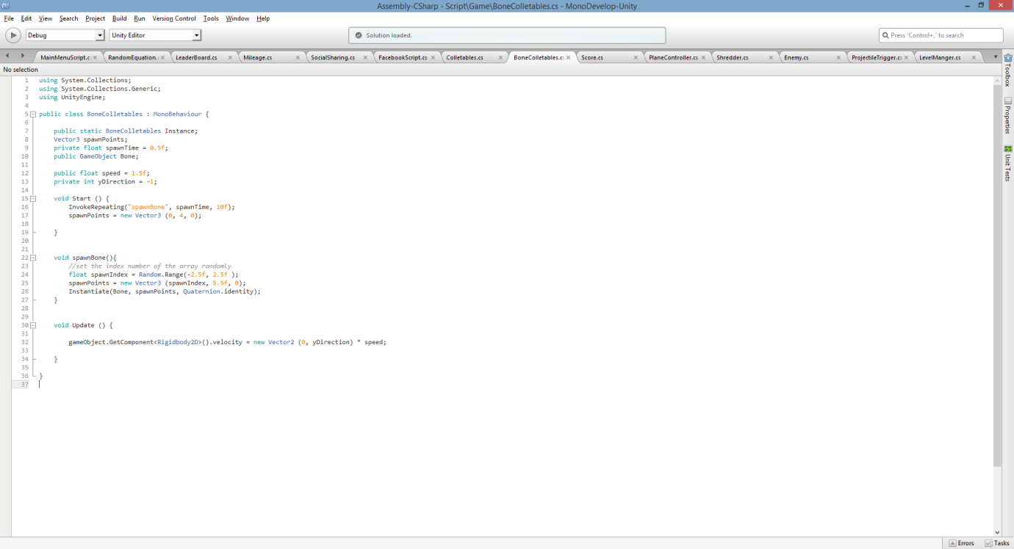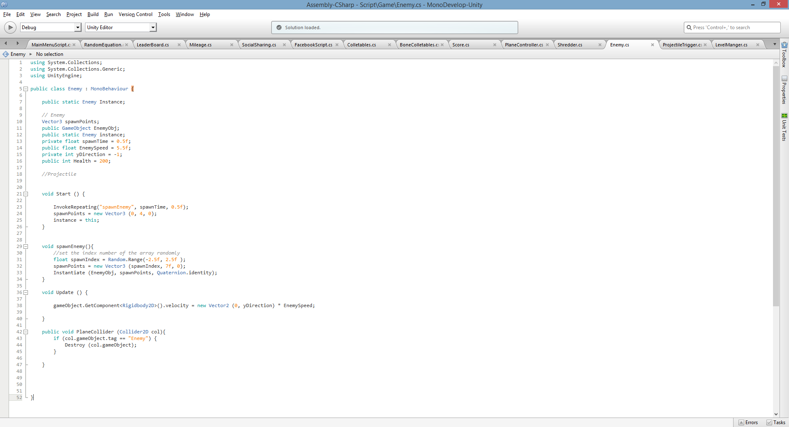

For the enemies and collectable the same code was used however with some tweaks. Both codes have random spawning, from line 1 towards update everything is the same code with different timing. The Enemy class contains an integer to keep track of its health. Line 42 checks for collision using a tag and destroy the object.

For the spawning of the objects:

1. I made a float variable to store the random range.
2. I set the position using the random float variable as the X position
3. I used Instantiate to make a copy of the object, putting in the GameObject, Position, and its rotation.
4. Using Invoke Repeating, this function allows me to spawn/summon as many times as I like. But it comes with conditions to control the amount spawned; taking the method name, time and its repeat rate.
5. To allow the objects to move towards the player or past. A Rigidbody is added to the object, giving it a velocity to move in the direction given.

Both classes have the same spawn sequence.

# Player Class

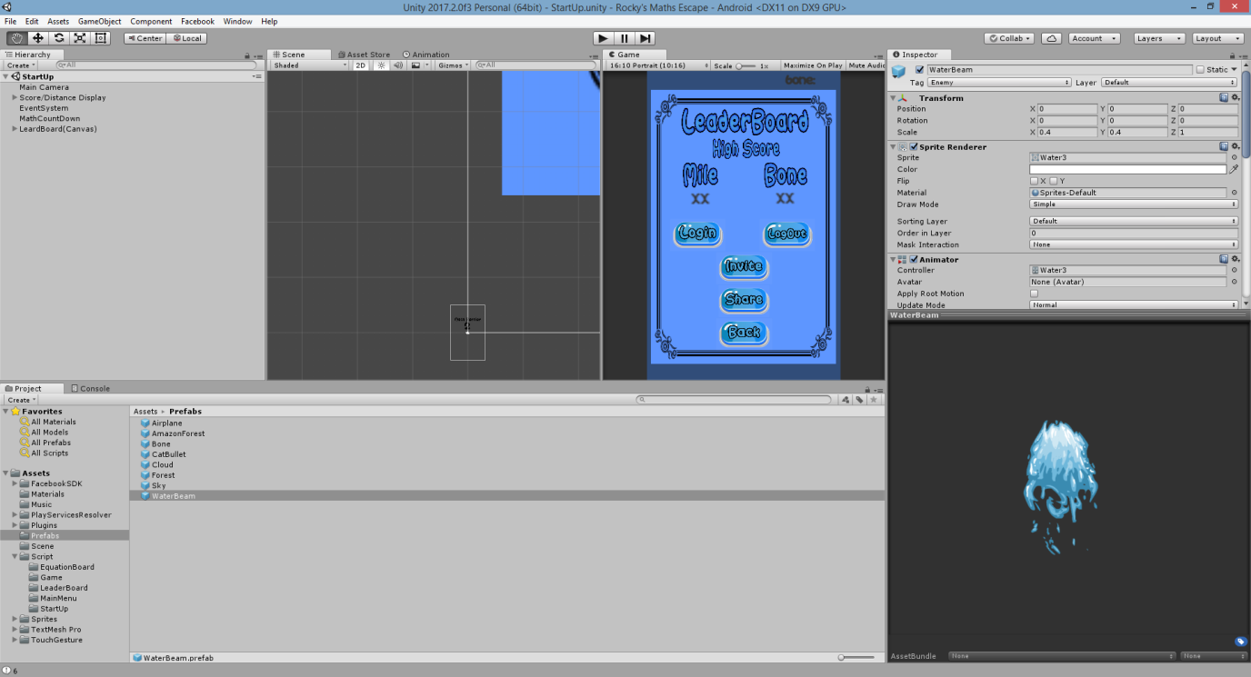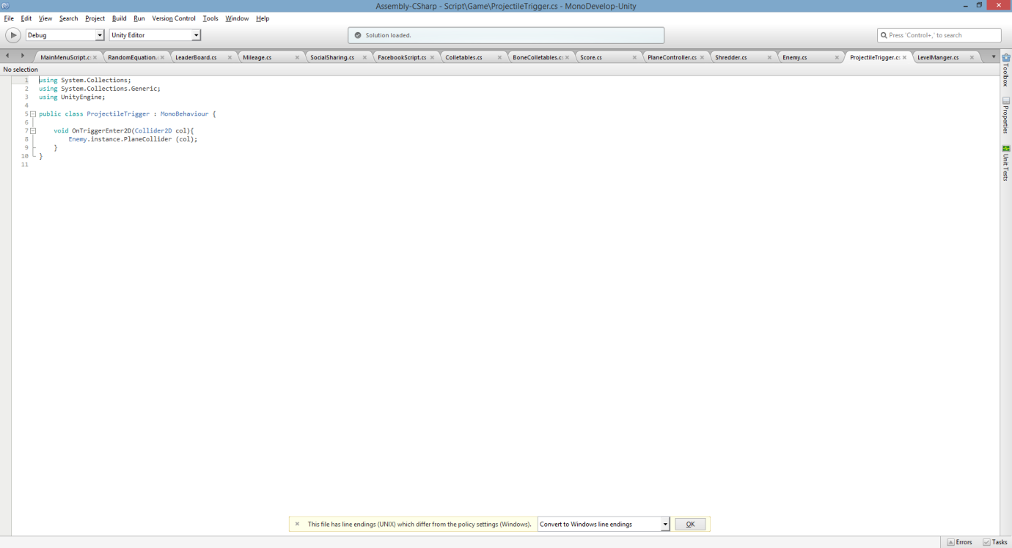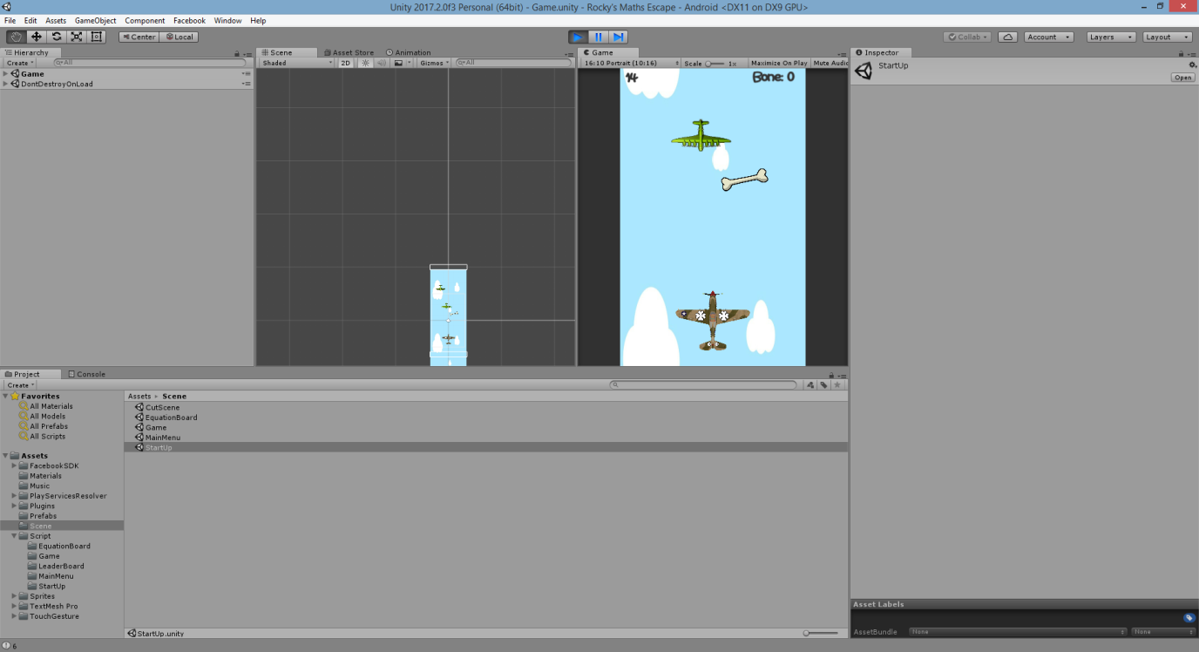

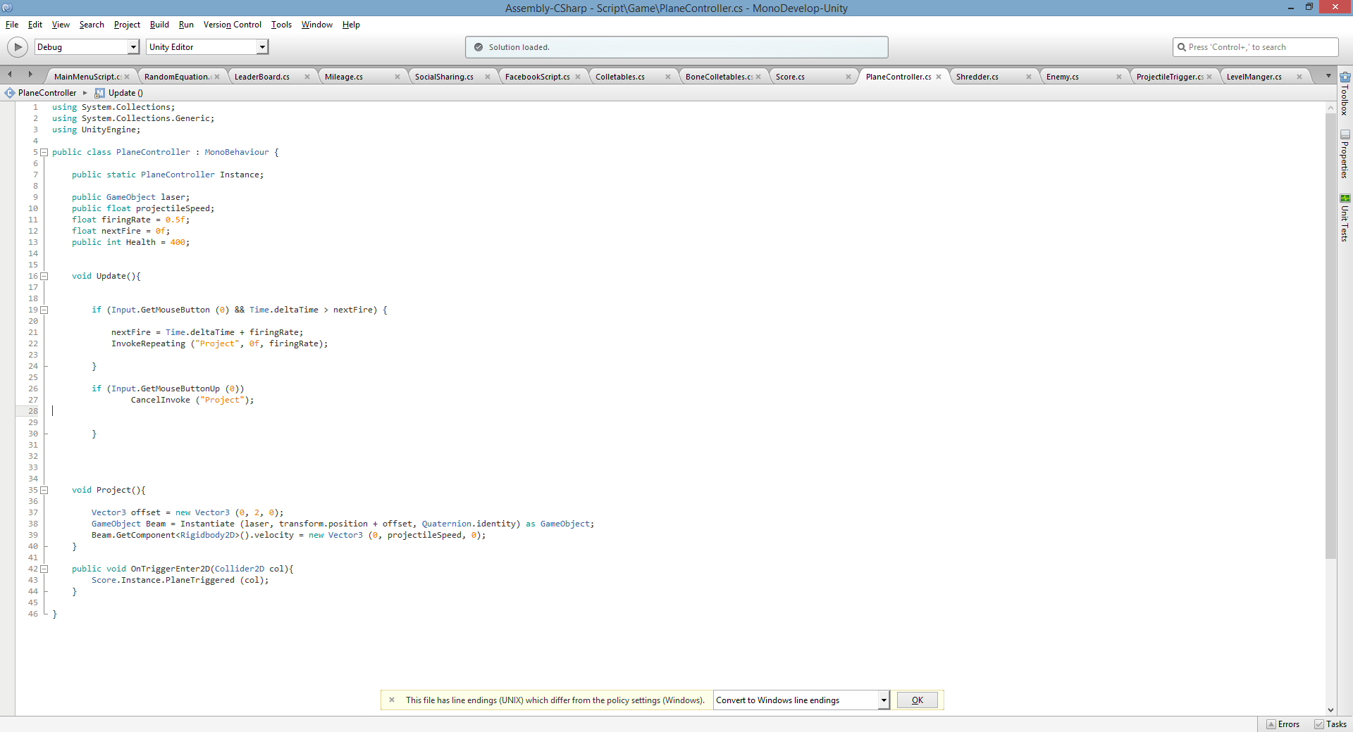

The planeController Class:

This class creates a projectile to take down the enemies. A water beam animation is produced and shot upwards.

Collecting bones (collectables) will be stored and shown on the leader board.

The class will call the water beam once the mouse/touch has been held down. Using invoke repeating the projectile will not stop until the input is released. The next fire rate is calculated to make sure there isn’t a big amount of projectiles shooting at the same time.

Not Included:

1. The enemies do not have projectiles to shot down the player
2. A health bar is not shown or implemented
3. Obstacles will not cause the player to die.
4. The power ups mentioned in the games design document have not been implemented
5. The idle method has not been added

# Mileage & Score

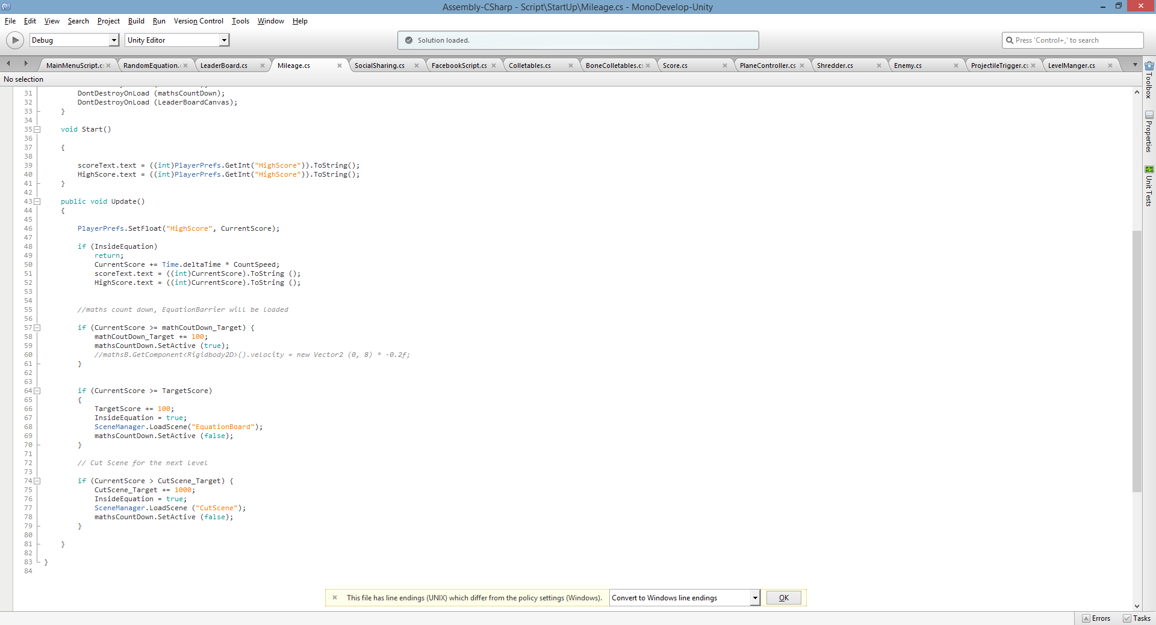

The Mileage Class:

The display was made using a canvas. The code stores the high score within the playerPrefs.

The mileage is limitless, it will keep going until the game ends, but every 100 miles the equation barrier will be displayed. There are four ‘if’ statements.

1. The first one is to make sure the score and mileage are active.
2. Second if statement will spawn the math barrier just before changing scene
3. Third if statement will change scene, taking the player to the equation board
4. The final statement will change scene and display a cut scene, taking the player to another map every 1000 miles

All statements have a Boolean variable which stops the mileage from counting. This will stop the mileage from increase on still scenes. The level manger is in charge of the background shown at specific miles. Once it reaches 1000 miles it will set the map to true, and the others to false.

The score will use a trigger to collect the GameObject.

Destroying the objecting and storing the score within the variable.

Not Included

1. The enemies will not increase
2. Bones will not increase
3. Difficulty will stay the same
4. Code was no implemented to increase difficulty

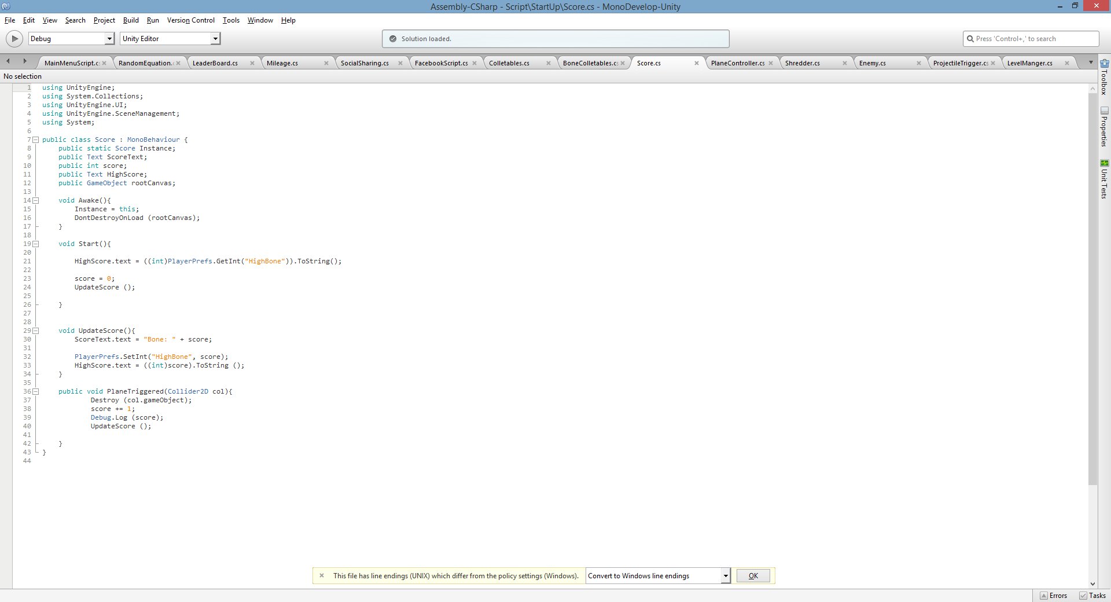

# Equation Board

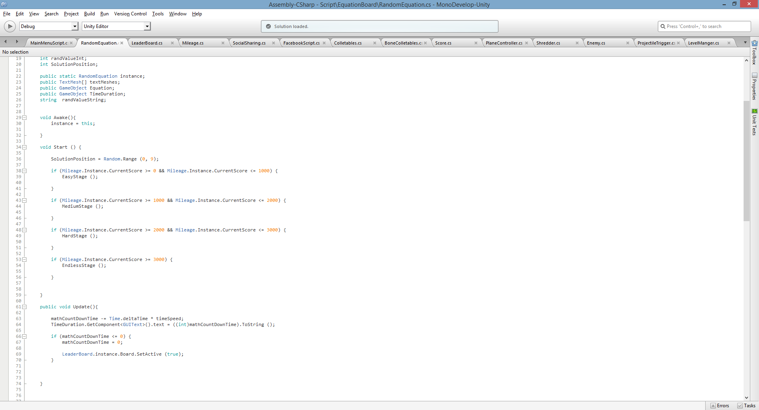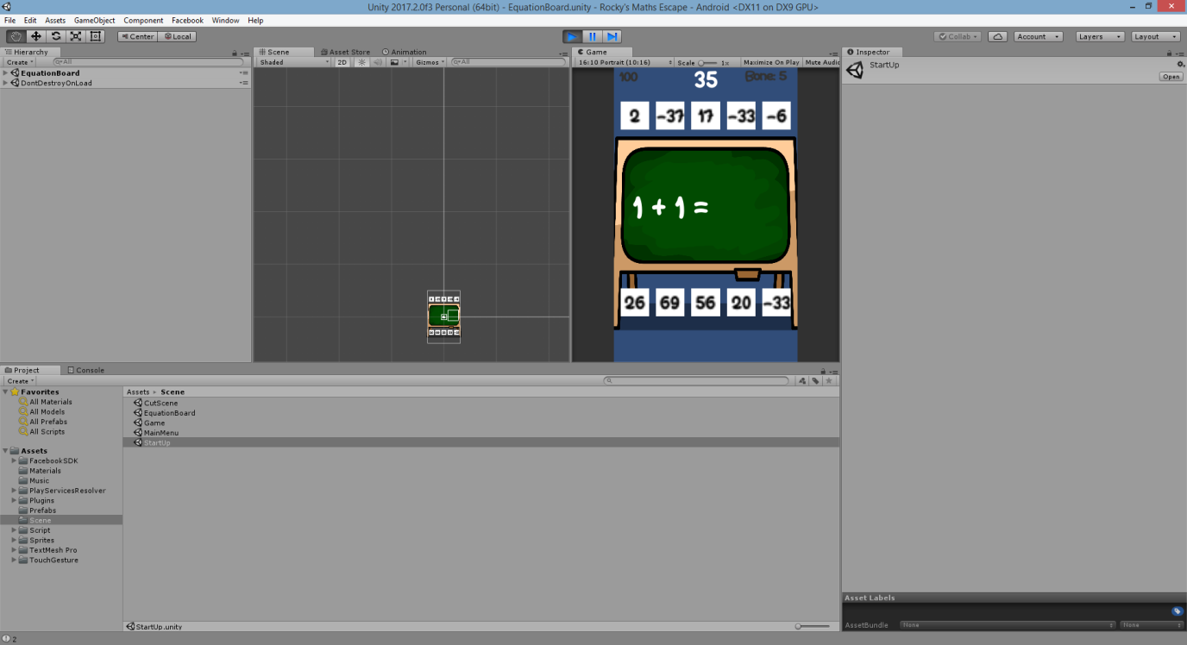

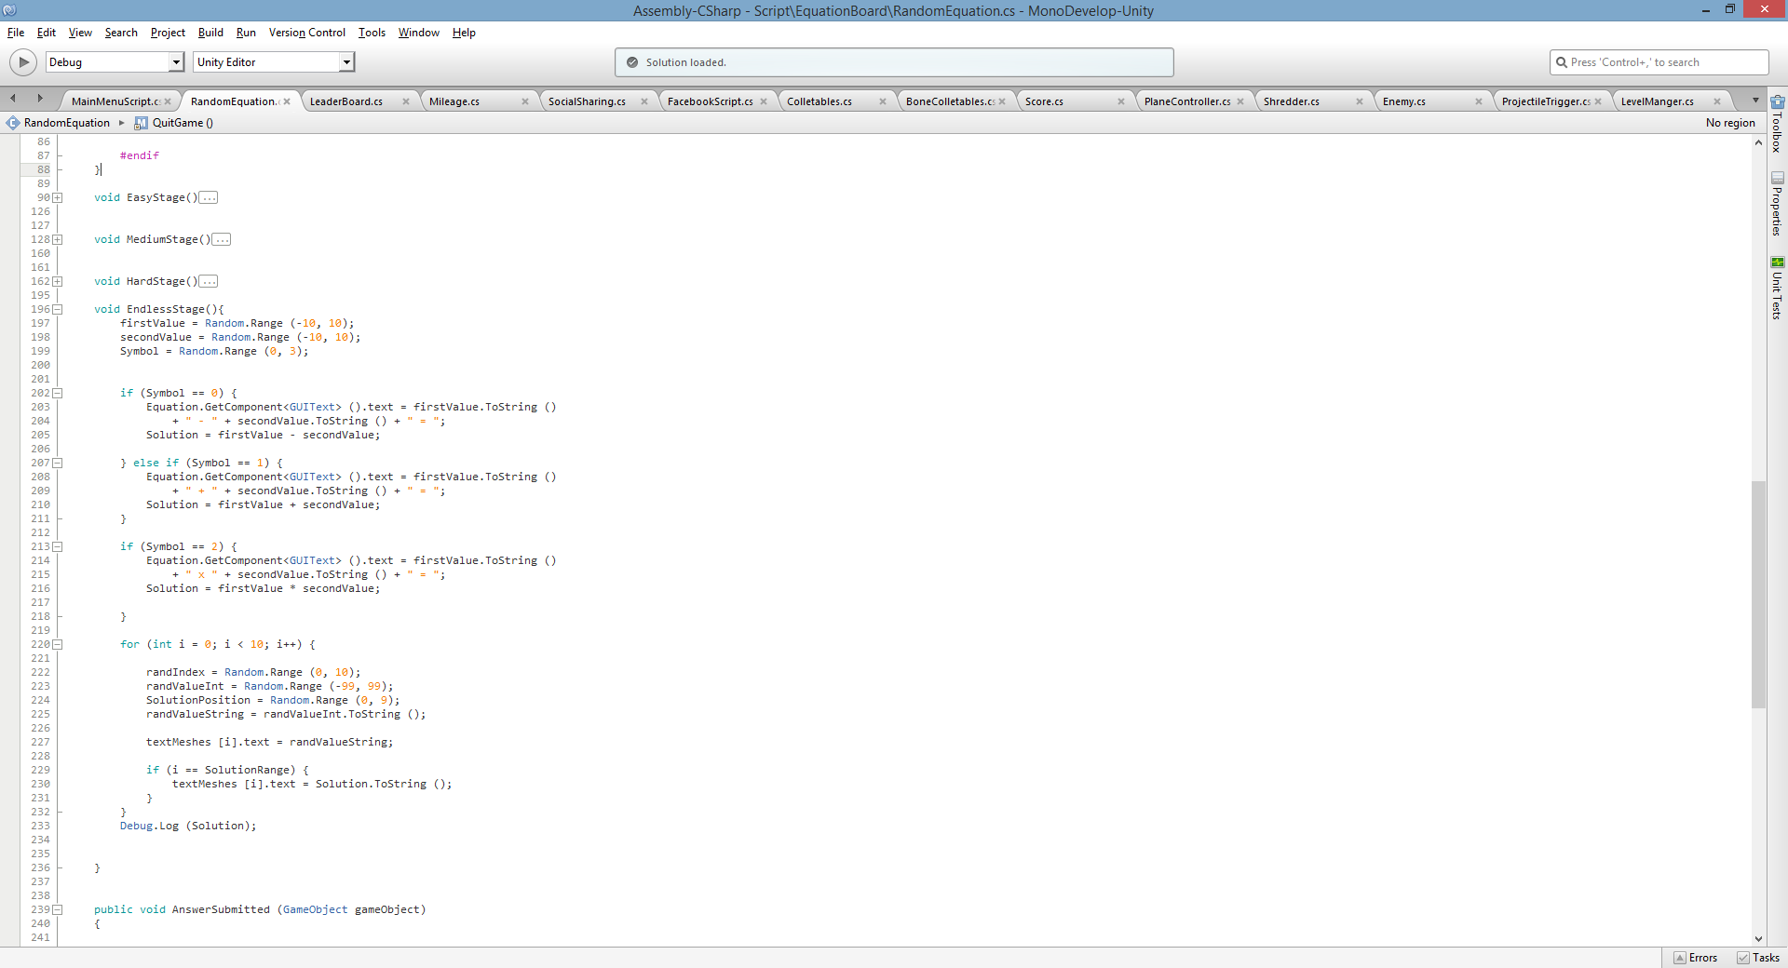

Random Equation Class

The game will display a board and 10 boxes with a randomly generated equation. But only one of the boxes will have the solution for the equation, the player will have to drag the right answer towards the equals’ symbol. The player will have 60 seconds to answer the equation or the game is over.

Line 61:

The update function contains code to perform the count down time, an ‘if’ statement checking if the time has reached zero. Once the time is up, the leader board is shown.

The class has four stages of difficulty which will increase over time. Line 38 is an example, if the mileage is between 0 and 1000 it will call the easy stage method.

The method contains random variables for the boxes shown above, and variables to generators random equations. A random variable is made to store the solution within the box.

# Leader Board

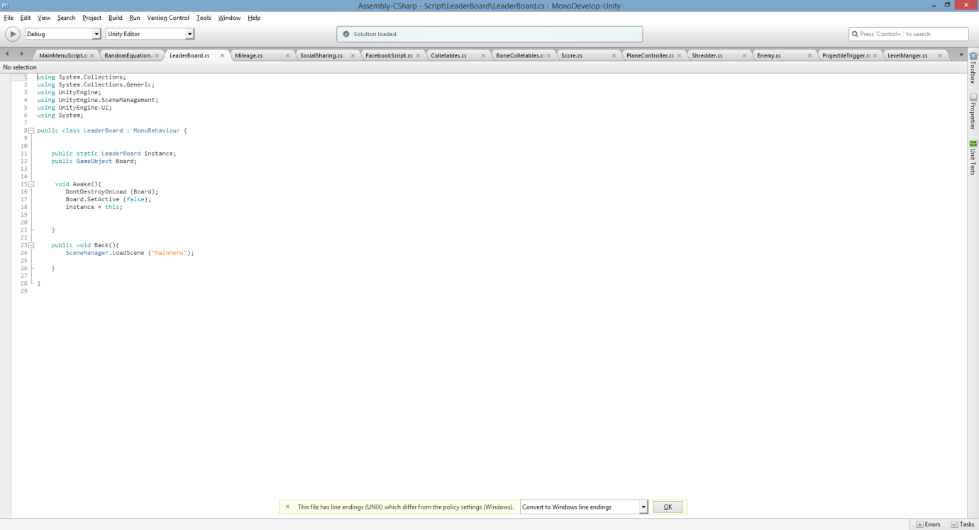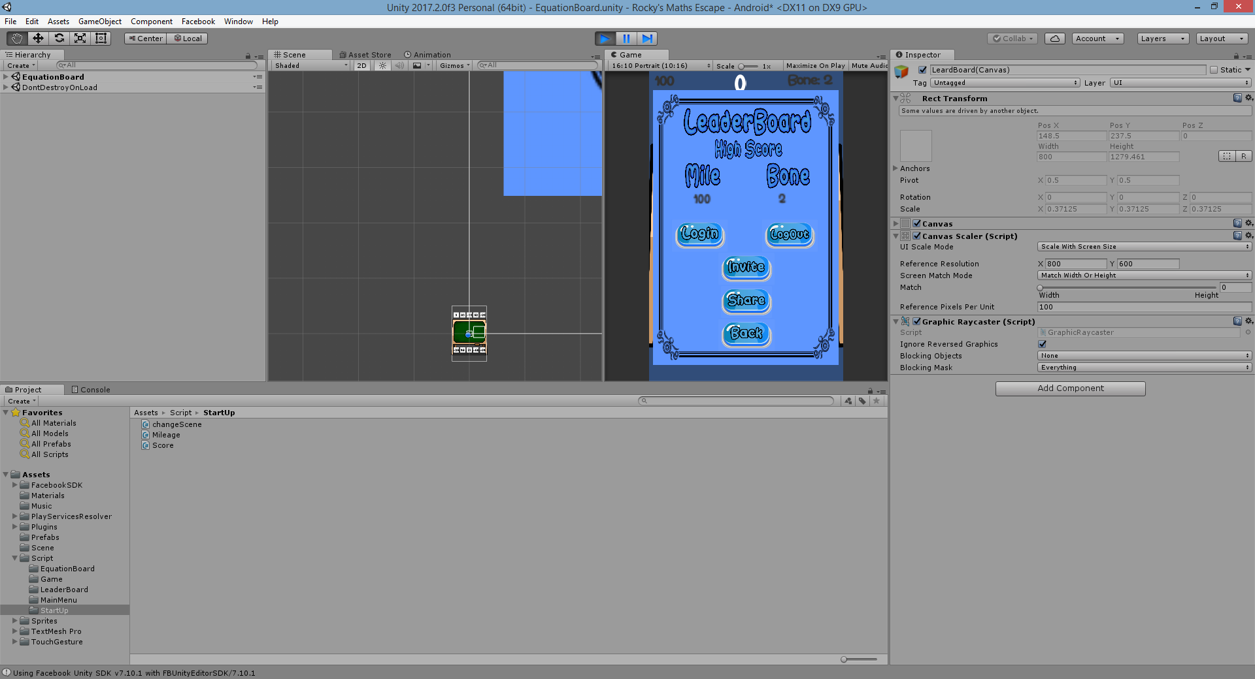

Leader Board Class

The leader board is hidden within the game until the player loses. The code to left will stop the canvas from being destroyed and it uses a back function, taking the player to the main menu.

The Mileage and bone is stored and shown on the leader board at the end of the game using how far you’ve gone and collected.

The code for Facebook link is not mine but from my understanding. The function will allow the player to login in and log out, share the game to Facebook and invite your friends. However without my permission the player will not be able to do any of the functions. I will have to manually add them on the developer Facebook page.

# Main Menu

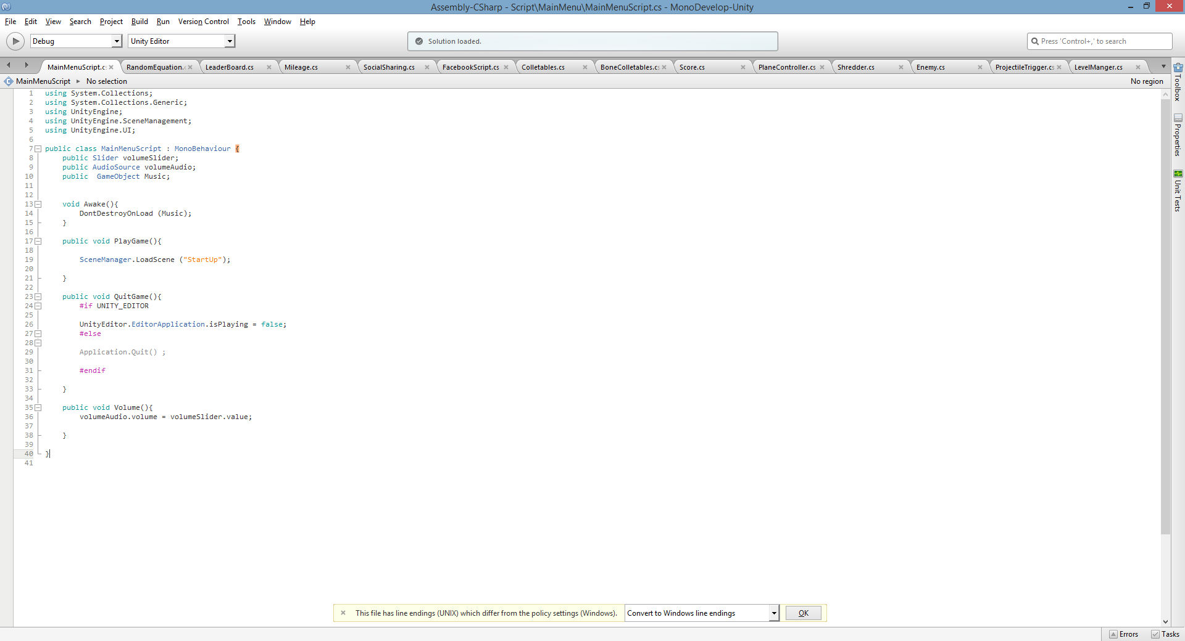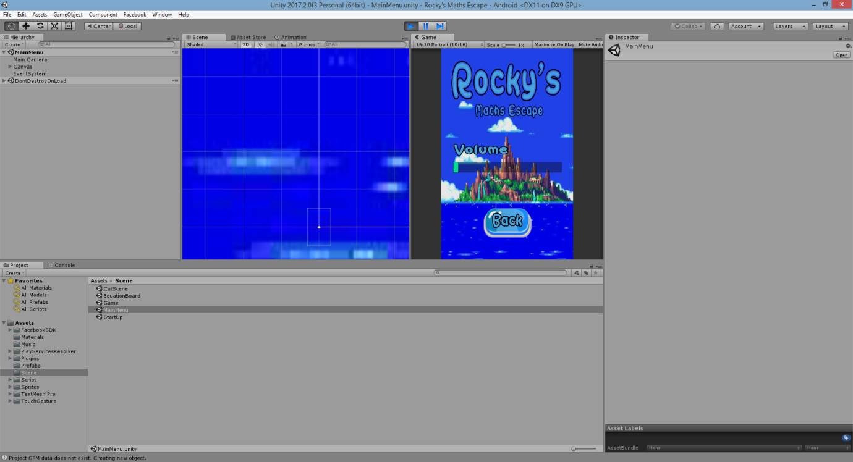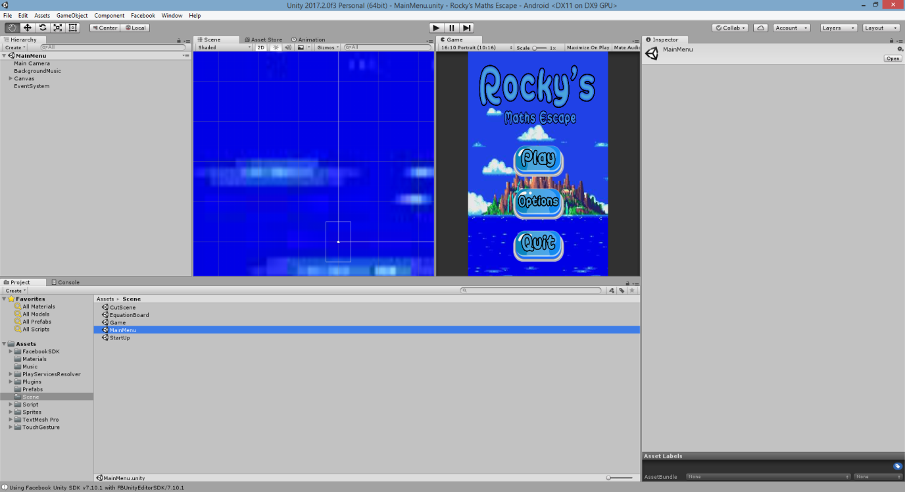

The main menu has a simple code to it, using buttons to call the function. The options will take the player to a volume slider; back will go to the main menu.

The game has come this far, it’s playable, has a function menu, scoring system and able to share to social media. However most the functions mentions in the game design document have not been implemented. For example majority of the SFX mentioned have not been implemented, power ups, music, and rocky encouragement the player to keep answering the questions.

# Testing

|  |  |  |
| --- | --- | --- |
| **Functions** | **Working** | **Comments** |
| Main Menu | Yes | Options with just a slider for main music |
| Leader Board | Yes |  |
| Movement | yes | Player can move all around the screen |
| Projectile | Yes | Projectile shoots once it’s held down |
| Collectables | Yes |  |
| Enemies | Yes | But enemies don’t have any attacking or projectiles to take down the player. |
| Background | Yes | Changes in distance |
| Equation | Yes | Displays all difficulty |
| Show numbers | Yes | Randomised |
| Changing Scene | Yes |  |
| Score | Yes | Keeps score till leaderboard |
| Mileage | Yes | Mileage is recorded and stopped in still scenes |
| Social | Yes | Need permission from administration to share on social media |
| Cut Scene | Yes |  |
| Time (equation board) | Yes | Once the timer reaches 0 the game is over |
| Shredder | Yes | Anything that passes the player or any projectiles shot is destroyed once it goes out of bound. |