Analysing the link between soybean production and deforestation

Firza Riany

04/02/2021

# Description

Using the datasets of export-import of soy production, I was asked to identify:  
1. The largest soy producing state in Brazil  
2. The soy exporting companies from this state that are exposed to deforestation

library(ggplot2) # for visualization  
library(hrbrthemes) # for ggplot theme  
library(RColorBrewer) # to generate a color palette  
library(gghighlight) # highlighting the bars in a plot  
library(stringr) # string manipulation  
library(dplyr) # subsetting the dataset  
  
soy_df = read.csv("Brazil-soy - Brazil-soy.csv", header = TRUE, na.strings = " ")  
  
# Assumption: NA in column soy_deforestation [,5] means that there is no  
# deforestation risks  
soy_df[is.na(soy_df)] = 0

## The largest soy producing state in Brazil

Procedures:  
1. Calculating the aggregate sum of soy production per state  
2. Histogram graphic

# Sum of soy production per state  
soy_aggr = aggregate(soy_df$SOY_EQUIVALENT_TONNES,  
 by = list(STATE = soy_df$STATE),  
 FUN = sum)  
  
# Aggregate returns a new column named "x" that contains the total soy production  
# per state  
# Renaming the "x" column into "total_soy_production"  
names(soy_aggr)[names(soy_aggr) == "x"] = "total_soy_production"  
  
# Sul of deforestation risk per state  
soy_aggr_risk = aggregate(soy_df$SOY_DEFORESTATION_5_YEAR_ANNUAL_RISK_HECTARES,  
 by = list(STATE = soy_df$STATE),  
 FUN = sum)  
  
names(soy_aggr_risk)[names(soy_aggr_risk) == "x"] = "risk_deforest"  
  
# Merging total soy production and deforestation risk  
soy_aggr = merge(soy_aggr, soy_aggr_risk, by = "STATE")  
  
# Sort rows in descending order  
soy_aggr_sort = soy_aggr[order(- soy_aggr$total_soy_production), ]  
  
# Scaling it for easy visualization  
soy_aggr_sort$scale = soy_aggr_sort$total_soy_production/1000  
  
# default = options("scipen"=0, "digits"=7)  
# deactivate scientific notation = options("scipen" = 100, "digits" = 4)  
  
# Tidy the names of the states  
soy_aggr_sort$STATE = str_to_title(soy_aggr_sort$STATE)  
  
# Histogram of total soy production  
soy_product = ggplot(data = soy_aggr_sort, aes(x = STATE, y = scale)) +  
 geom_bar(stat = "identity", fill = "#F53434", alpha = 0.6, width = 0.6) +  
 gghighlight(scale > 20000, label_key = STATE,  
 unhighlighted_params = list(fill = "black")) +  
 xlab("States") +  
 ylab("Soy production (x1000 tonnes)") +  
 labs(title = "Soy production in Brazil") +  
 coord_flip() +  
 theme_ipsum(base_size = 9,  
 axis_title_size = 12,  
 base_family = "Calibri")  
  
# Histogram of total deforestation risk  
risk_deforest = ggplot(data = soy_aggr_sort, aes(x = STATE, y = risk_deforest)) +  
 geom_bar(stat = "identity", fill = "#F53434", alpha = 0.6, width = 0.6) +  
 gghighlight(scale > 20000, label_key = STATE,  
 unhighlighted_params = list(fill = "black")) +  
 xlab("States") +  
 ylab("Deforestation risk (hectares)") +  
 labs(title = "Deforestation risk associated to each state") +  
 coord_flip() +  
 theme_ipsum(base_size = 9,  
 axis_title_size = 12,  
 base_family = "Calibri")  
  
risk_deforest

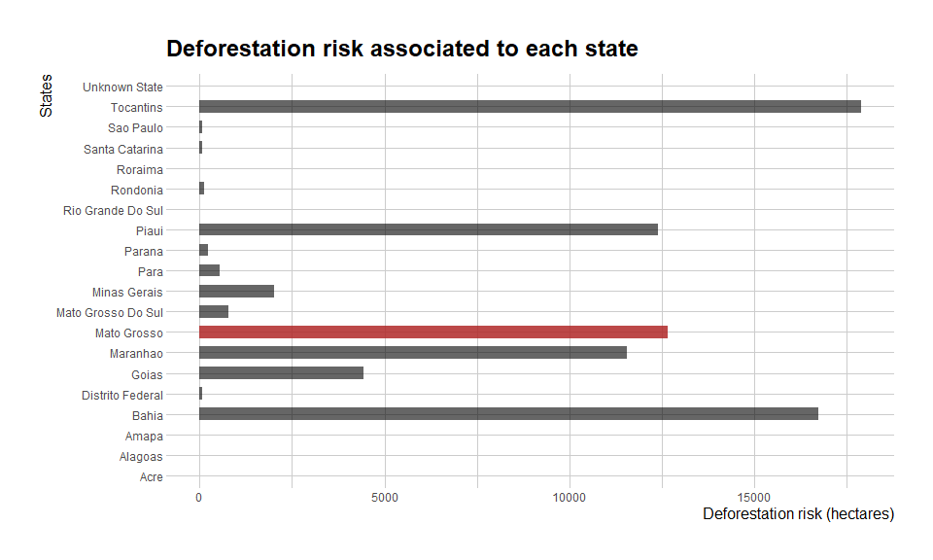

## Which companies from Moto Grosso that is exposed to deforestation?

Procedures:  
1. I will select the exporting companies present in Moto Grosso  
2. With the assumption *each company has the same probability to cause deforestation* I will calculate the deforestation for producing 1 tonne of soy bean  
3. I will define the threshold to say whether the companies are posing a high deforestation risk

I found out that Moto Grosso is the state in Brazil with the largest soy production, namely 25 million tonnes of soy. So, firstly I will answer the question how many exporting companies are there in Moto Grosso?

mg_companies = soy_df %>%  
 filter(STATE == "MATO GROSSO")  
  
# Calculating the deforestation caused by the production of 1 tonne of soy  
mg_companies$def_per_tonne =   
 mg_companies$SOY_DEFORESTATION_5_YEAR_ANNUAL_RISK_HECTARES/mg_companies$SOY_EQUIVALENT_TONNES

I calculated the forest areas that are being cleared to produce 1 tonne of soy (def_per_tonne) because I wanted to compare the companies in the same production scale. To understand which companies that pose a high risk to deforestation, I have to determine a cutoff/threshold value. Companies are considered to pose deforestation risk when their def_per_tonne is larger than the cutoff value.

I determined the cutoff value based on:  
1. The deforestation target in 2020 = 400 000 ha  
2. Brazilian forest areas in 2020 = 49 662 000 ha 3. The yield of soybean in 2020 = 3.41 tonnes / ha

target = 400000  
forest_areas = 49662000  
soy_yield = 3.41  
  
allowed = target / forest_areas  
  
cutoff = allowed / soy_yield  
  
cutoff

## [1] 0.002362008

The logic behind the calculation:  
The deforestation target in 2020 is 400 000 ha. So, out of 49 million ha of forest, the allowed forest to be cleared is 400 000 ha / 49 million ha = 0.008 of Brazilian forests. The optimal soy production is 3.41 tonnes / ha, so 0.008 / 3.41 yields the amount of forest cleared to optimally produce 1 tonne of soy. That is then the cutoff value I will use in my calculation.

So, I will filter the companies whose def_per_tonne is larger than cutoff (0.002362)

mg_deforest = mg_companies %>%  
 filter(def_per_tonne > cutoff)

There are 68 companies that potentially pose a risk to deforestation from Moto Grosso state. So, now I want to link these companies to the economic block. The aim is to see which blocks that directly support/drive deforestation.

# Tidying the strings in the dataset  
mg_deforest$EXPORTER.GROUP = str_to_title(mg_deforest$EXPORTER.GROUP)  
  
mg_deforest$COUNTRY.OF.IMPORT = str_to_title(mg_deforest$COUNTRY.OF.IMPORT)  
  
mg_deforest$ECONOMIC.BLOC = str_to_title(mg_deforest$ECONOMIC.BLOC)  
  
# Plotting  
## Generating the color palette using RColorBrewer  
qual_col_pals = brewer.pal.info[brewer.pal.info$category == 'qual',]  
col_vector = unlist(mapply(brewer.pal, qual_col_pals$maxcolors, rownames(qual_col_pals)))  
  
col_palette = sample(col_vector, 13)  
  
## Histogram of the deforestation risk per company (in Mato Grosso)  
mg_deforest_plot = ggplot(data = mg_deforest, aes(fill = ECONOMIC.BLOC,  
 y = def_per_tonne,  
 x = EXPORTER.GROUP)) +  
 geom_bar(position = "stack", stat = "identity") +  
 scale_fill_manual(values = col_palette) +  
 xlab("Exporting companies") +  
 ylab("Deforestation to produce 1 tonne of soy (ha/tonne)") +  
 labs(title = "Exporting companies linked to deforestation", fill = "Economic blocks") +  
 coord_flip() +  
 theme_ipsum(base_size = 9, axis_title_size = 12, base_family = "Calibri")  
  
mg_deforest_plot

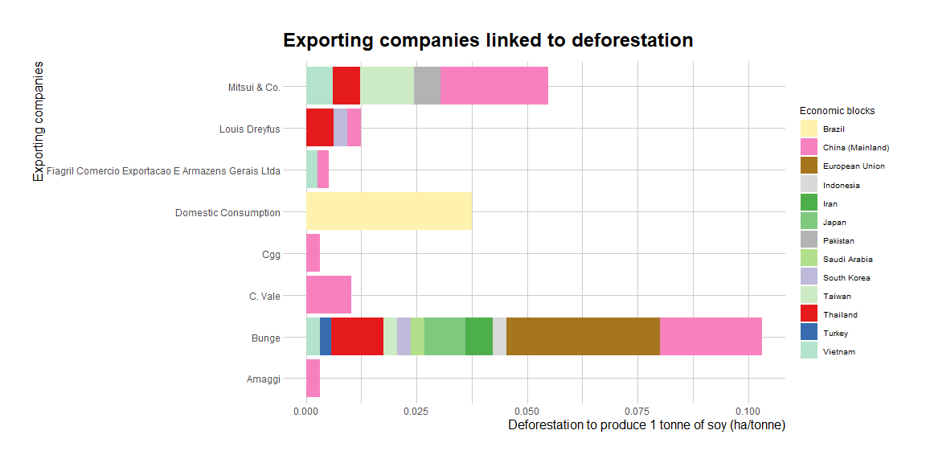

The exporting companies Bunge and Mitsui & Co. are the top 2 companies that cause the highest deforestation to produce 1 tonne of soy. These companies export soy to China that makes China the biggest economic block that support deforestation for soybean plantation in Moto Grosso. Beside China, the European Union also sources its soybean from Bunge which makes the EU the driver for deforestation in Moto Grosso.

If I have to communicate the result to a sustaianability officer from China, I would also show him/her the Brazilian exporting companies that China is partnering with.

# Companies in Moto Grosso that are exporting only to China  
mg_china = mg_companies %>%  
 filter(COUNTRY.OF.IMPORT == "CHINA (MAINLAND)")  
  
# Exporting companies that supply the soybean to China  
mg_china_supply = aggregate(mg_china$SOY_EQUIVALENT_TONNES,  
 by = list(EXPORTER.GROUP = mg_china$EXPORTER.GROUP),  
 FUN = sum)  
  
names(mg_china_supply)[names(mg_china_supply) == "x"] = "total_soy_production"  
  
mg_china_supply = mg_china_supply[order(mg_china_supply$total_soy_production), ]  
  
# The top 10 suppliers  
top_suppliers = tail(mg_china_supply, n = 10)  
  
# Their aggregate deforestation risk (for all the exports including China)  
mg_china_risk = aggregate(mg_companies$SOY_DEFORESTATION_5_YEAR_ANNUAL_RISK_HECTARES,  
 by = list(EXPORTER.GROUP = mg_companies$EXPORTER.GROUP),  
 FUN = sum)  
  
names(mg_china_risk)[names(mg_china_risk) == "x"] = "deforestation_risk"  
  
# Merge with the top suppliers  
top_suppliers_2 = merge(top_suppliers, mg_china_risk, by = "EXPORTER.GROUP")  
  
# Their aggregate deforestation per 1 tonne of soy production (for all the exports)  
# (including China)  
mg_china_def = aggregate(mg_companies$def_per_tonne,  
 by = list(EXPORTER.GROUP = mg_companies$EXPORTER.GROUP),  
 FUN = sum)  
  
names(mg_china_def)[names(mg_china_def) == "x"] = "def_per_tonne"  
  
# Merge with the top suppliers  
top_suppliers_2 = merge(top_suppliers_2, mg_china_def, by = "EXPORTER.GROUP")  
  
top_suppliers_2$EXPORTER.GROUP = str_to_title(top_suppliers_2$EXPORTER.GROUP)  
  
# Plotting the suppliers with no deforestation risks  
suppliers = ggplot(data = top_suppliers_2, aes(x = EXPORTER.GROUP,   
 y = total_soy_production)) +  
 geom_bar(stat = "identity", fill = "firebrick2", alpha = 0.7, width = 0.6) +  
 gghighlight(def_per_tonne > cutoff, label_key = EXPORTER.GROUP,   
 unhighlighted_params = list(fill = "forestgreen")) +  
 xlab("Exporting companies") +  
 ylab("Total soy production (tonnes)") +  
 labs(title = "Top 10 soy suppliers to China market") +  
 theme_ipsum(base_size = 9, axis_title_size = 12, base_family = "Calibri") +  
 coord_flip()  
  
suppliers

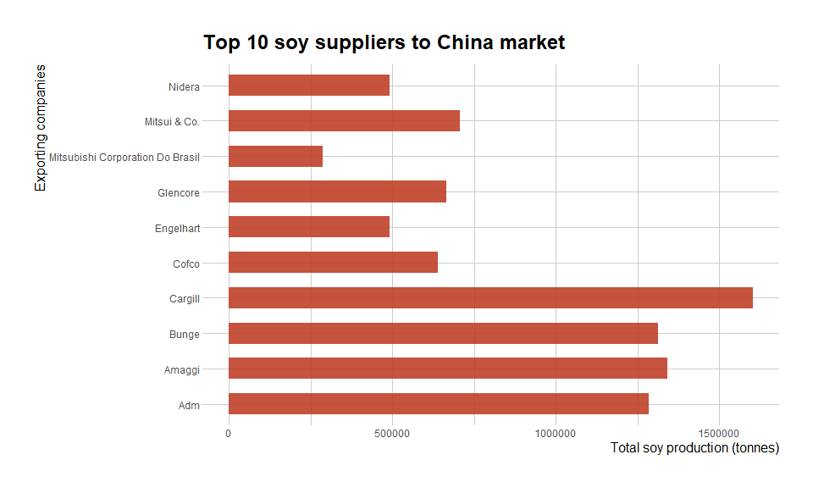

deforest = ggplot(data = top_suppliers_2, aes(x = EXPORTER.GROUP,  
 y = def_per_tonne)) +  
 geom_bar(stat = "identity", fill = "yellow", alpha = 0.7, width = 0.6) +  
 gghighlight(def_per_tonne < 0.008, label_key = EXPORTER.GROUP,  
 unhighlighted_params = list(fill = "firebrick2")) +  
 geom_hline(aes(yintercept = cutoff, color = "Cutoff"), size = 1.5) +  
 scale_color_manual(name = "Cutoff (0.0024)", values = "black") +  
 xlab("Exporting companies") +  
 ylab("Deforestation (ha/tonne)") +  
 labs(title = "Deforestation per 1 tonne of soy production") +  
 theme_ipsum(base_size = 9, axis_title_size = 12, base_family = "Calibri") +  
 coord_flip()  
  
deforest

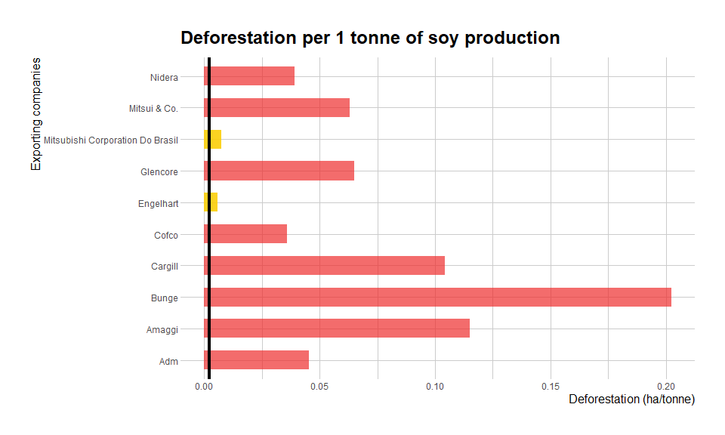

I identified the top 10 soy exporting companies that are partnering with China. Cargill is the exporting company that exports the most. It exports 1.5 million tons of soy to China only. Other companies with the most exports are Bunge, Amaggi and ADM. However, these 10 companies are not deforestation-free. Each one of them are associated with deforestation in Mato Grosso.

It is indicated by the deforestation risk in every 1 ton of soy production in these companies. With the cutoff value = 0.00020, all the exporting companies from Mato Grosso are not deforestation-free. They cannot comply with Brazil’s ambitious deforestation target (400 000 ha in 2020, even though in reality they caused deforestation in 110 000 ha of forest). However, there are two companies, namely Engelhart and Mitsubishi, with deforestation risk a bit over the cutoff value. If I have to recommend which companies that the officer should consider if he wants to source a sustainable soybean, I would recommend Engelhart and Mitsubishi.

## Estimation of carbon emission

I have an idea to estimate the possible carbon emission from deforestation given the exporting company’s total soy production. I found an equation that can return the equivalent CO2 emission from deforestation using the amount of area changed (ha) and the potential carbon stock in the area (C/ha) (USAID 2014). I sourced the carbon stock for Moto Grosso from Nogueira et al. 2009, and it was 159.7 mgC/ha. So I will try to estimate the possible carbon emission caused by these top 10 soy exporting companies.

c_stock = 159.7  
  
# Calculating the total emission generated by the companies  
# Assumption: companies that are present in Moto Grosso  
top_suppliers_2$emission_mgC = top_suppliers_2$deforestation_risk * c_stock  
  
# Scale to ton  
top_suppliers_2$emission_tC = top_suppliers_2$emission_mgC/1000000000  
  
# Plotting overall emission from deforestation  
emission = ggplot(data = top_suppliers_2, aes(x = EXPORTER.GROUP,  
 y = emission_tC)) +  
 geom_bar(stat = "identity", fill = "firebrick2", alpha = 0.7, width = 0.6) +  
 xlab("Exporting companies") +  
 ylab("Total possible emission (tC)") +  
 labs(title = "The total possible emission of the top exporting companies") +  
 theme_ipsum(base_size = 9, axis_title_size = 12) +  
 coord_flip()  
  
emission

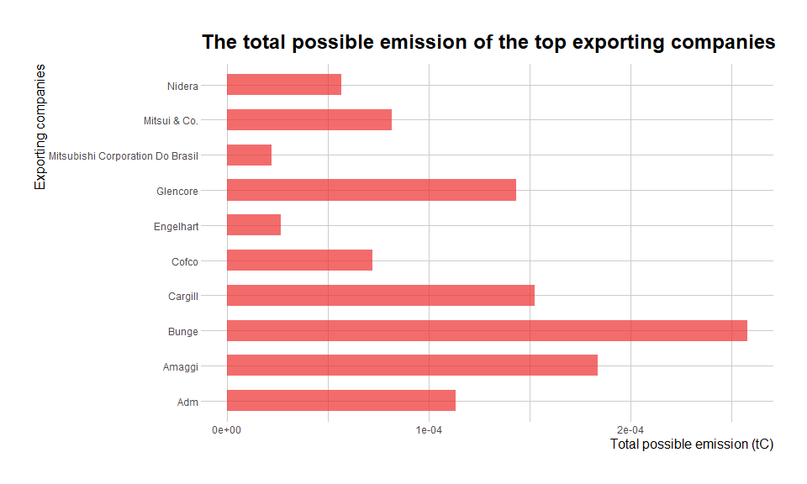

# (total_def/total_soy) ha/ton * mgC/ha = mgC/ton  
# The bigger the area changed, the lower the soy produced, the higher the def  
# bigger area linear with def  
# soy production non_linear with def  
# the bigger 492296, 151.2  
  
# Calculating the total emission per 1 ton of soy production  
top_suppliers_2$emission_per_ton_mgC = top_suppliers_2$def_per_tonne * c_stock  
  
# Scale to tC  
top_suppliers_2$emission_per_ton_tC = top_suppliers_2$emission_per_ton_mgC/1000000000  
  
# Plotting  
emission_per_ton = ggplot(data = top_suppliers_2, aes(x = EXPORTER.GROUP,  
 y = emission_per_ton_tC)) +  
 geom_bar(stat = "identity", fill = "firebrick2", alpha = 0.7, width = 0.6) +  
 xlab("Exporting companies") +  
 ylab("Possible emission per 1 ton of soy (tC)") +  
 labs(title = "Carbon emission per 1 tonne of soy production") +  
 theme_ipsum(base_size = 9, axis_title_size = 12) +  
 coord_flip()  
  
emission_per_ton

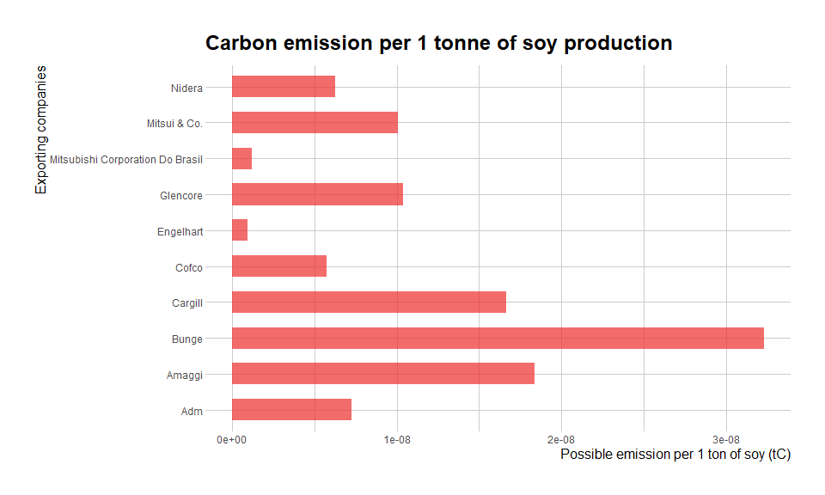

I calculated the total possible emission for each company. In this calculation, I summed the deforestation risk for each company that are present in Moto Grosso. Then I multiply the total deforestation risk with the carbon stock in the area (159.7 mgC/ha). The result indicates that Bunge emits the most due to deforestation. In terms of deforestation caused by the production of 1 ton of soy, Bunge still emits the most. It is followed by Glencore in. The smallest emission is caused by Mitsubishi and Engelhart, which I woud recommend to the officer if he wants to partner with deforestation-free soybean exporting companies. However, I would still do further research involving benchmarking with exporting companies that are exporting similar amount of soy and benchmarking with the companies that are present in other states in Brazil.

# Bottomline

I would recommend the Chinese sustainability officer to partner with Cargill.

# References