Tugas Basis Data Terdistribusi

1. Desain Arsitektur Sistem

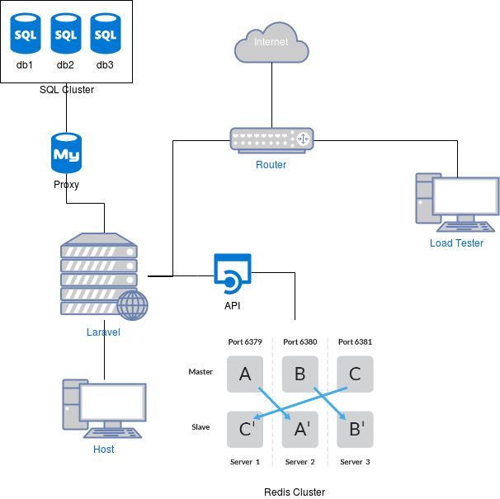

2. Mysql Cluster

- Clustering step
  - vagrant up
  - vagrant ssh proxy
  - mysql -u admin -padmin -h 127.0.0.1 -P 6032 < /vagrant/mysql/proxysql.sql

- Testing bahwa clustering berhasil
SELECT * FROM performance_schema.replication_group_members;

- Menyalakan cluster lagi ketika mysql mati
  - member1
SET GLOBAL GROUP_REPLICATION_BOOTSTRAP_GROUP=ON;
START GROUP_REPLICATION;
SET GLOBAL GROUP_REPLICATION_BOOTSTRAP_GROUP=OFF;
  - member2 & member3
START GROUP_REPLICATION;
3. Redis Cluster
- vagrant up
- node1
  - master.conf
  - slave.conf
  - redis-server /vagrant/redis/cluster/nd1-master.conf > /dev/null 2>&1 &
  - redis-server /vagrant/redis/cluster/nd1-slave.conf > /dev/null 2>&1 &
  - redis-cli --cluster create 192.168.33.21:6379 192.168.33.22:6380 192.168.33.23:6381
  - redis-cli --cluster add-node 192.168.33.21:6381 192.168.33.23:6381 --cluster-slave
- node2
  - master.conf
  - slave.conf
  - redis-server /vagrant/redis/cluster/nd2-master.conf > /dev/null 2>&1 &
  - redis-server /vagrant/redis/cluster/nd2-slave.conf > /dev/null 2>&1 &
  - redis-cli --cluster create 192.168.33.21:6379 192.168.33.22:6380 192.168.33.23:6381
  - redis-cli --cluster add-node 192.168.33.22:6379 192.168.33.21:6379 --cluster-slave
- node3
  - master.conf
  - slave.conf
  - redis-server /vagrant/redis/cluster/nd3-master.conf > /dev/null 2>&1 &
  - redis-server /vagrant/redis/cluster/nd3-slave.conf > /dev/null 2>&1 &
  - redis-cli --cluster create 192.168.33.21:6379 192.168.33.22:6380 192.168.33.23:6381
  - redis-cli --cluster add-node 192.168.33.23:6380 192.168.33.22:6380 --cluster-slave
4. Laravel
- Koneksi MySQL
- Koneksi Redis Cluster menggunakan API dengan Python Flask
- Crontab
5. API
6. Testing
7. Jmeter
8. Referensi
- https://www.linode.com/docs/applications/big-data/how-to-install-and-configure-a-redis-cluster-on-ubuntu-1604/
- https://www.digitalocean.com/community/tutorials/how-to-configure-mysql-group-replication-on-ubuntu-16-04
- https://www.digitalocean.com/community/tutorials/how-to-use-proxysql-as-a-load-balancer-for-mysql-on-ubuntu-16-04
- https://www.laravel.web.id/2017/07/07/membuat-pagination-secara-manual/
- https://tutsforweb.com/how-to-set-up-task-scheduling-cron-job-in-laravel/
- https://www.blazemeter.com/blog/how-get-started-jmeter-part-1-installation-test-plans

