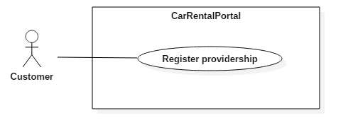

|  |  |  |  |
| --- | --- | --- | --- |
| USE CASE – US01 | | | |
| Use Case No. | US01 | **Use Case Version** | 2.0 |
| Use Case Name | Register providership | | |
| Author | KhoaLVD | | |
| Date | 05/11/2016 | **Priority** | Normal |
| Actor:   * Customer   Summary:   * This use case allows customer to become provider.   Goal:   * Customer becomes provider.   Triggers:   * Customer clicks on “Trở thành nhà cung cấp” at navigation bar.   Preconditions:   * Log in successful as role customer.   Post Conditions:   * Success: Customer becomes provider. * Fail: Show error message.   Main Success Scenario:   |  |  |  | | --- | --- | --- | | Step | Actor Action | System Response | | 1 | Customer clicks on “Trở thành nhà cung cấp” at navigation bar. | System shows become provider page which has 3 packs for customer to choose. | | 2 | User clicks on “Đăng ký” button in 1 of 3 packs. | System shows “Phương thức thanh toán” panel where user can choose what types of purchase user want to make:   * Thanh toán online bằng thẻ ngân hàng nội địa: purchase online by interior bank’s card. * Thanh toán bằng thẻ tín dụng / ghi nợ: purchase by visa. * Thanh toán bằng Ví điện tử NgânLượng: purchase by NgânLượng. | | 3 | User clicks on “Thanh toán” button.  [Alternative 1] | System redirect to purchase page of the purchase type user choose. | | 4 | User fills information and clicks on “Thanh toán” button.  [Alternative 2] | System redirect to homepage with provider role for that user |   Alternative Scenario:   |  |  |  | | --- | --- | --- | | No | Actor Action | System Response | | 1 | User clicks on “Hủy đơn hàng” button at become provider page. | System will redirect to homepage. | | 2 | User clicks on “Hủy đơn hàng” button at purchase page. | System will clear order and redirect to homepage. |   Exceptions: N/A  Relationships: N/A  Business Rules:   * User’s payment method must be safe. * After become provider, system must display the expired day below provider’s name. | | | |

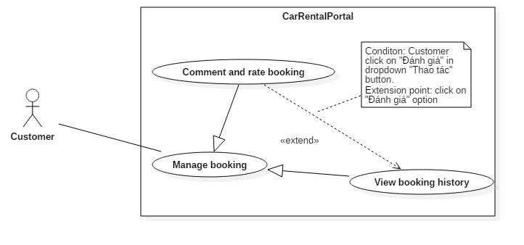

|  |  |  |  |
| --- | --- | --- | --- |
| USE CASE – US01 | | | |
| Use Case No. | US01 | **Use Case Version** | 2.0 |
| Use Case Name | Comment and rate booking | | |
| Author | KhoaLVD | | |
| Date | 05/11/2016 | **Priority** | Normal |
| Actor:   * Customer   Summary:   * This use case allows customer to comment and rate booking they booked.   Goal:   * Customer can rate and comment booking they booked.   Triggers:   * Customer choose “Đánh giá” option in  at “Lịch sử đặt xe” page.   Preconditions:   * Log in successful as role customer and has booked booking. * Current time must be after start time (time customer start using booked vehicle). * Customer hasn’t comment and rating that vehicle yet.   Post Conditions:   * Success: Comment and rating of customer appear in that vehicle’s information page. * Fail: Show error message.   Main Success Scenario:   |  |  |  | | --- | --- | --- | | Step | Actor Action | System Response | | 1 | Customer choose “Đánh giá” option in  at “Lịch sử đặt xe” page | System shows “Đánh giá xe” popup for customer to comment and rate. | | 2 | Customer clicks on star | System fill the stars fit which how many customer choose. | | 3 | Customer type in “Đánh giá” rick text box. | System requirement: min length 20, max length 500 | | 4 | Customer clicks  button.  [Alternative 1] | System will show “Đã gửi đánh giá thành công” alert.  [Exception 1]  [Exception 2]  [Exception 3]  [Exception 4] |   Alternative Scenario:   |  |  |  | | --- | --- | --- | | No | Actor Action | System Response | | 1 | Customer clicks  ,  or clicks outside the popup box. | System will close “Đánh giá xe” popup and back to “Lịch sử đặt xe” page. |   Exceptions:   |  |  |  | | --- | --- | --- | | No | Actor Action | System Response | | 1 | Customer don’t do anything and clicks  button | System will display “Vui lòng nhập” warning. | | 2 | Customer rate but don’t type anything in “Đánh giá” box. | System will display “Vui lòng nhập” | | 3 | Customer type less than 20 words. | System will display “Vui lòng nhập ít nhất 20 chữ” | | 4 | Customer type more than 200 words | System will display “Vui lòng nhập ít hơn 200 chữ” |   Relationships: Extend for “View booking history”  Business Rules:   * User’s payment method must be safe. * After become provider, system must display the expired day below provider’s name. | | | |

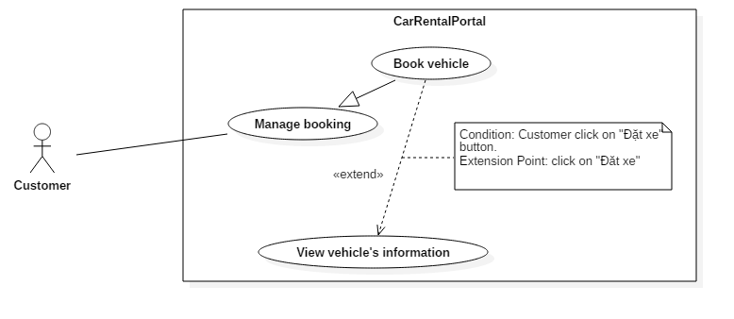

|  |  |  |  |
| --- | --- | --- | --- |
| USE CASE – US01 | | | |
| Use Case No. | US01 | **Use Case Version** | 2.0 |
| Use Case Name | Book vehicle | | |
| Author | KhoaLVD | | |
| Date | 06/11/2016 | **Priority** | Normal |
| Actor:   * Customer   Summary:   * This use case allows customer to book vehicle.   Goal:   * Customer book vehicle successful.   Triggers:   * Customer clicks on vehicle’s name.   Preconditions:   * Log in successful as role customer.   Post Conditions:   * Success: Booked vehicle will appears in “Lịch sử đặt xe” page. * Fail: Show error message.   Main Success Scenario:   |  |  |  | | --- | --- | --- | | Step | Actor Action | System Response | | 1 | Customer clicks on vehicle’s name. | System will shows “Thông tin xe” page of that vehicle. | | 2 | Customer chooses option in “Gói thời gian thuê” list. [Alternative 1] | System list out pack time customer want to rent:   * Thuê theo ngày: rent by days * Thuê 6 giờ: rent for 6 hours * Thuê 12 giờ: rent for 12 hours | | 3 | Customer clicks on time box at “Thời gian nhận xe” | System shows out a calendar where customer can choose day to pick up vehicle. | | 4 | Customer clicks  button.  [Alternative 2] | System will redirect to booking confirm page show out again information of the vehicle customer want to book, the price customer has to pay and payment method:   * Thanh toán online bằng thẻ ngân hàng nội địa: purchase online by interior bank’s card. * Thanh toán bằng thẻ tín dụng / ghi nợ: purchase by visa. * Thanh toán bằng Ví điện tử NgânLượng: purchase by NgânLượng. | | 5 | User clicks on “Thanh toán” button. | System redirect to purchase page of the purchase type user choose. | | 6 | User fills information and clicks on “Thanh toán” button. | System shows out receipt page which have information of the purchase. |   Alternative Scenario:   |  |  |  | | --- | --- | --- | | No | Actor Action | System Response | | 1 | Customer chooses “Thuê theo ngày” option. | System wills allows customer to fill how many day they want to rent.  [Exception] | | 2 | Customer clicks on button. | System wills redirect back to vehicle’s information page. |   Exceptions:   |  |  |  | | --- | --- | --- | | No | Actor Action | System Response | | 1 | Customer fills in negative number | System wills display the smallest day for rent. | | 2 | Customer fills in number out of rent range. | System wills display the largest day for rent. |   Relationships: Extend for “View vehicle’s information”  Business Rules:   * User’s payment method must be safe. * After rent, the information must have in “Lịch sử đặt xe” page. * Information of price customer has to pay must be clear and show out for customer. * Maximum days customer can rent is 30 days. | | | |

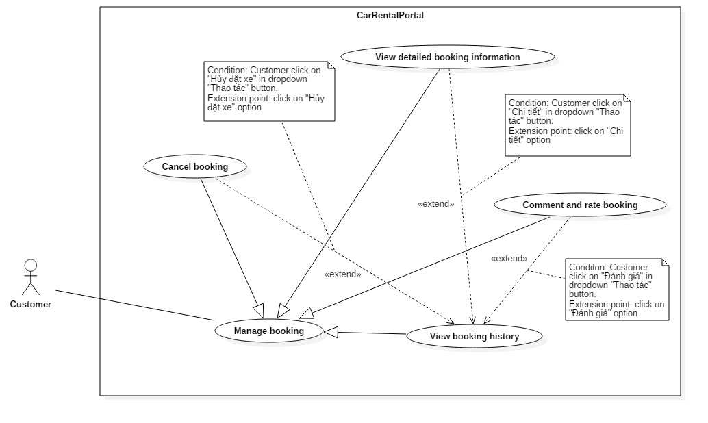

|  |  |  |  |
| --- | --- | --- | --- |
| USE CASE – US01 | | | |
| Use Case No. | US01 | **Use Case Version** | 2.0 |
| Use Case Name | View booking history | | |
| Author | KhoaLVD | | |
| Date | 06/11/2016 | **Priority** | High |
| Actor:   * Customer   Summary:   * This use case allows customer to view their booked history.   Goal:   * Customer can view their booked history.   Triggers:   * Customer clicks on “Lịch sử đặt xe” at navigation bar.   Preconditions:   * Log in successful as role customer.   Post Conditions:   * Success: Booked vehicle will appears in “Lịch sử đặt xe” page. * Fail: Show error message.   Main Success Scenario:   |  |  |  | | --- | --- | --- | | Step | Actor Action | System Response | | 1 | Customer clicks on “Lịch sử đặt xe” at navigation bar. | System wills show list of vehicles customer had booked. |   Alternative Scenario: N/A  Exceptions: N/A  Relationships: extended by “Cancel booking”, “View detail’s information” and “Comment and rate booking”.  Business Rules:   * All information of booked vehicle must show on this page. | | | |

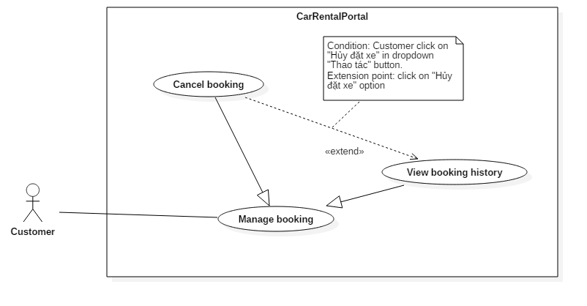

|  |  |  |  |
| --- | --- | --- | --- |
| USE CASE – US01 | | | |
| Use Case No. | US01 | **Use Case Version** | 2.0 |
| Use Case Name | Cancel booking | | |
| Author | KhoaLVD | | |
| Date | 07/11/2016 | **Priority** | High |
| Actor:   * Customer   Summary:   * This use case allows customer to cancel their booking.   Goal:   * Customer can cancel their renting or booking vehicle.   Triggers:   * Customer clicks on “Lịch sử đặt xe” at navigation bar and choose “Hủy đặt xe” at “Thao tác” button.   Preconditions:   * Log in successful as role customer and has their booked vehicle.   Post Conditions:   * Success: Booked vehicle will appears in “Lịch sử đặt xe” page. * Fail: Show error message.   Main Success Scenario:   |  |  |  | | --- | --- | --- | | Step | Actor Action | System Response | | 1 | Customer clicks on “Lịch sử đặt xe” at navigation bar and choose “Hủy đặt xe” at “Thao tác” button. | System wills show a popup ask customer to confirm their cancel. | | 2 | Customer clicks on “Hủy” button  [Alternative 1] | System wills close the popup and change status of the chosen vehicle. |   Alternative Scenario:   |  |  |  | | --- | --- | --- | | Step | Actor Action | System Response | | 1 | Customer clicks on “Đóng” button or click outside the popup. | System wills close the popup and show back “Lịch sử đặt xe” page. |   Exceptions: N/A  Relationships: extend for “View booking history”.  Business Rules:   * All information of booked vehicle must show on this page. * Cancel booking just allows for the vehicle is booking or renting not for ended. | | | |

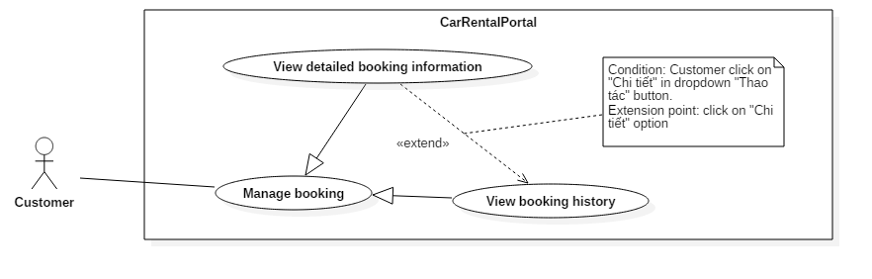

|  |  |  |  |
| --- | --- | --- | --- |
| USE CASE – US01 | | | |
| Use Case No. | US01 | **Use Case Version** | 2.0 |
| Use Case Name | View detailed booking information | | |
| Author | KhoaLVD | | |
| Date | 07/11/2016 | **Priority** | High |
| Actor:   * Customer   Summary:   * This use case allows customer to view detailed their booking information.   Goal:   * Customer can review their booking information.   Triggers:   * Customer clicks on “Lịch sử đặt xe” at navigation bar and choose “Chi tiết” at “Thao tác” button.   Preconditions:   * Log in successful as role customer and has their booked vehicle.   Post Conditions:   * Success: Detail information of the chosen booking view show out for customer. * Fail: Show error message.   Main Success Scenario:   |  |  |  | | --- | --- | --- | | Step | Actor Action | System Response | | 1 | Customer clicks on “Lịch sử đặt xe” at navigation bar and choose “Chi tiết” at “Thao tác” button.  [Alternative 1] | System wills show a popup has all the information of the booking:   * Vehicle’s name * Time pick up and release vehicle. * Detail information of the receipt: price order, service price, deposit price, distance. * Vehicle’s detail information: year, number of doors, number of seats, color, fuel type, transmission type. * Garage’s detail information: address, email, phone number. |   Alternative Scenario:   |  |  |  | | --- | --- | --- | | Step | Actor Action | System Response | | 1 | Customer clicks on “Đóng” button or click outside the popup. | System wills close the popup and show back “Lịch sử đặt xe” page. |   Exceptions: N/A  Relationships: extend for “View booking history”.  Business Rules:   * All information of booked vehicle must show on this page. | | | |