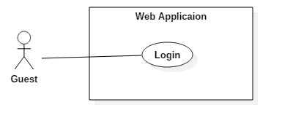

|  |  |  |  |
| --- | --- | --- | --- |
| USE CASE – UG01 | | | |
| Use Case No. | UC | **Use Case Version** |  |
| Use Case Name | Login | | |
| Author | TamNT | | |
| Date | 06/10/2016 | **Priority** | Normal |
| Actor:   * Guest.   Summary:   * This use case allows guest to log in the system.   Goal:   * Guest can log in the system.   Triggers:   * Guest sends the login command.   Preconditions:   * N/A   Post Conditions:   * Success: Guest login the system. * Fail: Show error message.   Main Success Scenario:   |  |  |  | | --- | --- | --- | | Step | Actor Action | System Response | | 1 | Guest click “Đăng nhập” button. | System show popup requires identity information :   * Email: Email format, required. * Password: free text input, required. | | 2 | Guest inputs information. |  | | 3 | Guest sends command to login to system by click button Login | Guest will be logged-in system with their specific role  [Alternative 1, 2]  [Exception 1, 2, 3, 4, 5] |   Alternative Scenario:   |  |  |  | | --- | --- | --- | | Step | Actor Action | System Response | | 1 | Guest click at link “Quên mật khẩu”. | Redirect to “Recover Password” page. | | 2 | Guest click at link “Đăng kí một tài khoản”. | Redirect to “Sign up” page. |   Exceptions:   |  |  |  | | --- | --- | --- | | No | Actor Action | System Response | | 1 | Guest missed to input “Email” field. | System show error message “The Email field is required”. | | 2 | Guest missed to input “Password” field | System show error message “The Password field id required” | | 3 | The email inputted is wrong with email format | System shows error message “The email field is not a valid e-mail address” | | 4 | Guest inputted wrong account, password this account was be blocked | System shows error message “Tài khoản không tồn tại hoặc bị chặn” | | 5 | Account was be blocked | System shows error message “Tài khoản không tồn tại hoặc bị chặn”. |   Relationships: N/A  Business Rules:   * Only active account can login into server. * After login to system, guest will been redirected to specific view based on their role on the system: Provider or customer or Admin * If role is “Customer”, the system will display to Information of this customer. * If role is “Provider” or “Admin”, the system will display to Dashboard view. | | | |

