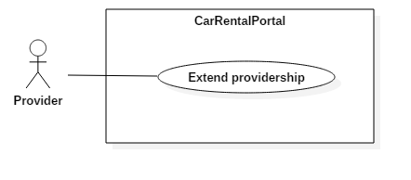

|  |  |  |  |
| --- | --- | --- | --- |
| USE CASE – US01 | | | |
| Use Case No. | US01 | **Use Case Version** | 2.0 |
| Use Case Name | Extend providership | | |
| Author | KhoaLVD | | |
| Date | 05/11/2016 | **Priority** | Normal |
| Actor:   * Provider   Summary:   * This use case allows provider to extend their providership.   Goal:   * Provider extend successful their providership.   Triggers:   * Provider clicks on “Trở thành nhà cung cấp” at navigation bar.   Preconditions:   * Log in successful as role provider.   Post Conditions:   * Success: Provider extend successful their providership. * Fail: Show error message.   Main Success Scenario:   |  |  |  | | --- | --- | --- | | Step | Actor Action | System Response | | 1 | Provider clicks on “Trở thành nhà cung cấp” at navigation bar. | System shows become provider page which has 3 packs for customer to choose. | | 2 | User clicks on “Đăng ký” button in 1 of 3 packs. | System shows “Phương thức thanh toán” panel where user can choose what types of purchase user want to make:   * Thanh toán online bằng thẻ ngân hàng nội địa: purchase online by interior bank’s card. * Thanh toán bằng thẻ tín dụng / ghi nợ: purchase by visa. * Thanh toán bằng Ví điện tử NgânLượng: purchase by NgânLượng. | | 3 | User clicks on “Thanh toán” button.  [Alternative 1] | System redirect to purchase page of the purchase type user choose. | | 4 | User fills information and clicks on “Thanh toán” button.  [Alternative 2] | System redirect to homepage with provider role for that user |   Alternative Scenario:   |  |  |  | | --- | --- | --- | | No | Actor Action | System Response | | 1 | User clicks on “Hủy đơn hàng” button at become provider page. | System will redirect to homepage. | | 2 | User clicks on “Hủy đơn hàng” button at purchase page. | System will clear order and redirect to homepage. |   Exceptions: N/A  Relationships: N/A  Business Rules:   * User’s payment method must be safe. * After extended providership, system must display the expired day below provider’s name. | | | |