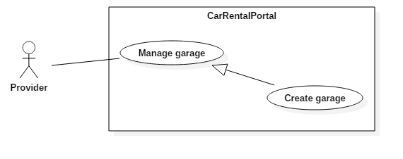

Figure 1: < Provider> Create garage

|  |  |  |  |
| --- | --- | --- | --- |
| USE CASE – UC001 | | | |
| Use Case No. | UC001 | **Use Case Version** | 2.0 |
| Use Case Name | Create garage | | |
| Author | ThànhHC | | |
| Date | 27/09/2016 | **Priority** | Normal |
| Actor:   * Provider   Summary:   * This use case allows provider to create a new garage.   Goal:   * Provider have a garge to manage vehicles belong to this garage.   Triggers:   * Provider send request in page “Quản lý garage” to create garage.   Preconditions:   * Login as roles provider.   Post Conditions:   * Success: Provider has new garage. * Fail: Show error message.   Main Success Scenario:   |  |  |  | | --- | --- | --- | | Step | Actor Action | System Response | | 1 | Provider click “Tạo garage mới” button. | System show popup requires information :   * Tên garage: free text input, required, max length 100 * Địa điểm: dropdown list, required * Địa chỉ: free text input, required, max length 200 * Email: free text input, required * Số điện thoại (mặc định): free text input, required, min length 10, max length 20 * Số điện thoại (bổ sung): free text input, min length 10, max length 20 * Mô tả: free text input * Điều khoản: free text input * Thời gian mở cửa: text input with time format and checkbox “Nghỉ”. By default, from Monday to Friday open at 8:00, close at 17:00. Saturday and Sunday checkbox “Nghỉ” is checked. | | 2 | Provider inputs information. |  | | 3 | Provider click to button “Tạo garage” that sends request to create to system  [Alternative 1] | Provider create a new garage successfully.  [Exception 1]  [Exception 2]  [Exception 3]  [Exception 4]  [Exception 5]  [Exception 6]  [Exception 7]  [Exception 8]  [Exception 9] |   Alternative Scenario:   |  |  |  | | --- | --- | --- | | No | Actor Action | System Response | | 1 | Provider click to “Đóng” button. | Current popup will be closed. |   Exceptions:   |  |  |  | | --- | --- | --- | | No | Actor Action | System Response | | 1 | Provider missed to input “Tên garage” field | System show error message “Vui lòng nhập tên garage” | | 2 | Provider missed to input “Địa chỉ” field | System show error message “Vui lòng nhập địa chỉ” | | 3 | Provider missed to input “Email” field | System shows error message “Vui lòng nhập email” | | 4 | Provider missed to input “Số điện thoại (mặc định)” field | System shows error message “Vui lòng nhập số điện thoại” | | 5 | Provider input “Tên garage” is over length allowed | System shows error message “Xin lỗi. Tên của garage vượt quá độ dài quy định” | | 6 | Provider input “Địa chỉ” is over length allowed | System shows error message “Xin lỗi. Địa chỉ vượt quá độ dài quy định” | | 7 | Provider input “Email” is wrong format | System shows error message “Email không hợp lệ” | |  | Provider input “Số điện thoại” is wrong format.  Valid format:  ^[0-9-+]+$ | System shows error message “Số điện thoại không hợp lệ” | | 8 | Provider input “Thời gian mở cửa” textfield “Từ” has higher value than textfield “Đến”. | System shows error message “Xin lỗi, thời gian đóng cửa không được sớm hơn thời gian mở cửa” | | 9 | Provider input “Thời gian mở cửa” wrong time format | System shows error message “Xin lỗi, giá trị thời gian không hợp lệ” |   Relationships: N/A  Business Rules:   * After garage is created, garage has no vehicle inside and status “Đang mở cửa”, list of garage will be reloaded. | | | |

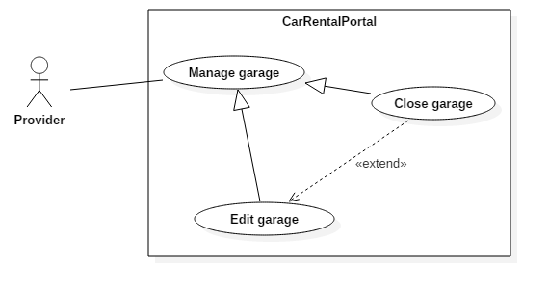

Figure 2: < Provider> Close garage

|  |  |  |  |
| --- | --- | --- | --- |
| USE CASE – UC002 | | | |
| Use Case No. | UC002 | **Use Case Version** | 2.0 |
| Use Case Name | Close garage | | |
| Author | ThànhHC | | |
| Date | 27/09/2016 | **Priority** | Normal |
| Actor:   * Provider   Summary:   * This use case allows provider to change garage’s status.   Goal:   * Garage’s status will be changed to “Đã đóng cửa”.   Triggers:   * Provider click to “Đóng cửa garage” in page “Quản lý garage” to change garage’s status. * Provider click to button “Ngừng hoạt động” in page “Thông tin garage” to change garage’s status.   Preconditions:   * Login as roles provider.   Post Conditions:   * Success: Garage’s status is changed. * Fail: Show error message.   Main Success Scenario:   |  |  |  | | --- | --- | --- | | Step | Actor Action | System Response | | 1 | Provider click “Đóng cửa garage” button. | System show popup with confirm message:  “Bạn có chắc chắn hủy kích hoạt garage này?  {garageName}” | | 2 | Provider choose an action. |  | | 3 | Provider click to button “Có” that sends request to change status to system  [Alternative 1] | Provider change garage’s status successfully. |   Alternative Scenario:   |  |  |  | | --- | --- | --- | | No | Actor Action | System Response | | 1 | Provider click to “Không” button. | Current popup will be closed. |   Exceptions: N/A  Relationships: Extend for “Edit garage”  Business Rules:   * After garage’s status is changed, garage’s status is “Đã đóng cửa” | | | |

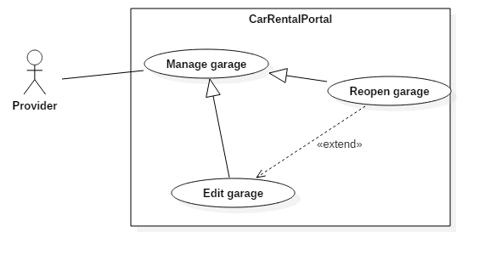

Figure 3: < Provider> Reopen garage

|  |  |  |  |
| --- | --- | --- | --- |
| USE CASE – UC003 | | | |
| Use Case No. | UC003 | **Use Case Version** | 2.0 |
| Use Case Name | Close garage | | |
| Author | ThànhHC | | |
| Date | 27/09/2016 | **Priority** | Normal |
| Actor:   * Provider   Summary:   * This use case allows provider to change garage’s status.   Goal:   * Garage’s status will be changed to “Đang mở cửa”.   Triggers:   * Provider click to “Mở cửa garage” in page “Quản lý garage” to change garage’s status. * Provider click to button “Tái kích hoạt” in page “Thông tin garage” to change garage’s status.   Preconditions:   * Login as roles provider.   Post Conditions:   * Success: Garage’s status is changed. * Fail: Show error message.   Main Success Scenario:   |  |  |  | | --- | --- | --- | | Step | Actor Action | System Response | | 1 | Provider click “Mở cửa garage” button. | System show popup with confirm message:  “Bạn có chắc chắn kích hoạt lại garage này?  {garageName}” | | 2 | Provider choose an action. |  | | 3 | Provider click to button “Có” that sends request to change status to system  [Alternative 1] | Provider change garage’s status successfully. |   Alternative Scenario:   |  |  |  | | --- | --- | --- | | No | Actor Action | System Response | | 1 | Provider click to “Không” button. | Current popup will be closed. |   Exceptions: N/A  Relationships: Extend for “edit garage”  Business Rules:   * After garage’s status is changed, garage’s status is “Đang mở cửa” | | | |

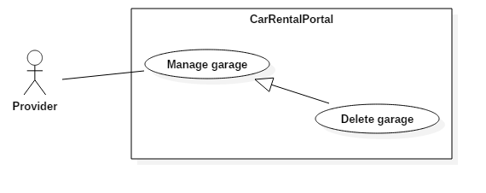

Figure 4: < Provider> Delete garage

|  |  |  |  |
| --- | --- | --- | --- |
| USE CASE – UC004 | | | |
| Use Case No. | UC004 | **Use Case Version** | 2.0 |
| Use Case Name | Delete garage | | |
| Author | ThànhHC | | |
| Date | 27/09/2016 | **Priority** | Normal |
| Actor:   * Provider   Summary:   * This use case allows provider to delete a garage.   Goal:   * Garage will be deleted from list of garage.   Triggers:   * Provider click to “Xóa” in page “Quản lý garage” to delete a garage. * Provicer click to button “Xóa garage” in page “Thông tin garage” to delete current garage.   Preconditions:   * Login as roles provider.   Post Conditions:   * Success: List of garage will be reloaded. * Fail: Show error message.   Main Success Scenario:   |  |  |  | | --- | --- | --- | | Step | Actor Action | System Response | | 1 | Provider click “Xóa” button. | System show popup with confirm message:  “Bạn có chắc chắn xóa garage này?  {garageName}” | | 2 | Provider choose an action. |  | | 3 | Provider click to button “Có” that sends request to delete to system.  [Alternative 1] | Provider delete garage successfully.  [Exception 1] |   Alternative Scenario:   |  |  |  | | --- | --- | --- | | No | Actor Action | System Response | | 1 | Provider click to “Không” button. | Current popup will be closed. |   Exceptions:   |  |  |  | | --- | --- | --- | | No | Actor Action | System Response | | 1 | Provider click “Có” button while number of vehicle in garage greater than 0. | System show error message “Còn xe trong garage, vui lòng, di chuyển xe qua garage khác trước khi xóa!” |   Relationships: N/A  Business Rules:   * After garage is deleted, list of garage will be reloaded. | | | |

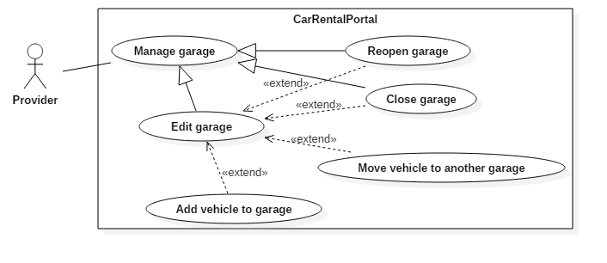

Figure 5: < Provider> Edit garage

|  |  |  |  |
| --- | --- | --- | --- |
| USE CASE – UC005 | | | |
| Use Case No. | UC005 | **Use Case Version** | 2.0 |
| Use Case Name | Edit garage | | |
| Author | ThànhHC | | |
| Date | 27/09/2016 | **Priority** | Normal |
| Actor:   * Provider   Summary:   * This use case allows provider to edit garage’s information.   Goal:   * Garage’s information will be updated.   Triggers:   * Provider send request to update garage’s information.   Preconditions:   * Login as roles provider.   Post Conditions:   * Success: Garage detail will be reloaded. * Fail: Show error message.   Main Success Scenario:   |  |  |  | | --- | --- | --- | | Step | Actor Action | System Response | | 1 | Provider click “Chỉnh sửa thông tin” button. | System show edit controls requires information :   * Tên garage: free text input, required, max length 100 * Địa điểm: dropdown list, required * Địa chỉ: free text input, required, max length 200 * Email: free text input, required * Số điện thoại (mặc định): free text input, required, min length 10, max length 20 * Số điện thoại (bổ sung): free text input, min length 10, max length 20 * Mô tả: free text input * Điều khoản: free text input * Thời gian mở cửa: text input with time format and checkbox “Nghỉ”. By default, from Monday to Friday open at 8:00, close at 17:00. Saturday and Sunday checkbox “Nghỉ” is checked. | | 2 | Provider choose an action. |  | | 3 | Provider click to button “Lưu lại” that sends request to update to system.  [Alternative 1] | Provider update garage’s information successfully.  [Exception 1]  [Exception 2]  [Exception 3]  [Exception 4]  [Exception 5]  [Exception 6]  [Exception 7]  [Exception 8]  [Exception 9] |   Alternative Scenario:   |  |  |  | | --- | --- | --- | | No | Actor Action | System Response | | 1 | Provider click to “Hủy bỏ” button. | All display controls will be closed. |   Exceptions:   |  |  |  | | --- | --- | --- | | No | Actor Action | System Response | | 1 | Provider missed to input “Tên garage” field | System show error message “Vui lòng nhập tên garage” | | 2 | Provider missed to input “Địa chỉ” field | System show error message “Vui lòng nhập địa chỉ” | | 3 | Provider missed to input “Email” field | System shows error message “Vui lòng nhập email” | | 4 | Provider missed to input “Số điện thoại (mặc định)” field | System shows error message “Vui lòng nhập số điện thoại” | | 5 | Provider input “Tên garage” is over length allowed | System shows error message “Xin lỗi. Tên của garage vượt quá độ dài quy định” | | 6 | Provider input “Địa chỉ” is over length allowed | System shows error message “Xin lỗi. Địa chỉ vượt quá độ dài quy định” | | 7 | Provider input “Email” is wrong format | System shows error message “Email không hợp lệ” | |  | Provider input “Số điện thoại” is wrong format.  Valid format:  ^[0-9-+]+$ | System shows error message “Số điện thoại không hợp lệ” | | 8 | Provider input “Thời gian mở cửa” textfield “Từ” has higher value than textfield “Đến”. | System shows error message “Xin lỗi, thời gian đóng cửa không được sớm hơn thời gian mở cửa” | | 9 | Provider input “Thời gian mở cửa” wrong time format | System shows error message “Xin lỗi, giá trị thời gian không hợp lệ” |   Relationships: extended by “Close garage”, “Reopen garage”, “Add vehicle to garage” and “Move vehicle to another garage”  Business Rules:   * After garage’s information is updated, garage’s detail page will be reloaded. | | | |

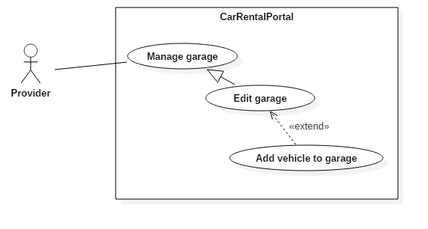

Figure 6: < Provider> Add vehicle to garage

|  |  |  |  |
| --- | --- | --- | --- |
| USE CASE – UC006 | | | |
| Use Case No. | UC006 | **Use Case Version** | 2.0 |
| Use Case Name | Add vehicle to garage | | |
| Author | ThànhHC | | |
| Date | 27/09/2016 | **Priority** | Normal |
| Actor:   * Provider   Summary:   * This use case allows provider to add vehicle to current garage.   Goal:   * A vehicle which is chosen will belong to this garage.   Triggers:   * Provider send request to update vehicle in garage.   Preconditions:   * Login as roles provider.   Post Conditions:   * Success: List of vehicle in current garage will be reloaded. * Fail: Show error message.   Main Success Scenario:   |  |  |  | | --- | --- | --- | | Step | Actor Action | System Response | | 1 | Provider click “Thêm xe vào Garage” button. | System show popup with requires information:   * Vehicle: dropdown list, required. | | 2 | Provider choose an action. |  | | 3 | Provider click to button “Thêm” that sends request to update garage’s vehicle to system.  [Alternative 1] | Provider update garage’s vehicle successfully. |   Alternative Scenario:   |  |  |  | | --- | --- | --- | | No | Actor Action | System Response | | 1 | Provider click to “Đóng” button. | Current popup will be closed. |   Exceptions: N/A  Relationships: Extend for “Edit garage”  Business Rules:   * Vehicle will be added to current garage with a link to view vehicle’s detail. | | | |

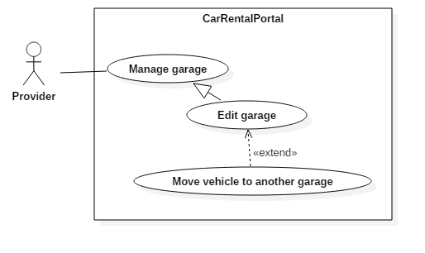

Figure 7: < Provider> Move vehicle to another garage

|  |  |  |  |
| --- | --- | --- | --- |
| USE CASE – UC007 | | | |
| Use Case No. | UC007 | **Use Case Version** | 2.0 |
| Use Case Name | Move vehicle to another garage | | |
| Author | ThànhHC | | |
| Date | 27/09/2016 | **Priority** | Normal |
| Actor:   * Provider   Summary:   * This use case allows provider to move a vehicle in current garage to another garage   Goal:   * Vehicle not belong to current garage any more. That will be tranfer to target garage.   Triggers:   * Provider send request to move vehicle to target garage.   Preconditions:   * Login as roles provider.   Post Conditions:   * Success: List of vehicle in current garage will be reloaded. * Fail: Show error message.   Main Success Scenario:   |  |  |  | | --- | --- | --- | | Step | Actor Action | System Response | | 1 | Provider click “Đổi garage” button. | System show popup with requires information:  Garage: dropdown list, required. | | 2 | Provider inputs information. |  | | 3 | Provider click to button “Đồng ý” that sends request to update this vehicle to another garage to system.  [Alternative 1] | Provider this vehicle to target garage successfully. |   Alternative Scenario:   |  |  |  | | --- | --- | --- | | No | Actor Action | System Response | | 1 | Provider click to “Đóng” button. | Current popup will be closed. |   Exceptions: N/A  Relationships: Extend for “Edit garage”  Business Rules:   * Selected vehicle will be moved to target garage, list of vehicle is updated. | | | |