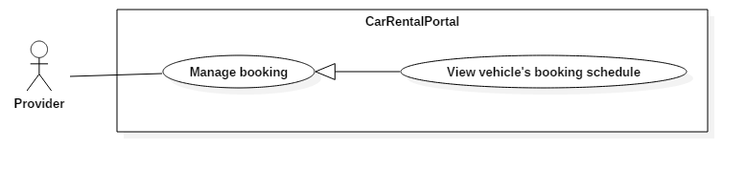

|  |  |  |  |
| --- | --- | --- | --- |
| USE CASE – UC01 | | | |
| Use Case No. | UC01 | **Use Case Version** | 2.0 |
| Use Case Name | View vehicle’s booking schedule | | |
| Author | KhoaLVD | | |
| Date | 04/11/2016 | **Priority** | Normal |
| Actor:   * Provider   Summary:   * This use case allows provider to view vehicle’s booking schedule.   Goal:   * Provider can view vehicle’s booking schedule.   Triggers:   * Provider clicks “Quản lý đặt xe” at the navigation bar. * At “Thông tin garage” page of the chosen vehicle, scroll down to vehicle datatable and clicks on “Thông tin đặt xe” tab. * Provider clicks on chosen vehicle name at “Quản lý xe” page or at vehicle datatable at “Thông tin garage” page to go to that vehicle’s detail page that include that vehicle booking schedule.   Preconditions:   * User must login into the system with role “Provider” still existed.   Post Conditions:   * Success: Vehicle’s booking schedule shows for provider. * Fail: Show error message.   Main Success Scenario:   |  |  |  | | --- | --- | --- | | Step | Actor Action | System Response | | 1 | Provider clicks “Quản lý đặt xe” at the navigation bar. | System shows “Quản lý đặt xe” page has the datatable include vehicle’s booking schedule. |   Alternative Scenario:   |  |  |  | | --- | --- | --- | | No | Actor Action | System Response | | 1 | Provider chose another garage at garage list. | Datatable will show information of vehicle of chosen garage | | 2 | Provider uncheck “Lọc theo garage” box. | Datatable will show information of vehicle of all garages. | | 3 | Provider choose “Tất cả” in “Thời gian thanh toán” box | Datatable will show information of the vehicle has booking in the past and in coming booking. | | 4 | Provider choose “Đã qua” in “Thời gian thanh toán’ box | Datatable will show information of the vehicle has booking in the past. | | 5 | Provider choose “Sắp đến” in “Thời gian thanh toán” box. | Datatable will show information of the vehicle has incoming booking. | | 6 | Provider checks “Hiện hóa đơn đã hủy” | Datatable will show information of the vehicle with status cancel. | | 7 | Provider checks “Hiện hóa đơn tự đặt” | Datatable will show information of the vehicle as provider booked. | | 8 | Provider clicks  of a vehicle | System will shows “Thông tin đặt xe” popup include detail information of that vehicle. |   Exceptions: N/A  Relationships: N/A  Business Rules:   * Datatable has to show correct and up-to-date information. | | | |

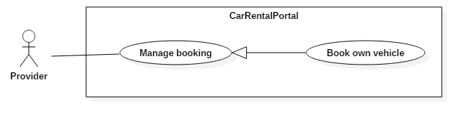

|  |  |  |  |
| --- | --- | --- | --- |
| USE CASE – UC02 | | | |
| Use Case No. | UC02 | **Use Case Version** | 2.0 |
| Use Case Name | Book own vehicle | | |
| Author | KhoaLVD | | |
| Date | 04/11/2016 | **Priority** | Normal |
| Actor:   * Provider   Summary:   * This use case allows provider to book their own vehicle.   Goal:   * Provider can book the vehicle they don’t want customer to book.   Triggers:   * Provider clicks on “Tự đặt xe này” button in “Thông tin chi tiết của xe” of that vehicle.   Preconditions:   * User must login into the system with role “Provider” still existed.   Post Conditions:   * Success: Provider successful book the vehicle. * Fail: Show error message.   Main Success Scenario:   |  |  |  | | --- | --- | --- | | Step | Actor Action | System Response | | 1 | Provider clicks “Quản lý đặt xe” at the navigation bar. | System shows “Quản lý đặt xe” page has the datatable include vehicle’s booking schedule. |   Alternative Scenario:   |  |  |  | | --- | --- | --- | | No | Actor Action | System Response | | 1 | Provider chose another garage at garage list. | Datatable will show information of vehicle of chosen garage | | 2 | Provider uncheck “Lọc theo garage” box. | Datatable will show information of vehicle of all garages. | | 3 | Provider choose “Tất cả” in “Thời gian thanh toán” box | Datatable will show information of the vehicle has booking in the past and in coming booking. | | 4 | Provider choose “Đã qua” in “Thời gian thanh toán’ box | Datatable will show information of the vehicle has booking in the past. | | 5 | Provider choose “Sắp đến” in “Thời gian thanh toán” box. | Datatable will show information of the vehicle has incoming booking. | | 6 | Provider checks “Đã hủy” in “Trạng thái hóa đơn” box | Datatable will show information of the vehicle with status cancel. | | 7 | Provider checks “Tự đặt” in “Trạng thái hóa đơn” box | Datatable will show information of the vehicle as provider booked. | | 8 | Provider clicks  of a vehicle | System will shows “Thông tin đặt xe” popup include detail information of that vehicle. |   Exceptions: N/A  Relationships: N/A  Business Rules:   * Datatable has to show correct and up-to-date information. | | | |

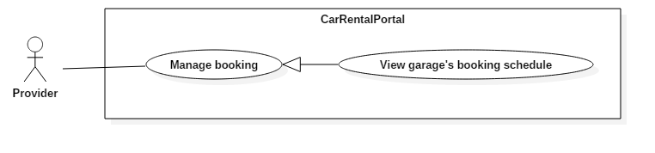

|  |  |  |  |
| --- | --- | --- | --- |
| USE CASE – UC03 | | | |
| Use Case No. | UC03 | **Use Case Version** | 2.0 |
| Use Case Name | View garage’s booking schedule | | |
| Author | KhoaLVD | | |
| Date | 04/11/2016 | **Priority** | Normal |
| Actor:   * Provider   Summary:   * This use case allows provider to view garage’s booking schedule.   Goal:   * Provider can view garage’s booking schedule.   Triggers:   * Provider clicks on “Thông tin đặt xe” tab in the datatable in “Thông tin garage” page.   Preconditions:   * User must login into the system with role “Provider” still existed.   Post Conditions:   * Success: Garage’s booking schedule shows for provider. * Fail: Show error message.   Main Success Scenario:   |  |  |  | | --- | --- | --- | | Step | Actor Action | System Response | | 1 | Provider clicks on “Thông tin đặt xe” tab in the datatable in “Thông tin garage” page. | System shows “Quản lý garage” page has the datatable include garage’s booking schedule. |   Alternative Scenario:   |  |  |  | | --- | --- | --- | | No | Actor Action | System Response | | 1 | Provider choose “Tất cả” in “Thời gian thanh toán” box | Datatable will show information of the vehicle has booking in the past and in coming booking. | | 2 | Provider choose “Đã qua” in “Thời gian thanh toán’ box | Datatable will show information of the vehicle has booking in the past. | | 3 | Provider choose “Sắp đến” in “Thời gian thanh toán” box. | Datatable will show information of the vehicle has incoming booking. | | 4 | Provider checks “Đã hủy” in “Trạng thái hóa đơn” box | Datatable will show information of the vehicle with status cancel. | | 5 | Provider checks “Tự đặt” in “Trạng thái hóa đơn” box | Datatable will show information of the vehicle as provider booked. | | 6 | Provider clicks  of a vehicle | System will shows “Thông tin đặt xe” popup include detail information of that vehicle. |   Exceptions: N/A  Relationships: N/A  Business Rules:   * Datatable has to show correct and up-to-date information. | | | |