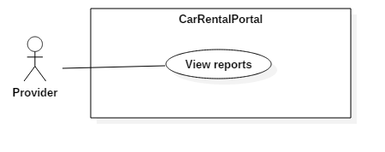

|  |  |  |  |
| --- | --- | --- | --- |
| USE CASE – UC01 | | | |
| Use Case No. | UC01 | **Use Case Version** | 2.0 |
| Use Case Name | View report | | |
| Author | KhoaLVD | | |
| Date | 04/11/2016 | **Priority** | Normal |
| Actor:   * Provider   Summary:   * This use case allows provider to view their report.   Goal:   * Provider can see their successful booking, current profit, comment and rating, numbers of garage and vehicle.   Triggers:   * After login successful into the website. * Clicks on “Xin chào, ___” button.   Preconditions:   * User must login into the system with role “Provider” still existed.   Post Conditions:   * Success: Provider can see their report. * Fail: Show error message.   Main Success Scenario:   |  |  |  | | --- | --- | --- | | Step | Actor Action | System Response | | 1 | Provider clicks on “Xin chào, ___” button. | System shows dashboard page has the chart and information of successful booking, current profit, comment and rating, numbers of garage and vehicle. |   Alternative Scenario: N/A  Exceptions: N/A  Relationships: N/A  Business Rules:   * Chart and information box has to show correct and up-to-date information. | | | |