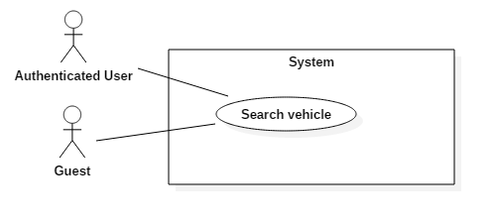

|  |  |  |  |
| --- | --- | --- | --- |
| USE CASE – US01 | | | |
| Use Case No. | US01 | **Use Case Version** | 2.0 |
| Use Case Name | Search vehicle | | |
| Author | KhoaLVD | | |
| Date | 04/11/2016 | **Priority** | High |
| Actor:   * Guest, customer   Summary:   * This use case allows users to search vehicle.   Goal:   * User can search for the vehicle fit with their required.   Triggers:   * User access homepage of the website.   Preconditions:  Post Conditions:   * Success: Shows fitted vehicles for user * Fail: Show error message.   Main Success Scenario:   |  |  |  | | --- | --- | --- | | Step | Actor Action | System Response | | 1 | User access homepage of the website. | System shows homepage with search bar. | | 2 | User clicks on “Chọn địa điểm thuê” | System shows list out places for users choose to book. | | 3 | User clicks on the 1st date time row. | System shows out calendar which can choose 30 days count from the day after. | | 4 | User clicks on the 2nd date time row. | System shows out calendar which can choose count from the day after. | | 5 | User clicks button. | System shows vehicles fit with user’s requirement. |   Alternative Scenario:   |  |  |  | | --- | --- | --- | | No | Actor Action | System Response | | 1 | User checks seats box at “Số chỗ ngồi” | System will shows vehicles which has seats corresponding with seats box user checked:   * 2 chỗ: 2 seats * 4 chỗ: 4 seats * 5 chỗ: 5 seats * 7 chỗ: 7 seats * 8 chỗ: 8 seats * 16 chỗ: 16 seats | | 2 | User pulls the slider at “Mức giá”  User pulls the left slider to the right  User pulls the right slider to the left | System will shows vehicles which has pride per day fit with the pride user pulls.  System will increase the min pride up to the left slider user pulls.  System will decrease max pride up to the right slider user pulls. | | 3 | User choose options of the list “Sắp xếp theo” | System will shows the result order by options user choose:   * Gói thời gian thuê xe phù hợp nhất: * Xe có điểm đánh giá tốt nhất: System will show vehicles order from high rating to lower. * Garage có điểm đánh giá tốt nhất: System will show vehicles order by their garage from high rating to lower * Giá từ thấp đến cao: System will show vehicles order from low pride to high pride. * Giá từ cao đến thấp: System will show vehicles order from high pride to low pride. * Xe từ mới đến cũ: System will show vehicles order from new to old which define by the year they made * Xe từ cũ đến mới: System will show vehicles order from old to new which define by the year they made | | 4 | User clicks on “Lọc chi tiết hơn về xe” tab:  User choose an option in “Dòng xe” list  User pulls the slider at “Năm sản xuất”  User checks options at “Hộp số”  User choose options of “Loại nhiên liệu” list  User choose options of “Loại xe” list  User checks colors at “Màu xe” | System will show more detail options for user to find suitable vehicles.  System will show vehicles which has brand fit with option user choose  System will show vehicles fit with the year range user choose  System will show vehicles which has transmission type fit which user choose:   * Số tự động: automatic * Số sàng: manual   System will show vehicles which has fuel type fit which user choose:   * Xăng: gasoline * Dầu diesel: diesel * Điện: electric * Điện hybrid: hybrid electric * Điện plug-in hybrid: plug-in hybrid electric   System will show vehicles fit with type of vehicle user choose  System will show vehicles which has the color user choose | | 5 | User clicks on “Lọc theo đánh giá” tab  User choose option of “Đánh giá xe” list  User choose option of “Đánh giá cửa hàng xe” list | System will show options for user to find vehicles by rating.  System will show vehicles which rated fit which option user choose:  : above 4 star  : above 3 star  : above 2 star  System will show vehicles which their garage’s rate fit which option user choose:  : above 4 star  : above 3 star  : above 2 star | | 6 | User clicks on “Xóa bỏ lọc” button. | System will clear all input user made to find vehicles and reset back to default. |   Exceptions: N/A  Relationships: N/A  Business Rules:   * Do not display unmatched vehicle(s) with options had been entered. * Result vehicle(s) must has pictures, pride, garage’s name, vehicle’s name, rating, number of rating, seats, fuel type and transmission type. | | | |

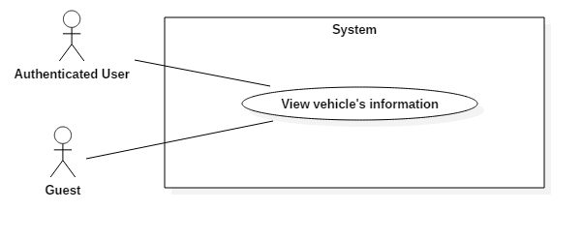

|  |  |  |  |
| --- | --- | --- | --- |
| USE CASE – UC02 | | | |
| Use Case No. | UC02 | **Use Case Version** | 2.0 |
| Use Case Name | View vehicle’s information | | |
| Author | KhoaLVD | | |
| Date | 05/11/2016 | **Priority** | High |
| Actor:   * Guest, authenticated user   Summary:   * This use case allows user to view vehicle’s information.   Goal:   * User can view information of the vehicle.   Triggers:   * User clicks on vehicle’s name at search page.   Preconditions:   * User can access the website.   Post Conditions:   * Success: Chosen vehicle show information in a new tab. * Fail: Show error message.   Main Success Scenario:   |  |  |  | | --- | --- | --- | | Step | Actor Action | System Response | | 1 | User clicks on vehicle’s name at search page. | Chosen vehicle show all information in a new tab. |   Alternative Scenario:   |  |  |  | | --- | --- | --- | | No | Actor Action | System Response | | 1 | User clicks on the picture | System will open a popup include all that vehicle’s pictures. | | 2 | Users clicks on  button | System will open “Thông tin liên lạc” popup include email, main phone number and sub phone number of the provider. |   Exceptions:   |  |  |  | | --- | --- | --- | | No | Actor Action | System Response | | 1 | User try to retrieve a vehicle information page but not exist in database | Redirect to an exception page |   Relationships: extended by “Book vehicle”  Business Rules:   * The information is loaded from the system correctly. | | | |

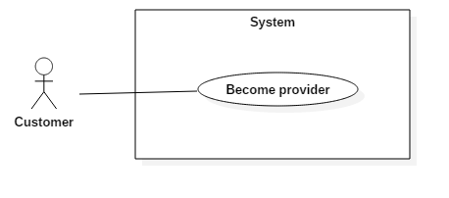

|  |  |  |  |
| --- | --- | --- | --- |
| USE CASE – US01 | | | |
| Use Case No. | US01 | **Use Case Version** | 2.0 |
| Use Case Name | Become provider | | |
| Author | KhoaLVD | | |
| Date | 05/11/2016 | **Priority** | Normal |
| Actor:   * Customer   Summary:   * This use case allows customer to become provider.   Goal:   * Customer becomes provider.   Triggers:   * Customer clicks on “Trở thành nhà cung cấp” at navigation bar.   Preconditions:   * Log in successful as role customer.   Post Conditions:   * Success: Customer becomes provider. * Fail: Show error message.   Main Success Scenario:   |  |  |  | | --- | --- | --- | | Step | Actor Action | System Response | | 1 | Customer clicks on “Trở thành nhà cung cấp” at navigation bar. | System shows become provider page which has 3 packs for customer to choose. | | 2 | User clicks on “Đăng ký” button in 1 of 3 packs. | System shows “Phương thức thanh toán” panel where user can choose what types of purchase user want to make:   * Thanh toán online bằng thẻ ngân hàng nội địa: purchase online by interior bank’s card. * Thanh toán bằng thẻ tín dụng / ghi nợ: purchase by visa. * Thanh toán bằng Ví điện tử NgânLượng: purchase by NgânLượng. | | 3 | User clicks on “Thanh toán” button. | System redirect to purchase page of the purchase type user choose. | | 4 | User fills information and clicks on “Thanh toán” button. | System redirect to homepage with provider role for that user |   Alternative Scenario:   |  |  |  | | --- | --- | --- | | No | Actor Action | System Response | | 1 | User clicks on “Hủy đơn hàng” button at become provider page. | System will redirect to homepage. | | 2 | User clicks on “Hủy đơn hàng” button at purchase page. | System will clear order and redirect to homepage. |   Exceptions: N/A  Relationships: N/A  Business Rules:   * User’s payment method must be safe. * After become provider, system must display the expired day below provider’s name. | | | |

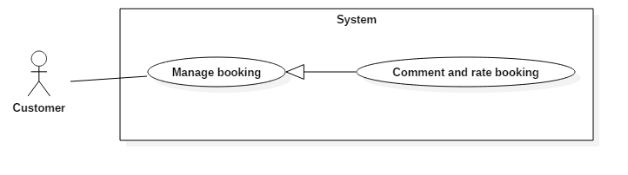

|  |  |  |  |
| --- | --- | --- | --- |
| USE CASE – US01 | | | |
| Use Case No. | US01 | **Use Case Version** | 2.0 |
| Use Case Name | Comment and rate booking | | |
| Author | KhoaLVD | | |
| Date | 05/11/2016 | **Priority** | Normal |
| Actor:   * Customer   Summary:   * This use case allows customer to comment and rate booking they booked.   Goal:   * Customer can rate and comment booking they booked.   Triggers:   * Customer choose “Đánh giá” option in  at “Lịch sử đặt xe” page.   Preconditions:   * Log in successful as role customer and has booked booking.   Post Conditions:   * Success: Comment and rating of customer appear in that vehicle’s information page. * Fail: Show error message.   Main Success Scenario:   |  |  |  | | --- | --- | --- | | Step | Actor Action | System Response | | 1 | Customer choose “Đánh giá” option in  at “Lịch sử đặt xe” page | System shows “Đánh giá xe” popup for customer to comment and rate. | | 2 | Customer clicks on star | System fill the stars fit which how many customer choose. | | 3 | Customer type in “Đánh giá” rick text box. | System requirement: minlenght20, maxlenght500 | | 4 | Customer clicks  button. | System will show “Đã gửi đánh giá thành công” alert. |   Alternative Scenario:   |  |  |  | | --- | --- | --- | | No | Actor Action | System Response | | 1 | Customer clicks  ,  or clicks outside the popup box. | System will close “Đánh giá xe” popup and back to “Lịch sử đặt xe” page. |   Exceptions:   |  |  |  | | --- | --- | --- | | No | Actor Action | System Response | | 1 | Customer don’t do anything and clicks  button | System will display “Vui lòng nhập” warning. | | 2 | Customer rate but don’t type anything in “Đánh giá” box. | System will display “Vui lòng nhập” | | 3 | Customer type less than 20 words. | System will display “Vui lòng nhập ít nhất 20 chữ” | | 4 | Customer type more than 200 words | System will display “Vui lòng nhập ít hơn 200 chữ” |   Relationships: N/A  Business Rules:   * User’s payment method must be safe. * After become provider, system must display the expired day below provider’s name. | | | |