Project
Cropper/Annotator

Application flow
- The program receives input/output directory on start
- Check if the directories exist
- Load the first image
- Register mouse event handler
- Display the first image
- Start application loop, waiting for user input
- Reacting to user input
  - Selecting cropping area (and accept annotation)
  - Moving to next/previous image
  - Crop and store to disk
  - Quit

Pressing the mouse button down starts the cropping area selection, the mouse can be moved to the desired location. On letting the left mouse button go, the selection will end. A rectangle will help to visualize the cropping area during and after selection. The area that lies outside of the cropping area gets darkened as soon as the mouse button is lifted.
If annotation mode is enabled, an annotation for the selection has to be typed into the command line (a graphical textbox or message box would have required a GUI-library – but we preferred to only keep using OpenCV).

The user can navigate to the next or previous image by pressing the N or B key respectively or quit the application with the Q key.
Pressing the S key crops and saves all images where a selection has been made. If annotation mode is enabled, a CSV file containing information about the cropped image and associated annotation is created and written to the output directory as well.

For the usage, please see the README. The link to the GitHub repository is as follows: https://github.com/fischly/FoIP-2020/tree/master/project
We attached a screenshot of the README file to this document as well.

Each step is commented in the code, we tried to make as many comments as we can.

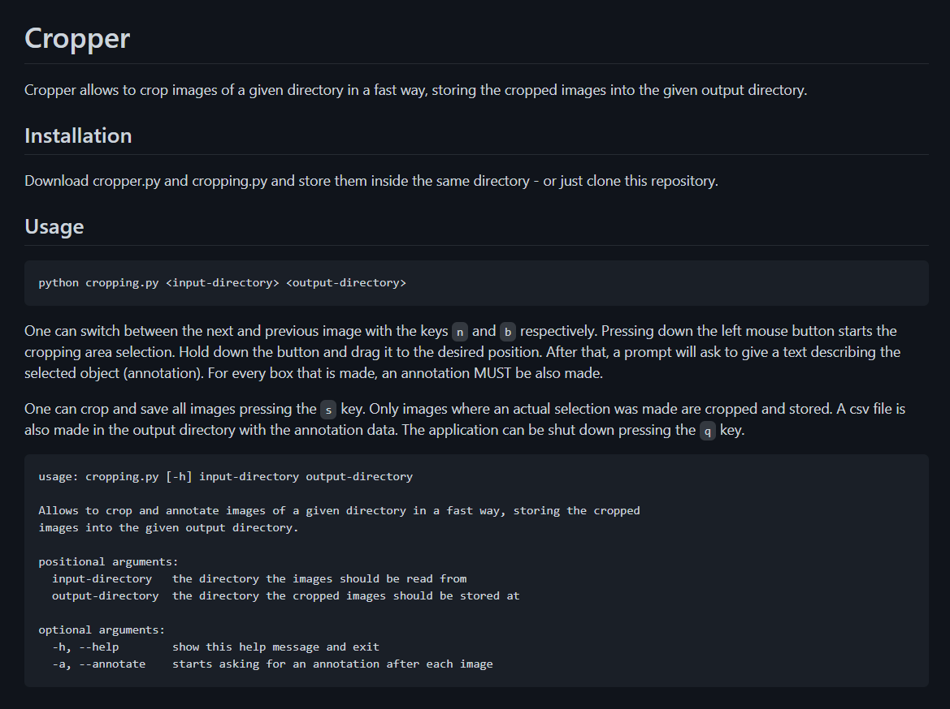
README.md

