Slidify your Presentations

Using HTML5 and Markdown to present R results

Daniel Fischer

## Disclaimer

I do not have any affiliation with any of the presented tools!

## Overview

1. Required Tools
2. ...

--- .segue .dark

## Required Tools

## Required Tools

We make use of the following Tools/ R-packages

1. RStudio
2. GitHub
3. Slidify (including Markdown)
4. googleVis

## RStudio

* Supposedly all of you have heard about RStudio.
* First version (v0.92) of RStudio was published in February 2011.
* Back then there were plenty of competing R editors, but these days RStudio became the quasi standard.
* The popularity of RStudio is due to its large amount of included features.
* RStudio is available as desktop and server version.
* RStudio also powers 'Shiny', a web application framework for R.
* One not so common, but very useful feature is the project feature.

## GitHub

* Supposedly most of you also have heard about GitHub (or at least git)
* git is a revision control system, initially developed 2005 by Linus Torvalds for the Linux kernel.
* GitHub is a filehosting service (founded 2008) that is based on the git technology.
* GitHub is designed especially for the development of larger software projects (branch, merge, fork).
* It is getting more and more popular to keep R-packages only on GitHub and not to submit to Cran.
* Researchers can apply for free private repositories via [GitHub education] (https://education.github.com/).
* GitHub provides webspace for webpages via GitHub pages (https://pages.github.com/).

## GitHub pages

* If you have a GitHub account, you could create a repository called

*username*.github.io

* Then, you can reach your webpage via

<http://username.github.io>

* To make things work proper, you should create a file

index.html

in the uppest level of the repository.

* Starting from there, you can have several subpages that can be stored in subfolders of your repository.
* It is advisable to name the entry page of ech subproject also index.html

## Setting up space for presentations on *GitHub pages*

* I recommend to use Linux, as this comes with practical all developer software installed.
* If your IT doesn't allow Linux, you could e.g. install it on a VirtualBox parallel to Windows so that you can literally switch between OS as you switch between Tools.
* Connect your computer to GitHub by providing an SSH keypair (create it in RStudio and add it to the profile at GitHub), this makes life easier.
* A step-by-step tutorial for this is provided by GitHub [here] (https://help.github.com/articles/generating-ssh-keys/).

## Setting up the GitHub repository

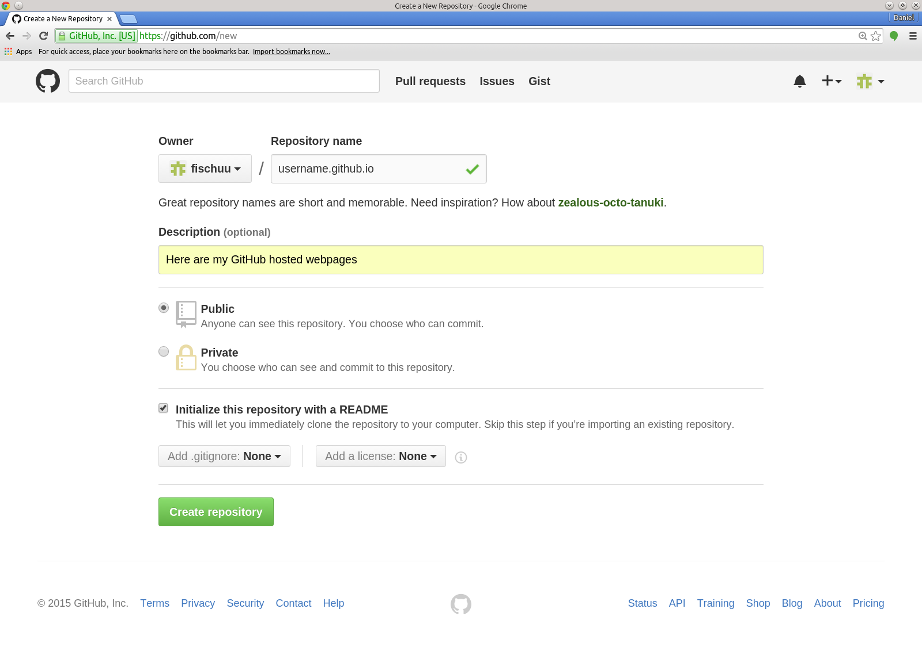

## Cloning to RStudio I

* It is important to tick the box

*Initialize this repository with a README*

* Having an initial README file in the repository enables us to clone it without any further problems.
* From the repository we get then its address (either HTTPS, SSH or Subversion)
* For RStudio we should copy the SSH address, e.g. in my case:

git@github.com:fischuu/fischuu.github.io.git

* We start RStudio and create a new project.

## Cloning to RStudio II

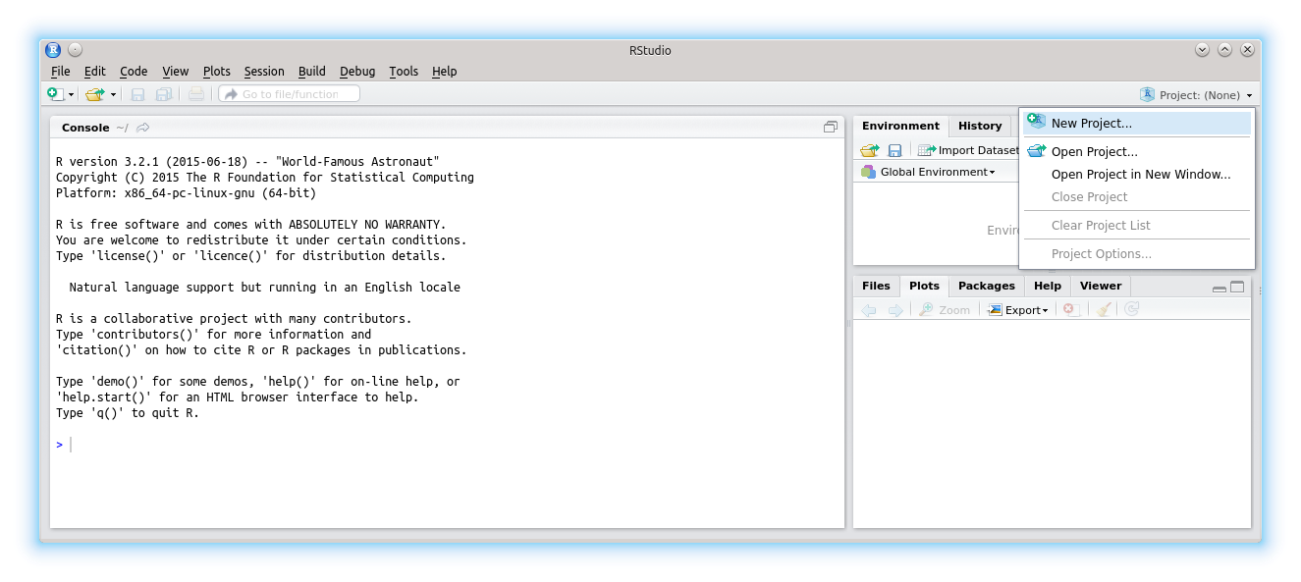

## Cloning to RStudio III

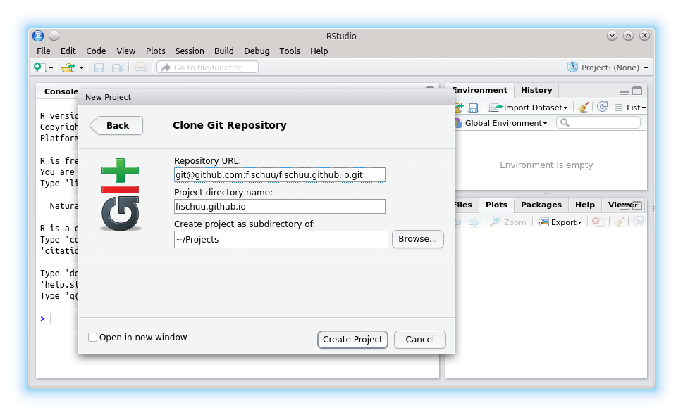

## Cloning to RStudio IV

* In the dialog we choose

1. Version Control
2. Git
3. And then we provide the URL (as SSH) of the repository, the name and location on HDD

* Then, we click on *'Create Project'*
* RStudio clones into the repository creates the folder/file structure on the HDD
* Now we can create an own folder structure (e.g. *presentations*, *lectures*, etc.)
* After those steps, we have succesful connected RStudio with GitHub pages and we can control the repository entirely with RStudio.

## Cloning to RStudio V

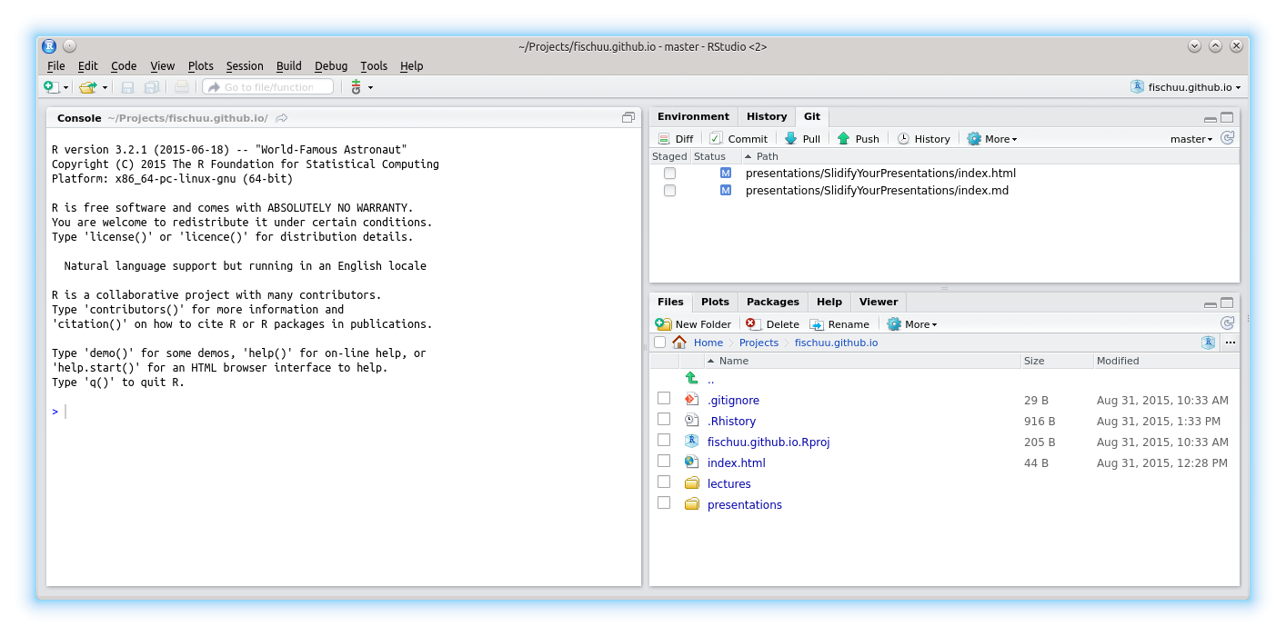

## Starting a new presentation

* To create a new presentation, we run

library("slidify")  
setwd("/home/ejo138/Projects/fischuu.github.io/presentations/")  
author("MyFirstPresentation", use_git = FALSE)

* The part use_git = FALSE might be irritating, but it is needed, as *slidify* would create otherwise a new git structure within the existing one (what is possible but would lead to far for now.)
* Slidify then creates all required files and you are ready to go.
* To create slides with Slidify no HTML knowledge is required, as everything is done via R [Markdown](https://en.wikipedia.org/wiki/Markdown).
* Markdown is a lightweight markup language with plain text formatting that can be transformed into HTML (or other languages).

## Output of author()

* The function author() creates several files and folders in the working directory.
* The main folder is called as defined in the author() call.
* Within that folder, two more folders called assets and libraries are created.
* The main document is called index.Rmd
* index.Rmd contains two main code chunks. The header written in YAML defines the meta-information of the document.
* The body contains the slides and uses the R Markdown language.

## This is where we start (YAML header of index.Rmd)

---  
title: "null"  
author: "null"  
highlighter: highlight.js  
output: pdf_document  
job: null  
knit: slidify::knit2slides  
mode: selfcontained  
hitheme: tomorrow  
subtitle: null  
framework: io2012  
widgets: []  
---  
  
## Read-And-Delete  
  
1. Edit YAML front matter  
...

## This is where we start (body of index.Rmd)

...  
hitheme: tomorrow  
subtitle: null  
framework: io2012  
widgets: []  
---  
  
## Read-And-Delete  
  
1. Edit YAML front matter  
2. Write using R Markdown  
3. Use an empty line followed by three dashes to separate slides!  
--- .class #id   
  
## Slide 2

## Markdown basics

* R markdown is a very simple markup language that makes creating slides extremely fast and easy.
* A reference overview can be found [here](http://rmarkdown.rstudio.com/authoring_basics.html)
* For example the [index.Rmd](https://github.com/fischuu/fischuu.github.io/raw/master/presentations/SlidifyYourPresentations/index.Rmd) of this presentation.