# Analysis of the cars data set in R

## by Fiseha Tadesse

**part1**

data (cars)  
str (cars)

## 'data.frame': 50 obs. of 2 variables:  
## $ speed: num 4 4 7 7 8 9 10 10 10 11 ...  
## $ dist : num 2 10 4 22 16 10 18 26 34 17 ...

summary (cars)

## speed dist   
## Min. : 4.0 Min. : 2.00   
## 1st Qu.:12.0 1st Qu.: 26.00   
## Median :15.0 Median : 36.00   
## Mean :15.4 Mean : 42.98   
## 3rd Qu.:19.0 3rd Qu.: 56.00   
## Max. :25.0 Max. :120.00

plot (cars)

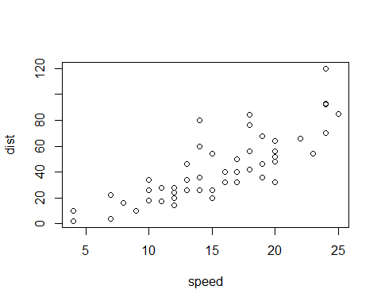

***part2***

hist(cars$speed)

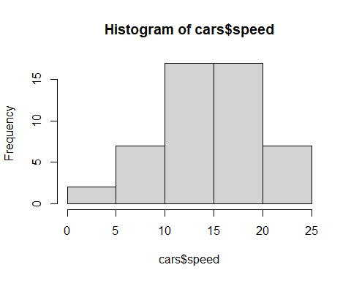

boxplot(cars$speed)

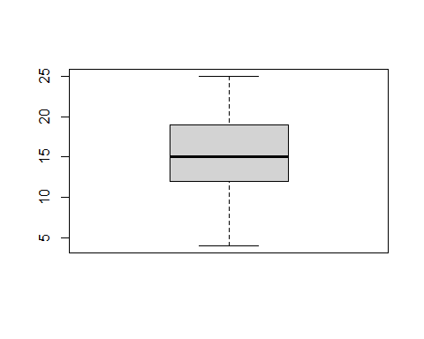

The mean speed of cars was 15.4.

#The end