UML - Class Diagrams

Project: Storm

The Very Best saling website

Creator: Nguyen Thi Luong

Last update: 24/11/2015

# AddCartAction

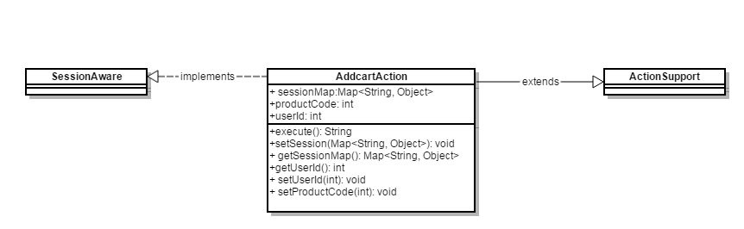

# AddFavoriteAction

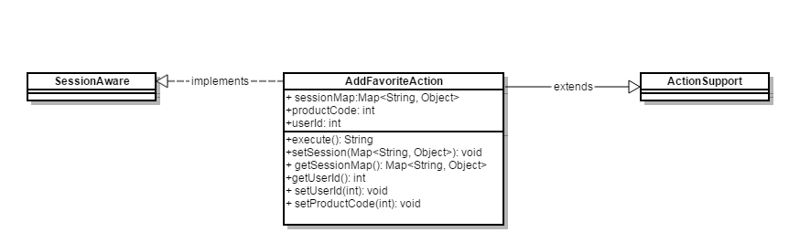

# CartAction

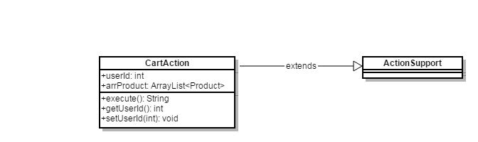

# ConnectionDB

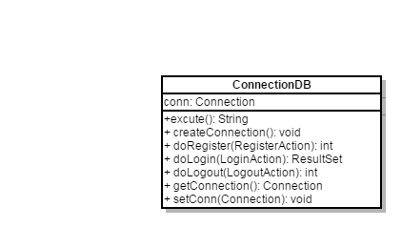

# DeleteCartAction

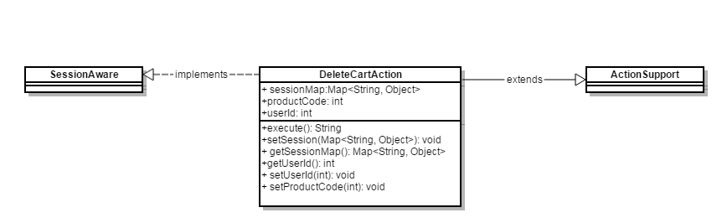

# DeleteFollowingAction

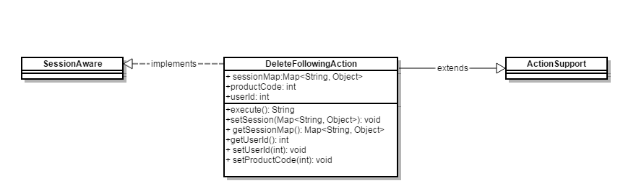

# DetailAction

# EditProfileAction

# 9. FollowingAction

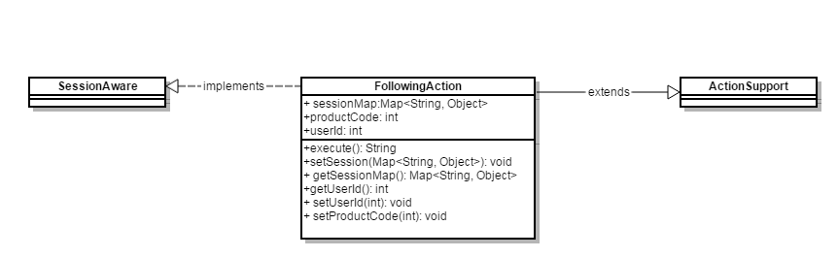

# 10. ListProductAction

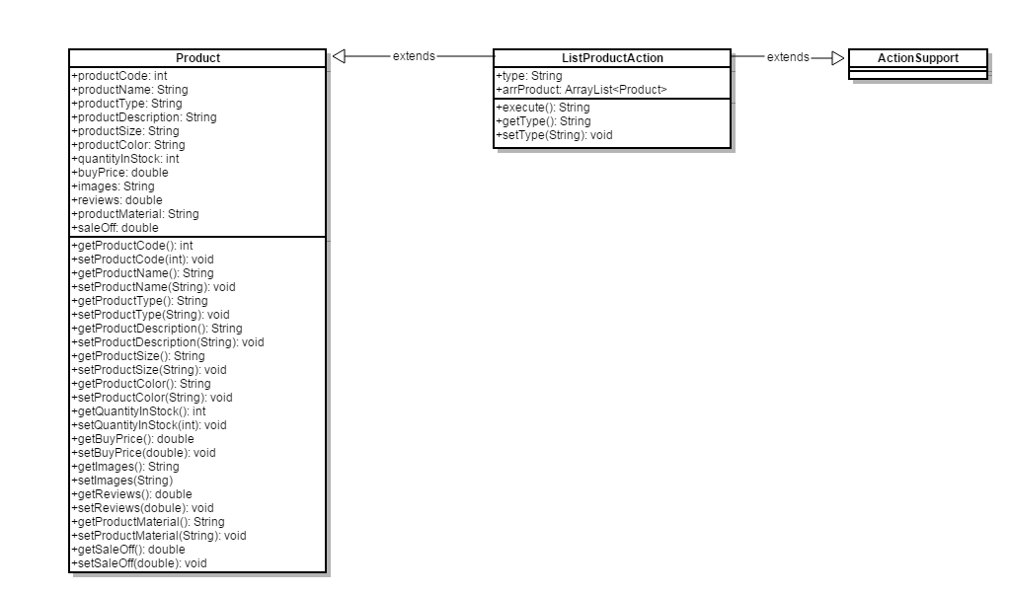

# 11. LoginAction

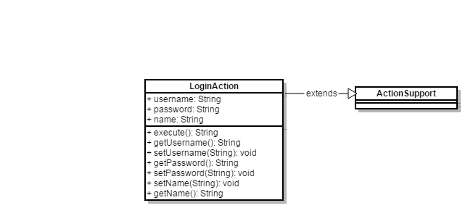

# 12. LogoutAction

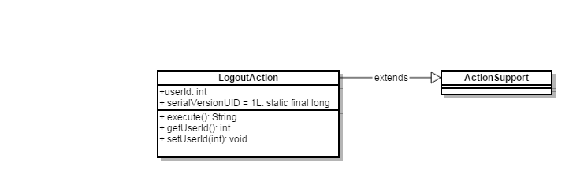

# 13. OrderAction

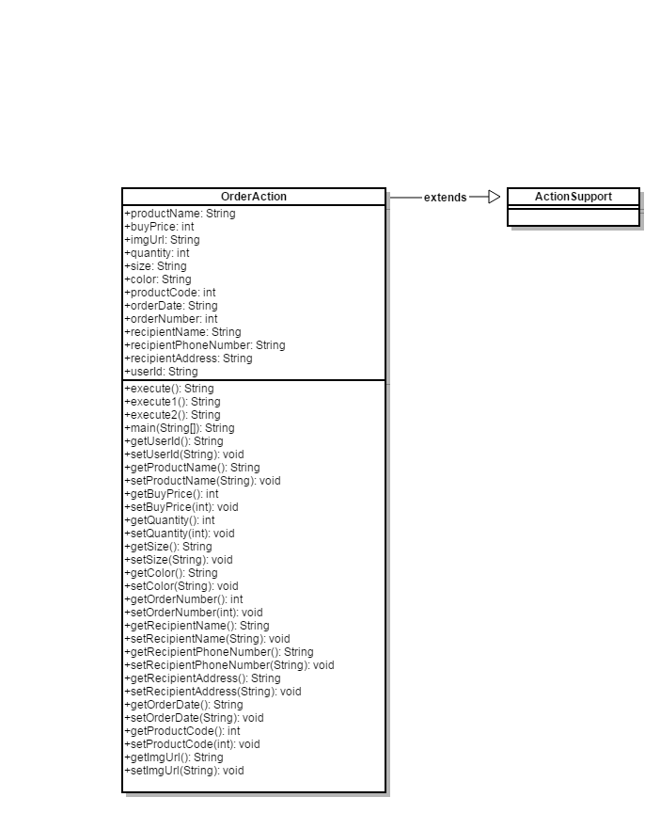

# 14. ProfileAction

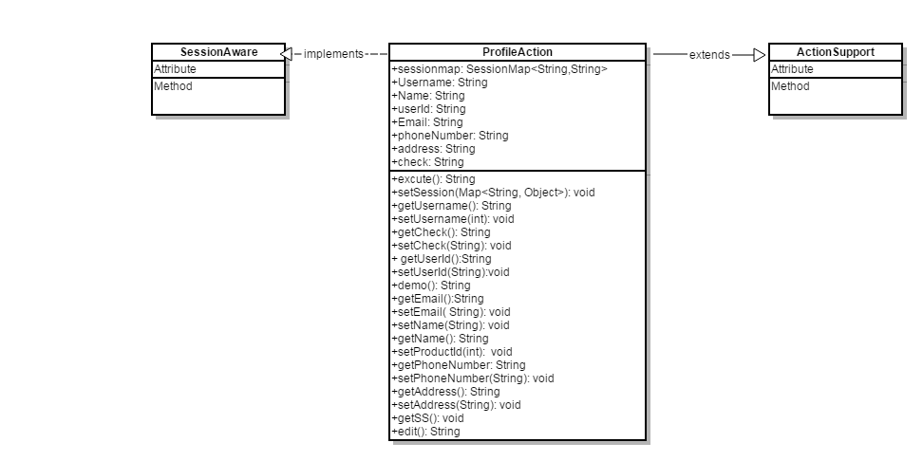

# 15. RegisterAction

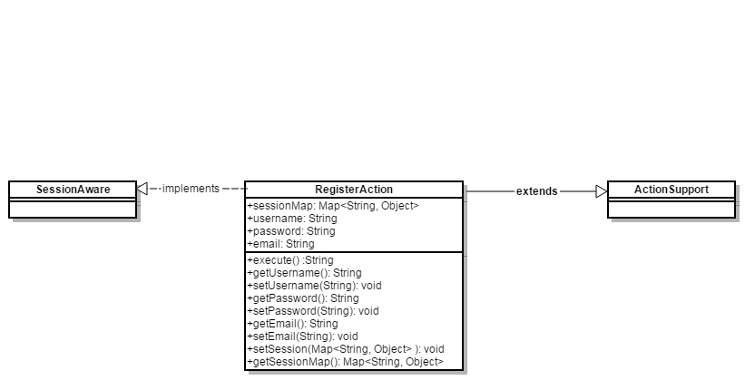

# 16. ReviewAction

