When you clone from github, project has config:

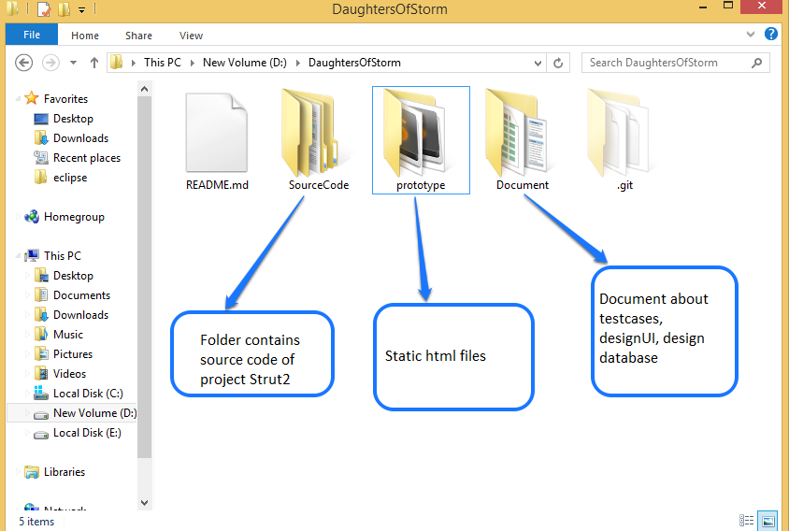

Open SourceCode Folder, you see folder DaughtersOfStorm: this is project Strut2

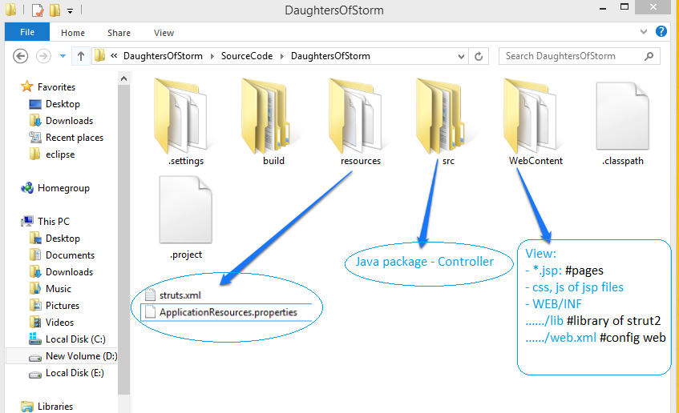

To write java class, you click to src, go to package com.storm.demo

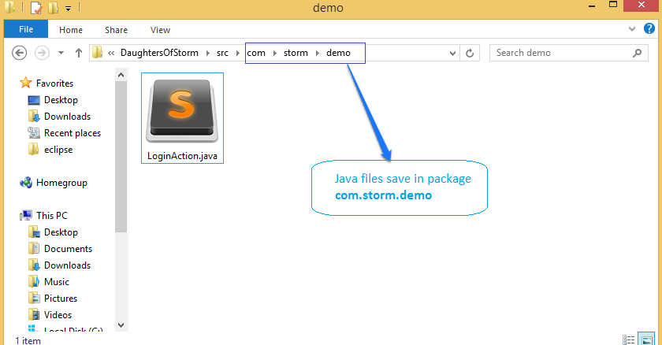

And see the views of project, you need to folder WebContent

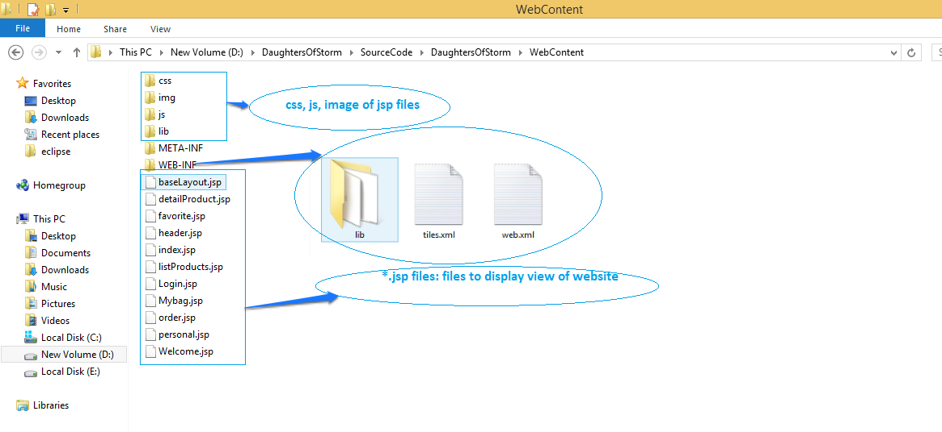

Detail of folder Web-INF:

