SET UP STORM_DEMO PROJECT DOCUMENT

1. **Setup java development (JDK):**

You can download the latest version of SDK from Oracle's Java site: <http://www.oracle.com/technetwork/java/javase/downloads/index.html> . You will find instructions for installing JDK in downloaded files, follow the given instructions to install and configure the setup. Finally set PATH and JAVA_HOME environment variables to refer to the directory that contains java and javac, typically java_install_dir/bin and java_install_dir respectively.

If you are running Windows and installed the SDK in C:\jdk1.5.0_20, you would have to put the following line in your C:\autoexec.bat file.



Alternatively, on Windows NT/2000/XP, you could also right-click on My Computer, select Properties, then Advanced, then Environment Variables. Then, you would update the PATH value and press the OK button.

On Unix (Solaris, Linux, etc.), if the SDK is installed in /usr/local/jdk1.5.0_20 and you use the C shell, you would put the following into your .cshrc file.



Alternatively, if you use an Integrated Development Environment (IDE) like Borland JBuilder, Eclipse, IntelliJ IDEA, or Sun ONE Studio, compile and run a simple program to confirm that the IDE knows where you installed Java, otherwise do proper setup as given document of the IDE.

1. **Setup apache Tomcat**

You can download the latest version of Tomcat from <http://tomcat.apache.org/> . Once you downloaded the installation, unpack the binary distribution into a convenient location. For example in C:\apache-tomcat-6.0.33 on windows, or /usr/local/apache-tomcat-6.0.33 on Linux/Unix and create CATALINA_HOME environment variable pointing to these locations.

Tomcat can be started by executing the following commands on windows machine, or you can simply double click on startup.bat.

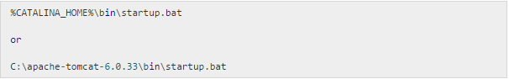

Tomcat can be started by executing the following commands on Unix (Solaris, Linux, etc.) machine:

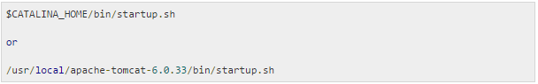

After a successful startup, the default web applications included with Tomcat will be available by visiting **http://localhost:8080/**. If everything is fine then it should display following result:

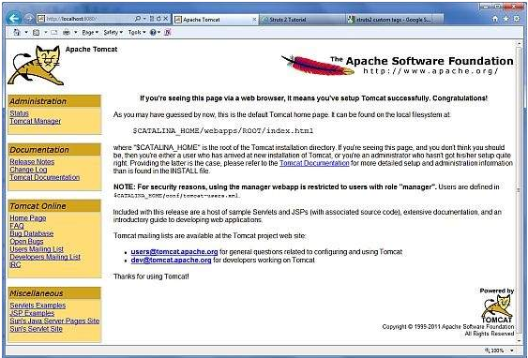

Further information about configuring and running Tomcat can be found in the documentation included here, as well as on the Tomcat web site: http://tomcat.apache.org

Tomcat can be stopped by executing the following commands on windows machine:

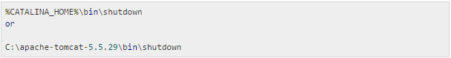

Tomcat can be stopped by executing the following commands on Unix (Solaris, Linux, etc.) machine:

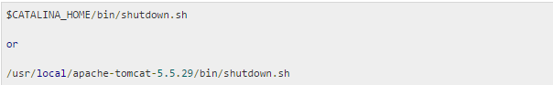

1. **Setup Eclipse**

To install Eclipse: Download the latest Eclipse binaries from <http://www.eclipse.org/downloads/> . Once you downloaded the installation, unpack the binary distribution into a convenient location. For example in C:\eclipse on windows, or /usr/local/eclipse on Linux/Unix and finally set PATH variable appropriately.

Eclipse can be started by executing the following commands on windows machine, or you can simply double click on eclipse.exe

%C:\eclipse\eclipse.exe

Eclipse can be started by executing the following commands on Unix (Solaris, Linux, etc.) machine:

$/usr/local/eclipse/eclipse

After a successful startup, if everything is fine then it should display following result:

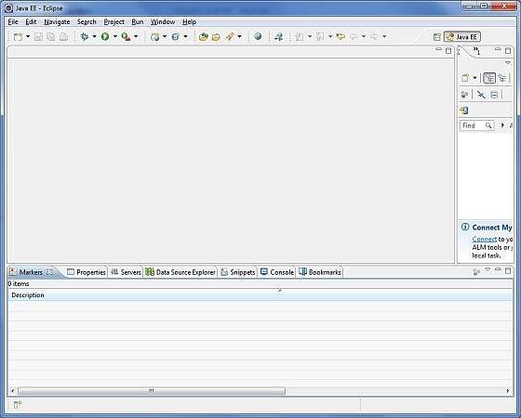

1. **Setup Struts2 Libraries**

Now if everything is fine, then you can proceed to setup your Struts 2 faremwork. Following are the simple steps to download and install Struts2 on your machine.

* Make a choice whether you want to install Struts2 on Windows, or Unix and then proceed to the next step to download .zip file for windows and .tz file for Unix.
* Download the latest version of Struts2 binaries from<http://struts.apache.org/download.cgi>.
* At the time of writing this tutorial, downloaded **struts-2.0.14-all.zip** and when you unzip the downloaded file it will give you directory structure inside C:\struts-2.2.3 as follows.

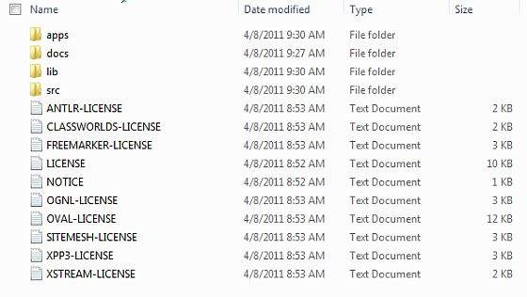

Second step is to extract the zip file in any location, downloaded & extracted **struts-2.2.3-all.zip** in **c:\** folder on my Windows 7 machine so that all the jar files into **C:\struts-2.2.3\lib**. Make sure you set your CLASSPATH variable properly otherwise you will face problem while running your application.

+  Now go to location where you have download strut2 package and open lib folder. You can have all jars but for now you can copy following jars

* struts2-core-2.3.15
* xwork-core-2.3.15
* ognl-3.4
* commons-io-2.0.1
* commons-fileupload-1.2.2
* javassist-3.11.0.GA
* freemarker-2.3.18
* commons-lang-2.5
* commons-logging-1.1.1
* commons-logging-api-1.1
* struts2-dojo-plugin-2.3.15.jar

Finally, open eclipe, choose project and paste all above copied jars to *WebContent->WEB-INF->lib*

1. **Download project**

<https://github.com/fiser-trangnt84/DaughtersOfStorm>

1. **Run project**

* Extract file DaughtersOfStorm.zip
* Open eclipse, click right mouse to project explorer section. And select import:

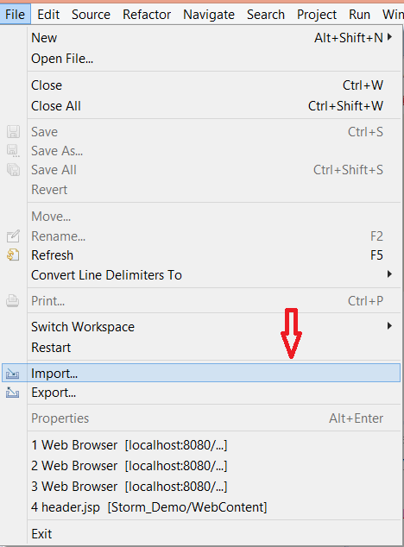

* Select Existing Projects into Workspace, select Next

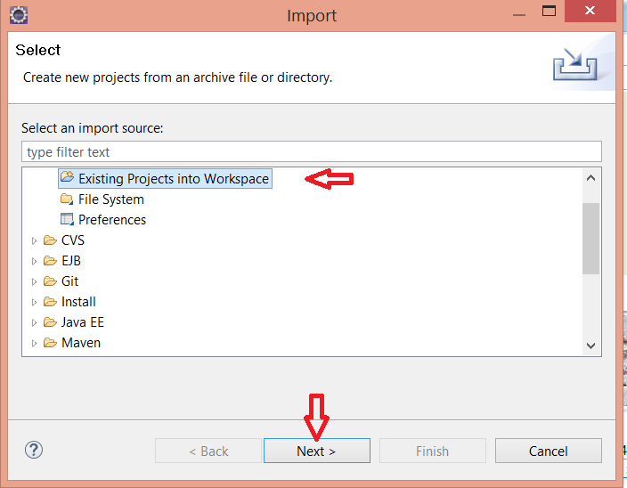

* Click Browse and choose link to project you download

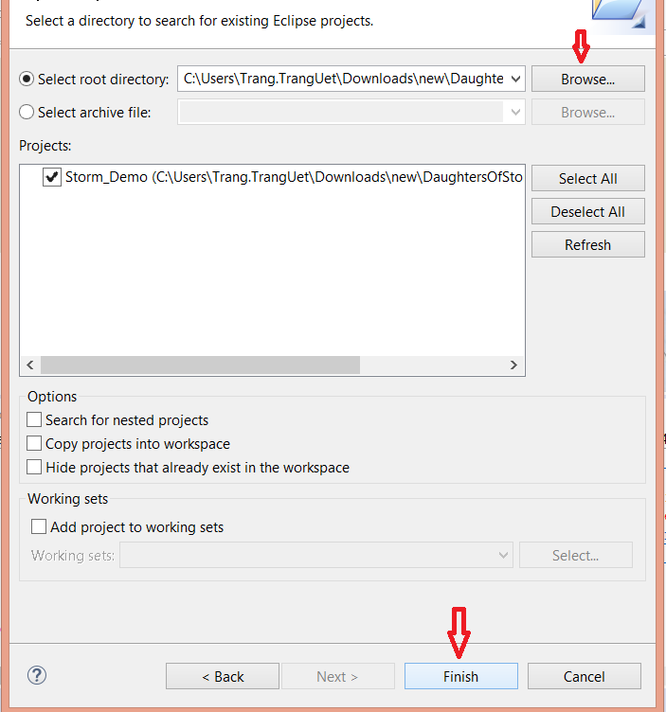

* Select Finish to start import project into Eclipse
* Then import, move mouse to Storm_Demo in Project window, click right mouse, choose Run As, choose Run in Server:

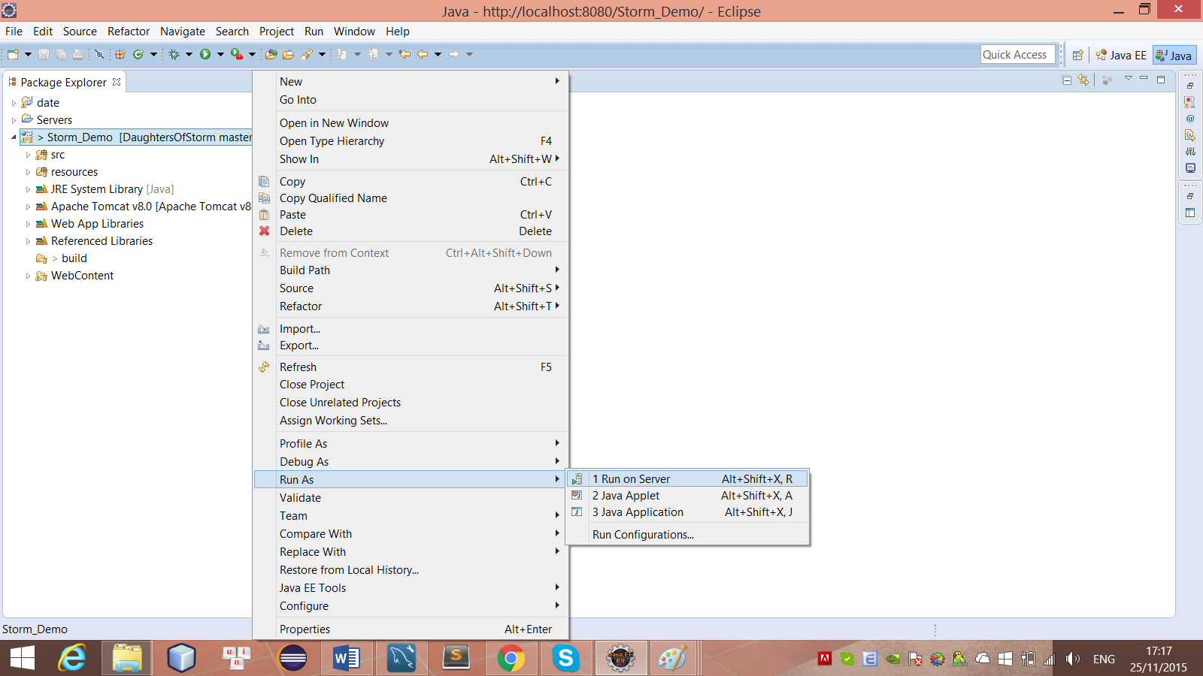

* A Run On Server Window appear, choose Tomcat v8.0 Server at localhost -> choose Next:

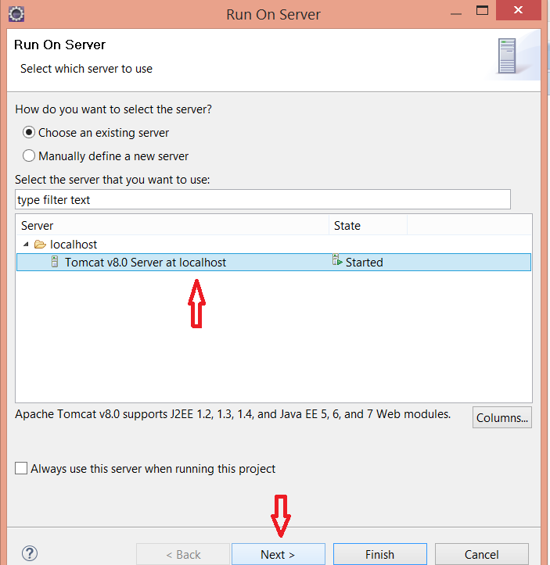

* In next window, you choose project Storm_Demo, then choose Finish to run project.

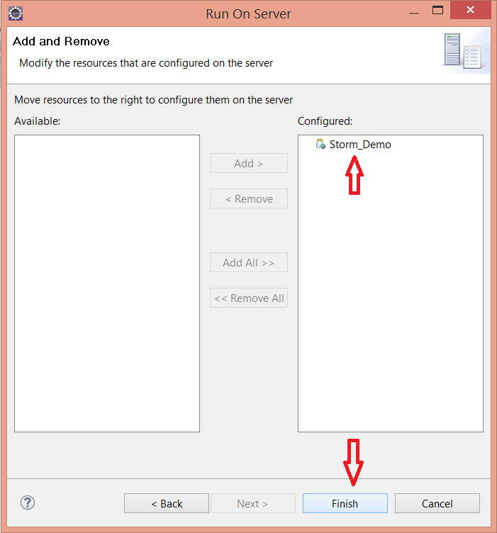

* Finally, click on Ok to start server.

