UML - UseCase Diagrams

Project: Storm

The Very Best Shopping website

Creator:Nguyen Thi Luong

Last update: 24/11/2015

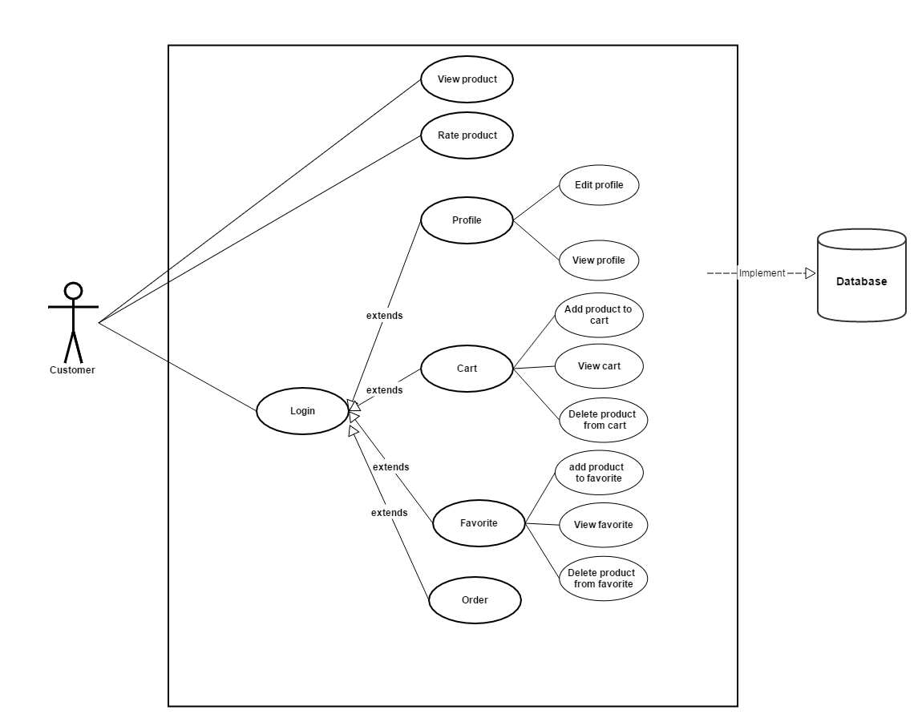

|  |  |
| --- | --- |
| **Name** | View product |
| **Actor** | Customer |
| **Description** | This function used to view list products following type and view detail a product. |
| **Preconditions** | Open website |
| **Postconditions** | Click on “Order” button to go to Order page or go to other page using links or button on header. |
| **Normal flow** | 1. Select type of list product  2. View list product  3. Click on image of product to view detail |
| **Alternative flow** |  |
| **Exception** |  |

|  |  |
| --- | --- |
| **Name** | Rate product |
| **Actor** | Customer |
| **Description** | This function used to rate a product. |
| **Preconditions** | 1.Open website  2. View detail a product |
| **Postconditions** | 1.Click number of stars on screen for product; |
| **Normal flow** | Click number of stars on screen for product from 1 to 5 |
| **Alternative flow** |  |
| **Exception** |  |

|  |  |
| --- | --- |
| **Name** | View profile |
| **Actor** | Customer |
| **Description** | This function used to view information in your profile and change data on database |
| **Preconditions** | 1.Open website  2. Login |
| **Postconditions** | Visit other links or button |
| **Normal flow** | 1.Click “username” link |
| **Alternative flow** |  |
| **Exception** | 1.Not login  2. ask to login |

|  |  |
| --- | --- |
| **Name** | Edit profile |
| **Actor** | Customer |
| **Description** | This function used to edit your profile and change data on database |
| **Preconditions** | 1.Open website  2. Login  3. View profile |
| **Postconditions** | 1.Enter all information include: name, email, phone, password, address.  2. Click “Submit” button |
| **Normal flow** | 1.Click “Edit” button  2.enter information  3.Click “Submit” |
| **Alternative flow** |  |
| **Exception** | 1.Not login  2. ask to login  3.One or more information not entered  4. show alert |

|  |  |
| --- | --- |
| **Name** | Add product to cart |
| **Actor** | Customer |
| **Description** | This function used to add product that you want to buy in to your cart and put them into database. |
| **Preconditions** | 1.Open website  2. Login  3. View product |
| **Postconditions** | Click cart icon below product |
| **Normal flow** | Click cart icon below product |
| **Alternative flow** | 1.Click image of product to view product detail  2.Click cart icon below product |
| **Exception** | 1.Not login  2. ask to login |

|  |  |
| --- | --- |
| **Name** | View products in cart |
| **Actor** | Customer |
| **Description** | This function used to view product in your cart |
| **Preconditions** | 1.Open website  2. Login |
| **Postconditions** | 1.Click other link or button on screen |
| **Normal flow** | 1.Click cart icon on header |
| **Alternative flow** | 1.Click “User name”  2.Click “My cart” below avatar |
| **Exception** | 1.Not login  2.Ask to login |

|  |  |
| --- | --- |
| **Name** | Delete product from cart |
| **Actor** | Customer |
| **Description** | This function used to delete product from your cart and update database |
| **Preconditions** | 1.Open website  2. Login  3. View cart |
| **Postconditions** | 1.Confirm deleting |
| **Normal flow** | 1.Click “delete” icon  2. confirm deleting by clicking “confirm” |
| **Alternative flow** |  |
| **Exception** | 1.Not login  2.Ask to login |

|  |  |
| --- | --- |
| **Name** | Add product to favorite |
| **Actor** | Customer |
| **Description** | This function used to add product that you want to follow and put them into customer table on database. |
| **Preconditions** | 1.Open website  2. Login  3. View product |
| **Postconditions** | Click following icon below product |
| **Normal flow** | Click cart icon below product |
| **Alternative flow** | 1.Click image of product to view product detail  2.Click following icon below product |
| **Exception** | 1.Not login  2. ask to login |

|  |  |
| --- | --- |
| **Name** | View favorite |
| **Actor** | Customer |
| **Description** | This function used to view product in your favorite |
| **Preconditions** | 1.Open website  2. Login |
| **Postconditions** | 1.Click other link or button on screen |
| **Normal flow** | 1.Click “User name”  2.Click “Following” below avatar |
| **Alternative flow** |  |
| **Exception** | 1.Not login  2.Ask to login |

|  |  |
| --- | --- |
| **Name** | Delete product from favorite |
| **Actor** | Customer |
| **Description** | This function used to delete product from your favorite and update database |
| **Preconditions** | 1.Open website  2. Login  3. View favorite |
| **Postconditions** | 1.Confirm deleting |
| **Normal flow** | 1.Click “delete” icon  2. confirm deleting by clicking “confirm” |
| **Alternative flow** |  |
| **Exception** | 1.Not login  2.Ask to login |

|  |  |
| --- | --- |
| **Name** | Order |
| **Actor** | Customer |
| **Description** | This function used to order and buy product |
| **Preconditions** | 1.Open website  2. Login  3. View product |
| **Postconditions** | 1.Click “Confirm” button |
| **Normal flow** | 1.Click “buy now” button  2. Enter information  3. Click “Submit” button  2 confirm ordering by clicking “confirm” |
| **Alternative flow** |  |
| **Exception** | 1.Not login  2.Ask to login |