USER GUIDE

Table of Contents

1 Introduction 4

1.1 Scope and Purpose of Document 4

1.2 Process Overview 4

2 Process/WorkFlow 6

2.1 Initialize website 6

2.1.1 Register 6

2.1.2 Login 7

2.2 Add a product to cart 7

2.3 Add a produc to favorite 7

2.4 Delete a product from cart 7

2.5 Delate a product from favorite 7

2.6 Order a product 7

3 Conclussion 9

# Introduction

## Scope and Purpose

This document is written to describe all of the function of sales website .

Document include 3 parts:

+ Introduction

+ Process

+ Conclussion

## Process Overview



* Home tab is where you can see first, you can find the newest and the most popular products .
* What’s New , click here to see the newest product
* The next tab is Hot, what is the most prevalent, the fashionable style is favorite and chosen by almost customer.
* The Sale tab show you the sale product with attractive price level. Give a lot of chooses for people would like own the cheap and beautiful products.
* The Trend help to update the fashion trends at the present time.
* The last is About Us, you can find comments, feebacks from other cusomers. You can see who are the salemans with their contact address, how you can get yourself a product most quickly, …

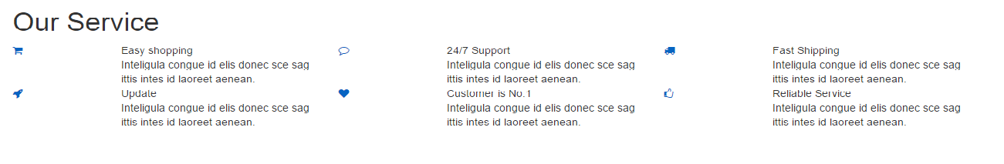

Our Service include all of convenient service for customer such as: Cart, Support, Shipping, Update, Favorite, Like



This bar show you how to contact with us, bring to you some connections to facebook, twitter, google,..

# Process/WorkFlow

## Initialize website

### Register

1. Click on Register button on the top to create a new account for a user.
2. Fill in the username, email and password blank.
3. Click Register to submit and complete .

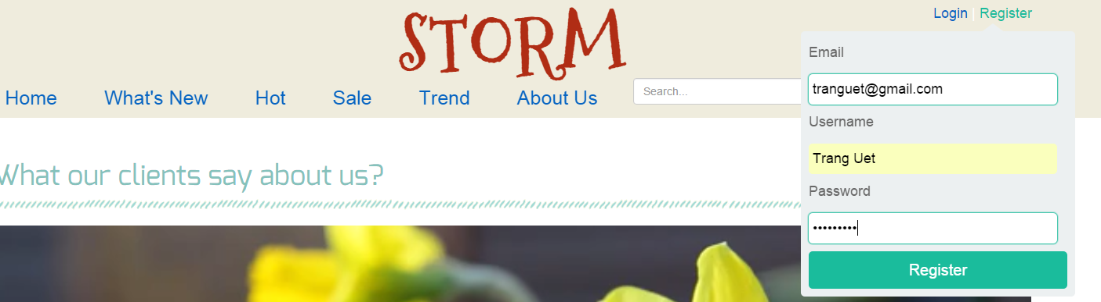

### Login

1. Click on Login button on the top to sign in for a user.
2. Fill in the username and password blank.
3. Click Login to sign in.

### 2.2 Add a product to cart

1. Enter <http://localhost:8080/Storm_Demo/>, the first thing you can see is Home, so you can click on What’s New, Hot, Trends,Sales to see products.

A list of product show on, you can click on symbol of Cart to add that product to your cart.

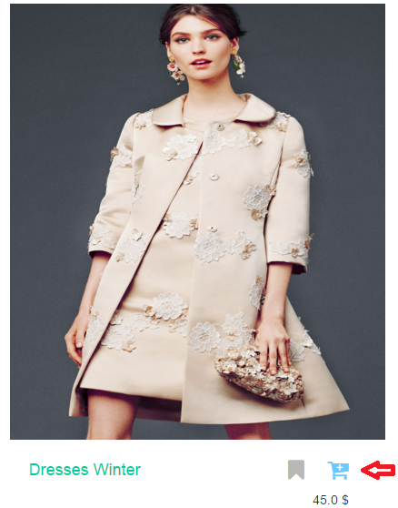

1. Then click, page move to your cart
2. Click or press something to complete the procedure.

## 2.3 Add a product to favorite

1. Add product to favorite   
   Enter <http://localhost:8080/Storm_Demo/>, the first thing you can see is Home, so you can click on What’s New, Hot, Trends,Sales to see products.

A list of product show on, you can click on symbol of Favorite to add that product to your favorite list.

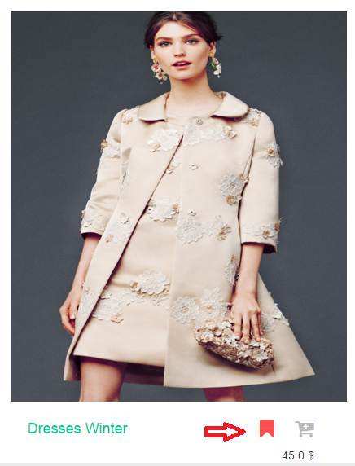

1. Then click, page move to your favorite list

## 2.4 Delete a product from a cart

1. Click on symbol of Cart on the bottom of Home page in Our Service to enter your cart, then choose a product you don’t want to buy to delete it from cart.

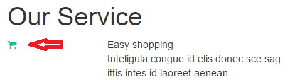

## 2.5 Delete a product from a favorite

1. Click on symbol of Favorite on the bottom of Home page in Our Service to enter your favorite, then choose a product you don’t like to delete it from Favorite.

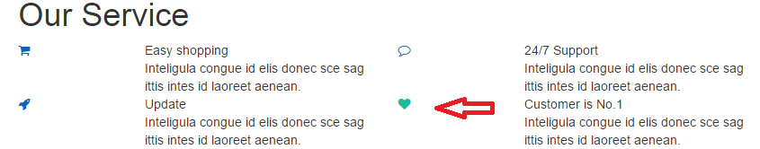

## 2.6 Order a product

1. Click on the picture of the product you’d like to order

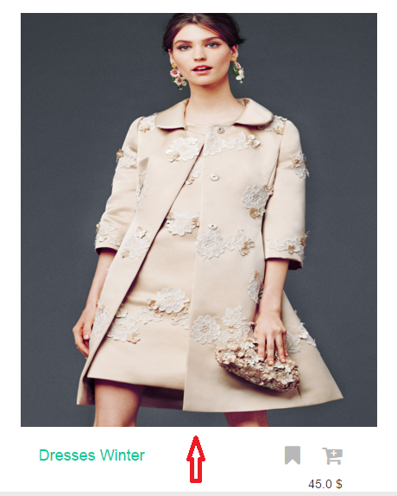

1. Appear a detail page of the product, you can watch some information about the product such as: Name, Price, Status, Number of Customer bought this product. Then, you click on Order button:

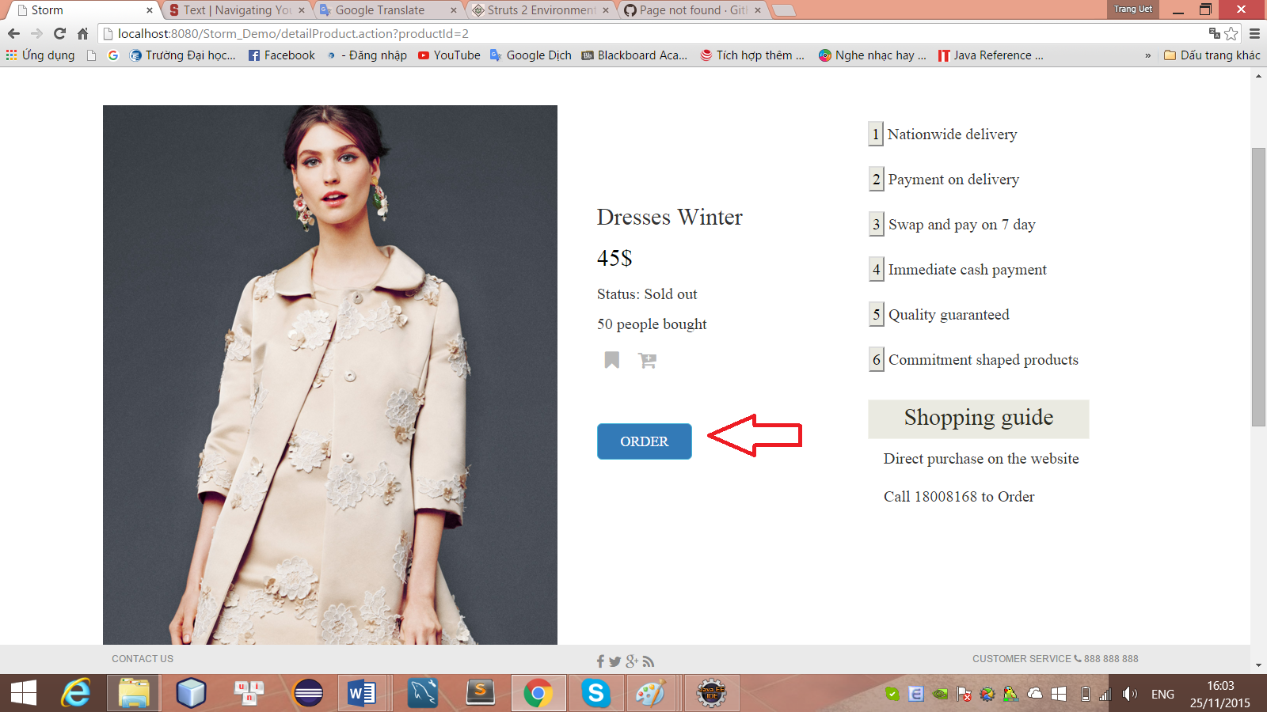

1. The page move to order page, you have to input quantity, color, size of the product and full name, phone number, address of you into, then click on Order button:

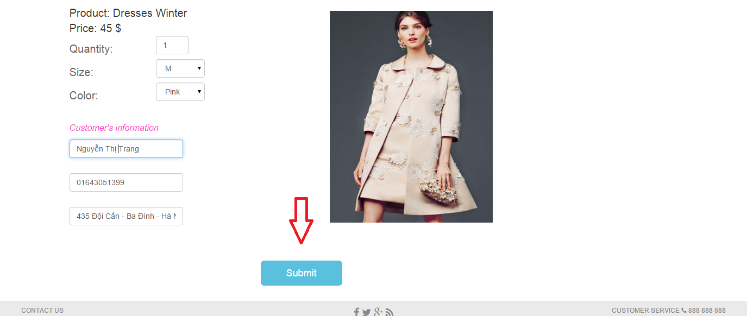

1. A pop – up window appear and show you all of information , then you can click on Submit button to finish your order:

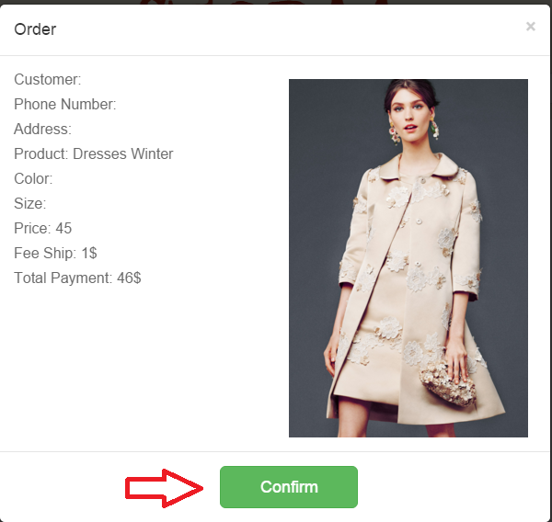

# Conclussion

We wish you would have the most wonderful experience, get the best products when visiting our website!