Statement and Confirmation of Own Work

***A signed copy of this form must be submitted with every assignment.***

***If the statement is missing your work may not be marked.***

**Student Declaration**

I confirm the following details:

|  |  |
| --- | --- |
| **Candidate Name:** | SHIHAB SAJID MIRZA |
| **Candidate ID Number:** | P00190603 |
| **Qualification:** | NCC L5DC |
| **Unit:** | COMPUTING PROJECT (MEMO OF UNDERSTADING) |
| **Centre:** | ZCAS UNIVERSITY |
| I have read and understood both NCC Education’s *Academic Misconduct Policy* and the *Referencing and Bibliographies* document. To the best of my knowledge my work has been accurately referenced and all sources cited correctly.  I confirm that this is my own work and that I have not colluded or plagiarised any part of it. | |
| **Candidate Signature:** |  |
| **Date:** | 03/04/2023 |

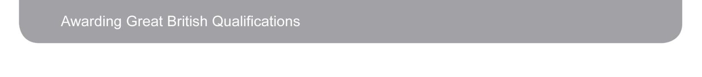

**OPS020_Candidate Statement of Own Work**