Statement and Confirmation of Own Work

***A signed copy of this form must be submitted with every assignment.***

***If the statement is missing your work may not be marked.***

**Student Declaration**

I confirm the following details:

|  |  |
| --- | --- |
| **Candidate Name:** | SHIHAB SAJID MIRZA |
| **Candidate ID Number:** | P00190603 |
| **Qualification:** | NCC L5DC |
| **Unit:** | COMPUTING PROJECT (PROJECT PROPOSAL) |
| **Centre:** | ZCAS UNIVERSITY |
| I have read and understood both NCC Education’s *Academic Misconduct Policy* and the *Referencing and Bibliographies* document. To the best of my knowledge my work has been accurately referenced and all sources cited correctly.  I confirm that this is my own work and that I have not colluded or plagiarised any part of it. | |
| **Candidate Signature:** |  |
| **Date:** | 30/03/2023 |



**OPS020_Candidate Statement of Own Work**

**INTRODUCTION**

[Visionary Technologies Enterprise (V.T.E)](https://www.vteofficial.com/) is a small to medium sized technology service and media production company located in Lusaka and is registered with [PACRA](https://www.pacra.org.zm/) in accordance with the laws of the republic of Zambia. It builds and offers technology products such as websites, applications and databases to various types of clients including businesses, banks, Individuals, churches etc.

The way it does this is that:

it hires people who are freelancers looking to build projects for a fortune.

It approaches these freelancers and interviews their skills to maintain the quality of VTE products. Once the freelancer is hired or partnered with VTE, they are now given projects to work on.

A project can be done by a single person or it may also be split up amongst 2, 3 or more freelancers and each freelancer may have a certain skill that they use to build a certain part of that project, for example, a graphic designer may design graphics and UI/UX, a front-end developer may build the front end, backend developer will build backend and so on, for the same project.

Once the project is finished and the client pays the company, the company will take its cut and then pay the rest of the money to the freelancers according to the amount of work they put into the project.

**JUSTIFICATION OF PROJECT**

Currently, there’s no organized way for the company to keep track of projects and which freelancers they are assigned to.

By adopting the proposed system,

the freelancers will be able to keep track of which projects they are assigned to work on, as well as the due dates of the project and what parts of the project they are supposed to work on.

The system will also have administrator accounts to allow management of freelancer accounts and assigning / revoking of project to freelancers, as well as marking projects as complete after verifying.

**DESCRIPTION OF PROPOSED SYSTEM:**

The proposed system will be a web-based application.

The website will look more like an admin dashboard style website.

Freelancers will have their own dashboard as the index route on the website, and admins will have their own dashboard as a /admins route as well.

Freelancers and admins will have log in pages. Freelancers will have a page to see the current projects they are assigned with. After clicking on one of the projects, they will then be given the details such as the due date, which components of the project they are supposed to work on, the compensation they will receive, and who else is working on that project etc. they will also have the option to mark a certain task as “complete”.

If one is unable to do given project or task, they may click on unlink project to be removed from that project.

Admins will have a page to add a new freelancer, a page where they can see the list of freelancers and remove, block or ban a freelancer. An option to update a freelancer’s details which then takes them to another page to update the details.

Admins will also have a page to assign projects to freelancers and button/s to mark the projects/task as complete if its complete.

**AIMS**

The aim of this project is to design and develop a flexible and multipurpose web-based application that allows seamless management of projects within the company.

The aim of the proposed system is to enable faster work flows and no delays by freelancers because of the deadline functionality.

Ultimately, the system will enhance the management of projects within the company and strengthen the link between the freelancers, the company and the clients by digitizing the workflow of projects withing the company.

**OBJECTIVES**

The main objectives of this project are:

* Identifying and analyzing of business processes.
* Identifying the requirements of the system.
* Roughly planning how the system will be looking and working.
* designing the User interface.
* implementing the user interface in React.js with bootstrap to help with styling.
* designing the database using ERDs etc.
* Implement and build database in MySQL.
* designing the backend architecture on paper.
* Implementing the backend in Node.js and connecting the database to it.
* Consuming backend APIs with the frontend.
* Testing and debugging all layers (frontend, backend, database).
* Deployment of all layers (frontend, backend, database).
* Writing a project report after the system is functional to the desired level.

**SCOPE**

This project will entail analyzing, designing, coding, testing, and debugging the system. To conduct the analysis, research and investigation of similar existing systems will be necessary, as well as gathering system requirements. The website will be responsive and clearly visible on all devices including laptops, mobile phones, Desktop PCs etc.

The testing that will be used is black box testing to find anything that is not working and apply an immediate fix to it.

be launched and will have a live domain for people to use and view the website easily.

The website will look more like an admin dashboard style website, which means the only people the website is going to be useful to, is the VTE registered freelancers and managers or VTE staff, so it’s not useful to any average user.

The project will use agile methodology, which means the steps mentioned at the start (analyzing, designing, coding, testing, and debugging the system) can be revisited and repeated if need be.

**ARCHITECHTURE**

The core technologies that will be used to build the system will be [*React.js*](https://react.dev/) *(a JavaScript library for building user interfaces)* for the front-end

[*Node.js*](https://nodejs.org/en) *(a JavaScript runtime) along with* [*express.js*](https://expressjs.com/) *(a backend framework)* for the back-end and MySQL for the database. Bootstrap for styling front-end etc.

The front end will be hosted on [firebase](https://firebase.google.com/).

Backend will be hosted on an [EC2](https://aws.amazon.com/ec2/) instance on [AWS (amazon web services).](https://aws.amazon.com/)

Database might be on the same EC2 instance or on an [RDS](https://aws.amazon.com/rds/) cluster or in a [docker](https://www.docker.com/) container on the EC2 instance.

[Bootstrap](https://getbootstrap.com/) will also be used to style the front-end.

**WORK BREAKDOWN STRUCTURE:**

**GANTT CHART:**

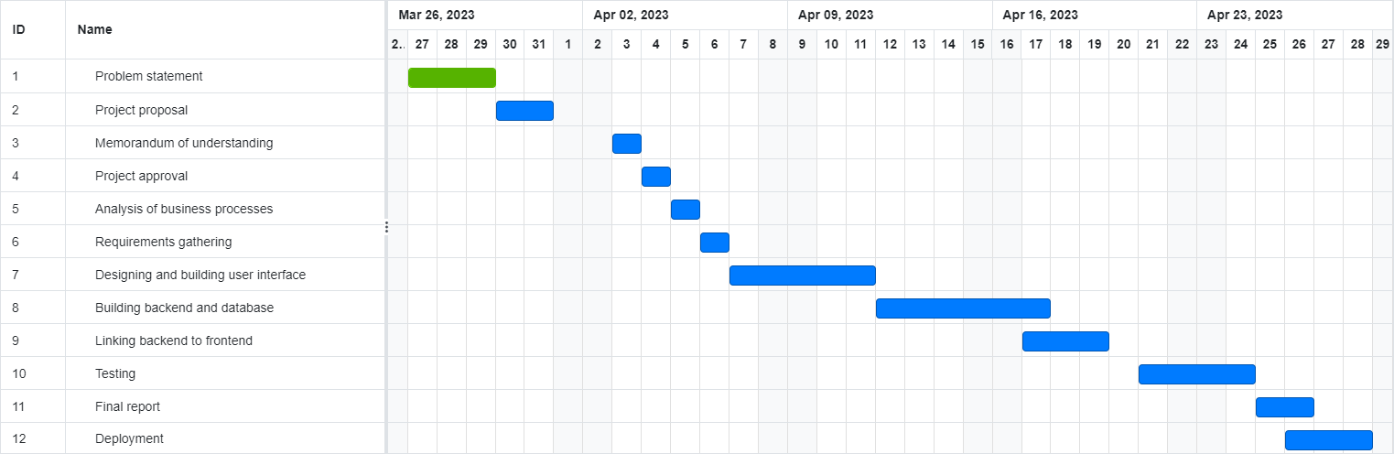

**KEY MILESTONES**

|  |  |  |  |
| --- | --- | --- | --- |
| **Milestone no.** | **Key milestone** | **Description** | **Date of completion** |
| 1 | Project proposal | Write a project proposal to create a project for VTE and present it to project supervisor | 28th march 2023 |
| 2 | Introductory letter to VTE | A letter sent along with memorandum of understanding to VTE | 29th march 2023 |
| 3 | Proposal approved | Proposal gets approved by supervisor | 30th march 2023 |
| 4 | Analysis done and Requirements gathered | Requirements about the system are gathered | 6th April 2023 |
| 5 | Design and develop the UI | The user interface is finished and working with dummy JSON data. | 12th April 2023 |
| 6 | Design and develop backend | The backend is finished  And working with dummy JSON data | 17th April 2023 |
| 7 | Design and develop the database | The database is working with dummy data and the backend is linked to use the database now | 20th April 2023 |
| 8 | Link backend to front end | The front end now consumes the backend APIs and is using real time data | 24th April 2023 |
| 9 | Testing and debugging | Thorough testing and debugging is done | 26th April 2023 |
| 10 | Deployment | The system is deployed and is now live | 28th April 2023 |
| 11 | Generate final report | A final report is written about the system | 30th April 2023 |

**KEY ACTIVITIES**

The key activities required to be completed are:

* Selecting a company
* Identifying the problems, the company faces.
* Decide what to build for the project
* Write a problem statement and a project proposal.
* Analyze business processes
* Gather system requirements.
* Design the system
* Develop and implement the system
* Test and debug the system
* Write a project report
* Deploy the system / website.