Statement and Confirmation of Own Work

***A signed copy of this form must be submitted with every assignment.***

***If the statement is missing your work may not be marked.***

**Student Declaration**

I confirm the following details:

|  |  |
| --- | --- |
| **Candidate Name:** | SHIHAB MIRZA |
| **Candidate ID Number:** | P00190603 |
| **Qualification:** | NCC L5DC |
| **Unit:** | Information systems Analysis (ISA) |
| **Centre:** | ZCAS University. |
| I have read and understood both NCC Education’s *Academic Misconduct Policy* and the *Referencing and Bibliographies* document. To the best of my knowledge my work has been accurately referenced and all sources cited correctly.  I confirm that this is my own work and that I have not colluded or plagiarised any part of it. | |
| **Candidate Signature:** |  |
| **Date:** | 08/03/2023 |



**OPS020_Candidate Statement of Own Work**

Table of contents:

Task1 a) ………………………………………………………………………………………………………………………………….3

b) ………………………………………………………………………………………………………………………………….4

Task2 a) ………………………………………………………………………………………………………………………………….5

Task3 a) ………………………………………………………………………………………………………………………………….6

b) ………………………………………………………………………………………………………………………………….7

Task4 a) ………………………………………………………………………………………………………………………………….8

HTA ………………………………………………………………………………………………………………………………….9

User interface …………………………………………………………………………………………………………………….10

Task 5 …………………………………………………………………………………………………………………………………. 11

References ……………………………………………………………………………………………………………………………. 12

**TASK 1 (Analysis)**

1. **Advantages and disadvantages of given methods.**

|  |  |  |
| --- | --- | --- |
| **Method** | **Advantages** | **Disadvantages** |
| **Interviews (face to face)** | * Provide an opportunity to ask open-ended questions to gather detailed information. * Allow the interviewer to clarify questions and responses as necessary. * Enable the interviewer to explore the interviewee's attitudes, opinions, and beliefs. * Can be tailored to specific individuals, roles, or departments. | * Can be time-consuming and may not be feasible for large groups. * Some interviewees may not feel comfortable speaking candidly with an interviewer. * The interviewer may unintentionally bias responses or fail to ask important questions. * The interviewer may not accurately document responses or may misinterpret responses. |
| **Observation** | * Allows the observer to see how employees interact with each other, systems, and customers in real-time. * Can maybe give insight into areas where employees might be experiencing difficulty or frustration. * Might identify factors that may not be identified through interviews. | * May not be able to capture all the necessary information. * May be influenced by the observer's biases or preconceived ideas. * May not be feasible in all kinds of situations or for all types of information. |
| **Documentation sampling** | * Provides a comprehensive view of the current system. * Enables the analyst to see how different elements of the system are related to one another. * Can identify inconsistencies or inaccuracies in documentation. | * May not capture all the important information. * Might not reflect the current practices or changes that have been made to the main system. * May be time-consuming to review all of the documentation. * Might not provide insight into employee or maybe customer perspectives. |
| **Questionnaires**  **(Paper and email)** | * Allow for a large number of responses to be gathered quickly. * Enable the analyst to ask standardized questions and gather quantitative data. * Can be distributed to a large number of individuals. | * May not capture detailed or nuanced information. * May not be answered by all individuals. * May not provide insight into employee or customer perspectives. * May be subject to response bias or incomplete responses. |

**Recommended methods:**

Upon conducting an analysis of the benefits and drawbacks of the four approaches to gathering information, I strongly recommend using a combination of the face-to-face interview technique and documentation sampling

Face-to-face interviews provide a highly personalized approach and have the potential to offer an abundance of important details concerning the roles and duties of different people within the organization, along with their habits and engagement levels in the new system. Additionally, it allows for follow-up questions and clarification of any doubts. However, it can be very time-consuming and difficult to manage for people living in distant regions.

Documentation sampling is an effective way of getting information on existing processes and procedures, showing any areas of inefficiency or potential issues. It is also less complicated to access and provides a wider overview of the current scenario. Though it is important to note that only relying on one technique won't give a clear idea of the users and their involvement in the new system. So, using both of these methods or approaches together can give a much more clearer understanding of the system and its users. This will be helpful in collecting the important details that might help in developing a new system more effectively.

**b) stakeholder matrix**

|  |  |
| --- | --- |
| **HIGH INFLUENCE**  **LOW INTEREST**  **(Keep Satisfied)**   * Admin staff * Investors * Board of directors * Customers | **HIGH INFLUENCE**  **HIGH INTEREST**  **(Manage closely)**   * Managing director * Claims representatives * Human resources |
| **Low influence**  **Low interest**  **(Monitor)**   * Call center Line manager * CSA (Customer services advisors) * Insurance under-writers * Accountants | **Low influence**  **High interest**  **(Keep informed)**   * IT Team * Call center manager |

**TASK 2 (Ethics)**

Questions to determine overall job satisfaction among Customer Service Advisors:

**Knowledge:** How sure are you that you can handle complex questions asked by customers?

**Psychologica**l: How do you feel about your team's and superiors' level of support and recognition?

**Task-Structure:** Do you believe your daily tasks are well-defined and that you have the tools necessary to complete them efficiently?

**Productivity:** Do you feel like that the current Information System assists you in performing your job effectively, or do you end up facing any challenges that affect your productivity?

**Ethical**: Have you ever been put under pressure to consider company goals over moral or ethical considerations when interacting with clients?

The careful selection of these specific questions was a deliberate and thoughtful process, as they cover a wide array of factors that hold the potential to greatly impact overall job satisfaction levels. These factors include but are not limited to, the individual's knowledge level and skillset, the level of support and recognition given by their team, the clarity and efficiency of their assigned tasks as well as some ethical considerations.

By collecting feedback in these key areas, the organization can get a much more clearer and comprehensive understanding of the current system's strengths and weaknesses. Additionally, this increased level of understanding can assist in making informed decisions regarding improvements that align with the company's values and the needs of its employees. Furthermore, by asking an important moral question, the organization shows that it is fully committed to behaving ethically and addressing serious concerns about protecting data and respecting privacy. This is very important because the organization wants to increase the amount of business insurance it sells at the end of the day.

**Task 3 (SWOT Analysis).**

1. **Analysis using swot framework**

The following is an analysis of Visor insurance using the SWOT framework:

|  |  |
| --- | --- |
| **Strengths**   * Visor Insurance has a good reputation and is well established in the insurance industry. * The company offers a range of insurance products to meet customer needs. * Visor Insurance has a loyal customer base. * The company has experienced and knowledgeable employees who provide very good customer service. | **Weaknesses**   * There have been several data protection issues and a recent data breach which may have affected customer trust. * Not all of the Claims Representatives or CSAs are immediately updating the CMIS after making contact with the customer which has caused inaccuracy in the data. * The Customers have given low to medium satisfaction levels for the usability of their online account section. |
| **Opportunities**   * Visor Insurance plans to increase its market share of business insurance since it is actually more profitable than personal insurance. * A much more integrated Information System could allow easier movement between employees in various departments and improve communication throughout the company. * Addressing concerns over user data protection and privacy coming with the implementation of the new system could improve customer trust. | **Threats**   * The insurance industry is highly competitive, and Visor Insurance faces competition from other big companies. * Any Changes in regulations and laws could impact the business operations and the types of products offered. * The recent data breach and data protection issues may result in some legal and financial consequences which may impact the company’s reputation. |

1. **Technical factors within weaknesses/threats section and how they could be resolved**

Based on the SWOT analysis, there are several key technical factors that can be identified within the Weakness/Threat sections. These include:

1. Outdated and inefficient Information System: The current information system is outdated and not integrated, leading to data inconsistencies and inefficiencies. A potential recommendation to resolve this issue is to implement a new, integrated information system that can handle the company's data more efficiently and accurately.
2. Security breaches: The recent data breach highlights the vulnerability of the current system and the need for improved security measures. A possible recommendation to resolve this issue is to invest in a robust security system that includes regular audits and updates, employee training, and strict access controls.
3. Inadequate data protection policies: The company has received many complaints from customers about data protection issues, indicating a need for better policies and procedures. A potential recommendation to resolve this issue is to update and communicate the data protection policies, provide regular training to employees on how to handle customer data, and ensure compliance with data protection regulations.
4. Poor customer satisfaction with online account section: The feedback from customers suggests that the online account section is difficult to use and confusing, leading to low-medium satisfaction. A possible recommendation to resolve this issue is to conduct user testing and improve the usability of the online account section by simplifying instructions, providing clear navigation, and making it more intuitive and attractive.
5. Inefficient data management practices: Not all Claims Representatives or CSAs are updating the CMIS after contact with a customer, leading to inaccurate data and loss of data. A potential recommendation to resolve this issue is to provide more training to employees on the importance of data management, streamline the process of updating the CMIS, and develop a system to monitor and enforce data management practices.

Just to summarize. For Visor Insurance, the key technical factors that must be addressed include upgrading the information system, trying to improve security measures, developing better data protection policies, improving the usability of the online account section, and improving data management practices. Visor Insurance can improve efficiency, accuracy, and customer satisfaction while lowering the risk of security breaches and data protection issues by implementing the recommended solutions.

**Task 4 (User Requirements & Design)**

**Analysis for identifying the characteristics and requirements of the claim’s representatives at visor insurance**

At Visor Insurance, the Claims Representatives are crucial to the company's success because they manage the claims process and make sure customers are satisfied. To do their job well, Claims Representatives need to have certain qualities. They should be great communicators so they can explain the claims process and answer any questions that the customers might have. They should also have good analytical skills so they can figure out if a claim is valid or not and decide what action to take next. And they need to be very detail-oriented to make sure all the required paperwork is complete and accurate.

To make sure the Claims Representatives handle online submitted claims properly, the company can use something called a hierarchical task analysis. This is just a way to break down all the steps involved in the claims process. First, the Claims Representative needs to log into the claims management information system (CMIS) to see the claim that was submitted. Then they should review all the information provided and see if they need anything else from the customer. If they do need anything else, they should contact the customer and ask for it. Once they have all the necessary information, they can decide if the claim is valid and either approve or deny it. If it's approved, they'll make the payment and update the CMIS. If it's denied, they'll explain why to the customer and update the CMIS.

So, in short, a good Claims Representative at Visor Insurance needs to be great at communicating, analyzing information, and paying attention to detail. And when handling online claims, they need to access the CMIS, review the claim, ask for more info if needed, decide if it's valid, and update the system accordingly.

**HEIRARCHICAL TASK ANALYSIS DIAGRAM (HTA)**

ACCESS CMIS

VIEW CLAIM

REVIEW INFO

DETERMINE IF ADDITIONAL INFO IS REQUIRED

GATHER INFO

CONTACT CUSTOMER

ASSESS VALIDITY

DENY CLAIM

APPROVE CLAIM

PROCESS PAYMENT

PROVIDE EXPLANATION

UPDATE CMIS

UPDATE CMIS

**User interface Design**

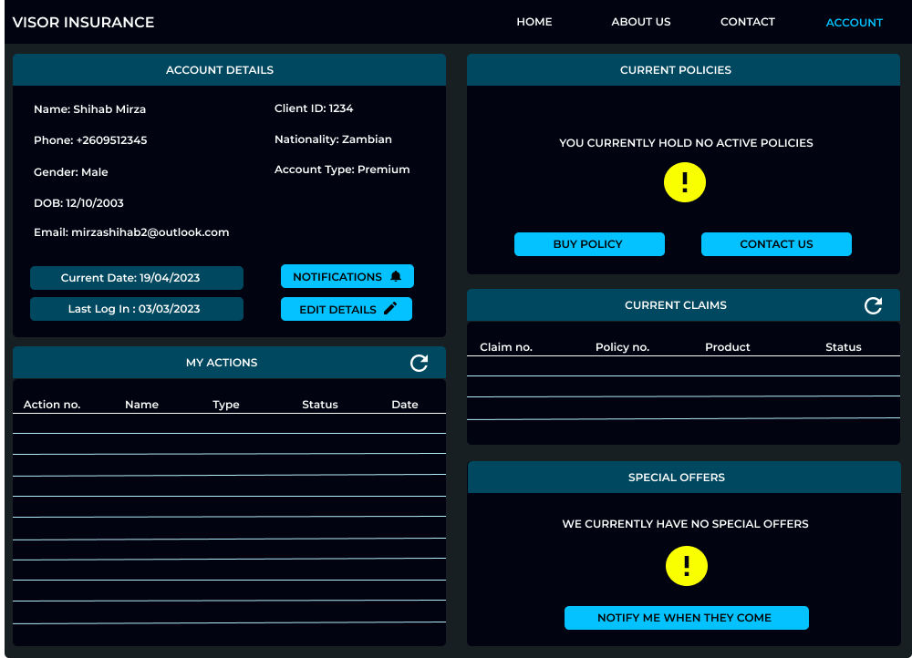

**User interface Design (Annotated)**

CURRENT PAGE WE ARE ON

THE LOGO

NAVIGATION BAR



CURRENT AND LAST LOG IN DATES.

CUSTOMER ACCOUNT DETAILS

CUSTOMER CAN VIEW THEIR ACTIONS HERE

CLAIMS WILL APPEAR HERE

CUSTOMER WILL VIEW SPECIAL OFFERS HERE

ACTIVE POLICIES WILL APPEAR HERE

REFRESH

**TASK 5 (Reflection)**

**Description:**

During this assignment, I have learned about the importance of requirements gathering and user analysis in software development projects. I have also gained a much clearer understanding of the different methods for collecting user data, such as interviews and observation. I was also exposed to new analysis methods like the SWOT analysis framework and stakeholder matrix.

**Analysis:**

This learning has helped me see the value of taking a user-centered approach to software development, and also to appreciate the importance of understanding user needs and user preferences. However, I found some of the technical aspects of the hierarchical task analysis to be challenging, and I struggled with identifying the key technical factors in the SWOT analysis. I also struggled a little bit on identifying the stakeholders in order to complete the stakeholder matrix.

**Action plan:**

To continue my learning, I plan to review the technical concepts and techniques covered in this session and practice applying them in different contexts. I also want to further develop my skills in user analysis by looking for additional resources and training opportunities. I aim to set specific goals for applying what I have learned to my work in software development, such as incorporating user feedback into project planning and design. I also plan to improve my skills on developing the SWOT framework and the stakeholder matrix. Finally, I aim to practice on the concepts I will learn by analyzing real world scenarios.

***Word count: 1250 (excluding titles, tables and diagrams)***

**References:**

Advantages and disadvantages of interviews: <https://in.indeed.com/careeradvice/interviewing/advantages-and-disadvantages-of-interviews>

*Accessed on: 07th April*

Information gathering methods:

<https://literacybasics.ca/strategic-planning/strategic-planning-assesssment/overview-and-information-gathering-tools/>

*Accessed on: 07th April*

stakeholder matrix:

[https://study.com/learn/lesson/stakeholder-matrix-examples-use.html#:~:text=A%20stakeholder%20matrix%20is%20a,best%20strategy%20for%20each%20group.](https://study.com/learn/lesson/stakeholder-matrix-examples-use.html%23:~:text=A%20stakeholder%20matrix%20is%20a,best%20strategy%20for%20each%20group.)

*Accessed on: 09th April*

Business ethics:

<https://www.financestrategists.com/financialadvisor/businessethics/?gclid=CjwKCAjw586hBhBrEiwAQYEnHUMehdacCkeANSIu8iJkqsoZyeAlAuM7vCISShR_z1L8TMMORJrRoCSQcQAvD_BwE>

*Accessed: 10th April*

SWOT Framework:

[https://www.techtarget.com/searchcio/definition/SWOT-analysis-strengths-weaknesses-opportunities-and-threats-analysis#:~:text=SWOT%20analysis%20is%20a%20framework,or%20establishing%20a%20business%20strategy.](https://www.techtarget.com/searchcio/definition/SWOT-analysis-strengths-weaknesses-opportunities-and-threats-analysis%23:~:text=SWOT%20analysis%20is%20a%20framework,or%20establishing%20a%20business%20strategy.)

*Accessed on: 11th April*

User interface design rules:

<https://www.elegantthemes.com/blog/resources/10-rules-of-good-ui-design-to-follow-on-every-web-design-project?utm_source=Blog&utm_medium=Manual%20Divi%20Targets&utm_campaign=Google%20Search&retargeting=off&gclid=CjwKCAjw586hBhBrEiwAQYEnHV8zgvKqWKAkimwPZ6umFnlIN8f5dMX8u4X-XS5LifLMC3Un7PBxXRoC_hUQAvD_BwE>

*Accessed on: 12th April*