Statement and Confirmation of Own Work

***A signed copy of this form must be submitted with every assignment.***

***If the statement is missing your work may not be marked.***

**Student Declaration**

I confirm the following details:

|  |  |
| --- | --- |
| **Candidate Name:** | SHIHAB SAJID MIRZA |
| **Candidate ID Number:** | 202100255 |
| **Qualification:** | NCC LEVEL 4 DIPLOMA FOR COMPUTING (L4DC) |
| **Unit:** | DDOOCP (With C#). |
| **Centre:** | ZCAS UNIVERSITY LUSAKA ZAMBIA. |
| I have read and understood both NCC Education’s *Academic Misconduct Policy* and the *Referencing and Bibliographies* document. To the best of my knowledge my work has been accurately referenced and all sources cited correctly.  I confirm that this is my own work and that I have not colluded or plagiarised any part of it. | |
| **Candidate Signature:** |  |
| **Date:** | 26/10/2021. |

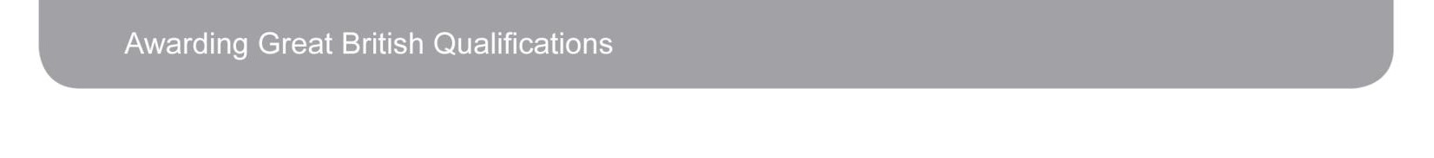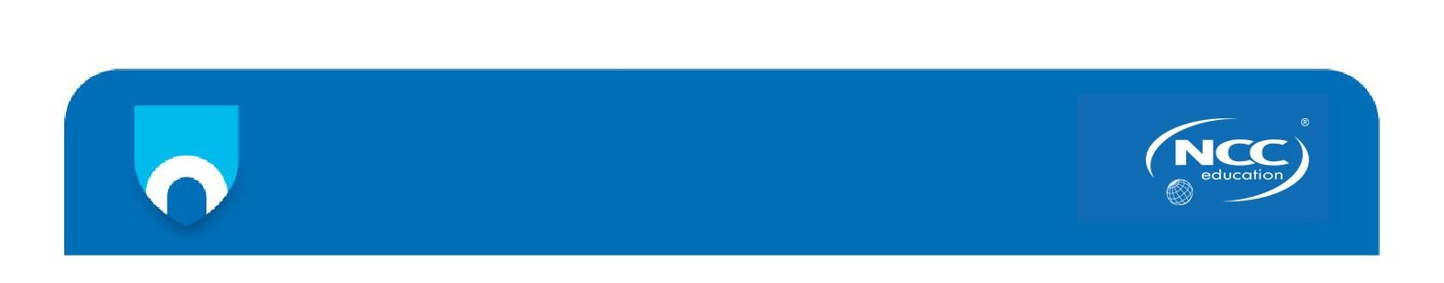

**OPS020_Candidate Statement of Own Work**

**Code Box Survey system.**

***Documentation***

**What to do first -**

The first thing you want to do as a user of this system is to create an account by clicking the signup link on the login page as soon as you run the program.

Make sure to create an account with suitable credentials and a very strong password.

Choose account type as consumer. (For consumers)

(For admins do the below mentioned instructions)

To create an Admin account, you will need to provide a secret key. This key is found by:

1. Other admins
2. In the secret key txt file which is found by the owner of this system.

After you hit create account You will be prompted to go to survey page, click yes.

*Note: Admins will also have to create an extra password for extra security. <The (special key) you see below>.*

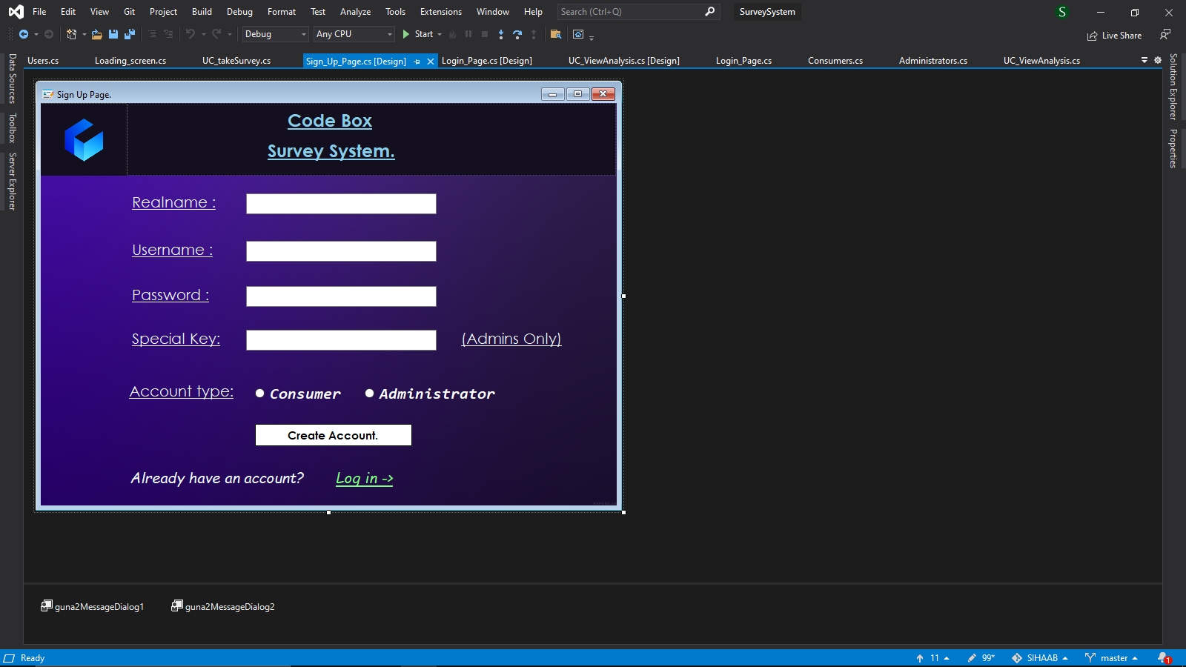

**Types of users –**

* Consumers
* Administrators

This system is developed to be used by both consumers and administrators. Consumers are only going to use the system for participating in surveys. However, admins use it solely to

* Create
* Delete
* Analyze.

Surveys, and be able to create a report of the analysis as well.

**How to take a survey (for consumers)-**

After logging in successfully, you will be greeted with the survey page. Click on the “take survey” navigation button, select the survey you wish to participate in, and click take survey. 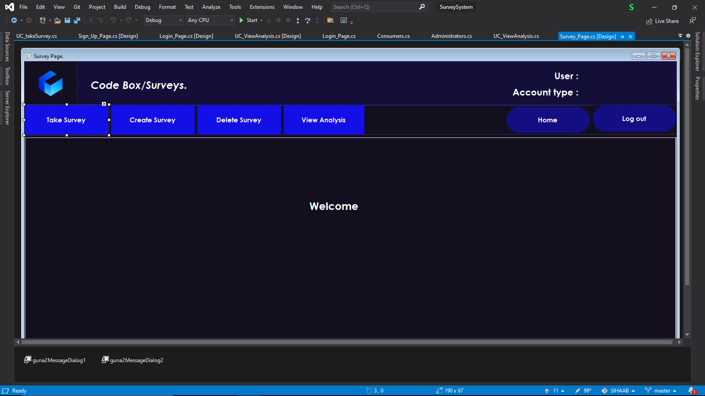

You will then be asked the first survey question. Answer the question as you wish and select next question. Do this until you reach the end of the survey and finally submit the survey.

If by any chance, you made a mistake answering a question, just hit the red quit survey button. And simply restart the process.

**How to create a survey (for Admins)-**

Right after logging in, click on the create survey navigation button, and you will be greeted with a survey creating screen like this.

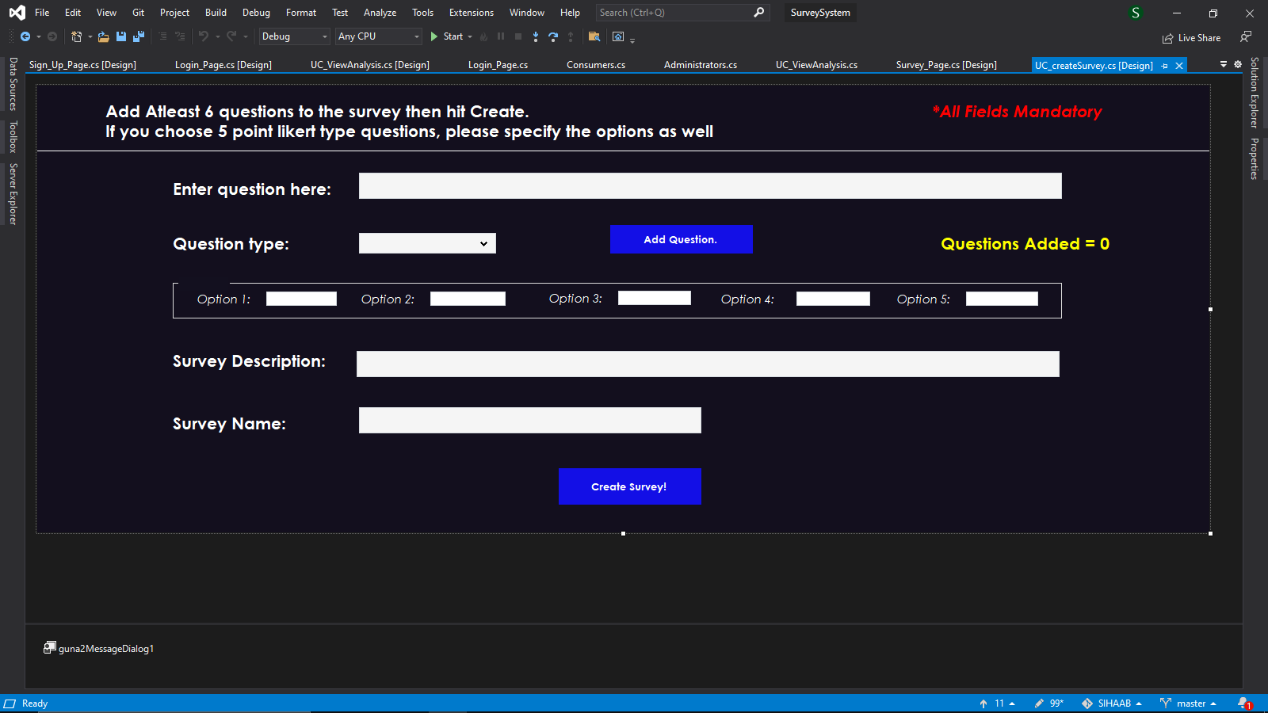

Here you will need to add at least 6(six) questions in order to create a successful survey, add the question where it says “Add question here” and select the type of question you want it to be, if you choose Likert, please specify the options as well.

Once you reach 6 questions, the other two fields will get activated, enter the survey description and survey name, and hit the create survey button.

**How to delete a survey (for Admins)-**

To delete a survey, all you have to do is click the delete survey navigation button, and select the survey you wish to delete from the combo box and hit delete survey.

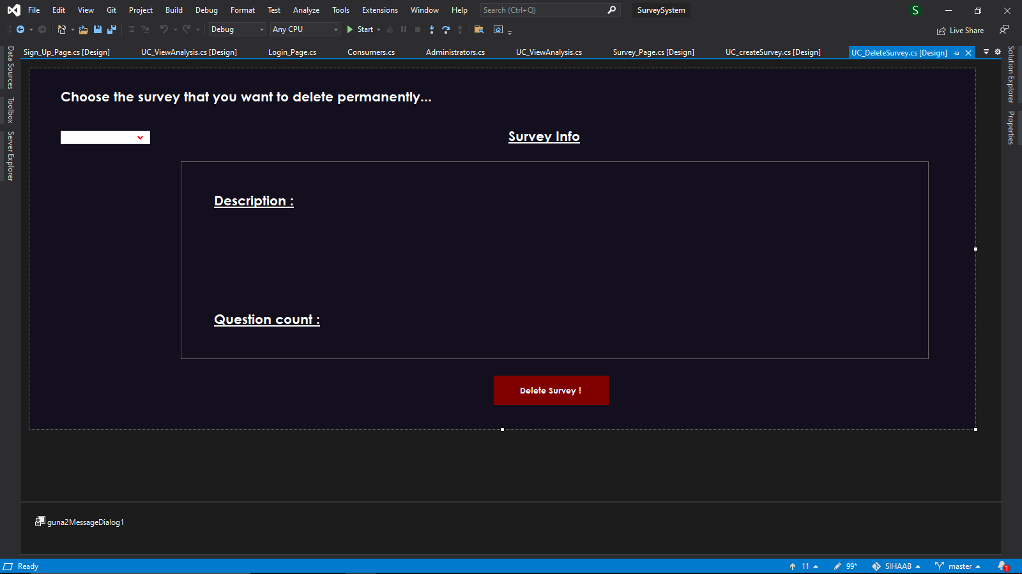

**How to view analysis of a survey (for Admins)-**

To view the analysis of a survey you will need to click on the “View analysis” navigation button and simply select the survey you want from the combo box,

this will bring some info on the screen about the survey such as question count, average responses and most chosen options e t c.

**Some background on Code box -**

this brings us to the end of the documentation and let us get some background about Code box.

Code box is a coding/programming question asking and answering website/app/platform. The following survey system was developed in order to survey its consumers about this website/app/platform.

**References**

* <https://www.techsmith.com/blog/user-documentation/>

Accessed on: [17th October 2021]

* <https://helpiewp.com/user-documentation/>

Accessed on: [17th October 2021]

This system is powered by .NET 4.7.2