NYCU Pattern Recognition, Homework 4

**Deadline: May 17, 23:59**

**Part. 1, Coding (50%)**:

For this coding assignment, you are required to implement Cross-Validation and Grid Search using only NumPy. After that, you should train the SVM model from scikit-learn on the provided dataset and test the performance with the testing data. **You will get no points by simply calling** [**sklearn.model_selection.GridSearchCV**](https://scikit-learn.org/stable/modules/generated/sklearn.model_selection.GridSearchCV.html)**.**

**(50%) K-Fold Cross-Validation & Grid Search**

**Requirements:**

* Implement **K-Fold Cross-Validation** by creating a function that takes K as an argument and returns a list of K sublists.
  + Each sublist should contain two parts:
    - The first part contains the index of all training folds (index_x_train, index_y_train), for example, Fold 2 to Fold 5 in split 1.
    - The second part contains the index of the validation fold (index_x_val, index_y_val), for example, Fold 1 in split 1 .
  + You need to handle if the sample size is not divisible by K.
  + The first **n_samples % n_splits** folds should have a size of **n_samples // n_splits + 1**, and the other folds should have a size of **n_samples // n_splits**. Here, n_samples is the number of samples and n_splits is K.
  + Each of the samples should be used **exactly once** as the validation data.
  + Please **shuffle** your data before partition.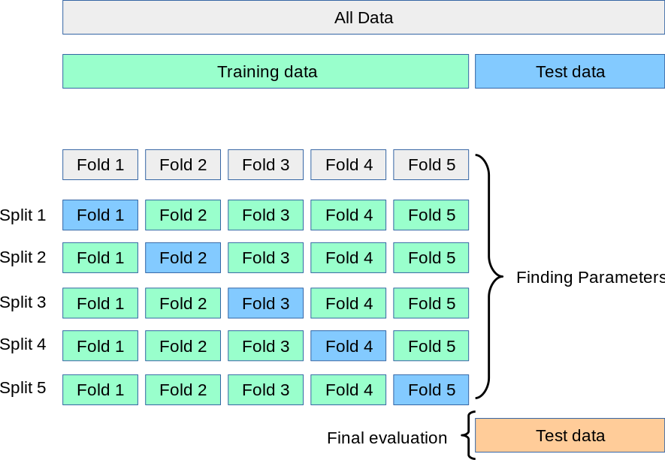
* Implement **Grid Search & Cross-Validation**:
  + Using [sklearn.svm.SVC](https://scikit-learn.org/stable/modules/generated/sklearn.svm.SVC.html) to train a classifier on the provided train set and perform **Grid Search** to find the best hyperparameters via cross-validation.

**Criteria:**

1. (10%) Implement K-fold data partitioning.
2. (10%) Set the kernel parameter to 'rbf' and do grid search on the hyperparameters **C** and **gamma** to find the best values through cross-validation. Print the best hyperparameters you found. Note that we suggest using K=5 for the cross-validation.
3. (10%) Plot the results of your SVM's grid search. Use "gamma" and "C" as the x and y axes, respectively, and represent the average validation score with color. Below image is just for reference.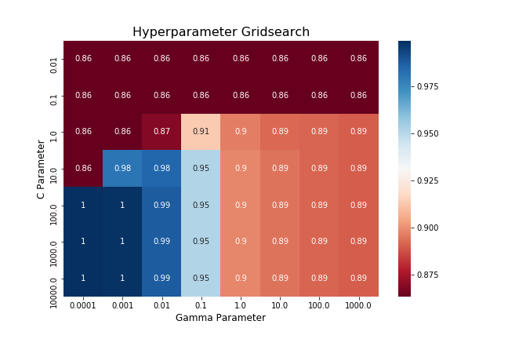
4. (20%) Train your SVM model using the best hyperparameters found in Q2 on the entire training dataset, then evaluate its performance on the test set. Print your testing accuracy.

| **Points** | **Testing Accuracy** |
| --- | --- |
| **20 points** | **acc > 0.9** |
| **10 points** | **0.85 <= acc <= 0.9** |
| **0 points** | **acc < 0.85** |

**Part. 2, Questions (50%):**

1. (10%) Show that the kernel matrix $K={\left[k\left(x_{n},x_{m}\right)\right]}_{nm}$ should be positive semidefinite is the necessary and sufficient condition for $k(x,x')$ to be a valid kernel.
2. (10%) Given a valid kernel k1(x,x'), explain that kx, x'= exp(k1x,x') is also a valid kernel. (Hint: Your answer may mention some terms like ____ series or ____ expansion.)
3. (20%) Given a valid kernel $k_{1}(x,x')$, prove that the following proposed functions are or are not valid kernels. If one is not a valid kernel, give an example of $k(x,x')$ that the corresponding $K$ is not positive semidefinite and show its eigenvalues.
$k\left(x, x'\right)= k_{1}\left(x, x'\right)+x$

$k\left(x, x'\right)= k_{1}\left(x, x'\right)-1$

$k\left(x, x'\right)= k_{1}{\left(x,x'\right)}^{2}+exp\left({‖x‖}^{2}\right)*exp({‖x'‖}^{2})$

$k\left(x, x'\right)= k_{1}{\left(x,x'\right)}^{2}+exp\left(k_{1}\left(x,x'\right)\right)-1$

4. Consider the optimization problem

$minimize {\left(x- 2\right)}^{2}$

$subject to \left(x+4\right)\left(x-1\right)≤ 3$

State the dual problem. (Full points by completing the following equations)

$L\left(x,λ\right)$ =

$∇_{x}L\left(x,λ\right)$ __________________________

= _____________________________

when $∇_{x}L\left(x,λ\right) =0$,

$x$ =

$L\left(x,λ\right)=L\left(λ\right)$ ____________________

= ___________________________________