Q1
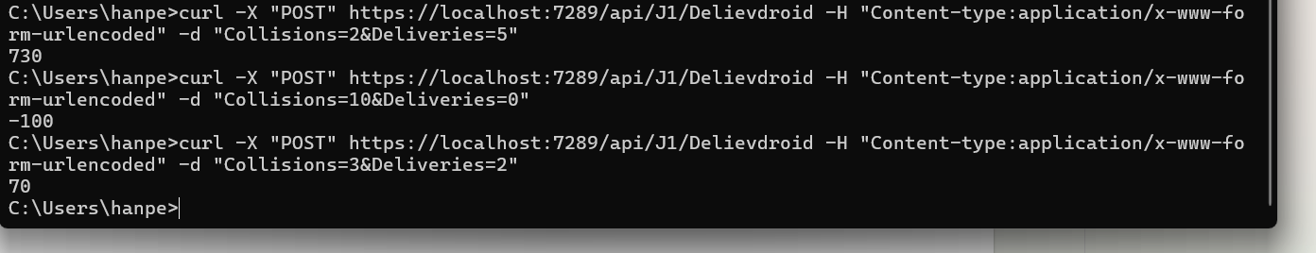

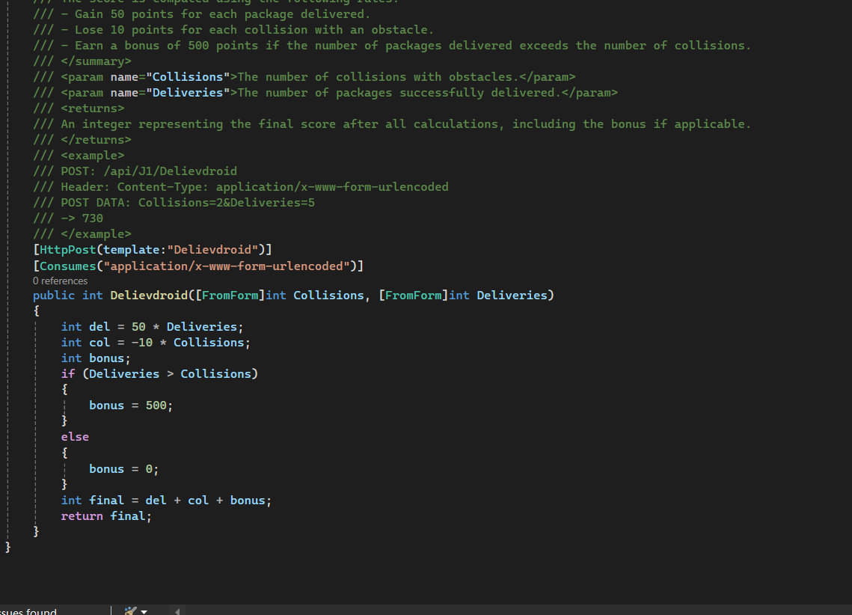

Q2
https://cemc.uwaterloo.ca/sites/default/files/documents/2022/2022CCCJrProblemSet.html

A regular box of cupcakes holds 8 cupcakes, while a small box holds 3 cupcakes. There are 28 students in a class and a total of at least 28 cupcakes. Your job is to determine how many cupcakes will be left over if each student gets one cupcake.

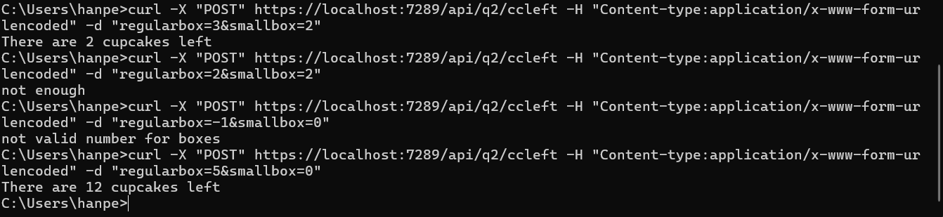
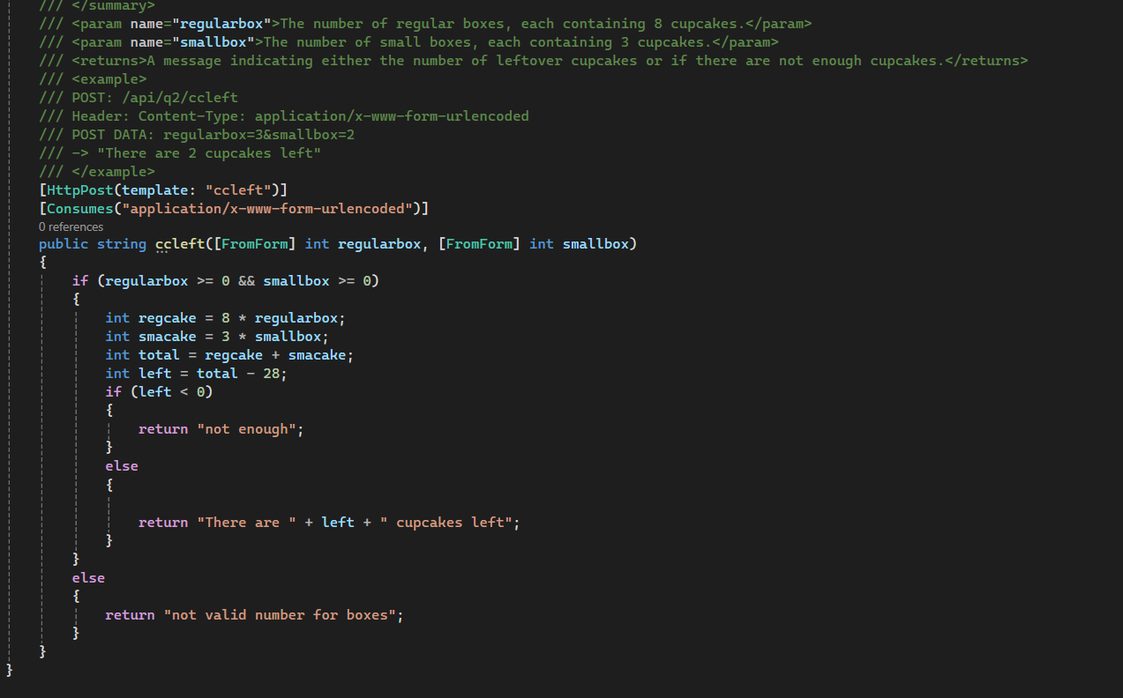

Q3
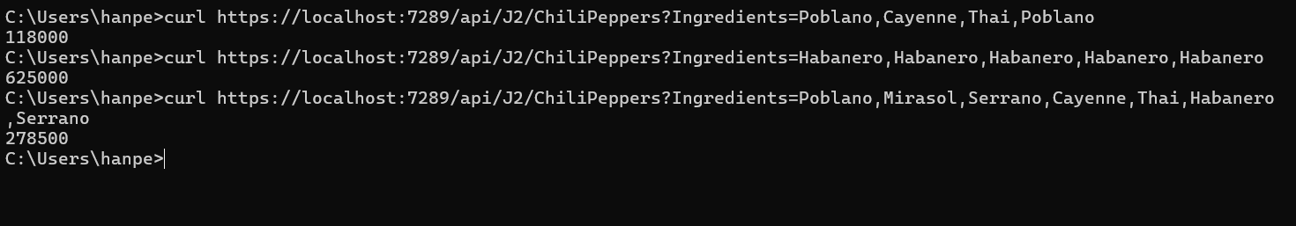
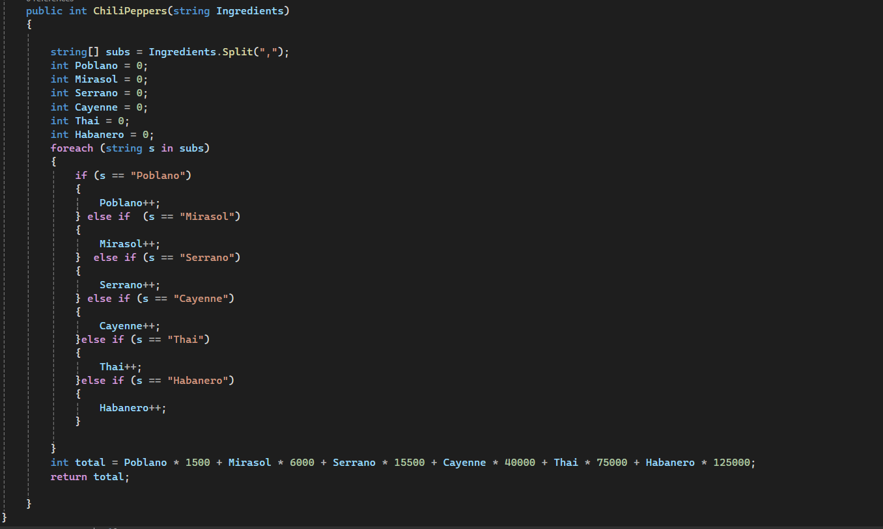

Q4
https://cemc.uwaterloo.ca/sites/default/files/documents/2015/2015CCCJrProblems.html

We often include emoticons in our text messages to indicate how we are feeling. The three consecutive characters :-) indicate a happy face and the three consecutive characters :-( indicate a sad face.
Write a program to determine the overall mood of a message.
The output is determined by the following rules:

If the input line does not contain any happy or sad emoticons, output => none.

Otherwise, if the input line contains an equal number of happy and sad emoticons, output => unsure.

Otherwise, if the input line contains more happy than sad emoticons, output => happy.

Otherwise, if the input line contains more sad than happy emoticons, output => sad.

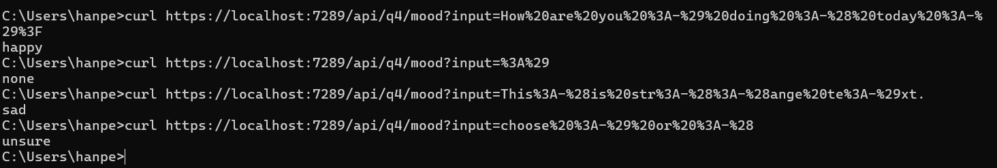
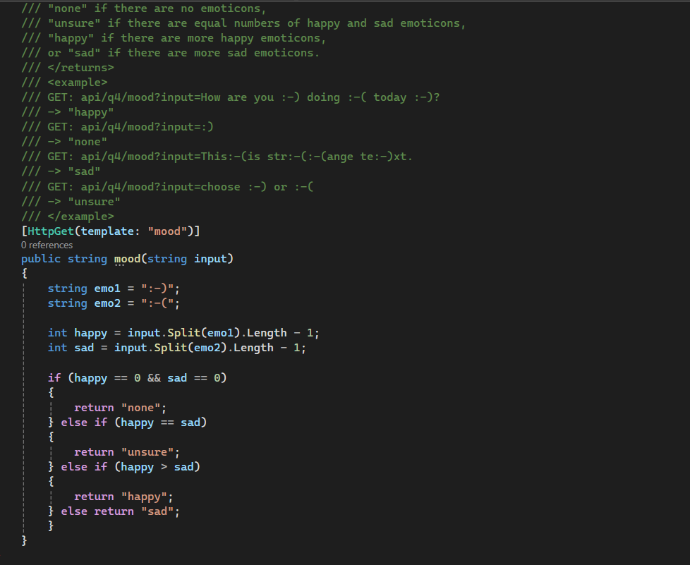

Q5
https://cemc.uwaterloo.ca/sites/default/files/documents/2024/2024CCCJrProblems.html

After completing a competition, you are struck with curiosity. How many participants were awarded bronze level?
Gold level is awarded to all participants who achieve the highest score. Silver level is awarded to all participants who achieve the second highest score. Bronze level is awarded to all participants who achieve the third highest score.
Given a list of all the scores, your job is to determine the score required for bronze level and how many participants achieved this score.

