Test API that Lists Teachers
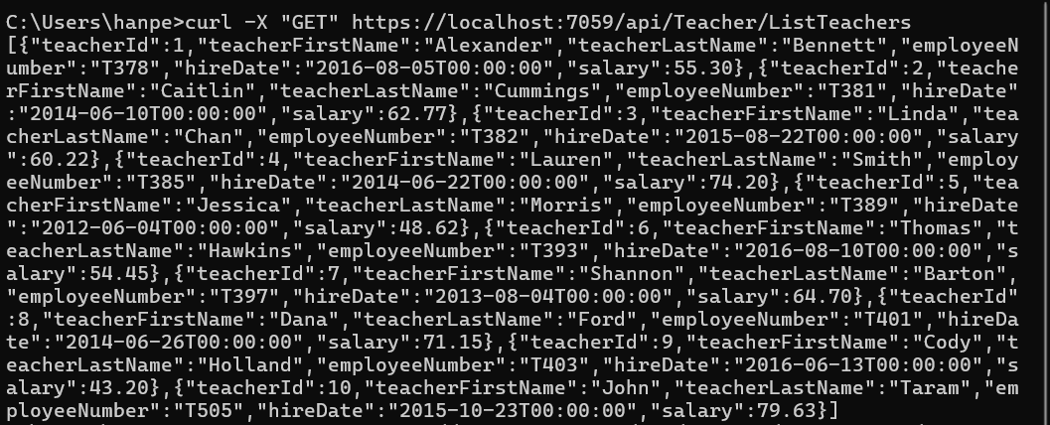

Test API that Finds a Teacher by the Teacher’s ID
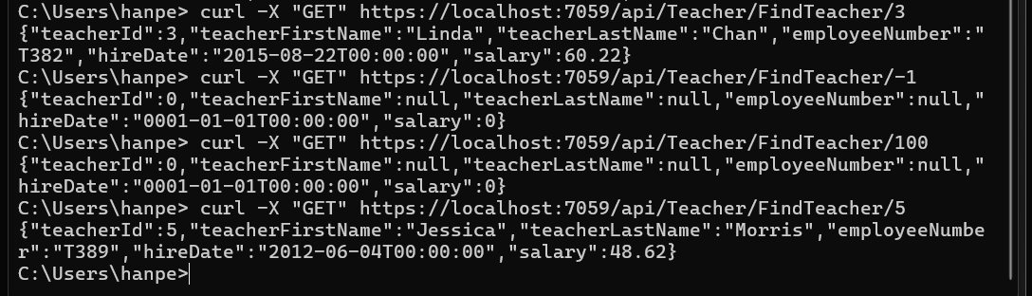

Test web page that displays all teachers
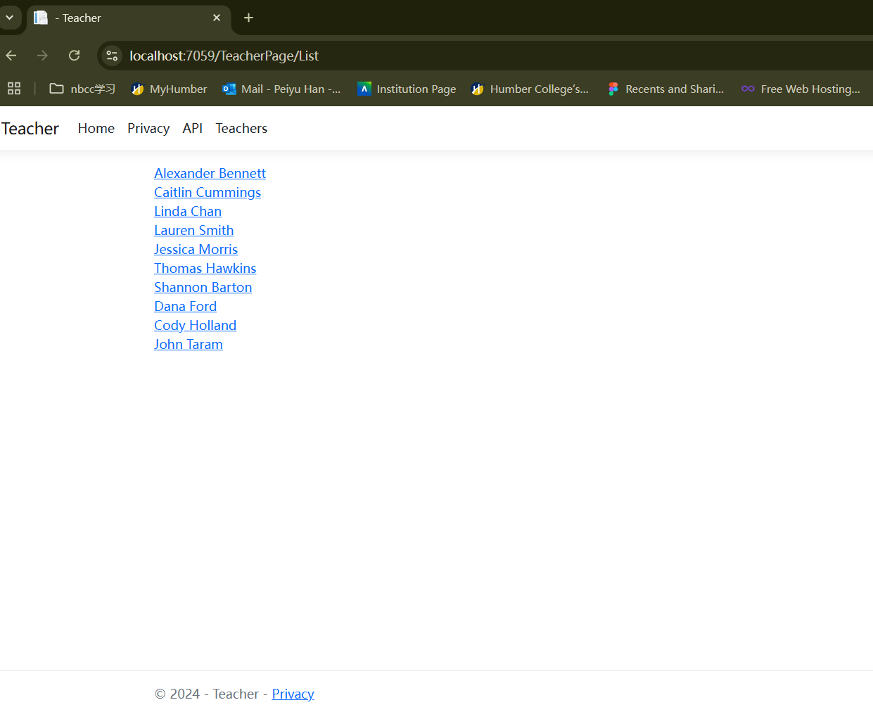
Test web page that displays a teacher
