**EIE1810 Electronic Circuit Design Laboratory**

**Lab2 - Thevenin and Norton Equivalent Circuits**

By *119010046*

Yabin CHENG

16nd October, 2021

The following contents are provided by Yabin CHENG submitted by ID 119010046 as a Lab report,

Copyright © 2021 Yabin CHENG, Edu.

All rights reserved. No part of this report may be reproduced or transmitted in any form or by any means, electronic or mechanical, including photocopying, recording or by any information storage retrieval system, without permission from Yabin CHENG, Edu.

**Table of Contents**

1 Introduction 3

1.1 Review of the Theories 3

1.2 Scopes 4

2 Experiment 1: Thevenin’s equivalent circuit 4

2.1 Procedure 4

2.2 Experiment results 5

2.3 Data Analysis and Conclusions 6

3 Experiment 2: Norton equivalent circuit 7

3.1 Procedure 7

3.2 Experiment results and analysis 7

4 Experiment 3: Maximum power transfer principle 7

4.1 Procedure 7

4.2 Experiment results and analysis 7

5 Conclusions 7

# Introduction

Thevenin and Norton’s theorems provides powerful tools in analyzing a linear circuit by modeling any internal part of a two-node open circuits as a combination of a source and a resistor. In this experiment, two theorems were verified by showing total equivalent property between the original circuit and the modelled one. Then we show the theorem’s usage in finding the maximum output power that can be provided by a two-open-node circuit in a fast and descend way.

## Review of the Theories

Thevenin’s theorem states that a two-port circuit with an independent voltage source and resistor can be equally treated as a series combination of the independent source and the inner resistor even when the ports are connected by load circuits. Similarly, Norton equivalent circuit is a transfer of the original circuit to a combination of an independent current source, whose value is the open circuit voltage divided by the inner resistance or be measured as the value of the current through the two ports after shorting circuit the two ports by joining them with a wire, combined in parallel with the inner resistor. A diagram of the transfer from the original circuit to Thevenin or Norton circuits are provided in the Figure 1.

|  |  |
| --- | --- |
| Figure1 a) A typical two port circuit network whose ports are connected with a load circuit | |
| Figure1 b) The Thevenin equivalent circuit | Figure1 c) The Norton equivalent Circuit |

Figure 1 The three mutually equivalent circuit by using Norton or Thevenin theorems

The maximum power principle states that the maximum power provided by a two-port circuit to the load is reached when the load resistance is the same as the two-port circuit’s inner resistance. When the load’s resistance is too small or too high, either the voltage across the load circuit is too small or the current through the load is too small that the load power is not at the maximum.

## Scopes

* Verify Thevenin and Norton equivalent circuit’s equivalence
* Verify the maximum power transfer principle
* Error analysis in finding the deviations from theorems.

# Experiment 1: Thevenin’s equivalent circuit

The original two-port circuit diagram is shown in Figure 2.

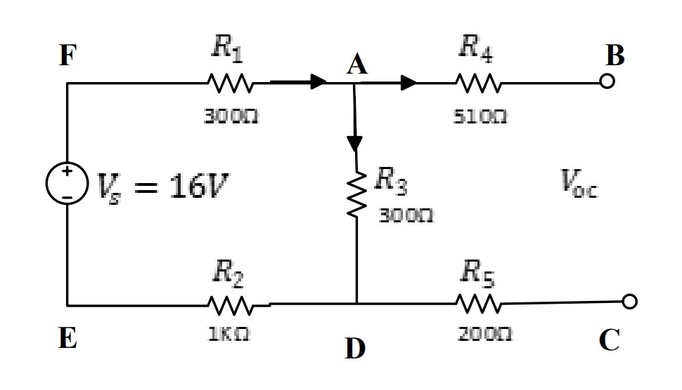

Figure 2. The original two-port circuit

## Procedure

1. Build up the origin circuit in Multisim, and obtain the theoretical value of the open-circuit voltage $V_{oc}$, short circuit current $I_{sc}$ and the equivalent resistor’s resistance $R_{eq}=\frac{V_{oc}}{I_{sc}}.$
2. Build up the circuit on a breadboard and measure values of $V_{oc}, I_{sc}$ using a multimeter, and then obtain $R_{eq}$ in the similar way.
3. To obtain the output property of the original circuit, we test it by insert different resistance as the loads circuit, and see the V-I diagram with the change of the loads. In details, Join two ports with a resistor box. This resistor box plays a role of load. Measure the voltage and current across the it when the resistor box provides resistor from 0, 400, … to 2400, 2800 $Ω$ and an open-circuit result. The circuit picture can be viewed in Figure 3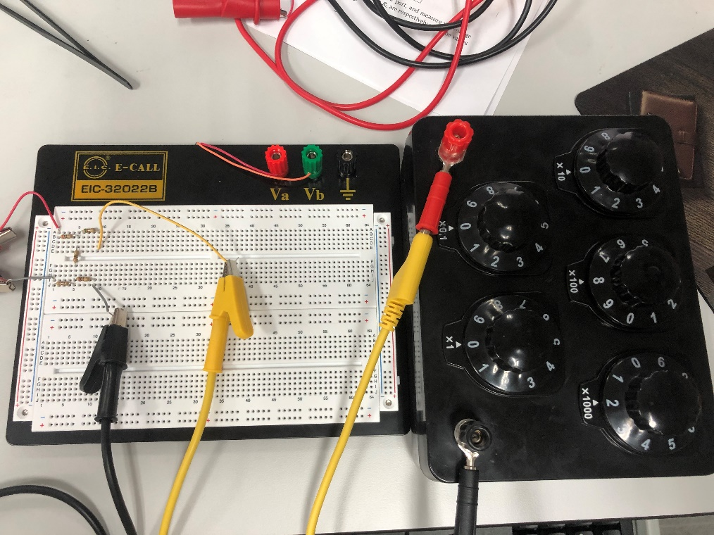

Figure 3. The origin circuit on a breadboard

1. Use Thevenin equivalent circuit to replace the original circuit by using a Voltage source to connect with a resistor box possessing the same value as the equivalent resistor’s resistance $R_{eq}$, which is read from the Multisim simulation result. Then record the voltage cross and the current through the load resistor box and change the resistance of the box continuously. Put all the data recorded above in $REF _Ref85345168 \backslash h Table 1, REF _Ref85345171 \backslash h Table 2, REF _Ref85345175 \backslash h Table 3$.
2. During the experiment, a noticeable difference between the real-resistance and the resistance value shown on the resistor-box. In Table 4, the resistance of the resistor-box obtained by reading from the box, calculated by from the V-I relations in the original circuit, and by measuring using the multimeter in the resistance mode.

## Experiment results

Data collected in Procedure2.1 are listed in tables below.

|  |  |  |  |
| --- | --- | --- | --- |
|  | $$V_{oc} (V)$$ | $$I_{sc} (A)$$ | $$R_{eq} (Ω)$$ |
| Theoretical Value | 3.0000 | 0.0032 | 954.0000 |
| Experimental Value | 3.0060 | 0.0032 | 945.0000 |
| Relative Error Scale | Small | No observable | Small |

Table 1. Theoretical and experimental values of open-circuit voltage, short-circuit current, and equivalent resistor

|  |  |  |  |  |  |  |  |  |  |
| --- | --- | --- | --- | --- | --- | --- | --- | --- | --- |
| $$R_{L} \left(Ω\right)$$ | 0 | 400 | 800 | 1200 | 1600 | 2000 | 2400 | 2800 | $$∞$$ |
| $$Theo. V_{L} \left(V\right)$$ | 0 | 0.886 | 1.37 | 1.67 | 1.88 | 2.03 | 2.15 | 2.24 | 3 |
| $$Exp. V_{L} \left(V\right)$$ | 0.03 | 0.909 | 1.387 | 1.69 | 1.895 | 2.047 | 2.163 | 2.251 | 3.006 |
| Rel. Error  (%) | Small in absolute difference | 2.595 | 1.240 | 1.197 | 0.797 | 0.837 | 0.604 | 0.491 | 0.2 |
| $$Theo. I_{L} \left(mA\right)$$ | 2.55 | 2.22 | 1.71 | 1.29 | 1.17 | 1.02 | .895 | .799 | 0 |
| $$Exp. { I}_{L} \left(mA\right)$$ | 3 | 2.21 | 1.63 | 1.34 | 1.14 | .987 | .873 | .783 | 0 |
| Rel. Error (%) | 17.641 | -0.450 | -4.67 | 3.876 | -2.56 | -3.23 | -2.45 | -2.00 | N.A. |

Table 2. Theoretical and experimental data of load current and voltage obtained from the original circuit.

|  |  |  |  |  |  |  |  |  |  |
| --- | --- | --- | --- | --- | --- | --- | --- | --- | --- |
| $$R_{L} \left(Ω\right)$$ | 0 | 400 | 800 | 1200 | 1600 | 2000 | 2400 | 2800 | Inf |
| $$Theo. V_{L} \left(V\right)$$ | 0 | 0.886 | 1.37 | 1.67 | 1.88 | 2.03 | 2.15 | 2.24 | 3 |
| $$Exp. V_{L} \left(V\right)$$ | .0288 | 0.903 | 1.378 | 1.682 | 1.888 | 2.04 | 2.156 | 2.245 | 3.008 |
| Rel. Error (%) | Small in absolute value | 1.9187 | 0.58394 | 0.71856 | 0.42553 | 0.49261 | 0.27907 | 0.22321 | 0.26667 |
| $$Theo. I_{L} \left(mA\right)$$ | 2.55 | 2.22 | 1.71 | 1.29 | 1.17 | 1.02 | 0.895 | 0.799 | 0 |
| $$Exp. { I}_{L} \left(mA\right)$$ | 2.84 | 2.06 | 1.62 | 1.33 | 1.13 | 0.984 | 0.871 | 0.781 | 0 |
| Rel. Error  (%) | 11.3 | -7.20 | -5.26 | 3.10 | -3.41 | -3.53 | -2.68 | -2.25 | N.A. |

Table 3. Theoretical and experimental data of load current and voltage obtained from the Thevenin equivalent circuit

|  |  |  |  |  |  |  |  |  |  |
| --- | --- | --- | --- | --- | --- | --- | --- | --- | --- |
| $$R_{L}(Ω)$$ | 0 | 400 | 800 | 1200 | 1600 | 2000 | 2400 | 2800 | Inf |
| $$R_{L\left(calculation\right)}(Ω)$$ | 10 | 411 | 851 | 1260 | 1670 | 2070 | 2480 | 2870 | Inf |
| $$R_{L\left(Measure\right)} (Ω)$$ | 10 | 409 | 806 | 1210 | 1610 | 2010 | 2410 | 2810 | Inf |

Table 4.the resistance value read from the resistor box, division of $V_{L}$ by $I_{L}$ and measured by multimeter in the original circuit analysis.

## Data Analysis and Conclusions

1. Verification of the Thevenin Theorem

From Table 2 and Table 3, it is noticed that both the original circuit and the Thevenin version circuit have noticeable relative error around $.2\% and 3\%$. This error may be caused by the errors between the real and expected resistance of the resistor box, which is observed in Table 4. So, the difference between the two circuits’ data errors to the theoretical value are of the most concern in verifying the theorem.

The Relative error difference between two circuits equals the relative Error of the Thevenin circuit to the theoretical data minus that of the original circuit to the theorem.

$$Rel. Error.difference. \left(V or I\right)=Rel.Error. Thevenin\left(V or I\right)-Rel. Error. Origin(V or I)$$

The value of the difference is summarized in the Table 5 below. Notice that, the difference is relatively small except when the load resistance is small (0, 400) the current percentage difference is around 6%. It is quite satisfying to conclude that the Thevenin Theorems work on this circuit well, especially when the load resistance is large. The not small difference in current when the load of the resistance is high may be due to unexpected experiment error, which is not clear.

Table 5. The difference of the relative errors between the Thevenin and the original circuit

|  |  |  |  |  |  |  |  |  |  |
| --- | --- | --- | --- | --- | --- | --- | --- | --- | --- |
| $$R_{L} (Ω)$$ | 0 | 400 | 800 | 1200 | 1600 | 2000 | 2400 | 2800 | Inf |
| Rel. V Error between two circuits (%) | N.A. | -0.68 | -0.65 | -0.47 | -0.37 | -0.34 | -0.32 | -0.26 | 0.067 |
| Rel. I Error between two circuits (%) | -6.34 | -6.75 | -0.59 | -0.78 | -0.85 | -0.3 | -0.23 | -0.25 | N.A. |

# Experiment 2: Norton equivalent circuit

## Procedure

In Norton equivalent circuit the voltage source is changed to a current source that with a current of 0.003A rather than 0.00032A due to the limitation of the power device. This could bring about an error of 6%.

The whole procedure is no more different than the previous experiment. To obtain a current source, the DC voltage supply was given a high output voltage limitation (20V) while only a small maximum current (3mA) was allowed. Wire the inner resistance (about 950 $Ω)$ in parallel with the current source.

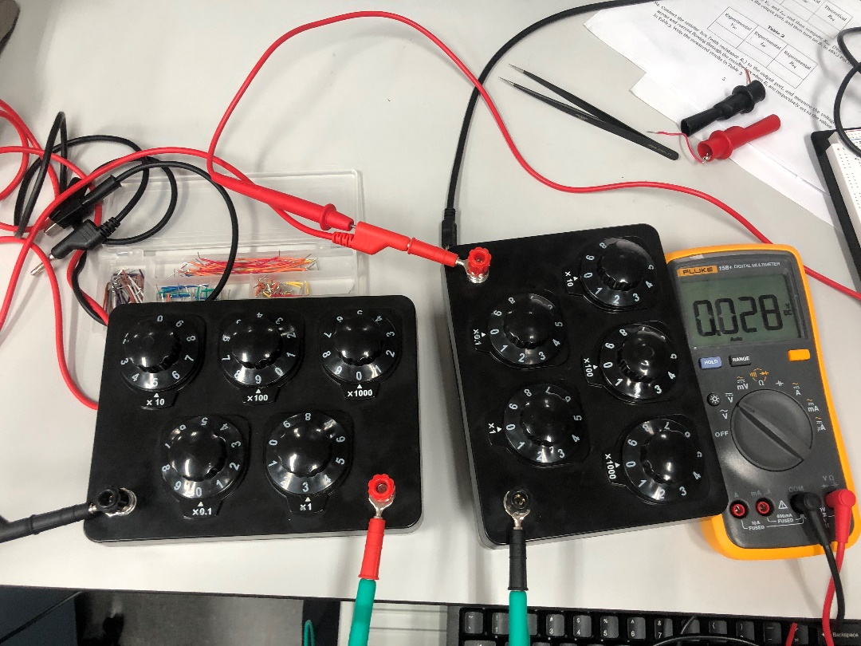

Figure 4. Part of the Norton equivalent circuit shot during experiment

After this, the Thevenin equivalent circuit is set up. Then join the circuit with a load (another resistor box). Then collect the output V-I data in conditions of different load resistance and listed in a table below.

## Experiment results

Table 6. Experimental $V_{L}$ and $I_{L}$ of the Norton equivalent circuit and compared with the theoretical original circuit

|  |  |  |  |  |  |  |  |  |  |
| --- | --- | --- | --- | --- | --- | --- | --- | --- | --- |
| $$R_{L} \left(Ω\right)$$ | 0 | 400 | 800 | 1200 | 1600 | 2000 | 2400 | 2800 | Inf |
| $$Theo. V_{L} \left(V\right)$$ | 0 | 0.886 | 1.37 | 1.67 | 1.88 | 2.03 | 2.15 | 2.24 | 3 |
| $$Exp. V_{L} \left(V\right)$$ | 0.028 | 0.903 | 1.378 | 1.682 | 1.888 | 2.04 | 2.156 | 2.245 | 3.008 |
| Rel. Error. V (%) | Small in absolute value | 1.9187 | 0.58394 | 0.71856 | 0.42553 | 0.49261 | 0.27907 | 0.22321 | 0.26667 |
| $$Theo. I_{L}\left(mA\right)$$ | 2.55 | 2.22 | 1.71 | 1.29 | 1.17 | 1.02 | 0.895 | 0.799 | 0 |
| $$Exp. { I}_{L}\left(mA\right)$$ | 2.84 | 2.06 | 1.62 | 1.33 | 1.13 | 0.984 | 0.871 | 0.781 | 0 |
| Rel. Error. I (%) | 11.3725 | -7.21 | -5.26 | 3.100 | -3.42 | -3.53 | -2.68 | -2.25 | N.A. |

## Analysis of the Norton equivalent circuit results

From Table6, we could see the pattern of the voltage and current provided by a Norton circuit is not much different from the original circuit, especially in the sense of voltage difference. The current difference has an overall difference in compared with the original circuit due to the limited current specification which we have mentioned in the procedure. The power supply can only provide current with a specification of $mA$, so instead of giving a current of 3.2mA, the current provided is around 3mA which could bring a shortage error in current around 6%. Another thing to notice is that, the relative error percentage is quite different between the voltage and current. This is a quite confusing. It may be explained by noting the measured load resistance provided by the resistor-box is always larger than the indicated value by 50 $Ω in REF _Ref85345612 \backslash h Table 4$. So the larger value in resistance and lower value in current multiplied together cancel out part of the relative error in voltage.

# Experiment 3: Maximum power transfer principle

## Procedure

1. Simulate both on Multisim and breadboard based on our theoretical values of $V_{oc}$ and $R_{eq}$ which we have obtained in Table 1.
2. Changing the load resistance and collect the voltage across and current through the load on Multisim and breadboard to obtain its current power and put power data collected in the table below.
3. Turn off powers supply and put everything to the original position for easier using next time.

## Experiment results

Table 7. Theoretical and experimental powers dissipated at the resistor and the relative errors to the theoretical expectation

|  |  |  |  |  |  |  |  |  |  |
| --- | --- | --- | --- | --- | --- | --- | --- | --- | --- |
| $$Δ R$$ | -953 | -350 | -150 | -50 | 0 | 50 | 150 | 350 | $$∞$$ |
| $$Theo. P_{L} (mW)$$ | 0 | 2.2415 | 2.3437 | 2.3593 | 2.361 | 2.3594 | 2.3484 | 2.304 | 9.0E-4 |
| $$Exp. P_{L} (mW)$$ | 0.002 | 2.12 | 2.24 | 2.26 | 2.26 | 2.26 | 2.25 | 2.22 | 0 |
| $$Rel. Error (\%)$$ | Inf | -5.42 | -4.43 | -4.20 | -4.27 | -4.21 | -4.19 | -3.65 | Small in abs value |

## Discussions

From the Table 7, with the load resistor goes from 0 to $∞,$ the power on load increases before the load resistance is around $R_{eq}$, and decreases after the resistor exceeds the $R_{eq}$ both theoretically and experimentally. The experiment could not review the trend of the power when load resistance is in range of 900 to 1000 $Ω$ because of the limitation in measurement specification. Since our overall observation match the maximum power dissipation law, we could state that our experiment verifies the law successfully. The verification will be more accurate with devices of higher precision.

# Conclusions

In this lab, by comparing the theoretical values with the measurement on the original circuit, Thevenin equivalent circuit and Norton equivalent circuit, we verify the two important theorems. Moreover, the law of the maximum output power provided by a circuit is verified.

This lab also gives a good real-example of what is a current source and how to generate it.