scallop_markdown

### Purple Hinged Rock Scallops (*Crassadomea gigantea*)

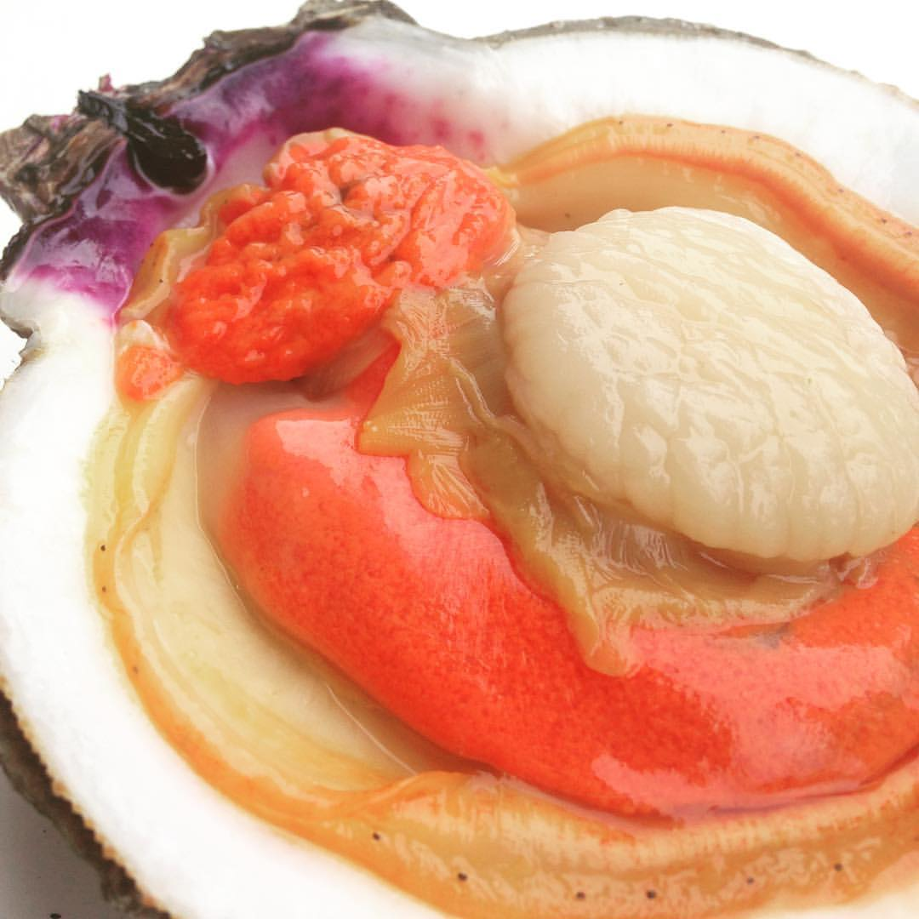

**Linear Model**

This linear model allows us to determine important factors impacting adduction diameter of *Crassadomea gigantea*.

##   
## Linear Model  
## ===============================================  
## Dependent variable:   
## ---------------------------  
## Adductor Diameter (mm)   
## -----------------------------------------------  
## Sex -0.425 (0.278)   
## Length 0.055* (0.031)   
## Width 0.459*** (0.084)   
## Height 0.082** (0.034)   
## Maturation Stage -0.209* (0.123)   
## Neah Bay 2.409*** (0.419)   
## Totten Inlet 1.525*** (0.234)   
## Constant -5.690*** (1.197)   
## -----------------------------------------------  
## Observations 398   
## R2 0.467   
## Adjusted R2 0.458   
## Residual Std. Error 2.087 (df = 390)   
## F Statistic 48.894*** (df = 7; 390)   
## ===============================================  
## Note: *p<0.1; **p<0.05; ***p<0.01

This table is showing that, given adductor diameter as the dependent variable, site and external metrics (length, width, height) are significant factors in predicting adductor diameter.

Thus we ran a linear regression with the external metric on the y axis and the adductor diameter and the x axis. Correlation values for all three external metrics ranged from 0.5-0.6.

