Career
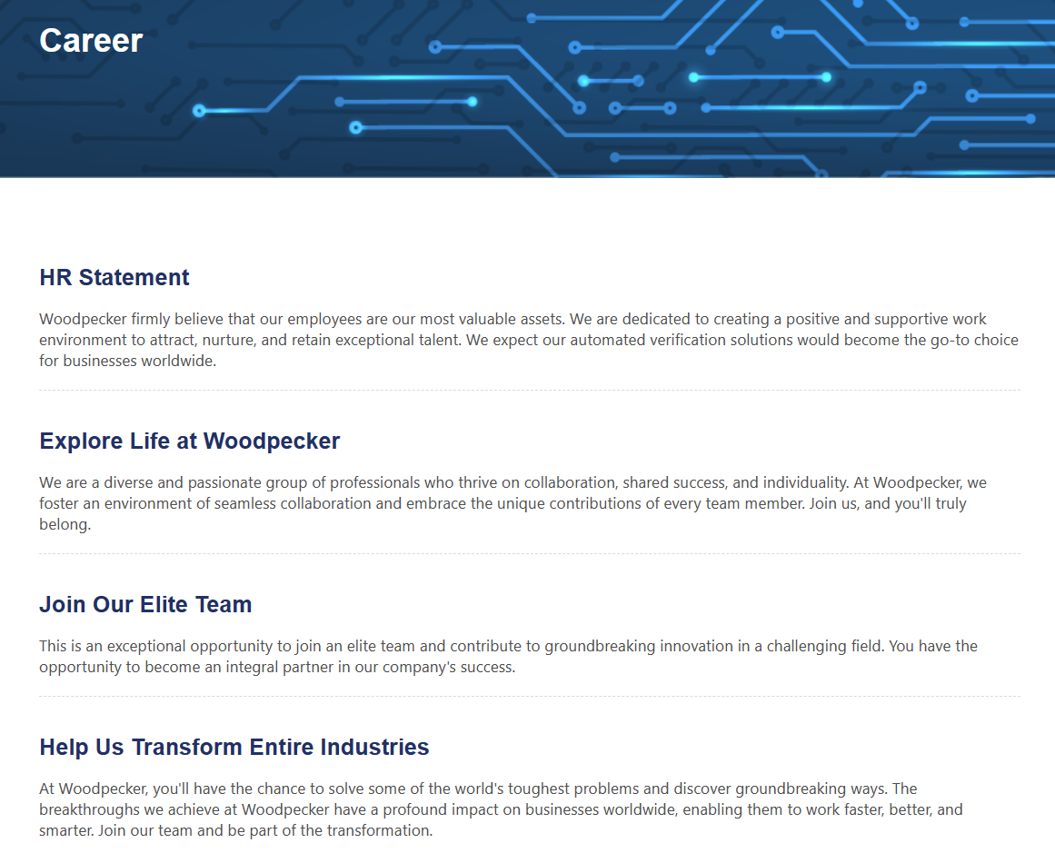
HR Statement
Woodpecker firmly believe that our employees are our most valuable assets. We are dedicated to creating a positive and supportive work environment to attract, nurture, and retain exceptional talent. We expect our automated verification solutions would become the go-to choice for businesses worldwide.

Explore Life at Woodpecker
We are a diverse and passionate group of professionals who thrive on collaboration, shared success, and individuality. At Woodpecker, we foster an environment of seamless collaboration and embrace the unique contributions of every team member. Join us, and you'll truly belong.

Join Our Elite Team
This is an exceptional opportunity to join an elite team and contribute to groundbreaking innovation in a challenging field. You have the opportunity to become an integral partner in our company's success.

Help Us Transform Entire Industries
At Woodpecker, you'll have the chance to solve some of the world's toughest problems and discover groundbreaking ways. The breakthroughs we achieve at Woodpecker have a profound impact on businesses worldwide, enabling them to work faster, better, and smarter. Join our team and be part of the transformation.

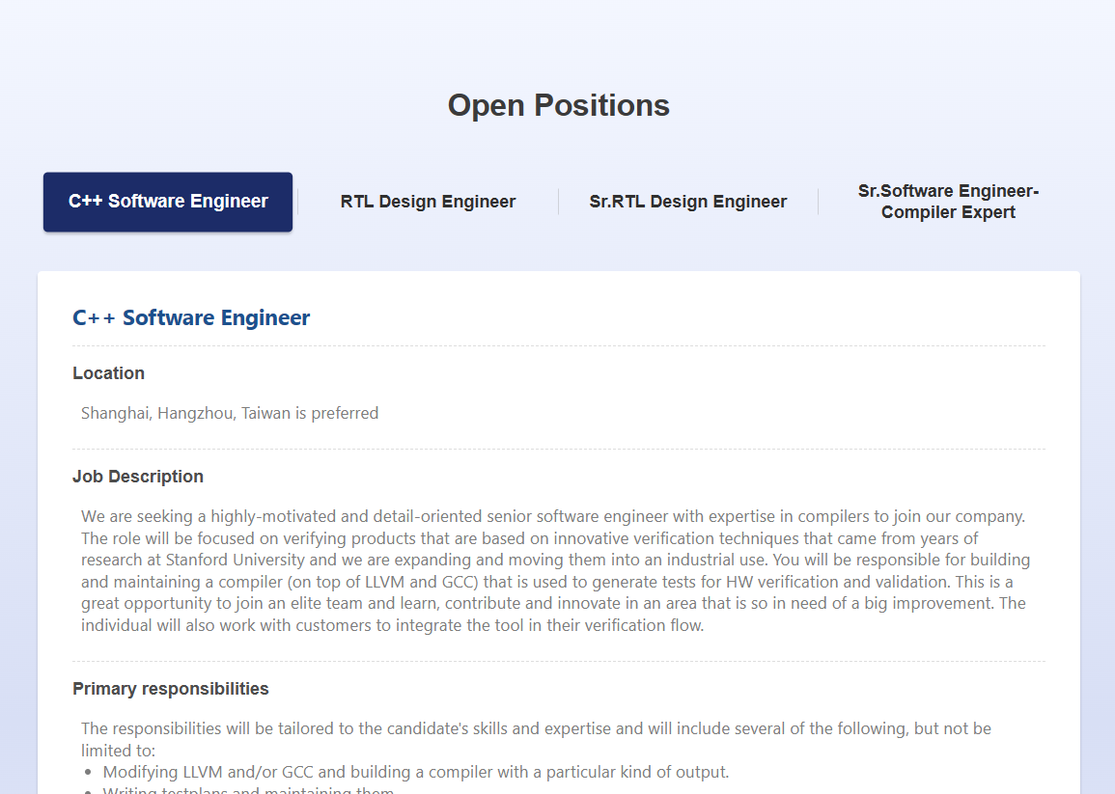
增加 ＡＰＰＬＹ ＮＯＷ 點了寄信

