Home
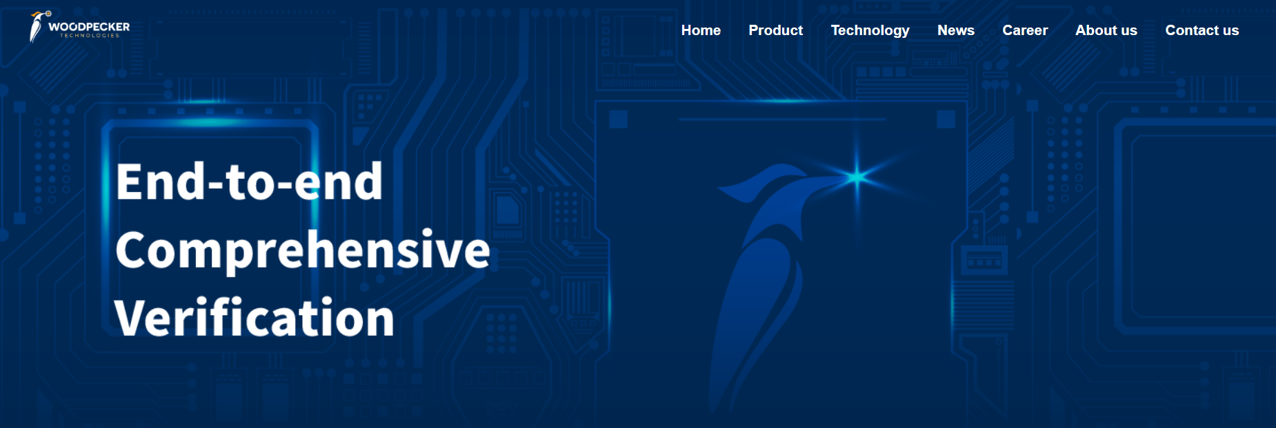
End-to-end
Comprehensive
Verification


Our Mission
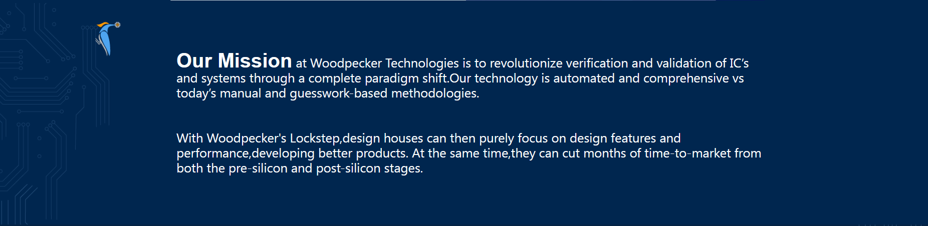

Our Mission at Woodpecker Technologies is to revolutionize verification and validation of IC’s and systems through a complete paradigm shift.Our technology is automated and comprehensive vs today’s manual and guesswork-based methodologies.

With Woodpecker's Lockstep,design houses can then purely focus on design features and performance,developing better products. At the same time,they can cut months of time-to-market from both the pre-silicon and post-silicon stages.

END-TO-END VERIFICATION
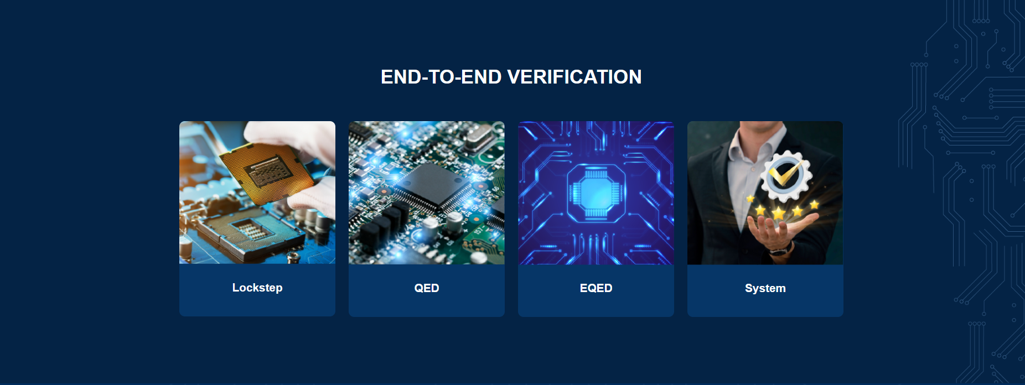

Core Values
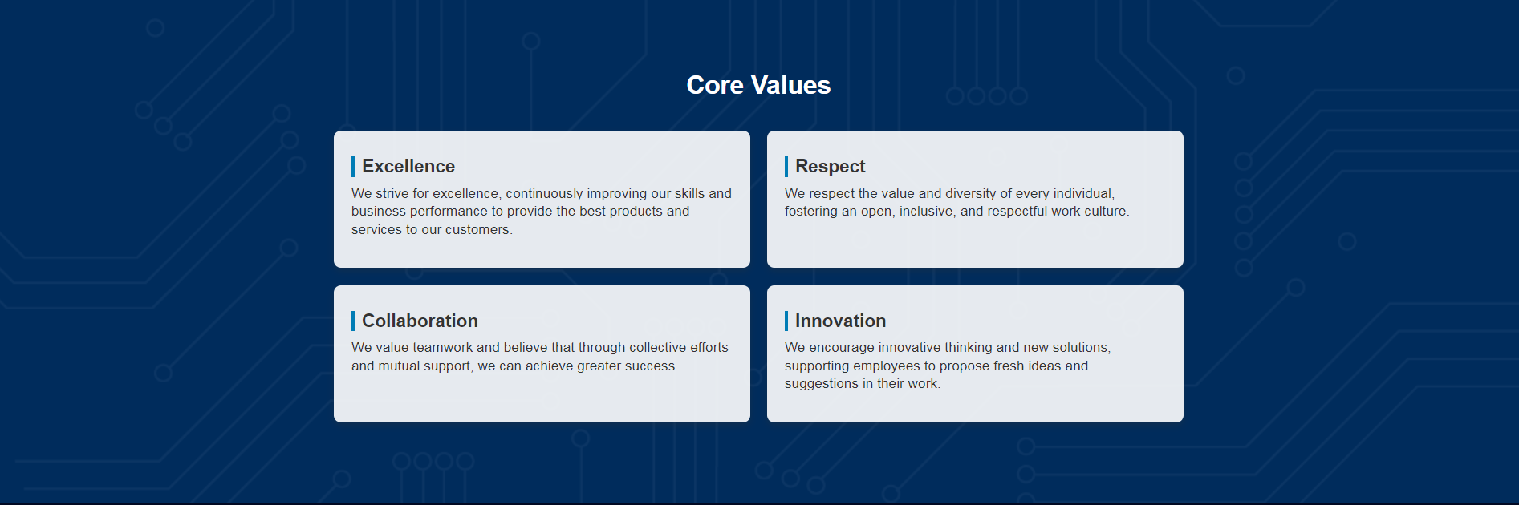
Core Values
Excellence  We strive for excellence, continuously improving our skills and business performance to provide the best products and services to our customers. | Respect  We respect the value and diversity of every individual, fostering an open, inclusive, and respectful work culture.
Collaboration  We value teamwork and believe that through collective efforts and mutual support, we can achieve greater success. | Innovation  We encourage innovative thinking and new solutions, supporting employees to propose fresh ideas and suggestions in their work.

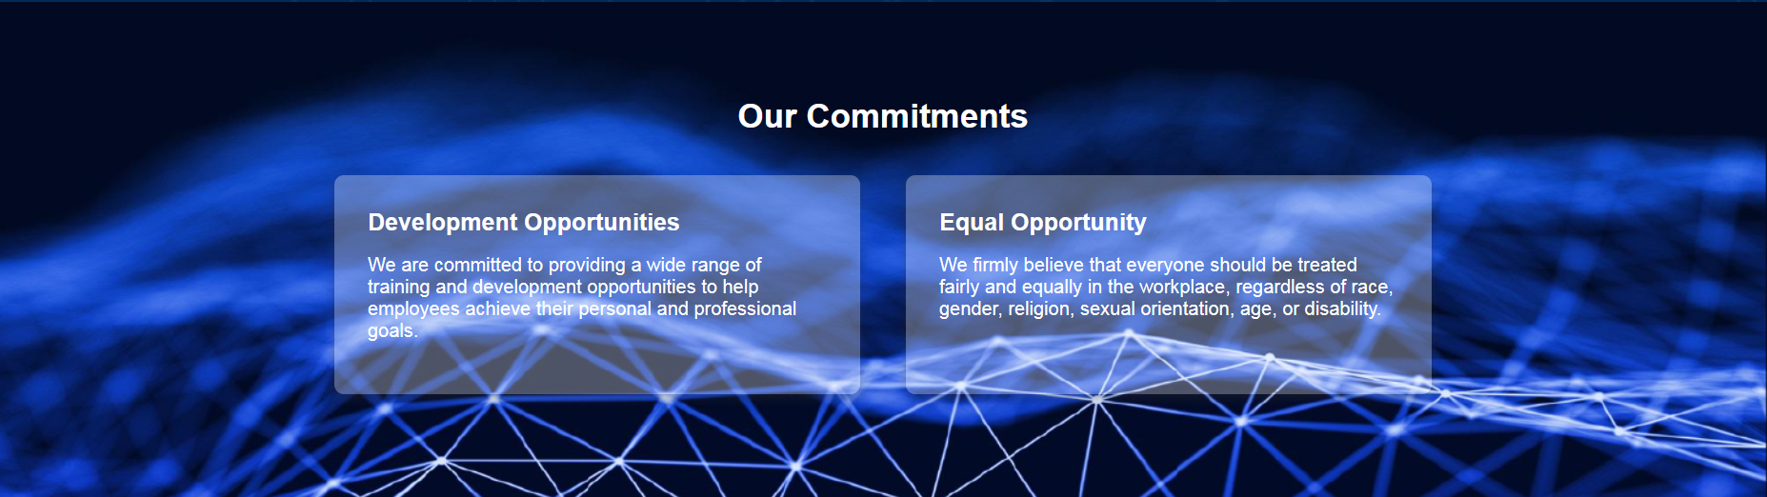
Our Commitments
Development Opportunities  We are committed to providing a wide range of training and development opportunities to help employees achieve their personal and professional goals. | Equal Opportunity  We firmly believe that everyone should be treated fairly and equally in the workplace, regardless of race, gender, religion, sexual orientation, age, or disability.

