Product
Lockstep
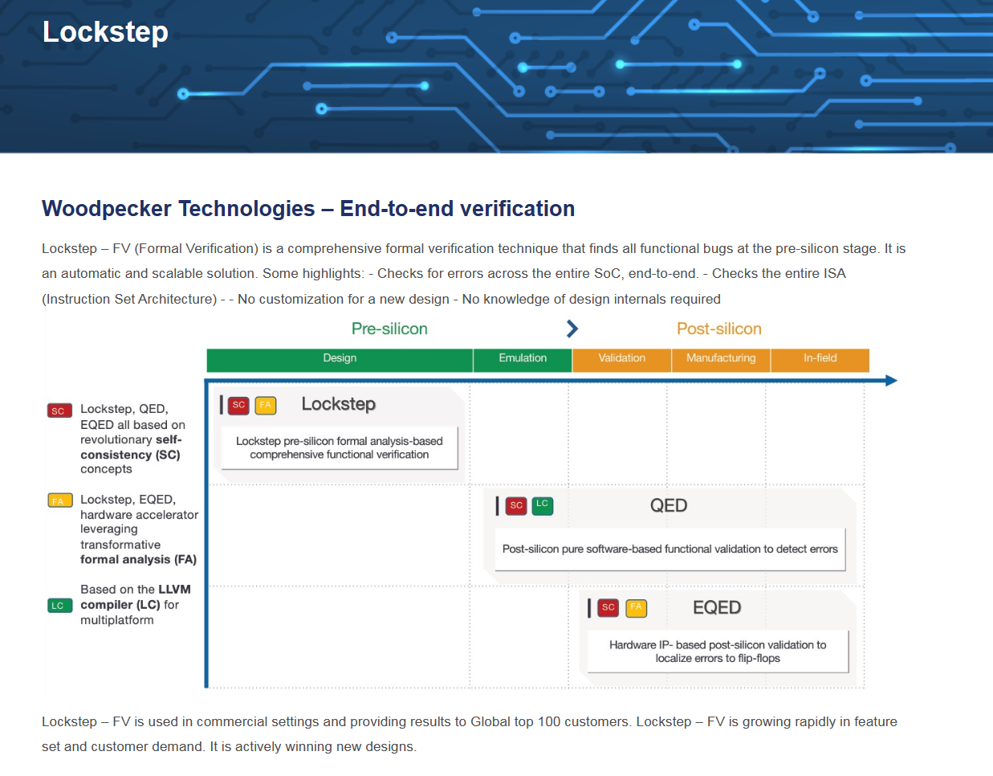
Woodpecker Technologies – End-to-end verification
Lockstep – FV (Formal Verification) is a comprehensive formal verification technique that finds all functional bugs at the pre-silicon stage. It is an automatic and scalable solution. Some highlights: - Checks for errors across the entire SoC, end-to-end. - Checks the entire ISA (Instruction Set Architecture) - - No customization for a new design - No knowledge of design internals required
Lockstep – FV is used in commercial settings and providing results to Global top 100 customers. Lockstep – FV is growing rapidly in feature set and customer demand. It is actively winning new designs.

QED
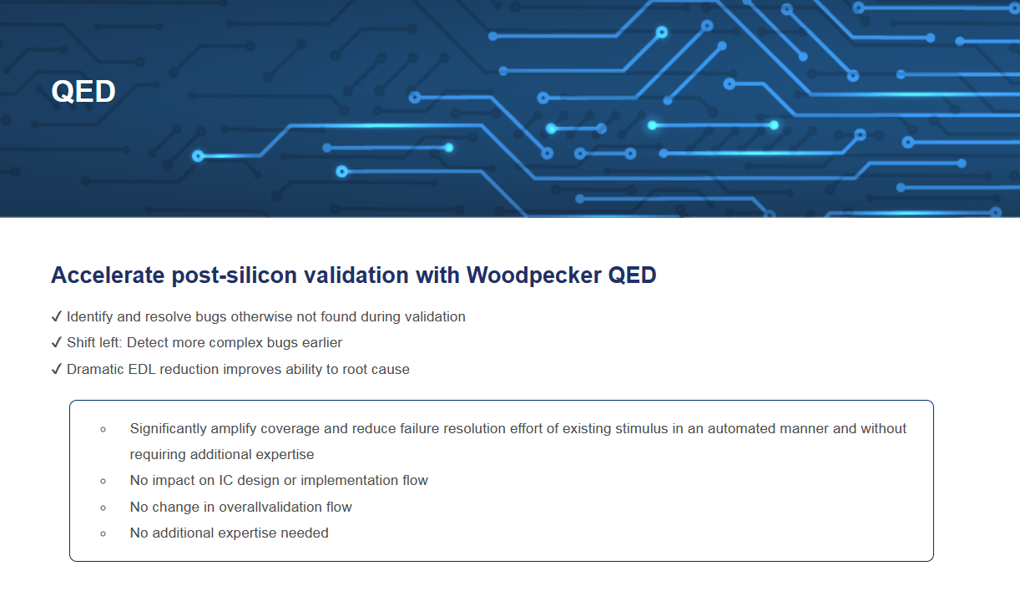
Accelerate post-silicon validation with Woodpecker QED
✔ Identify and resolve bugs otherwise not found during validation
✔ Shift left: Detect more complex bugs earlier
✔ Dramatic EDL reduction improves ability to root cause

▪ Significantly amplify coverage and reduce failure resolution effort of existing stimulus in an automated manner and without requiring additional expertise
▪ No impact on IC design or implementation flow
▪ No change in overallvalidation flow
▪ No additional expertise needed

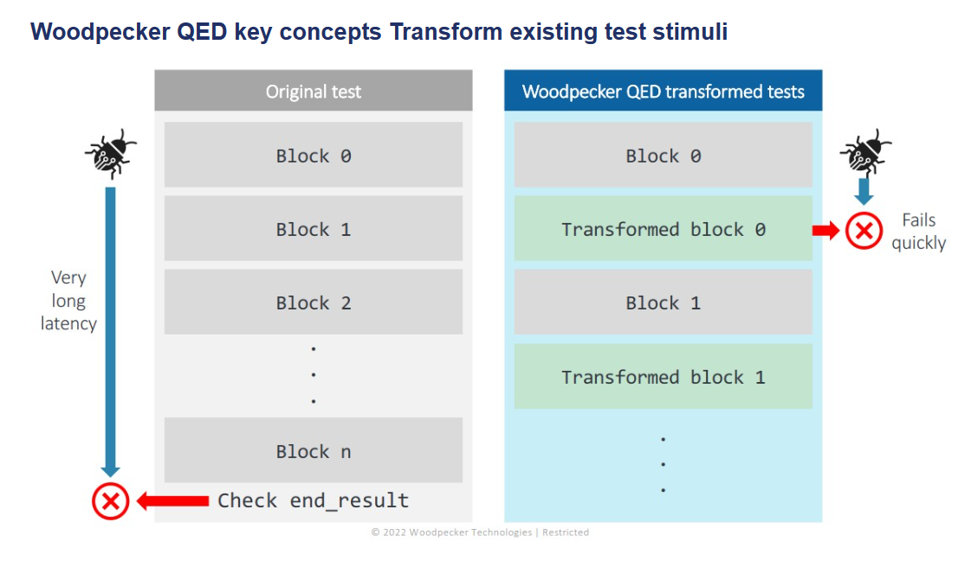
Woodpecker QED key concepts Transform existing test stimuli

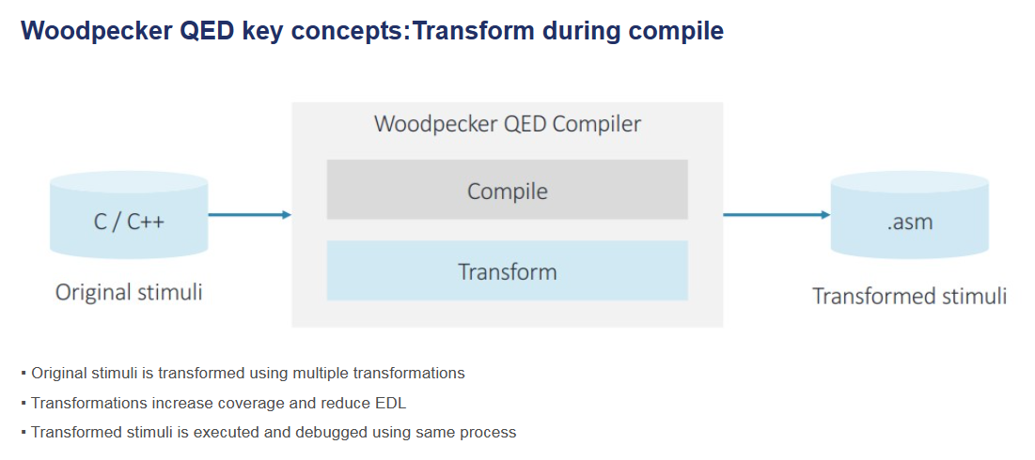
Woodpecker QED key concepts:Transform during compile
<圖片>
▪ Original stimuli is transformed using multiple transformations
▪ Transformations increase coverage and reduce EDL
▪ Transformed stimuli is executed and debugged using same process

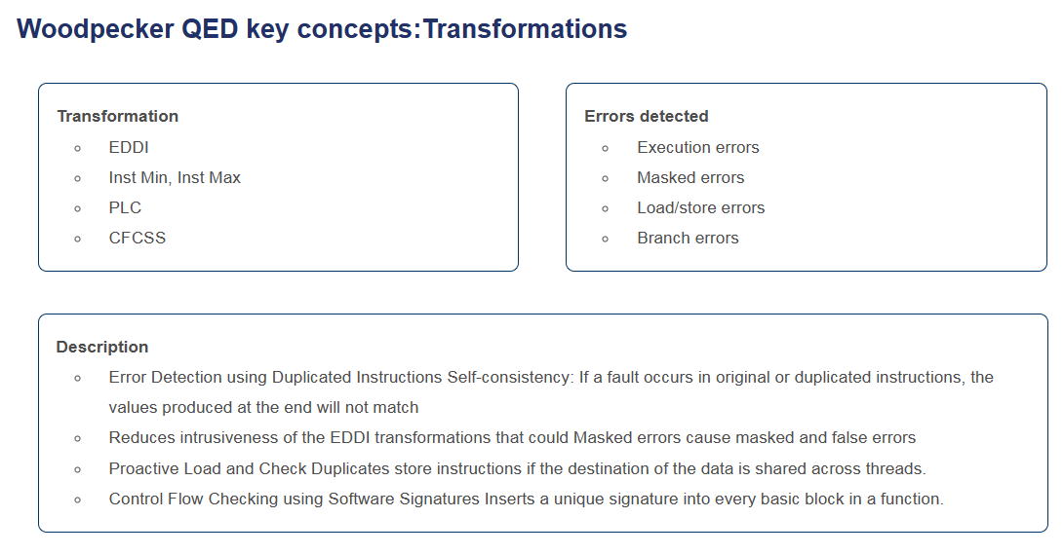
Woodpecker QED key concepts:Transformations
Transformation  EDDI  Inst Min, Inst Max  PLC  CFCSS | Errors detected  Execution errors  Masked errors  Load/store errors  Branch errors
Description
Error Detection using Duplicated Instructions Self-consistency: If a fault occurs in original or duplicated instructions, the values produced at the end will not match

Reduces intrusiveness of the EDDI transformations that could Masked errors cause masked and false errors
Proactive Load and Check Duplicates store instructions if the destination of the data is shared across threads.
Control Flow Checking using Software Signatures Inserts a unique signature into every basic block in a function.

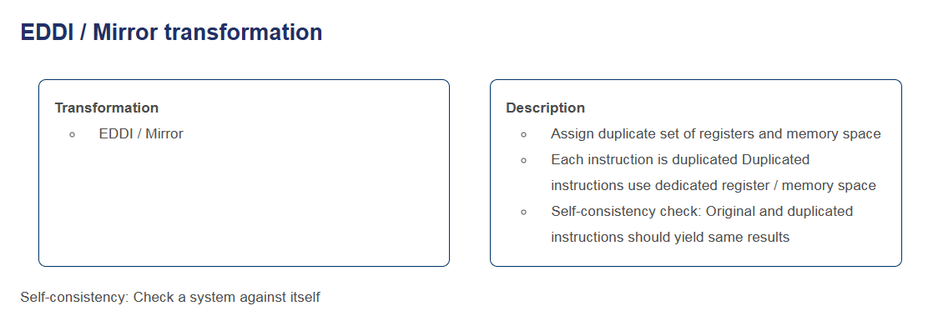
EDDI / Mirror transformation
Transformation  E▪ DDI / Mirror | Description  ▪ Assign duplicate set of registers and memory space  ▪ Each instruction is duplicated Duplicated instructions use dedicated register / memory space  ▪ Self-consistency check: Original and duplicated instructions should yield same results
Self-consistency: Check a system against itself

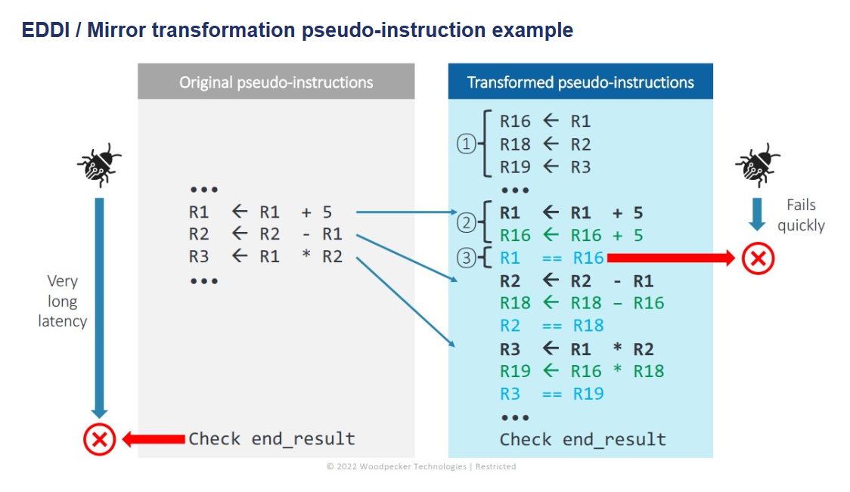

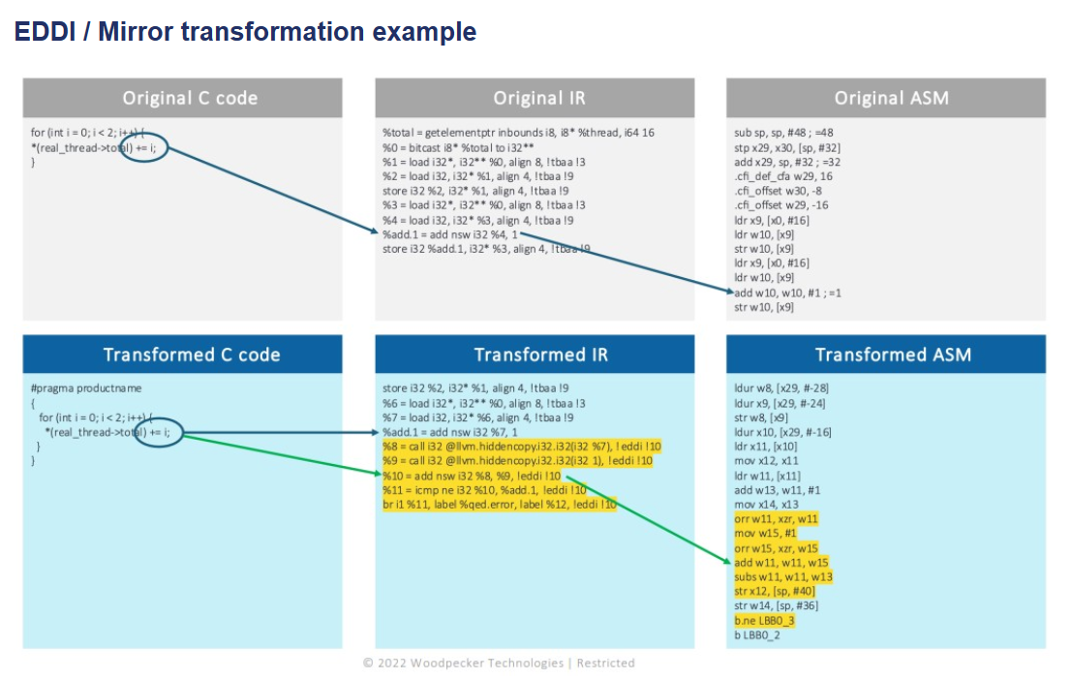

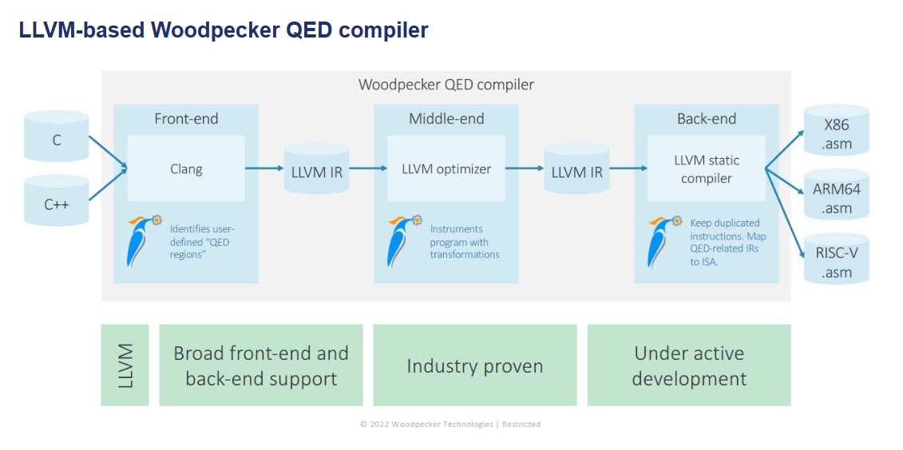

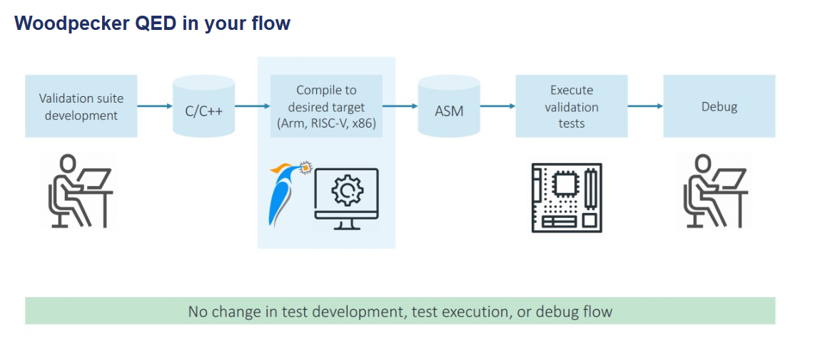

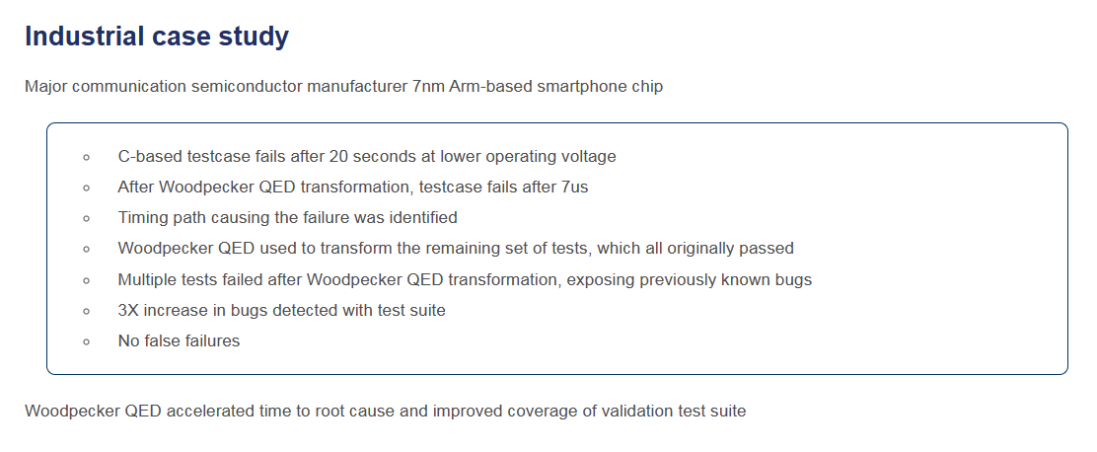
Industrial case study
Major communication semiconductor manufacturer 7nm Arm-based smartphone chip

▪ C-based testcase fails after 20 seconds at lower operating voltage
▪ After Woodpecker QED transformation, testcase fails after 7us
▪ Timing path causing the failure was identified
▪ Woodpecker QED used to transform the remaining set of tests, which all originally passed
▪ Multiple tests failed after Woodpecker QED transformation, exposing previously known bugs
▪ 3X increase in bugs detected with test suite
▪ No false failures

Woodpecker QED accelerated time to root cause and improved coverage of validation test suite

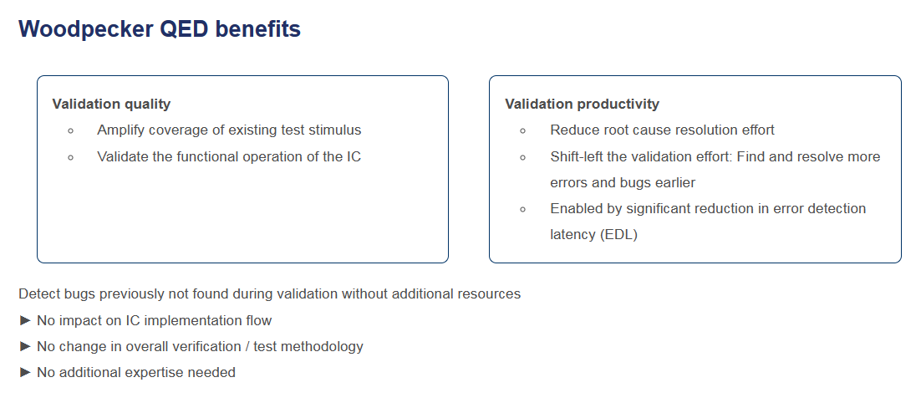
Woodpecker QED benefits
Validation quality  ▪ Amplify coverage of existing test stimulus  ▪ Validate the functional operation of the IC | Validation productivity  ▪ Reduce root cause resolution effort  ▪ Shift-left the validation effort: Find and resolve more errors and bugs earlier  ▪ Enabled by significant reduction in error detection latency (EDL)
Detect bugs previously not found during validation without additional resources
► No impact on IC implementation flow
► No change in overall verification / test methodology
► No additional expertise needed

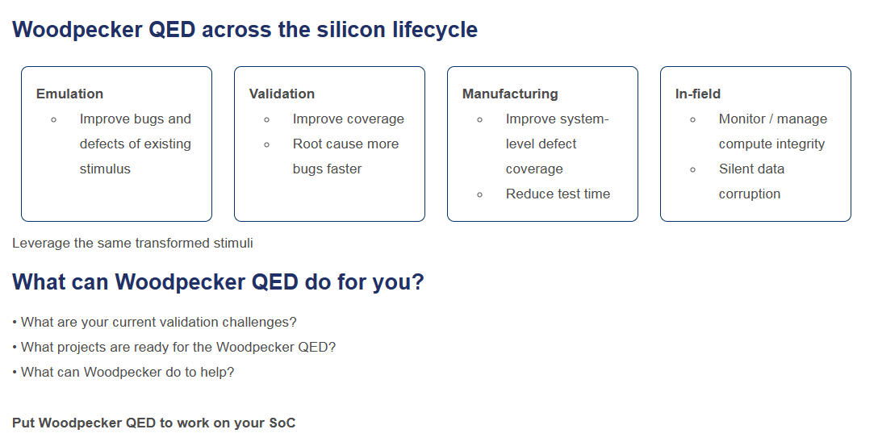
Woodpecker QED across the silicon lifecycle
Emulation  ▪ Improve bugs and defects of existing stimulus | Validation  ▪ Improve coverage  ▪ Root cause more bugs faster | Manufacturing  ▪ Improve system-level defect coverage  ▪ Reduce test time | In-field  ▪ Monitor / manage compute integrity  ▪ Silent data corruption
Leverage the same transformed stimuli

What can Woodpecker QED do for you?

• What are your current validation challenges?
• What projects are ready for the Woodpecker QED?
• What can Woodpecker do to help?

Put Woodpecker QED to work on your SoC

EQED—內容 網站製作中(圖示…)
Roadmap—內容 網站製作中(圖示…)

