Design and Implementation of Online Ordering System Based on SpringBoot

Wenjuan Shao, Kun Liu*
College of Applied Science and Technology, Beijing Union University, Beijing, China
*Corresponding author.

Abstract: With the rapid development of the economy, knowledge, information and networks have become the hallmarks of the times, driving traditional catering towards information-based and intelligent transformation. Modern catering industry has introduced online ordering systems, which not only enhance service efficiency and quality, but also strengthen enterprise management. Theme restaurants should establish core competitiveness through appropriate marketing strategies and computer-managed ordering systems. This system is designed based on the Java language, and the main development content includes web page design, database design, account management and authorization, and functional modules. The system is developed using SpringBoot and MyBatis frameworks, with the front end using HTML and JavaScript, and the backend using ApacheShiro and Tomcat server, and the database is MySQL, achieving structured online ordering management.
Keyword: Online Ordering System; Core Competitiveness; Springboot; Mysql; Information-Based Transformation

- Introduction
With the rapid development of the internet economy, the networked management mode of enterprises is constantly upgrading, and automation and intelligent management have gradually become important directions for enterprise development. Catering enterprises provide online ordering services for meals, which not only improves the service quality of catering enterprises, expands their popularity, but also provides users with convenient and fast services. The online ordering system ^{[1]} developed based on SpringBoot adopts the B/S (Browser/Server) architecture, providing an efficient solution for the front and back desk
management of restaurants. At the front desk, customers can freely choose their seats, place orders, and enjoy a convenient service experience; In the backend, managers can efficiently manage store information, view sales data in real-time, and adjust business strategies based on sales reports. This system not only optimizes the service level of the restaurant, but also reduces operating costs. By providing efficient and smooth ordering services, restaurants can better win customer trust and achieve greater economic benefits.
- System Function Analysis
The restaurant's ordering system consists of two main modules: front-end for customer interaction and back-end for management. The front-end is customer-focused, offering an intuitive interface for table selection, menu browsing, order placement, and search features, enhancing the dining experience by allowing customers to find and order dishes easily. The back-end is designed for various management roles, such as managers, waiters, cashiers, and chefs, each with distinct permissions. Managers can oversee sales, modify menus, and manage inventory; waiters track orders to provide timely service; cashiers handle payment efficiently, and chefs access detailed order information to expedite food preparation. This division of responsibilities and role-based permissions boosts the restaurant’s operational efficiency, providing a seamless experience for both customers and staff, as shown in Figure 1:
- Introduction to Key Technologies
The system functional module diagram illustrates the overall architecture and module division of this online ordering system. The diagram employs a tree-like structure to clearly depict the system's core components, including the front-end user interaction layer and the back-end management layer. The front-end module primarily consists of the "Customer Entrance" sub-module, which includes three key functions: "Seat Selection Management," "Menu Browsing and Search," and "Order Generation and Payment." These functions are implemented through responsive interfaces, allowing users to view available seats in real-time (indicated by colors and numbers for idle/occupied status), browse dish details (including images, prices, and descriptions), and place and pay for orders with one click, supporting mainstream methods such as WeChat and Alipay. This module emphasizes user-friendliness, reducing operational steps and improving conversion rates.
The back-end module is divided into the "Role Management" layer and the "Data Processing" layer. The role management includes four sub-roles: "Manager," "Waiter," "Cashier," and "Chef," each corresponding to specific permissions: Managers can access the global dashboard to view sales reports, inventory alerts, and user feedback; Waiters focus on order tracking and dish serving status updates; Cashiers handle payment confirmations and transaction records; Chefs view order details and provide feedback on cooking progress. The data processing layer implements inter-module communication via Spring Boot's RESTful APIs, ensuring real-time synchronization (such as pushing order status from "Pending" to "Completed"). Additionally, the diagram marks the security module (based on Shiro's permission authentication) and database connection (MySQL), highlighting the system's modular design for easy maintenance and extension. This diagram not only embodies the advantages of the B/S architecture (such as cross-platform access) but also emphasizes the system's high cohesion and low coupling characteristics, effectively supporting restaurants' transition from traditional manual management to digital transformation. Through visual presentation, the module diagram provides developers and users with an intuitive system blueprint, facilitating understanding of data flow paths and functional interaction logic. In actual deployment, this design can be flexibly adjusted based on the restaurant's scale; for example, small restaurants can simplify role permissions, while chain stores can extend multi-store synchronization functions.
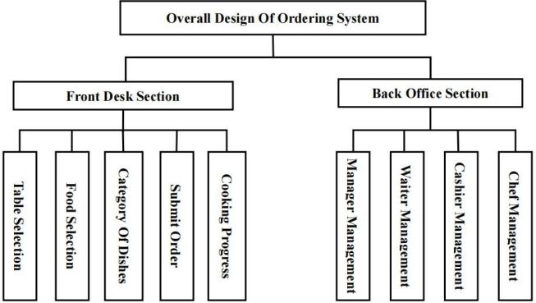
Figure 1. System Function Module Diagram3.1 MVC ^{[2]} Pattern
Key Technology Introduction: This online ordering system adopts Spring Boot + Spring MVC + MyBatis technology. The backend is mainly developed using the Java language, as Java is a typical static object-oriented programming language that allows programmers to complete complex program designs in a concise manner. The implementation of the frontend pages is primarily based on languages such as HTML and JavaScript, and the database management system uses MySQL. All of the above languages, software, and technologies fully adapt to the development needs of this system.
MVC is a typical software design pattern widely used in web application development. The MVC architecture consists of three core components: Model, View, and Controller. These three parts are separated and independent in the MVC architecture, which not only clarifies the roles of each part, but also reduces the coupling between modules and the repetitive writing of code, which is conducive to unit testing, improves software quality, and enhances the maintainability and scalability of the entire system. (The relationship diagram between the three is shown in Figure 2.
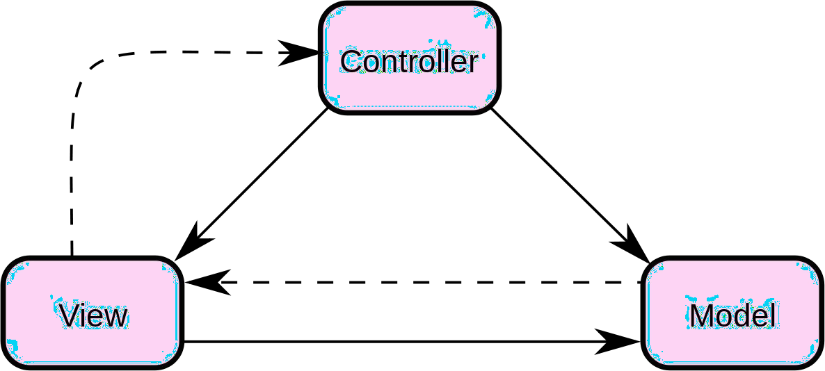
Figure 2. Model-View-Controller Pattern Diagram
  - SpringBoot [3] Framework
Spring Boot is an extension to the Spring Framework that simplifies the process of configuring and deploying Spring based applications. Spring Boot is designed to allow developers to get new Spring applications up and running quickly, reducing the complexity of building projects. It provides a wide range of default configurations (the idea that convention trumps configuration) while allowing developers to easily override and adjust these configurations. The core features of Spring Boot include embedded server support (such as Tomcat, Jetty, or Undertow), autoconfiguration, health checking, externalized configurations, and
natural support for microservices architectures. This makes it well suited for building enterprise-class applications and microservices.
  - MySQL[4]
MySQL is a widely used open-source relational database management system (RDBMS) that uses SQL (Structured Query Language) as its data access language. It is based on a client-server model, where the server runs the MySQL software and manages access to the database, and the client performs data operations by sending requests to the server. MySQL is used by many websites and applications around the world, including many large and high-traffic websites.
- Implementation of Main System Functions
[5]

  - Front Desk Function Design
The front-end functional modules mainly aimed at customers include dish selection function, seat selection, payment order confirmation and other functions
    - Table selection function
The seat selection function is one of the most important features presented to customers by this system. It provides customers with seat choices. Customers can browse empty seats, unfilled seats, and seats with customers on the client homepage. These seats are displayed to customers in the form of numbers and colors. After customers click on the seat selection, they can enter the menu selection page, as shown in Figure 3.

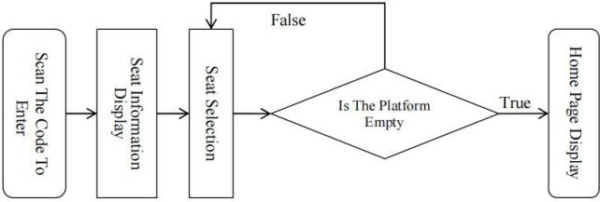
Figure 3. Part of the Background Music Code
    - Dish display function
As shown in Figure 4, one of the most important functions of the system is the dish display function. It provides customers with an online based menu selection portal, where they can browse the platform's recommended dishes on the client's homepage. These dishes are displayed in horizontal or vertical format, showing their prices, names, etc. After clicking on the dish, customers can enter the detailed introduction of the dish. On the details page,

customers can learn about the dish's introduction details and add them to their order.
    - Order management function
As shown in Figure 5, the order management function is a functional entrance designed to provide customers with convenient order management. In this entrance, users can add or delete orders generated by dishes. Each order will be displayed in the form of a card, and the order status (pending/completed), creation time, order dish list, and total order price will also be displayed on the card.
  - Backend Function Design
    - Employee login and registration function Before the employee enters the client, the system will confirm whether the employee is a company employee. Its judgment logic is whether the system has saved the employee's account information when the employee uses the client program. If the account information entered by the employee has been confirmed by the backend server, the account will be logged into the system. If it cannot pass the verification, a password error will appear and appear on the login page. The employee can choose to log in again or forget the password, as shown in Figure 6.
    - Waiter management function
After the waiter enters the client, the system will upload the customer's order information to the waiter management platform. Based on this platform, the waiter can grasp the customer's order and timely upload the dishes completed by the chef to the customer. For certain dishes that cannot be cooked due to lack of ingredients or other reasons, the waiter can provide timely feedback to the customer. At the same time, the waiter can also check the selected table of the customer in a timely manner to see if there are other customers or uncleaned tables, and provide
feedback information to the customer. And hand over the dishes made by the chef to the customers. As shown in Figure 7 and Figure 8.
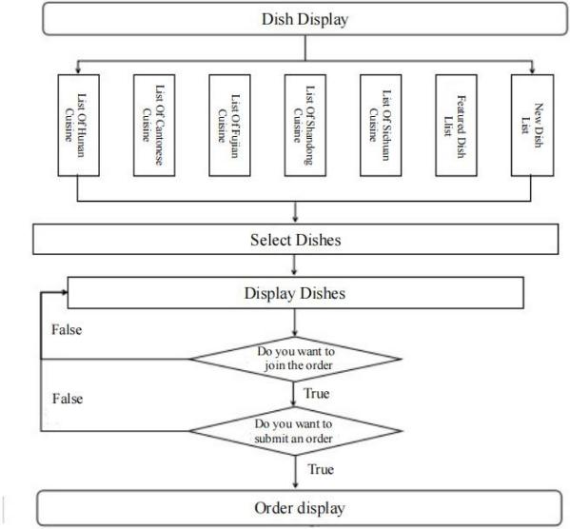
Figure 4. Process Diagram for Displaying Dishes
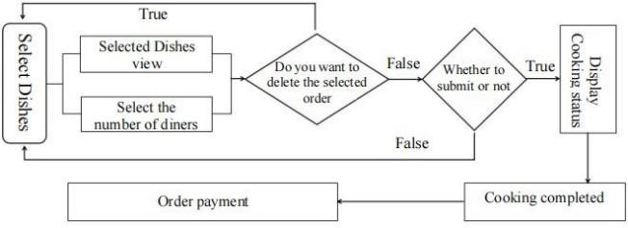
Figure 5. Order Management Flowchart
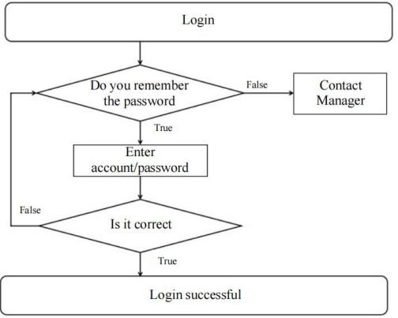
Figure 6. Employee Login and Registration Function

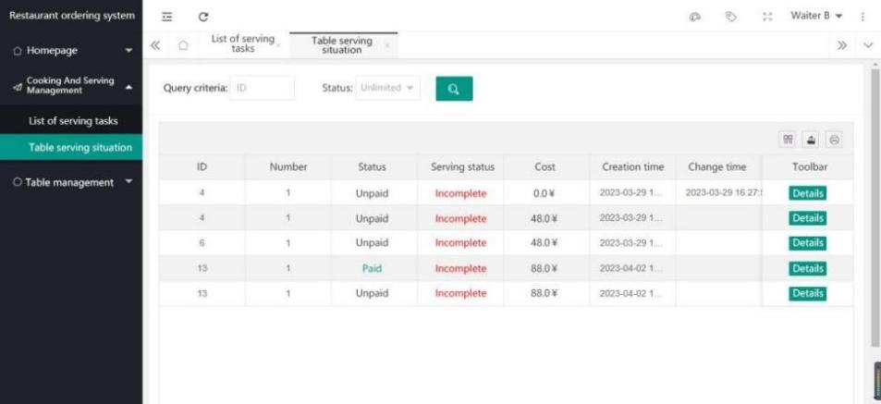
Figure 7. Table Serving Status List

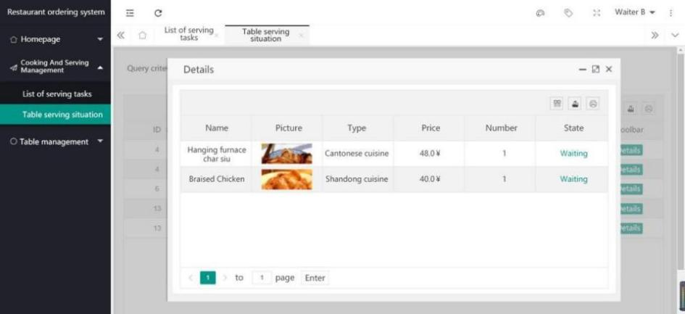
Figure 8. Table Serving Situation Details View

    - Cashier management function
After the cashier enters the client, the system will upload the customer's order information to the cashier management platform. Based on this platform, the cashier can promptly process the customer's order amount and provide feedback to the customer requesting payment. After the customer makes the payment, the payment status of the customer can be displayed, as shown in the Figure 9:
    - Chef management function
After the chef enters the client, the system will upload the customer's order information to the chef management platform. Based on this platform, the chef can promptly process the
customer's dish requirements and provide feedback to the waiter, who will then hand them over to the customer.As shown in the Figure10:
    - Manager management function
After the manager enters the client, the system will provide feedback on customer evaluations of dishes and employee suggestions for work to the manager management platform. The cashier management platform will also transfer the amount to the manager management platform's account. Based on this platform, the manager can timely understand the relevant information of customers, employees, and even daily income. As shown in the Figure 11.

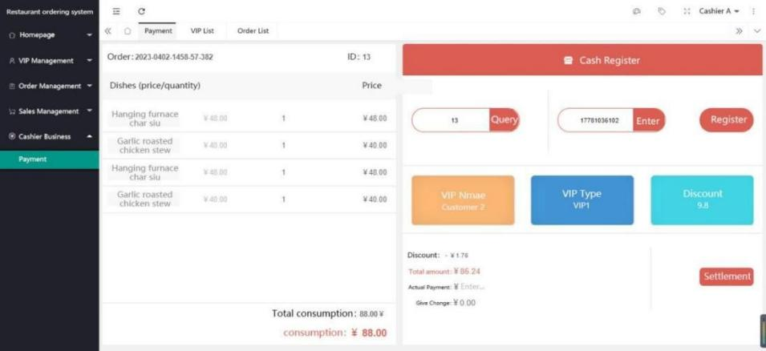
Figure 9. Transaction Detailed Record Display
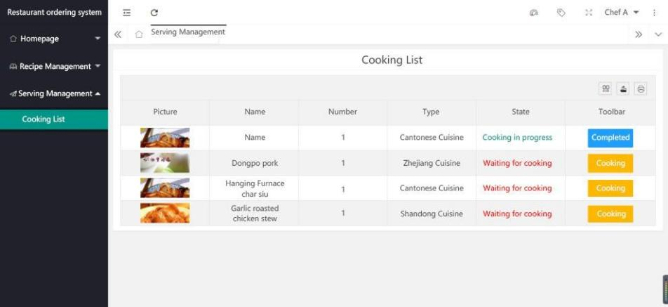
Figure 10. Order List Display

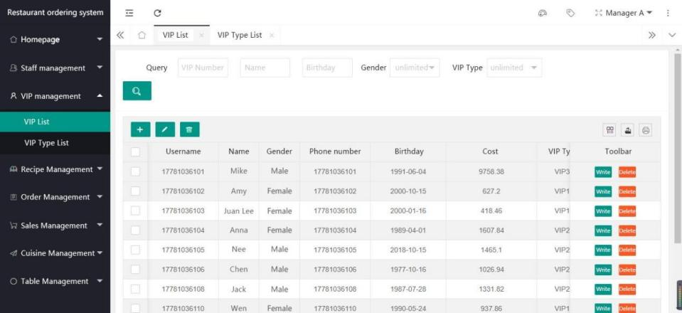

- System Test
Figure 11. Manager Viewing Member Information
solutions, and reduce user losses, it is necessary to test the entire system [7]. Table 1 and Table 2

In order to ensure high-quality operation of the system [6], identify defects in the system, find
provides a detailed list of the test contents.

Table 1. System Test
Example name | System front − end page testing
Example number | 001 | Designer: Wenjuan Shao
Test target | Can the front-end system open and display relevant functions
step | Operation description | Desired result
1 | Click on the website to enter the main interface | Successfully entered the main interface
2 | Click the seat button | Tip "Seat selection information"
3 | Click on 'To be Cleaned' | Pop up "Non idle state cannot be cleared"
4 | Click on the 'Dining' button | Pop up "Non idle state cannot be cleared"
5 | Click on the type of dish | Display dish information
6 | Click the add menu button | The words' another one 'turn red
7 | Click the zoom in button | Enlarge related pages
8 | Click the exit button | Page exit
9 | Click on order submission | Successfully submitted order
Table 2. System Test
Example name | System backend page testing
Example number | 002 | Designer: Wenjuan Shao
Test target | Can the backend system open and display relevant functions
step | Operation description | Desired result
1 | Click on the 'Type of dish' button | Display dish types
2 | Click to forget password | Pop up relevant registration information
3 | After successful login, click to view the order | Display relevant customer order information
4 | Click on personal information | Normal personal information
5 | Click on customer information | Display customer information
6 | Click on dish information | Display dish information
7 | Click on the add, delete, modify, and search buttons | Can perform related operations
8 | Click the exit button | Page exit

- Summary
There is no other country in the world with a catering industry like China, which has a long history of thousands of years and such a large scale. This online ordering system, developed
with SpringBoot, streamlines the ordering process for customers while reducing time and costs for restaurants. It offers a user-friendly interface, enabling customers to easily view tables, browse menus, and place orders. The system features a front-end for customer use and

a back-end for efficient restaurant management, supporting order tracking, inventory, and sales data. Designed for usability and efficiency, it uses a compact third-party framework to minimize storage and resource needs. The front-end integrates HTML, JavaScript, and Layui for a responsive interface, while the back-end employs SpringBoot and MyBatis for efficient data processing, with MySQL ensuring reliable data storage. Overall, the system provides a convenient ordering management solution for restaurants through systematic management, modular managemen, and structured management design. It not only enhances customers' ordering experience, but also makes the daily operation of restaurants smoother and more efficient.
References
- Trupthi B, Online Food Ordering System. International Journal of Recent Technology and Engineering, 2019(8):834-836.
- Neeraj Kumar Singh, On the Benefits of Using MVC Pattern for Structuring Event-B Models of WIMP Interactive Applications.
Interacting with Computers, 2021(33):92-114.
- Yixuan Liu. Design and Implementation of a Student Attendance Management System based on Springboot and Vue Technology. Frontiers in Computing and Intelligent Systems, 2024(1):91-97.
- Babatunde Olagoke Sunday, MySQL Database Server: Deploying Software Application to Enhance Visibility and Accountability. Current Journal of Applied Science and Technology, 2023(42):16-23.
- Xiaoyu Liu. Design of Online Examination System Based on Java EE. International Conference on Mechatronics and Industrial Informatics, 2015(3):513-516.
- Md. Rokonuzzaman, Levenberg-Marquardt algorithm-based solar PV energy integrated internet of home energy management system. Applied Energy, 2024(348):1-15.
- Xie Zongfu, Thoughts on the Construction of Local Characteristic Catering Market. Research on Business Economics, 2024(20):180.

